**Year 6**

Maths

Firstly, we will be consolidate the application of the four operations learnt in Autumn 1. We will then spend quite some time on fractions: learning to finding equivalents, adding and subtracting, and multiplying and dividing fractions. The children will be taught how to apply these processes to problem solving.

We will continue to encourage children to practice and consolidate their tables’ knowledge and arithmetic skills for homework.

English

The first genre we will cover in our English is narrative in the form of a horror. We will be using the Write Stuff approach and continue to sentence stack then the children will write their own. We will continue to read out class book, Goodnight Mr Tom and complete comprehension questions relating to the chapters. Our second genre for writing is biographies. Linked with our history topic, we will be writing a biography on Winston Churchill. Our spellings this half term will be consolidating what has been taught and moving onto Y6 spellings.

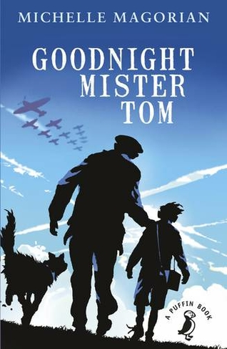**Autumn 2**

Art/DT

The children will be designing and building a motorised vehicle, using a wooden framework, constructed using Jinx triangles. These buggies will be powered by circuits made by the children. These will also be used in computing later in the year

PE

This half term the children will begin their indoor sessions with dance, using a thematic approach based on war at the home front. For our outdoor session, the children will build on their skills for tennis. They will learn develop skills for serving and returning within a game.

.

History/Geography

This half term we will be learning about war on the home front. Some of the experiences during the build up of WW2 will be shared through our Class Read and Book Study of Goodnight Mr Tom. The children will learn about evacuees while learning other key vocabulary associated with the war. Throughout the half term, we will be comparing what life was like as a child in WW1 and WW2. We will be looking in detail at rationing and how this affected daily life on the home front. Towards the end of the half term, we will consider the impact of propaganda and poetry on the views of WW1 and WW2.

RE

We will be continuing our Big Question this half term, ‘What do religions say to us when life gets hard?’

We will seek to answer this question by learning about Christianity, Islam and Non-religious beliefs and views.

Computing

This half term we will be learning about concept of variables in programming through games in Scratch.

Children will identify where they see variables used in daily life and what a variable is, before creating programs which use variables to create scoring systems.

Music

This half term children will be learning about how music is used for different purposes. Linked to our history topic, the children will be learning about WW2 songs and music, including dance music and they will be trying out some swing dance moves.

PSHE

In our PSHE, we will be learning the importance of equality, the impact of discrimination on society and how stereotypes are shaped. Furthermore, we will discuss the importance of the family within different cultures and describe the difference between identity, diversity and culture.

Science

This half term, we will start by investigating light. We will learn about how light travels; how light travels in straight lines and that images are received through reflections into the eyes. The children will be taught how shadows are created and investigate how the size of shadows can be changed.

To improve their scientific enquiry skills, the children will be conducting experiments which will require observing, recording and presenting findings through line graphs, tables and written sentences.

The children will further develop their understanding of fair testing, while developing their own questions to be explored and tested.