**Year 6**

Maths

We will start this term by looking at place value up to ten million. We will partition, order and round whole numbers.

After the children are confident with their place value, we will move onto calculations for addition, subtraction, multiplication and division. Children will be asked to apply their calculations while solving a range of single and multistep problems.

We will be encouraging children to practice and consolidate their tables knowledge and arithmetic skills for homework.

English

Our first writing genre this half term will be a recount. As stimuli, we will be reading Letters from the Lighthouse by Emma Carroll.

This year, we will be increasing the time within school spent on reading lessons. The children will be learning new vocabulary, participating in oral comprehensions and answer a range of question types.

In order to prepare for the SATs, the children will be learning and applying Y6 writing features to their independent pieces of writing.

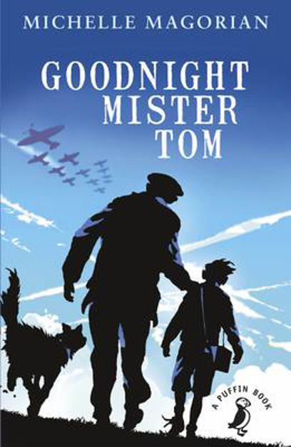**Autumn 1**

Art

We are developing photography skills and techniques to design a range of creative photographic outcomes. We will then move on to analysing and evaluating artworks. The children will exploring various artists and research their techniques and artistic intentions. They will be collecting ideas in sketchbooks, planning for a final piece and presenting what they have learnt.

Computing

Computing this term will be implemented through other curriculum areas and specific units will be taught in Autumn 2. We will however, be covering online safety throughout the year.

Spanish

This year, we will be building on the children’s understanding of numbers by counting up to 100 in Spanish. They will then apply this knowledge to questions relating to age and money.

Geography

This term we will be learning about South America. The children will be identifying the countries that make up South America, along with cites and geographical features. Within the unit, we will be using atlases and understanding more about what it would be like to live in a South American country.

PE

This year the 2 hours allocation for PE will consist of one and a half hours of a lesson, in addition to time on the outdoor gym and planned activities over lunch. The lessons will be split between health related fitness and Dodgeball. These lessons will be taught by either Mr Walker or Mrs Halkyard.

Music

This half term, the children will be developing their skills in rhythm and performance. They will learn to play a variety of percussion instruments and develop the skills of African Drumming to create ensemble pieces.

Science

Our first topic this half term is animals, including humans. The children will build on their knowledge from previous years. We will begin with reviewing their understanding of the body and key vocabulary used to identify organs and skeletal structure. Within the Y6 syllabus, we will then take a look at the human circulatory system, and describe the functions of the heart, blood vessels and blood.

By the end of the unit, the children will be able to recognise the impact of diet, exercise, drugs and lifestyle on the way their bodies function. Additionally, they will be able to describe the ways in which nutrients and water are transported within animals, including humans.

Throughout the unit, we will be using scientific skills by planning investigations, recording findings, identifying what makes a fair test and presenting conclusions.

PSHE

In our PSHE, we will be learning how to discern information online while staying safe.

The class will begin the year with recognising their personal strengths and learning to set goals. We will also discuss the importance of rules and create class rules together.

RE

Our Big Question this half term is, ‘What do religions say to us when life gets hard?’

We will seek to answer this question by learning about Christianity, Islam and Non-religious beliefs and views.