**Year 6**

Maths

Firstly, we will be consolidate the application of the four operations learnt in Autumn 1. We will then spend quite some time on fractions: learning to find equivalents, adding and subtracting, and multiplying and dividing fractions. The children will be taught how to apply these processes to problem solving. We will then move on to converting metric and imperial measures.

We will continue to encourage children to practice and consolidate their tables’ knowledge and arithmetic skills.

English

The first genre we will cover in our English is narrative in the form of a horror story. We will be using the Write Stuff approach and continue to sentence stack, then the children will write their own. We will be reading a new class book, Stormbreaker (Alex Rider) by Anthony Horowitz and complete comprehension questions relating to the chapters. Our second genre for writing is persuasive text. We will continue to work through the Year 5/6 spellings in class, learning patterns and spelling rules.

**Autumn 2**

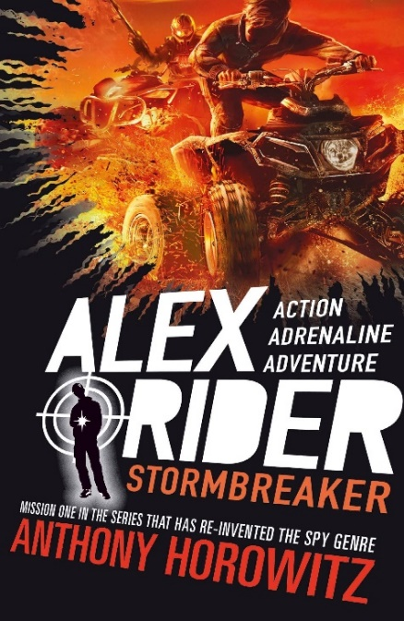

History

This half term we will be learning about the causes and consequences of WW2. Children will look at what paved the way to the start of WW2 after WWI; which countries were at war and how Britain prepared and reacted to being at war. They will also discover the role of women and evacuees; how propaganda was used, the Battle of Britain as a turning point in WWII and how D-Day led to the Allies eventually defeating Hitler and bringing an end to WW2. This unit will provide opportunities to study a range of primary and secondary sources throughout.

PE

This half term the children will begin their sessions with dance, using a thematic approach based on the war. The children will also be learning the skills and rules to play hockey. Over the term, they will develop their dribbling, shooting and passing which will then be applied to games.

DT

This half term we will be designing a waistcoat in accordance to a specific design criteria. This will involve: annotating designs, using a template, marking and cutting fabric accurately, and sewing. Throughout this unit children will be evaluating their work continually as it is created.

Science

Our topic this half term is Evolution and adaptation. The children will be learning about how all animals and pants vary and how these variations are passed on to their offspring – the children will be looking at their own ancestors/families and trying to see which characteristics they may have inherited themselves.

We will be exploring how animals are adapted to their environments and researching the characteristics of animals and plants that live in hot places (deserts) and cold places (the arctic). How do their characteristics help them to survive?

We will the finally move onto looking at the work of Charles Darwin and how his discoveries and the fossil record give us evidence to support theories of evolution. We will also be thinking about the differences between natural selection and artificial selection (breeding).

RE

We will be continuing our Big Question this half term, ‘What do religions say to us when life gets hard?’

We will seek to answer this question by learning about Christianity, Islam and Non-religious beliefs and views.

Computing

This half term we will be learning about concept of variables in programming through games in Scratch.

Children will identify where they see variables used in daily life and what a variable is, before creating programs which use variables to create scoring systems.

Music

This half term children will be learning about how music is used for different purposes. Linked to our history topic, the children will be learning about WW2 songs and music, including dance music and they will be trying out some swing dance moves.

PSHE

In our PSHE, we will be learning the importance of equality, the impact of discrimination on society and how stereotypes are shaped. Furthermore, we will discuss the importance of the family within different cultures and describe the difference between identity, diversity and culture.