**Year 6**

English

Our class read this half term is Holes, by Louis Sachar. This will be our stimulus for our reading lessons each week.

This term, we will be developing the children’s understanding of editing writing and improving writing. For our independent writes, we will be learning the features of a newspaper and narrative. The children will be learning how to apply Y6 writing features in our daily writing lessons and spelling rules in our spelling lessons.

Maths

We will continue to practise skills and knowledge taught in lessons from the Autumn term on a daily basis. Children will also be given mathematical key facts to learn which will greatly help them in their Y6 SATS. This term, we will be learning about, reading and writing decimals and applying our knowledge to the four operations. After decimals, we will develop our understanding of percentages. The children will learn how to find a percentage of an amount. They will order fractions, decimals and percentages using the concepts of equivalence.

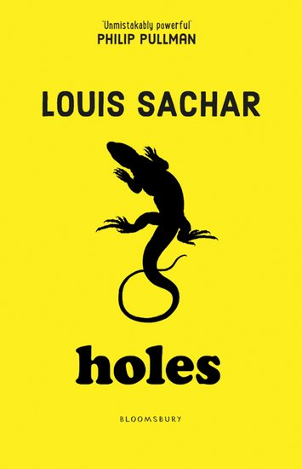**Spring 1**

Art

In Art this half term we will be looking at Ancient Maya and modern-day street art. We will look at how artists convey a message and explore: imagery, symbols, expressive mark making, and 'chiaroscuro'. We will use this to create powerful drawings of our own.

RE

Our Big Question this half term is, ‘Is it better to express your religion in arts and architecture or in charity and generosity?’

We will seek to answer this question by learning about Christianity, Islam, Non-religious beliefs and hope to visit a place of worship.

PSHE

In our PSHE, we will reviewing our expectations in Y6 and the importance of resilience. Throughout this half term, we will be learning how to recognise early signs of illness and learning more about allergies, immunisations and vaccinations as part of our health unit.

Spanish

This half term we will be focussing on developing speaking and listening in Spanish. We will learn how to say where someone is from; discuss nationality, and languages.

Science

We will begin the half term, reviewing the learning that took place in the Autumn 2 half term. The children will produce a showcase to demonstrate their understanding.

For the remainder of the half term, our focus will be electricity. We will be planning different types of scientific enquiries to answer questions, including recognising and controlling variables where necessary. The children will be creating circuits with a range of components while identifying the symbols for them. They will test how the number of cells in the circuit will affect the brightness of a lamp or the volume of a buzzer.

Computing

Computing this term will be implemented through other curriculum areas and specific units will be taught in Spring 2. We will however, be covering online safety throughout the year within PSHE.

PE

This half term the children will be learning the skills of counter-balance and counter tension within gymnastics. In outdoor sessions, the children will learn the rules, skills and strategies needed to play lacrosse.

Geography

This half term we will be exploring and answering the big question ‘are resources shared equally?’ We will begin by looking at why people migrate, how we link through trade, the similarities and differences of shops and deciding if we live in a fair world.

Music

This half term, the children will be developing their skills in reading music and playing simple melodies on the keyboard. They will learn to play using both hands separately and then together.