Meanwood Primary School Relationship and sex education policy


Approved by: | Full Governing Board | Date: 19th March 2026
Last reviewed on: | January 2026
Next review due by: | January 2027

Contents
- Aims 2
- Statutory requirements 2
- Policy development 3
- Definition 3
- Curriculum 3
- Delivery of RSE 4
- Use of external organisations and materials 6
- Roles and responsibilities 7
- Parents’ right to withdraw 8
- Training 8
- Monitoring arrangements 8
Appendix 1: Curriculum maps 9
Pol-Ed covers all areas of PSHE for primary schools 9
Appendix 2: By the end of primary school pupils should know 12
Appendix 3: Parent/carer form requesting their child’s withdrawal from sex education within RSE 15

Aims
The aims of relationships and sex education (RSE) at our school are to:
Provide a framework in which sensitive discussions can take place
Prepare pupils for puberty, and give them an understanding of sexual development and the importance of health and hygiene
Help pupils develop feelings of self-respect, confidence and empathy, and cultivate positive characteristics such as kindness and integrity
Create a positive culture around issues of sexuality and relationships
Teach pupils the correct vocabulary to describe themselves and their bodies
Help pupils be responsible, respectful and kind during discussions and to value others opinions and ideas.

Statutory requirements
As a maintained primary school, we must provide relationships education to all pupils under section 34 of the Children and Social Work Act 2017.
We are not required to provide sex education, but we do need to teach the elements of sex education contained in the science curriculum.

In teaching RSE, we must have regard to guidance issued by the secretary of state, as outlined in section 403 of the Education Act 1996.
We also have regard to legal duties set out in:
- Sections 404 to 407 of the Education Act 1996.
- Part 6, chapter 1 of the Equality Act 2010
- The Public Sector Equality Duty (PSED) (as set out in section 149 of the Equality Act 2010). This duty requires public bodies to have due regard to the need to eliminate discrimination, advance equality of opportunity and foster good relations between different people when carrying out their activities
At Meanwood Primary School, we teach RSE as set out in this policy.

Policy development
This policy has been developed in consultation with staff. The consultation and policy development process involved the following steps:
- Review – a member of staff pulled together all relevant information including relevant national and local guidance
- Staff consultation – all school staff were given the opportunity to look at the policy and make recommendations

- Parent/stakeholder consultation – parents/carers were invited to attend a meeting about the policy
- Ratification – once amendments were made, the policy was shared with governors and ratified

Definition
For the purpose of this policy:
The focus of our curriculum will be ensuring children are taught about respect and making positive choices with regards to all aspects of relationships and health. We believe this is crucial in preparing them for the next stage of their lives and education and will support them in making a positive contribution to society and their community.
RSE is about the emotional, social and cultural development of pupils, and involves learning about relationships, sexual health, sexuality, healthy lifestyles, diversity and personal identity.
RSE involves a combination of sharing information, and exploring issues and values. RSE is not about the promotion of sexual activity.

Curriculum
Our RSE curriculum is set out as per Appendix 1. We use the Pol-Ed PSHE curriculum, which will cover not only aspects of Relationships Education but PSHE as well, we may need to adapt it as and when necessary.
If pupils ask questions outside the scope of this policy, teachers will respond in an appropriate manner so they
are fully informed and don’t seek answers online.
Primary puberty education will focus on:
- Preparing boys and girls for the changes that adolescence brings
- Why these changes take place - this is how a baby is created.

- Parents will be sent a letter informing them about the puberty talks, led by the school nursing team.
- Puberty sessions will take place for all children in Year 5 and Year 6.

We will share all curriculum materials with parents and carers on request.

Delivery of RSE
RSE is taught within the personal, social, health and economic (PSHE) education curriculum. Biological aspects of RSE are taught within the science curriculum, and other aspects are included in religious education (RE).
Pupils also receive stand-alone puberty sessions delivered by a trained health professional - our school nurse.

The school will make sure that:
Core knowledge is sectioned into units of manageable size
The required content is communicated to pupils clearly, in a carefully sequenced way and within a planned scheme of work
Teaching includes sufficient and well-chosen opportunities and contexts for pupils to embed new knowledge, so that it can be used confidently in real-life situations

Relationships education focuses on teaching the fundamental building blocks and characteristics of positive relationships including:
Families and people who care for me Caring friendships
Respectful, kind relationships Online safety and awareness Being safe

Primary sex education will focus on:
Preparing boys and girls for the changes that adolescence brings How a baby is conceived and born
Naming of body parts

Throughout each year group we will use appropriate material to assist learning, such as: Diagrams
Videos Books Games
Discussions and practical activities

Teachers will make sure that all pupils’ views are listened to, and will encourage them to ask questions and engage in discussion. Teachers will answer questions sensitively, honestly and appropriately for the age of the pupils.

The programme will be designed to engage boys and girls equally, with activities planned to ensure both groups are actively involved.

The school will ensure that all teaching and materials are appropriate for pupils’ ages and needs, including
those with special educational needs and disabilities (SEND).

Community nurses will visit the school to deliver puberty lessons. These sessions will be taught in gender groups to help pupils feel more comfortable and confident asking questions in smaller settings. Religious beliefs and individual needs, including SEND, will be considered. The nurses’ experience and expertise will enable them to respond appropriately to any challenging questions.

Parents and carers will be informed in advance of any Sex Education lessons, and their views will be respected. The parental right to withdraw from Sex Education remains in place; an example withdrawal letter is provided on page 15.

Following updates to RSE guidance, the school has reviewed its policy and determined that no additional Sex Education content is required to meet pupils’ needs. However, in line with current expectations, pupils will learn the correct terminology for body parts, including genitalia. This supports children’s understanding of personal safety and helps them identify and report signs of abuse.

The curriculum may be adapted when necessary to respond to pupils’ needs or to address relevant issues in an age-appropriate way. Parents and carers will be informed in advance of any changes to the published policy, and related materials will be shared on request.

For more information about our RSE curriculum, see Appendices 1 and 2.

When learning is taught within the context of family life, the school will ensure that no child is stigmatised based on their home circumstances. Teaching will reflect the diversity of family structures, including
single-parent families, same-sex parents, families headed by grandparents, adoptive families, foster families, and others. We will also be sensitive to pupils who may have different support structures, such as looked-after children, young carers, or those in kinship care.

Across the school, we will remain mindful of the law and legal requirements, ensuring that teaching does not condone or encourage illegal activity, including violence, criminal damage, or hate crime. Any disclosures or concerns will be reported to the Designated Safeguarding Lead (DSL).

  - Inclusivity
We will teach about these topics in a manner that:
Considers how a diverse range of pupils will relate to them
Is sensitive to all pupils’ experiences
During lessons, makes pupils feel:
    - Safe and supported
    - Able to engage with the key messages We will also:
Make sure that pupils learn about these topics in an environment that’s appropriate for them, for example
in:
    - A whole-class setting
    - Small groups or targeted sessions
    - 1-to-1 discussions

    - Digital formats
Give careful consideration to the level of differentiation needed

  - Use of resources
We will consider whether any resources we plan to use:
    - Are aligned with the teaching requirements set out in the statutory RSE guidance
    - Would support pupils in applying their knowledge in different contexts and settings
    - Are age-appropriate, given the age and maturity of the pupils
    - Are evidence-based and contain robust facts and statistics
    - Fit into our curriculum plan
    - Are from credible sources
    - Are compatible with effective teaching approaches
    - Are sensitive to pupils’ experiences and won’t provoke distress
We will make sure that when we consult parents/carers we provide examples of the resources that the school plans to use.

Use of external organisations and materials
We will make sure that an agency and any materials used are accurate, age and stage appropriate and unbiased and in line with our legal duties around political impartiality.
We will:
Make appropriate checks and engage with external agencies to make sure that their approach to teaching about RSE is balanced, and it and the resources they intend to use:
- Are age-appropriate
- Are in line with pupils’ developmental stage
- Comply with:
  - This policy
  - The Teachers’ Standards
  - The Equality Act 2010
  - The Human Rights Act 1998
  - The Education Act 1996
Only work with external agencies where we have full confidence in the agency, its approach and the resources it uses
Make sure that any speakers and resources meet the intended outcome of the relevant part of the curriculum
Review any case-study materials and look for feedback from other people the agency has worked with Be clear on:
- What they’re going to say
- Their position on the issues to be discussed
Ask to see in advance any materials that the agency may use

Know the named individuals who will be there, and follow our usual safeguarding procedures for these people
Conduct a basic online search and address anything that may be of concern to us, or to parents and carers
Check the agency’s protocol for taking pictures or using any personal data they might get from a session
Remind teachers that they can say “no” or, in extreme cases, stop a session
Make sure that the teacher is in the room during any sessions with external speakers
Inform all external organisations that the school is legally obliged to share all content with parents and carers
Share all external materials with parents and carers We won’t, under any circumstances:
Work with external agencies that take or promote extreme political positions
Use materials produced by such agencies, even if the material itself is not extreme
Work with agencies who don’t allow their material to be shared with parents and carers

Roles and responsibilities
  - The governing board
The governing board will approve the RSE policy, and hold the headteacher to account for its implementation.

  - The headteacher
The headteacher is responsible for making sure that RSE is taught consistently across the school, for sharing all resources and materials with parents and carers, and for managing requests to withdraw pupils from non- statutory/non-science components of RSE (see section 9).

  - Staff
Staff are responsible for:
Delivering RSE in a way that is sensitive, high-quality and appropriate for each year group Modelling positive attitudes to RSE
Monitoring progress
Responding to the needs of individual pupils
Responding appropriately to pupils whose parents/carers wish them to be withdrawn from the [non- statutory / non-science] components of RSE
Modelling positive behaviour and avoiding language that might perpetuate harmful stereotypes, and being conscious of everyday sexism, misogyny, homophobia and stereotypes
Reporting any safeguarding concerns or disclosures that pupils may make as a result of the subject content to the school’s designated safeguarding leads (DSL) Mrs Helen Vyse, Mrs Julia Fletcher, Mrs Samantha Molloy, Mrs Kathryn Beeley or Miss Charlotte Sandiford.
Staff do not have the right to opt out of teaching RSE. Staff who have concerns about teaching RSE are encouraged to discuss this with the PHSE Champion or the headteacher.

  - Pupils

Pupils are expected to engage fully in RSE and, when discussing issues related to RSE, treat others with respect and sensitivity.

Parents’ right to withdraw
Parents/carers do not have the right to withdraw their child from relationships education.
Parents/carers have the right to withdraw their child from the non-statutory/non-science components of sex education within RSE.
Requests for withdrawal should be put in writing using the form found in Appendix 3 of this policy and addressed to the headteacher.
Alternative schoolwork will be given to pupils who are withdrawn from sex education.

Training
Staff are trained on the delivery of RSE as part of their induction and it is included in our continuing professional development calendar.
The headteacher will also invite visitors from outside the school, such as school nurses or sexual health professionals, to provide support and training to staff teaching RSE.
The PSHE Champion attends all Relationships Education RUSC group meetings and disseminates important information to changes to staff. Staff meetings are organised accordingly.

Monitoring arrangements
The delivery of RSE will be monitored by Mrs Heidi Cunnelly, PSHE Champion, through:

- Evidence of taught lessons submitted via Pol-Ed
- Teacher-recorded discussion evidence stored in Active Inspire notebooks for monitoring and coverage verification
- Teacher feedback and pupil voice

Pupil progress in RSE will be monitored by class teachers as part of the school’s internal assessment
processes.

This policy will be reviewed annually by Mrs Heidi Cunnelly, PSHE Champion. Following each review, the policy will be submitted to the headteacher, Mrs Helen Vyse, and to the Governing Body for approval.

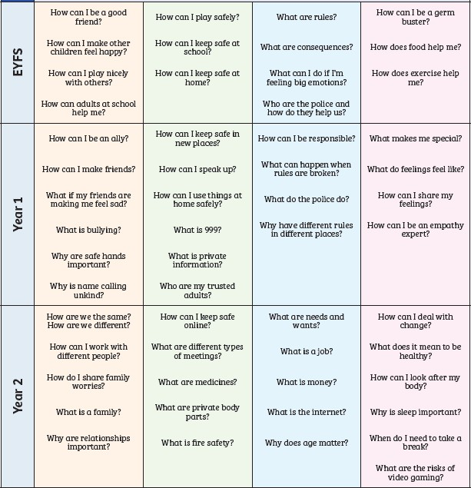
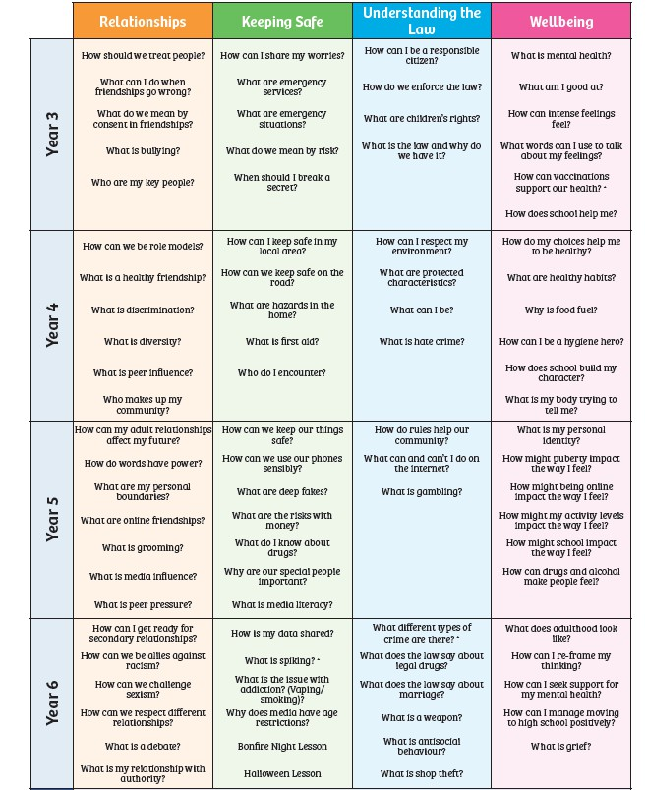
Appendix 1: Curriculum maps

Pol-Ed covers all areas of PSHE for primary schools.
Note: EYFS currently using ‘Think Equal’ and we are currently looking at merging the two schemes.

Appendix 1: Curriculum map R.E Overview
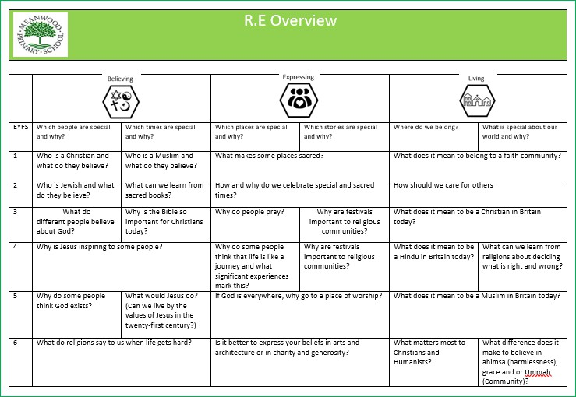

Meanwood Primary School

Appendix 1: Curriculum map Science Overview
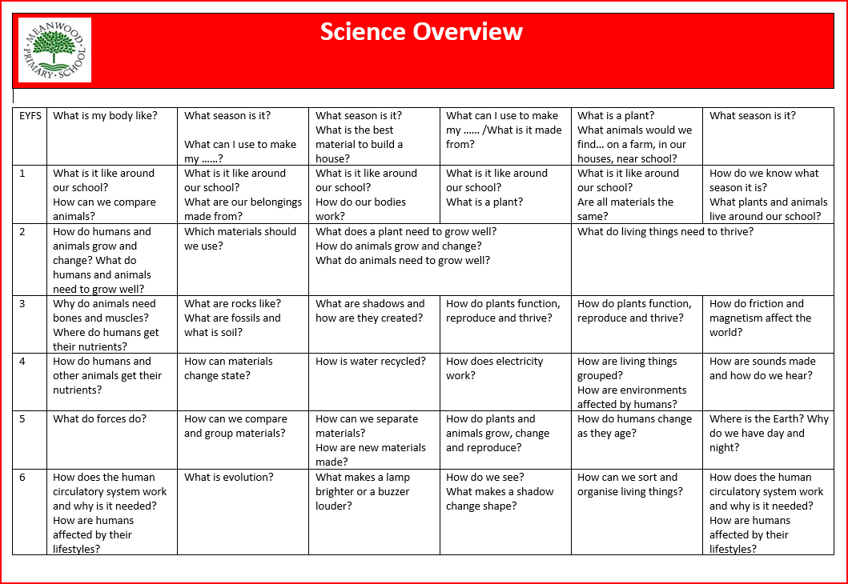

Meanwood Primary School

Appendix 2: By the end of primary school pupils should know

TOPIC | PUPILS SHOULD KNOW
Families and people who care for me | - That families are important for children growing up because they can give love, security and stability  - The characteristics of safe and happy family life, such as: commitment to each other, including in times of difficulty, protection and care for children and other family members, the importance of spending time together and sharing each other’s lives  - That other children’s families, either in school or in the wider world, sometimes look different from their own, but they should respect those differences and know that other families are also characterised by love and care  - That stable, caring relationships are at the heart of safe and happy families, and are important for children’s security as they grow up  - That marriage and civil partnerships represent a formal and legally recognised commitment of 2 people to each other which is intended to be lifelong  - How to recognise if family relationships are making them feel unhappy or unsafe, and how to seek help or advice from others if needed
Caring friendships | - How important friendships are in making us feel happy and secure, and how people choose and make friends  - The characteristics of friendships that lead to happiness and security, including: mutual respect, truthfulness, trust and trustworthiness, loyalty, kindness, generosity, sharing interests and experiences and support with problems and difficulties  - That healthy, caring and kind friendships are positive and welcoming towards others, and do not make others feel lonely or excluded. Pupils should learn skills for developing caring, kind friendships  - That not every child will have the friends they would like at all times, that most people feel lonely sometimes, and that there is no shame in feeling lonely or talking about it  - That most friendships have ups and downs, and that these can often be worked through so that the friendship is repaired or even strengthened  - About managing conflict with kindness and respect, and that violence is never right  - How to recognise when a friendship is making them feel unhappy or uncomfortable, and how to seek help or advice from others, if needed

Meanwood Primary School

TOPIC | PUPILS SHOULD KNOW
Respectful, kind relationships | - The importance of respecting others, including in families and friendships. Pupils should be encouraged to discuss how we can balance the needs and wishes of different people, and why this can be complicated  - The importance of setting and respecting healthy boundaries in all relationships with friends, family, peers and adults  - How to communicate effectively: how to be assertive and express needs and boundaries and manage feelings, including disappointment and frustration  - That they can expect to be treated with respect and the importance of respecting others, including those who are different (for example: physically, in character, personality or background), or make different choices, or have different preferences or beliefs  - The practical steps they can take in a range of different contexts to improve or support their relationships  - The conventions of courtesy and manners  - The importance of self-respect and how this links to their own happiness. They should have opportunities to consider issues like self- esteem and building a sense of their own identity  - Pupils should have opportunities to discuss the difference between being assertive and being controlling, and the difference between being kind to other people and neglecting your own needs.  - About different types of bullying (including cyberbullying), the impact of bullying, responsibilities of bystanders (primarily reporting bullying to an adult) and how to get help  - How to seek help when needed, including when they are concerned about violence, harm, or when they are unsure who to trust  - What a stereotype is, and how stereotypes can be unfair, negative or destructive or lead to bullying and how to challenge a stereotype

Meanwood Primary School

TOPIC | PUPILS SHOULD KNOW
Online safety and awareness | - That people sometimes behave differently online, including by pretending to be someone they are not and/or pretending to be a child  - That the same principles apply to online relationships as to face-to face relationships, including the importance of respect for others online including when we are anonymous  - The rules and principles for keeping safe online, how to recognise risks, harmful content and contact, and how to report them  - That there is a minimum age for joining most social media sites which protects children from inappropriate content or unsafe content with older social media users, who may be strangers, including other children and adults  - That it’s important to be cautious about sharing any information about themselves online, and how to use privacy and location settings to protect their information online  - How to critically consider their online friendships and sources of information, including awareness of the risks associated with people they have never met  - How information and data is shared and used online, including where pictures or words might be circulated  - Online risks, including that any material provided online might be circulated, and that once a picture or words has been circulated there is no way of deleting it everywhere and no control over where it ends up  - That the internet contains a lot of content that can be inappropriate and upsetting for children, and where to go for advice and support when they feel worried or concerned about something they have seen or engaged with online
Being safe | - What sorts of boundaries are appropriate in friendships with peers and others (including in a digital context). This can include learning about boundaries in play and in negotiations about space, toys, books, resources for example  - About the concept of privacy and the implications of it for both children and adults, including that it’s not always right to keep secrets if they relate to being safe  - That each person’s body belongs to them, and the differences between appropriate and inappropriate or unsafe physical, and other, contact  - How to respond safely and appropriately to adults they may encounter (in all contexts, including online) including those they do/don’t know  - How to recognise when a relationship is harmful or dangerous, including skills for recognising who to trust and who not to trust  - How to report concerns or abuse, about something seen online or experienced in real life, or feelings of being unsafe or feeling bad about any adult, and the vocabulary and confidence needed to do so  - Where to get advice, for example from their family, school and/or other sources

Meanwood Primary School

Appendix 3: Parent/carer form requesting their child’s withdrawal from sex education within RSE

TO BE COMPLETED BY PARENTS/CARERS
Name of child |  | Class
Name of parent/carer |  | Date
Reason for withdrawing from sex education within relationships and sex education
Any other information you would like the school to consider
Parent/carer signature

TO BE COMPLETED BY THE SCHOOL
Agreed actions from discussion with parents/carers

