Green Learning Team Reading for Pleasure Books
 | Aliens Love Underpants  Claire Freeman | 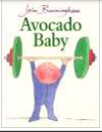 | Avocado Baby  John Burmingham | 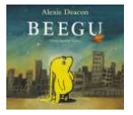 | Beegu  Alex Deacon
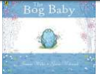 | Bog Baby  Jeanne Willis | 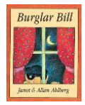 | Burglar Bill  Janet and Allan Alhberg | 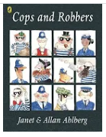 | Cops and Robbers  Janet and Allan Ahlberg
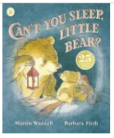 | Can’t you sleep Little Bear?  Martin Wadell | 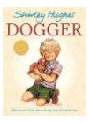 | Dogger  Shirley Hughes | 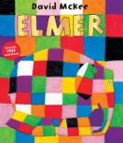 | Elmer  David Mckee
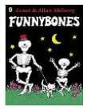 | Funnybones  Janet & Alan Ahlberg | 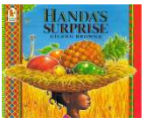 | Handa’s Suprise  Eileen Brown | 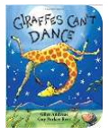 | Giraffe’s Can’t Dance  Giles Andres
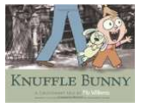 | Knuffle Bunny  Mo Willems | 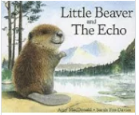 | Little Beaver and the Echo  Amy MacDonald | 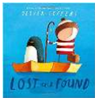 | Lost and Found  Oliver Jeffers
 | Mama Panya’s Pancakes  Mary & Rich Chamberlin | 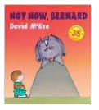 | Not Now Bernard  David McKee |  | Peace At Last  Shirley Hughes
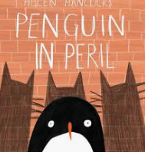 | Penguin In Peril  Helen Hancocks | 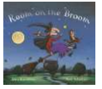 | Room on the Broom  Julia Donaldson | 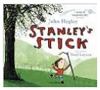 | Stanley’s Stick  John Hegley
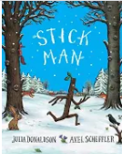 | Stickman  Julia Donaldson | 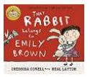 | That Rabbit belongs to Emily Brown  Cressida Cowell |  | The Great Dog Bottom Swap  Peter Bently
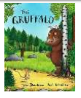 | The Gruffalo  Julia Donaldson | 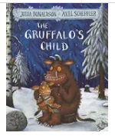 | The Gruffalo’s Child  Julia Donaldson | 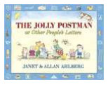 | The Jolly Postman  Janet & Alan Ahlberg
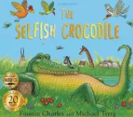 | The Selfish Crocodile  Faustin Charles | 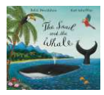 | The Snail and the Whale  Julia Donaldson | 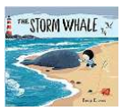 | The Storm Whale  Benji Davies
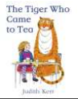 | The Tiger who came to Tea  Judith Kerr |  | Tall  Jez Alborough | 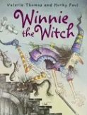 | WinnieThe Witch  Valerie Thomas
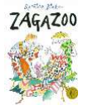 | Zagazoo  Quentin Blake
MINDFUL MOMENTS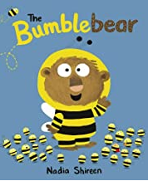 | MINDFUL MOMENTS 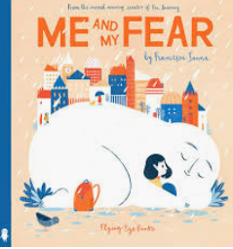 | MINDFUL MOMENTS 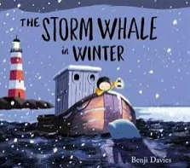 | MINDFUL MOMENTS 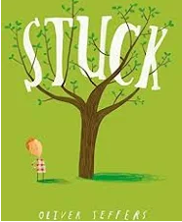 | MINDFUL MOMENTS 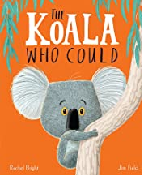 | MINDFUL MOMENTS 