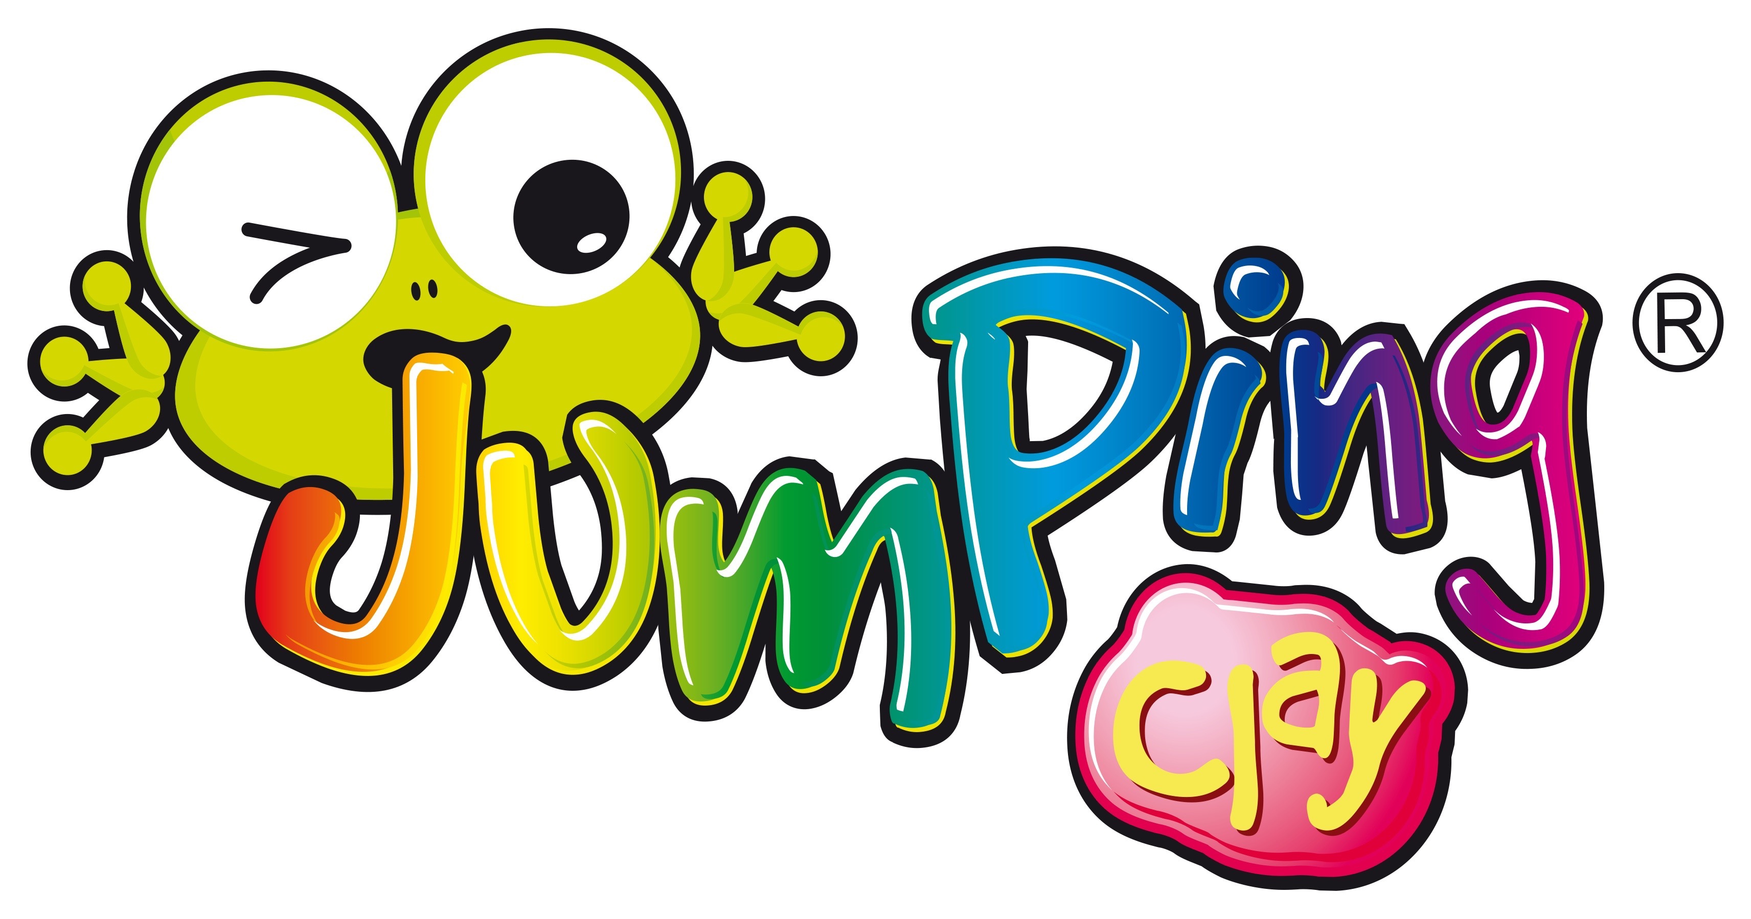
Jumping Clay After-School Club

Start a creative adventure into the magical world of 3D educational fun !
Jumping Clay is delighted to be back and offering a term
of our fun and creative after-school at Melbourne Infants

Years 1 & 2– Thursdays Times to and from 15:30-16:30 pm

Beginners are warmly welcomed
The programme will engage children in the wonders of colour and shape, helping them to develop observation skills, creative thinking, spatial awareness, fine tune their motor skills and stimulate their senses all whilst having FUN!

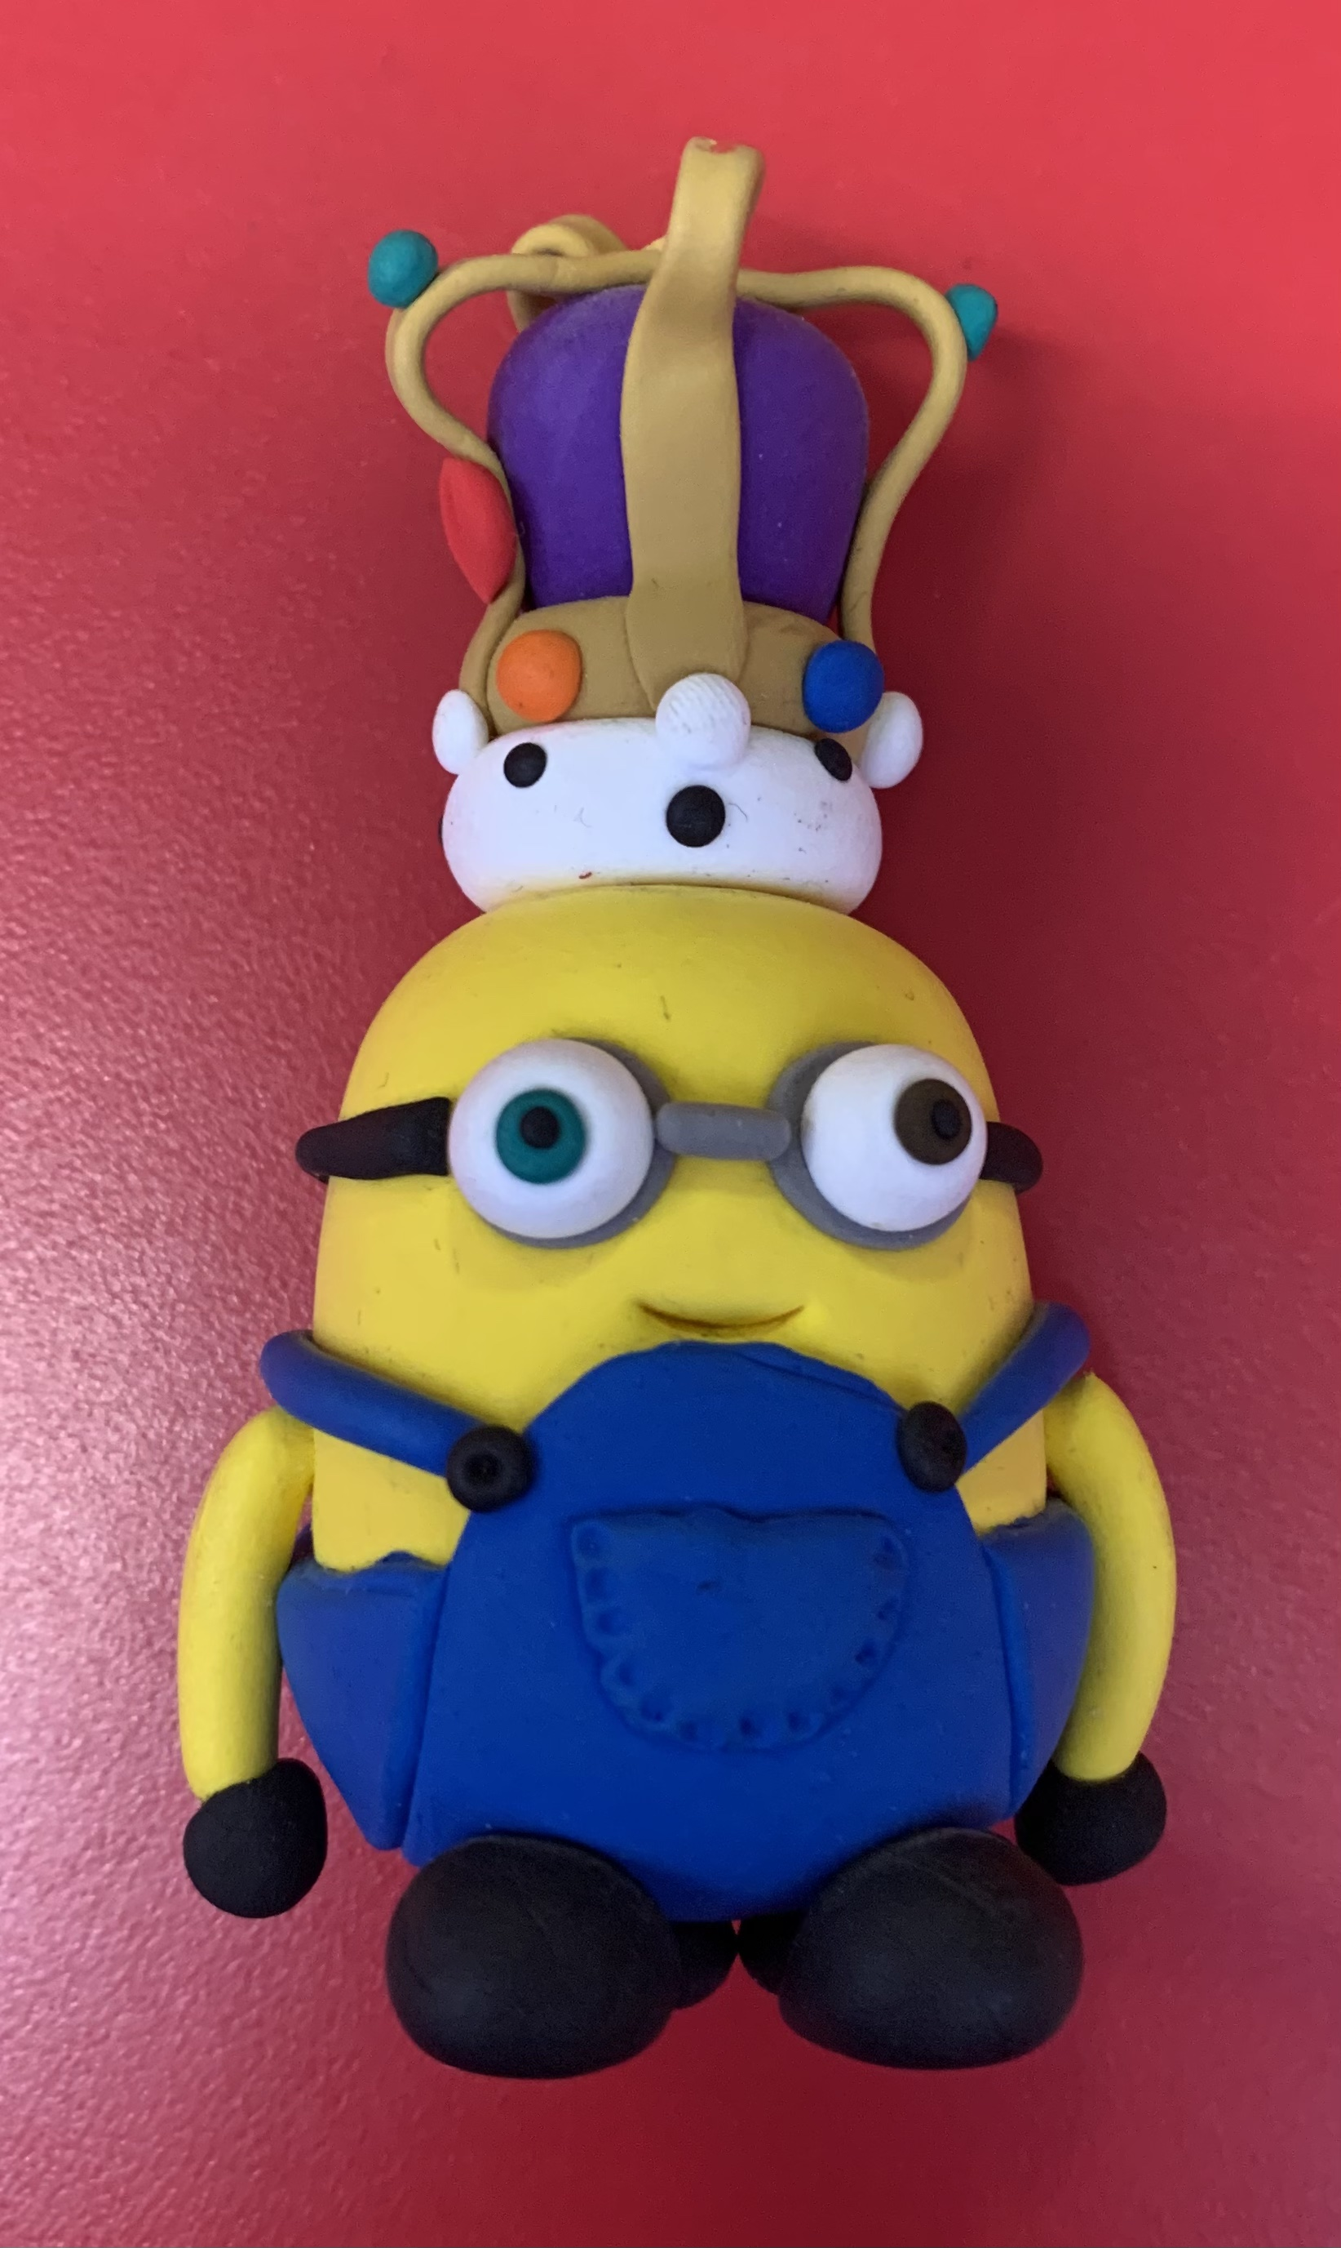
* Booking available 31st of March
Dates; 20th and 27th of April, 4th, 11th , 18th & 25th of May,
8th, 15th, 22nd & 29th of June 6th & 13th of July

£72 for the whole 12 weeks course
How to Book:
Online booking and payment system - To access the booking system, go to https://bookwhen.com/JC-Derbyshire
It’s a brand-new booking system so old login details will no longer work.

Places are subject to availability and are issued on a first come basis.
Please text or email us if you would like to set up a password system to enable other people (not just the “parent” registered on our system) to collect your child.

www.artintheparkderby.co.uk/jumpingclay,
facebook - jumpingclayderby, twitter - jumpingclay Derby
Markeaton Craft Village, 07952901589, derby@jumpingclay.co.uk, 01332 46007

