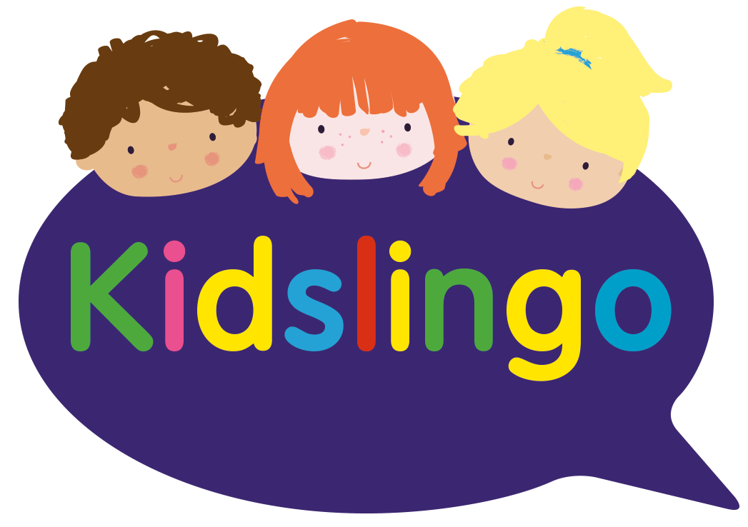

**Introducing Kidslingo to Melbourne Infant School!**

**We are delighted to announce that Kidslingo is launching a Wednesday Lunchtime Spanish Club from Weds 5th November 2025 for all year groups.**

**To enrol your child, please follow the link below. Places are limited and will be allocated on a first come first served basis.**

Learning a language at a young age helps children to grow in self-confidence and boosts their natural creativity.

At Kidslingo, we are dedicated to teaching Spanish to children through fun. We use stories, games, songs, role play and drama to bring the language to life and inspire our learners.

**Class details:**

* **30 minute classes on Wednesdays 12.30pm-1.00pm.**
* **Starting on Wednesday 5th November 2025 with a maximum of 15 children.**
* **£5.50 per class, payable in half term blocks. 2% handling fee applies to all bookings. Existing customers will have priority booking at the renewal for the next half term.**
* **We will provide worksheets related to the class activities**
* **You will receive FREE access to the Kidslingo games website with over 250 games**

To register your child, please go to the following link and scroll to ‘School age classes’ and click ‘enroll now’ for the Melbourne class. **Please book early to avoid disappointment.**

<https://www.kidslingo.co.uk/area/spanish-classes-southderbyshire/>

If you have any questions, please visit <https://www.kidslingo.co.uk/faqs/> or email nicola.roseby@kidslingo.co.uk if you have any problems with registering. All Kidslingo teachers are fully trained, insured and hold an enhanced DBS / PVG certificate.

This is a Kidslingo Franchise owned and operated under licence by Nicola Roseby.