Melbourne Infant School
Prospectus
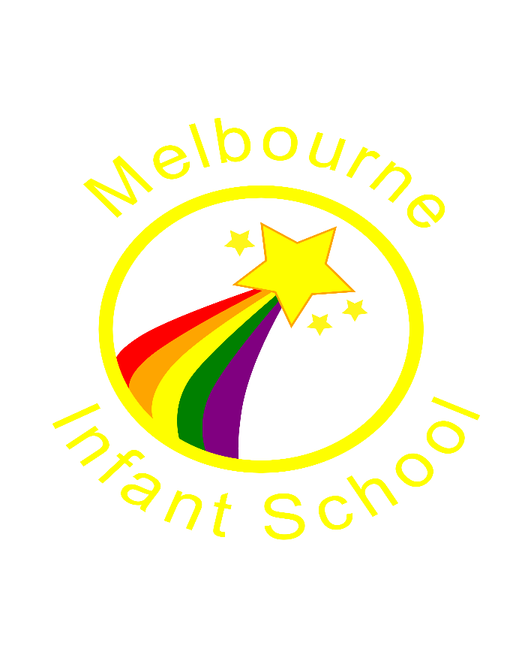

Headteacher: Mrs C Gibbs
Age range: 4-7 years
2023 – 2024
Contact details
You may contact school using the following:

Address: Melbourne Infant School
Packhorse Road
Melbourne
Derbyshire
DE73 8JE
Telephone: 01332 862335
Email: enquiries@melbourne-inf.derbyshire.sch.uk

You may also find further useful information on our school website: https://www.melbourne-inf.derbyshire.sch.uk/

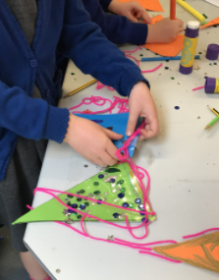
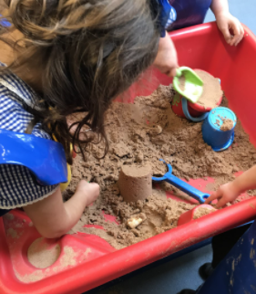
We offer tours to prospective parents – please contact the school if you would like a tour of the school.

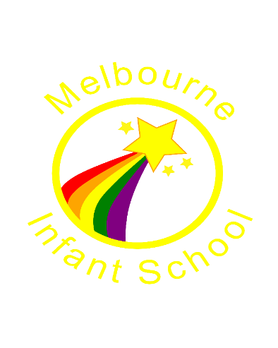

Vision and Values
Our Vision
To inspire, motivate and engage all children to become life-long learners, who reach for the stars.

Our Values
Our school values are reflected through our STAR Standards:
We aim to achieve our vision by working together as a team – staff, parents, governors and local community – to enable our school to SHINE.

We

offer a Supportive, fun and caring atmosphere, where children access an ambitious, globally diverse, purposeful and creative curriculum where achievement in all areas is celebrated
create a Happy, safe and stimulating environment where all individuals are valued, diversity is embraced, and STAR potential realised
foster self-belief and a positive self-image, which encourage Individual talents to shine, and children engage collaboratively with our school community
provide opportunities to Nurture curiosity and exploration so that children develop emotional literacy and a lifelong love of learning
respect ourselves and each other, Enabling us to be active participants in the world around us.
Our Motto
Shine brightly together and reach for the stars.
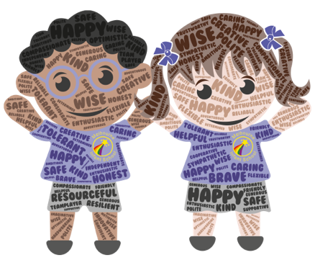

Admissions
Applying for a Reception place
If your child was born between 1 September 2019 and 31 August 2020 they will be able to start school in September 2024.
You should apply for their infant or primary school place between November 2023 and January 2024.
Admissions criteria
At Melbourne Infant School we follow the Derbyshire County Council Admissions criteria. The details are as follows:
Individual pupils who have a statement of special educational needs or an education, health and care plan (EHC) which names the school will be admitted.
In deciding on admissions, the following order of priority will be adopted:
- Looked after children and children who were looked after but ceased to be so because they were adopted (or became subject to a residence order or special guardianship order).
- Children living in the normal area served by the school at the time of application and admission who have brothers or sisters attending the school at the time of application and admission.
- Children living in the normal area served by the school at the time of application and admission.
- Children not living in the normal area served by the school but who have brothers or sisters attending the school at the time of application and admission.
- Other children whose parents have requested a place.
Where, in the case of 2, 3, 4, or 5, choices have to be made between children satisfying the same criteria, those children living nearest to the school measured by the straight line distance will be given preference.
In year applications
You may want to apply for your child to change schools other than when they are due to start primary education. You can do this anytime of the year.
If you want to apply for a place at Melbourne Infant School you should contact Derbyshire County Council.
Pupil Premium
Pupil Premium is a Government fund given to schools for eligible pupils; to ensure that all children have an equal opportunity to learn and succeed.
This extra funding allows us to provide additional staffing and resources, bringing learning benefits to eligible pupils as well as all children throughout the school. It is also used to subsidise after school clubs (one full term each year for each eligible child), school trips, school uniform, specific interventions and staff training.
What are the eligibility criteria?
Children are entitled to receive Pupil Premium funding if their parents or guardians receive any of the benefits below:
• Universal Credit
• Income Support
• Income based jobseekers allowance
• Income related Employment and Support Allowance
• Support under Part 6 of the immigration and asylum act 1999
• Guarantee Pension Credit
• Child Tax Credit, provided there is no entitlement to Working Tax Credit and the annual gross income is less than £16190 as assessed by HMRC

You can apply online at: https://www.derbyshire.gov.uk/education/schools/your-child-at-school/meals/pupil-premium/school-meals-pupil-premium-form.aspx or ask at the school office.

Snack time
The children have a snack in the morning and also one in the afternoon. Children bring in one snack from home in a named container, and the other snack is a piece of fruit provided by school.
Children need to bring a named, non-spill drinks container each day, filled with water only.

Lunch time
All children at Melbourne Infant School are eligible for a Universal free school meal each day.
Alternatively if you prefer, you can bring in a packed lunch from home. We ask that parents choose one or other option, and do not frequently switch between the two.

Before and after school clubs
We have a before-school club run by Premier Sports which takes place in the school hall. Children can be dropped off from 7.30am for breakfast and activities.
After school, there are a variety of paid clubs which children may sign up to which run until 4.30pm. Reception children may attend after school clubs after their transitional period.

Our school day
EYFS
8.45-8.55 | Arrival
 | Fine motor morning starter activities
 | Morning whole class activities, indoor and outdoor continuous provision and snack
 | Lunch in School hall
 | Afternoon whole class activities and indoor and outdoor continuous provision
 | Story, snack and singing session
3.20 | Home time
Key Stage one
8.45 | Arrival
 | Maths session
 | Break and snack time
 | English session
 | Phonics session
 | Lunch in classrooms
 | Topic-based Foundation subject curriculum
 | Story and snack time
3.20 | Home time

School Uniform
At Melbourne Infant School, the uniform is as follows:
- Royal blue sweatshirt/ cardigan or jumper
- White/blue shirt or polo shirt
- Grey skirt/ pinafore dress or trousers
- Grey/ black/ white tights or socks
- Black sensible shoes

In summer, items as above or:
- Blue and white gingham dress
- Grey mid length shorts
- Sensible sandals (worn with socks).
All uniform items need to be labelled with your child’s name.

As a school we understand that school uniform can be expensive. Therefore, our uniform does not need to have the branded logo on. You can buy the uniform from a range of places including local supermarkets, as well as from Pupils Schoolwear: 35 West St, Swadlincote, DE11 9DN / www.pupilsschoolwear.co.uk
On days when your child will be involved in lots of physical activity, they will come to school in ‘PE ready’ clothes: dark blue, black, grey jogging bottoms and sweatshirts, blue, black, grey shorts and white t shirt). Parents will be notified in advance of these days.

Communication
A weekly email is sent to all parents and carers on a Friday, communicating any new and key information. This keeps everyone in our school community up to date with what is happening.
At Melbourne Infant School we use Class Dojo for communication between parents and carers. This is also used to log behaviour points for children. Each child has a portfolio within Class Dojo where staff and parents can record aspects of their child’s learning and share this between home and school.
Our school website is also a source of lots of useful information, and is updated regularly. We also have a Facebook page.
Each academic year, parents are invited to two parent’s meetings* with their child’s class teacher, in the Autumn and Spring term. They also receive an end of year report in the Summer term.
We like to invite parents and carers into school for open events on a regular basis to experience learning with their children, and for an insight into school life.

