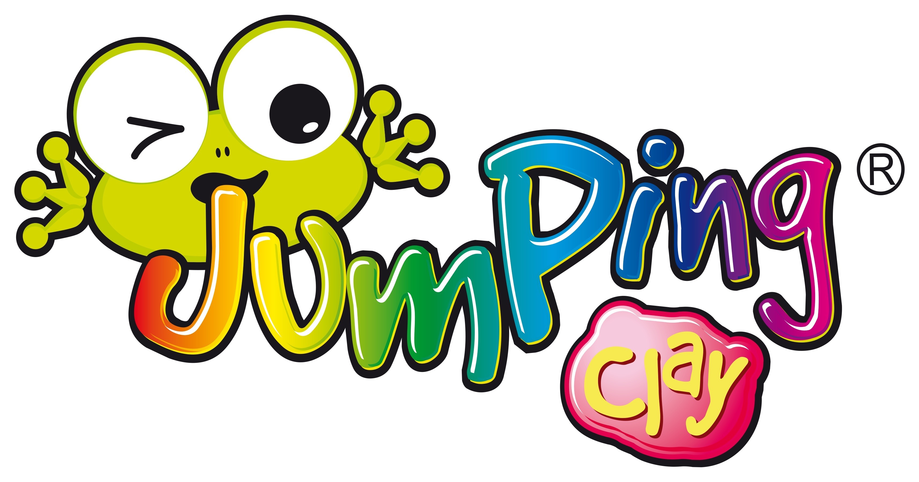 Jumping Clay After-School Club

**Start a creative adventure into the magical world of 3D educational fun !**

Jumping Clay is delighted to be back and offering a term

of our fun and creative after-school club at Melbourne Infants School

Years 1 and 2 – Thursday’s Times to and from 15:30 - 16:30pm

**Beginners are warmly welcomed**

The programme will engage children in the wonders of colour and shape, helping them to develop observation skills, creative thinking, spatial awareness, fine tune their motor skills and stimulate their senses all whilst having FUN!

Dates ; 14th,21st & 28th of Sept, 5th, 12th, 19th & 26th of Oct , 9th, 16th, 23rd and 30th of Nov & 7th of December

£84 for the whole 12 week course.

**How to Book:**

**Online booking and payment system – **BOOKINGS OPEN 22nd July 2023\*\***

To access the booking system, go to <https://bookwhen.com/JC-Derbyshire>

Places are subject to availability and are issued on a first come basis.

Please text or email us if you would like to set up a password system to enable other people (not just the “parent” registered on our system) to collect your child.

***www.artintheparkderby.co.uk/jumpingclay,***

***facebook - jumpingclayderby, twitter - jumpingclay Derby***

***Markeaton Craft Village, 07952901589, derby@jumpingclay.co.uk, 01332 460079***