Red Learning Team Reading for Pleasure Books
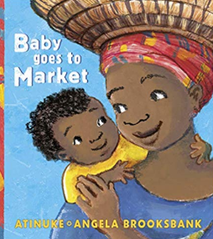 | Baby goes to Market  Atinuke | 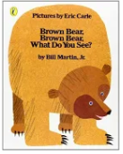 | Brown bear, Brown Bear, What do you See?  Bill Martin Jr | 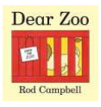 | Dear Zoo  Rod Campbell
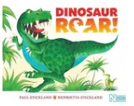 | Dinosaur Roar  Henrietta Stickland | 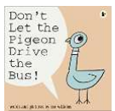 | Don’t Let the Pigeon Drive the Bus  Mo Williams | 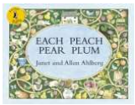 | Each Peach Pear Plum  Janet and Allan Ahlberg
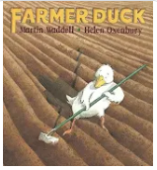 | Farmer Duck  Martin Wadell | 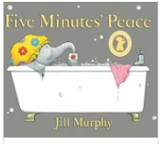 | Five Minutes Peace  Jill Murphy | 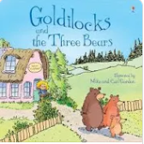 | Goldilocks and the three bears  Johnathan Langley
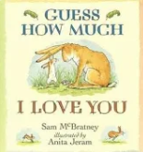 | Guess How Much I love you?  Sam McBratney | 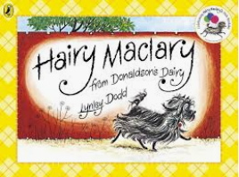 | Hairy Maclary from Donaldson’s Dairy  Lynley Dodd | 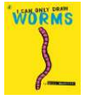 | I can only draw worms  Will Mabbitt
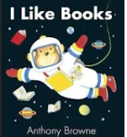 | I like books  Anthony Brown | 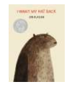 | I want my Hat Back  Jon Klassen |  | I want my potty!  Tony Ross
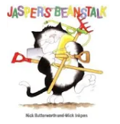 | Jaspers Beanstalk  Nick Butterworth | 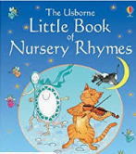 | Little Book of Nursery Rhymes  Usborne | 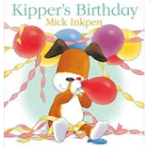 | Kippers Birthday  Mick Inkpen
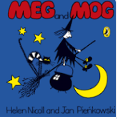 | Meg and Mog  Helen Nicoll | 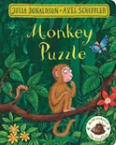 | Monkey Puzzle  Julia Donaldson | 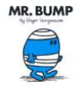 | Mr Bump  Roger Hargreaves
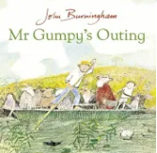 | Mr Gumpy’s Outing  John Burningham | 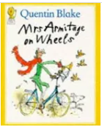 | Mrs Armitage on Wheels  Quentin Blake | 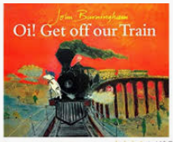 | Oi! Get off our train  John Burningham
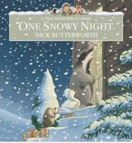 | One Snowy Night  Nick Butterworth | 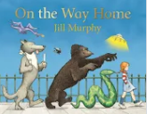 | On the way home  Jill Murphy | 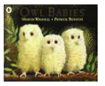 | Owl Babies  Martin Wadell
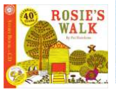 | Rosie’s Walk  Pat Hutchins |  | Suddenly!  Colin McNaughton | 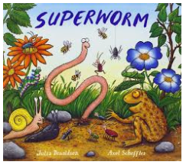 | Superworm  Julia Donaldson
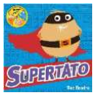 | Supertato  Sue Hendra | 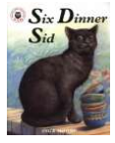 | Six Dinner Sid  Inga Moore |  | The Cat in the Hat  Dr Seuss
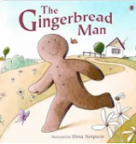 | The Gingerbread Man  Usborne | 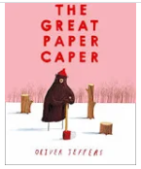 | The Great Paper Caper  Oliver Jeffers | 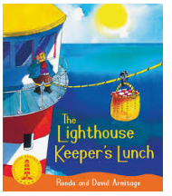 | The Light House Keeper’s Lunch  Ronda Armitage
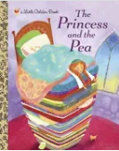 | The Princess and the Pea  Usborne | 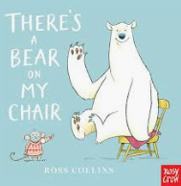 | There’s a bear in my chair  Ross Collins | 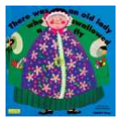 | There was an old woman who swallowed a fly  Pat Adams
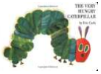 | The Very Hungry Caterpillar  Eric Carle | 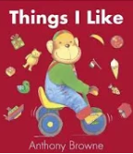 | Things I like  Antony Brown | 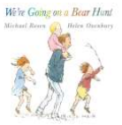 | We’re Going on a Bear Hunt  Michael Rosen
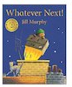 | Whatever Next!  Jill Murphy
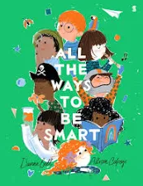  All the Ways to be Smart  Davina Bell | 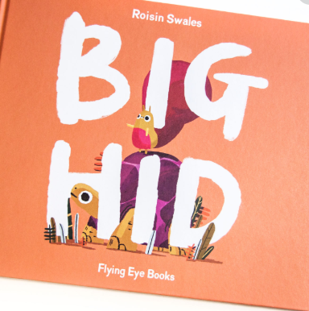  Big Hid  Roisin Swales | 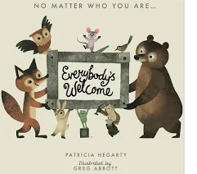  Everyone’s Welcome!  Patricia Hagerty | 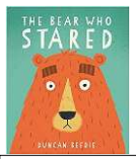  The Bear Who Stared  Duncan Beedie | 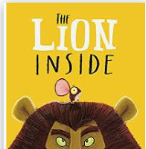  The Lion Inside  Rachel Bright | 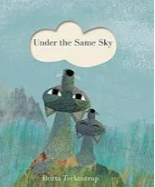  Under the Same Sky  Britta Teckentrup

