Blue Learning Team Reading for Pleasure Books
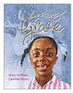 | Amazing Grace  Mary Hoffman | 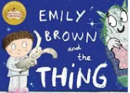 | Emily Brown and the Thing  Cressida Cowell | 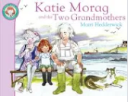 | Katie Morag and the tale of two Grandmothers  Mairi Hedderwick
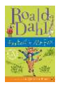 | Fantastic Mr Fox  Roald Dahl | 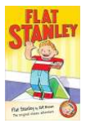 | Flat Stanley  Jeff Brown | 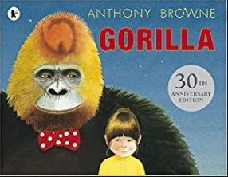 | Gorilla  Antony Browne
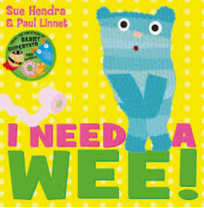 | I Need a Wee  Sue Hendra | 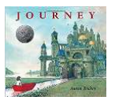 | Journey  Aaron Becker |  | Meerkat Mail  Emily Gravett
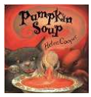 | Pumpkin Soup  Helen Cooper | 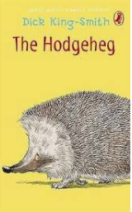 | The Hodgeheg  Dick King Smith | 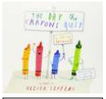 | The Day the Crayons Quit  Drew Daywalt
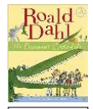 | The Enormous Crocodile  Roald Dahl | 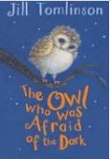 | The owl that was afraid of the dark  Jill Tomlinson | 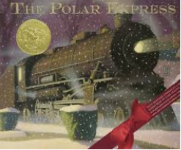 | The Polar Express  Chris Van Allsburg
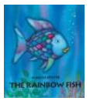 | The Rainbow Fish  Marcus Pfister | 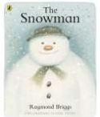 | The Snowman  Raymond Briggs | 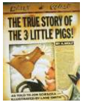 | The True Story of the 3 little Pigs  Jon Scieszka
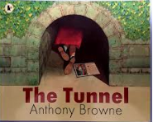 | The Tunnel  Antony Browne | 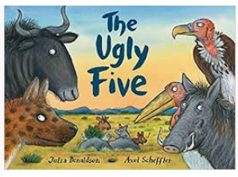 | The Ugly 5  Julia Donaldson | 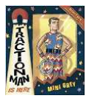 | Traction Man  Mini Grey
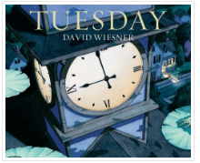 | Tuesday  David Wiesner | 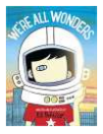 | We’re all wonders!  R J Palacio | 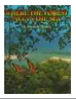 | Where the Forest Meets the Sea  Jeannie Baker
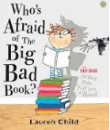 | Who’s afraid of the big bad book?  Lauren Child
MINDFUL MOMENTS  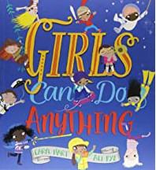 | MINDFUL MOMENTS 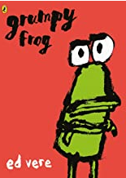 | MINDFUL MOMENTS 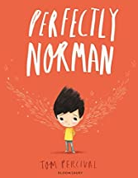 | MINDFUL MOMENTS 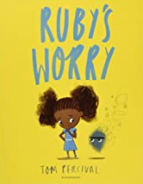 | MINDFUL MOMENTS 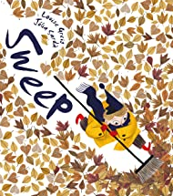 | MINDFUL MOMENTS 