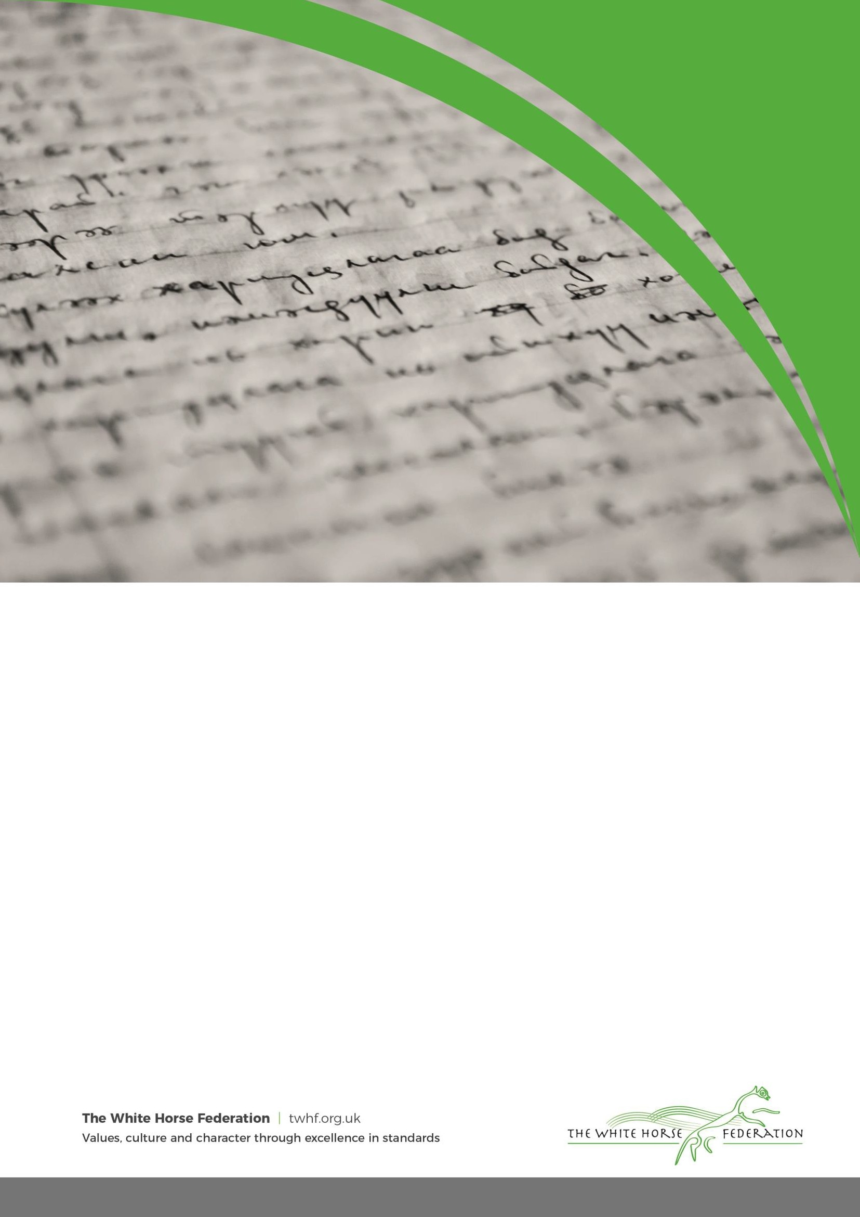

Accessibility Plan

School Name: | Melksham Oak
Version No: | 1 | Ratified date: | September 2025
Author: | H.Ornov | Interim review date: | September 2026
Owner: | D.Cooper | Next review date: | September 2027
Approved by: | D.Cooper


Contents
- Aims
- Legislation and guidance
- Action plan
- Monitoring arrangements
- Links with other policies

Aims

Schools are required under the Equality Act 2010 to have an accessibility plan. The purpose of the plan is to:
  - Increase the extent to which disabled students can participate in the curriculum
  - Improve the physical environment of the school to enable disabled students to take better advantage of education, benefits, facilities and services provided Improve the availability of accessible information to disabled students
  - Our school aims to treat all its students fairly and with respect. This involves providing access and opportunities for all students without discrimination of any kind.

We believe that all children and young people have the right to be healthy, happy and safe, to be loved, valued and respected; and to have high aspirations for their future

Our school endorses the definition that says:

‘Inclusion is the process of taking necessary steps to ensure that every young person is given equality of opportunity to develop socially, to learn and to enjoy community life.’

The plan will be made available online on the school website, and paper copies are available upon request. For further information, please contact H Ornov (SENDCO) ornovh@melkshamoak.wilts.sch.uk

Our school is also committed to ensuring staff are trained in equality issues with reference to the Equality Act 2010, including understanding disability issues. The school supports any available partnerships to develop and implement the plan. The school will seek the advice of the Advisory Teaching Service / Occupational Therapy.

Our school’s complaints procedure covers the accessibility plan. If you have any concerns relating to accessibility in school, this procedure sets out the process for raising these concerns.

We have included a range of stakeholders in the development of this accessibility plan, including students, parents, staff and governors of the school.

Page 2 of 4

Legislation and guidance

This document meets the requirements of schedule 10 of the Equality Act 2010 and the Department for Education (DfE) guidance for schools on the Equality Act 2010.

The Equality Act 2010 defines an individual as disabled if he or she has a physical or mental impairment that has a ‘substantial’ and ‘long-term’ adverse effect on his/her ability to undertake normal day to day activities.

Under the Special Educational Needs and Disability (SEND) Code of Practice, ‘long-term’ is defined as ‘a year or more’ and ‘substantial’ is defined as ‘more than minor or trivial’.

The definition includes sensory impairments such as those affecting sight or hearing, and long-term health conditions such as asthma, diabetes, epilepsy and cancer.

Schools are required to make ‘reasonable adjustments’ for students with disabilities under the Equality Act 2010, to alleviate any substantial disadvantage that a disabled pupil faces in comparison with non- disabled students. This can include, for example, the provision of an auxiliary aid or adjustments to premises.

Action plan

This action plan sets out the aims of our accessibility plan in accordance with the Equality Act 2010.

Aim | Current good practice  Include established practice and practice under development
Increase access to the curriculum for pupils with a disability | - Our school offers a differentiated curriculum for all pupils.  - We use resources tailored to the needs of pupils who require support to access the curriculum.  - Curriculum resources include examples of people with disabilities.  - Curriculum progress is tracked for all pupils, including those with a disability.  - Targets are set effectively and are appropriate for pupils with additional needs. The curriculum is reviewed to ensure it meets the needs of all pupils.  - Use of technology such as immersive reader and reading pens to facilitate effective reading comprehension if appropriate.

Page 3 of 4

Improve and maintain access to the physical environment | The environment is adapted to the needs of pupils as possible considering the nature and age of the buildings.  This includes:  - Ramps where possible  - Lifts in some of the buildings  - Corridor width in newer buildings  - A disabled parking bay at the front of the school  - Disabled toilets  - Portable library book trolleys for use in a range of venues
Improve the delivery of information to pupils with a disability | Our school uses a range of communication methods to ensure information is accessible. This includes:  - Internal signage  - Large and colour print resources  - Pictorial or symbolic representations

Monitoring arrangements

This document will be reviewed every 3 years, but may be reviewed and updated more frequently if necessary. This document is reviewed by the Principal and Governors.

Links with other policies

This accessibility plan is linked to the following policies and documents:
  - Risk assessment policy
  - Health and safety policy
  - Equality information and objectives (public sector equality duty) statement for publication Special educational needs (SEN) information report
  - Supporting students with medical conditions policy

Page 4 of 4

