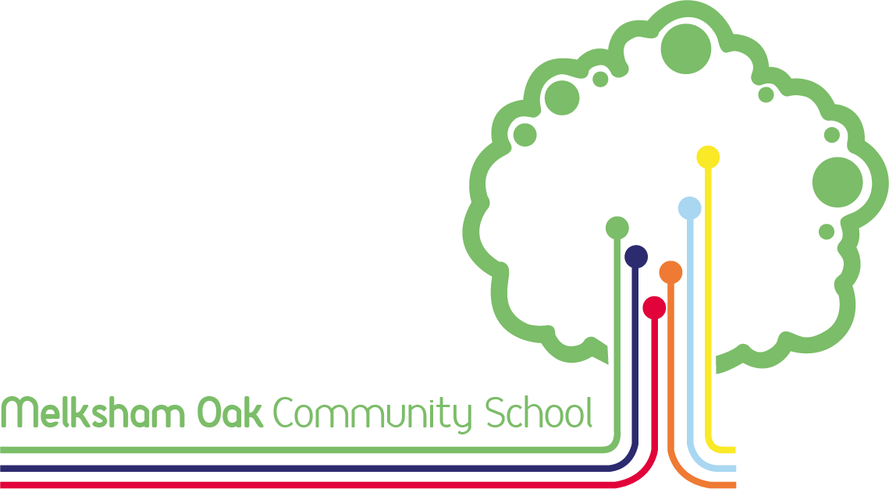

Year 9 GCSE Course Guide
2026

Welcome to Melksham Oak School’s Year 9 GCSE Course Guide for students in year 9 in Spring 2026.

This is an exciting and important time for students – the first opportunity they will have to make decisions about the courses they will follow during the next stage in their education.

At Melksham Oak School, we are proud of the range of options available where each student can choose from courses that suit their interests and aptitudes. As well as helping to ensure academic success, the aim is that every young person is supported to develop as a well-rounded individual fully-equipped to succeed as a global citizen within increasingly diverse communities and careers.

This booklet provides information on the courses available. It is divided into three main sections:
- The first section explains the courses on offer to our students, how these relate to grades and to support a broad curriculum
- The second section provides information about core courses. This covers those courses which are compulsory. These core courses are: English (Language and Literature), Maths, Combined Science and non-examined Physical Education and Personal, Social, Health and Citizenship Education (PSHCE).
- The third section is about optional courses, covering those for which students may state their preference. It is these choices which students and parents will need to research to help decide which are of interest and best match the student’s educational and career aspirations.

We look forward to working with students and parents over the coming terms to ensure that decisions are well-informed and result in students following courses which enable them to excel.

As well as the information and advice contained within this booklet, students are able to access additional guidance from a range of sources including their tutor, subject teachers and our Head of Careers, Ms Tranter.

Please also rest assured that we are willing to give further advice and guidance at any time during the process. So, if you have any questions, please e-mail them to admin@melkshamoak.wilts.sch.uk marked for the attention of your child’s tutor.

Yours sincerely,

Pavarnie Jackson
Deputy Headteacher

Key Date | Event
January onwards | Assembly and tutor programme – Year 9 students participate in activities designed to identify strengths and interests which may inform their choice of subjects.
Thursday 5th February | Options information evening – time for students and parents to learn more about the range of qualifications on offer.
Tuesday 10th February | First Year 9 student reports published to parents and students.  These reports show how well each student is progressing in their current subject, and could be used to inform discussions about course choices.
Wednesday 11th March | Options taster morning for students – students have 30 minute introductory lessons for subjects on offer that are new in Key Stage 4.
Thursday 12th March | Year 9 Parents Evening. This will support the advice and guidance to students and help identify strengths and subjects that students may be suited to studying in Key Stage 4.
Friday 13th March | Online option form opens for parents to complete with their children. Instructions and a link to this online form will be e-mailed to Year 9 parents and carers.
Friday 27th March | Deadline for parents to submit students’ course choices via the online form.
Term 5 | Individual advice and guidance to students as required following choices submission and discussion of any reserve subjects that may be offered.
Term 6 | Formal written confirmation of courses which students will follow during Year 10 and Year 11.  Options Taster Day – students experience 8 short taster sessions to support them making informed choices for new subjects.
Key Dates

Which courses will I study?
Core GCSE Courses:
The following courses will be taken by all students:
English Language, English Literature, Maths, Combined Science

Other compulsory but non-examined course:
Physical Education and PSHCE (Physical, Social, Health and Citizenship Education)

All students will choose from GCSE Geography or GCSE History

Students will then choose from a selection of Science, Creative and Language options

Other Optional Courses:
Every student will be able to express their preference for at least two of the following courses:
GCSEs:
Art and Design: Fine Art (1)
Business Studies
Computer Science
Design and Technology
Drama (2)
Food Preparation and Nutrition
Geography
History
Religious Studies
Spanish
Separate Sciences
Textiles (1)

Vocational qualifications:
Child Development
Creative and Digital Media
Music
Performing Arts (2)
Sport Studies

Sport Studies

NB. (1) It is not possible to select both Art and Design and Textiles, (2) it is not possible to select both Drama and Performing Arts.
How can I choose the best courses for me?

Good reasons for choosing a course: | Unwise reasons for choosing a course:
- You’re good at the subject  - You think you’ll enjoy the course  - It fits with your career hopes and plans  - It goes well with your other choices  - You’re interested in the knowledge and skills it will develop  - It will give you lots of choices in the future | - Your friends are doing the same course  - People say it’s easy  - You like the teacher you have now  - You didn’t have time to research your options properly

How to choose your courses:
• Look at all courses available to you before you decide. There’s information about each course within this booklet.
• If you have a firm idea about the career you’d like to follow, choose subjects that you’ll need to make this possible - the ones you need to go into further or higher education or into an apprenticeship or job with training. If you don’t have a firm career idea, choose subjects that will allow you to keep your options open.
• Don’t be afraid to ask for help and advice from your subject teachers, Head of Careers, Ms Tranter, and your tutor. A guide to support, advice and guidance can be found on the next page.
• Involve your family – discuss things with them.
• Talk to your friends – but remember, it must be your interests and skills that determine your choices, not someone else’s.

Thinking Ahead:

Aim to be flexible and well-qualified. Research tells us that:
- Most people will change jobs several times during their working lives;
- Employers will need more and more people with qualifications at Level 3 (A-level,
Level 3 vocational qualifications) or above;
- People with higher level qualifications will earn more and have better employment prospects than those with lower level qualifications or no qualifications at all;
- Employers want people with good employability skills. For instance, employers know that studying a language develops invaluable and transferable skills including communication, confidence and other interpersonal skills.
- On each subject page there is a section called ‘Thinking Ahead’. This is designed to make some example links between courses and careers but there are many others. Remember: you can use the Careers Pilot website to carry out further research into future employment opportunities.

.
What advice, support and guidance are available?

When choosing the best courses, the following are available for advice, support and guidance:

Costs
Some courses indicate that the purchase of specialist materials may be necessary. Whilst we are always grateful when parents can help out in this way, we recognise that this can present some parents with financial difficulties. This must not prevent any child from studying a course of their choice. Please speak to us in confidence if this concerns you. In particular, if your child is in receipt of Free School Meals, or has been within the last six years, we will be able to help.

Core Courses

Examined Core Courses:
English – Language and Literature | GCSE
Mathematics | GCSE
Combined Science | GCSE

Non-examined Core Course:
Physical Education
Physical, Social, Health and Citizenship Education (PSHCE)

GCSE English Language and GCSE English Literature
Head of English: Mrs R Robinson

Which topics or units will I study?

In GCSE English Language you will analyse high quality, challenging literature and non-fiction texts from a range of genres, types and historical periods (the 19th, 20th and 21st centuries).

You will also be required to write original texts in exam conditions, paying particular attention to spelling, punctuation and vocabulary.

In GCSE English Literature you will be examined on a range of texts studied during lessons:


• A 19th century novel;
• A Shakespeare play;
• A themed selection of poetry from an anthology;
• A modern British drama text;
• Poetry that you haven’t encountered before.

What skills will I develop during this course?

Studying GCSE English Language and English Literature will further develop critical reading skills, including the ability to analyse, evaluate and compare texts. Reading a range of texts from different times, places and traditions will help develop wider cultural awareness and empathy with others.

Your skills as a writer will also be extended through opportunities to write for a variety of different audiences and purposes, including descriptive, narrative and persuasive texts. This includes writing accurately and choosing appropriate and ambitious vocabulary.

In addition, you will become even more confident as speakers and listeners by taking part in paired and group discussions, presentations and role plays.

Overall, GCSE English Language and English Literature will equip you to confidently communicate and to critically interpret the language used by others.

How will I be taught?

You will be taught by the same teacher for both GCSE English Language and English Literature.

You will learn though a variety of activities centred around the key skills of reading, writing and speaking and listening.

How will I be assessed?

GCSE English Language
Students will sit two exam papers and are skilled based, rather than content based. The exams will test students’ ability to respond analytically to unseen extracts of Literature and Non-Fiction writing. These elements of the exams test students’ reading skills. Students will also be prepared to write creatively. These elements of the exams text students’ writing skills.

In addition, you will participate in a spoken language assessment. This will be certified separately and must be taken to achieve GCSE English Language accreditation.

GCSE English Literature
Students will sit two exam papers, which will cover the content outlined below. The Literature exams are both content and skill based. Students will be taught how to respond to texts analytically, looking at key literary concepts including character, setting, voice, theme, relationships, context and audience. Students will learn how to compare texts analytically; this skill is tested in the poetry element of the course. The following texts are the ones currently taught at GCSE:
- Shakespeare (Macbeth)
- 19th Century Novel (A Christmas Carol)
- Model Prose and Drama (An Inspector Calls)
- One cluster from AQA poetry anthology (Power and Conflict)
- Unseen Poetry (students will respond to an unseen poem before comparing it to another unseen poem)

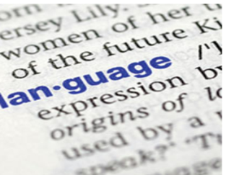
Other important information:
Although texts are provided in lessons, we strongly recommend that students obtain their own copies of the set texts for their Literature to support their learning at home and their revision for exams.

Thinking Ahead:

English is a core qualification valuable for all aspects of the world of work and further study.

It can lead to a variety of careers, including in the fields of journalism, law, marketing and teaching.
GCSE Mathematics
Head of Curriculum Area: Mr A. May

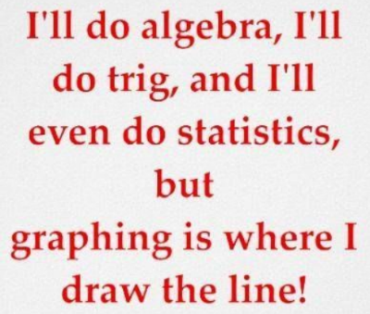
Which topics or units will I study?
While studying GCSE Maths, you will cover the following strands:
- number;
- algebra;
- ratio and proportion;
- geometry and measures;
- statistics and probability.

Some examples from each of the strands include; compound interest and depreciation, finding roots of equations, trigonometry, histograms and conditional probability.

What skills will I develop during this course?

A GCSE in Mathematics will enable you to:
• develop fluent knowledge, skills and understanding of mathematical methods and concepts;
• acquire, select and apply mathematical techniques to solve problems confidently;
• build fluency in procedural skill;
• reason mathematically, make deductions and inferences and draw conclusions;
• comprehend, interpret and communicate mathematical information in a variety of forms appropriate to the information and context.

How will I be taught?
As in previous years, you will be taught in sets. Your set will be based on previous assessments and will be reviewed regularly to ensure that you are in the group which supports you to achieve your best.

Your teachers will have access to numerous quality resources to allow you to develop your fluency within a topic and also explore its depth with reasoning and problem-solving style questions.

How will I be assessed?
Whether studying towards Higher or Foundation, you will be assessed with three 90-minute exam papers at the end of Year 11. The three exam papers are one calculator, one non-calculator and another calculator paper. All three exam papers will contribute equally to your final grade.

In order to support you in the years leading up to Year 11, we break each into three assessment windows, each lasting around ten weeks. At the end of each ten-week window, you will sit a summative assessment. This will allow you to develop your skills in recall, remembering and revision, which will be essential at the end of Year 11. This will also allow your teachers to determine that you are in the correct set to make progress.



Other important information:
You will need your own scientific calculator, which you should bring to every lesson.
Thinking Ahead:

Maths is a core qualification valuable for all aspects of the world of work and further study.

It can lead to a variety of careers, including in the fields of banking, finance, accountancy, computing and engineering.
GCSE Combined Science

Which topics or units will I study?

Science is a subject that helps us to grasp how the world around us works. From the smallest subatomic particles, moments after the big bang, to the evolution of planet Earth and the possibilities in the future, Biology, Chemistry and Physics all interlink to explain our past and pave the way for a new exciting tomorrow.

The breadth of study in science is vast and over the duration of the GCSE Science course you will learn about the following topics:

Biology | Chemistry | Physics
1 Cell Biology | 1 Atomic structure and the periodic table | 1 Energy
2 Organisation | 2 Bonding, structure and the properties of matter | 2 Electricity
3 Infection and response | 3 Quantitative chemistry | 3 Particle model of matter
4 Bioenergetics | 4 Chemical changes | 4 Atomic structure
5 Homeostasis and response | 5 Energy changes | 5 Forces
6 Inheritance, variation and evolution | 6 The rate and extent of chemical change | 6 Waves
7 Ecology | 7 Organic Chemistry | 7 Magnetism and electromagnetism
 | 8 Chemical analysis
 | 9 Chemistry of the atmosphere
 | 10 Using resources

What skills will I develop during this course?

Alongside gaining scientific knowledge, runs the importance of developing practical skills that you can transfer into everyday life, after you have left the classroom. The practical skills that you will develop at GCSE will pave the way if you want to pursue a career in science, as they will form the foundation for A-level courses and beyond.

Throughout this subject students will also have the opportunity to:
- Develop their scientific thinking.
- Develop experimental skills and strategies.
- Develop their analysis and evaluation.
- Develop their use of scientific vocabulary, quantities, units, symbols and nomenclature.

There is no coursework in Science. Instead, a number of required practicals are carried out in lessons over the three years. All students complete 30 required practicals (10 for each subject). Each of these are examinable so, as with any other lesson, it is important students do not miss these.

How will I be taught?

We do our best to ensure that all pupils are taught by a subject specialist. Therefore, you will have teachers who are experts in their field, who are able to support and challenge you to achieve the best you can.

Biology, Chemistry and Physics is delivered through a wide range of teaching methods. These include: modelling; practical experiments; literacy activities and mathematical tasks, amongst others.

How will I be assessed?

Ongoing Assessment

In Science, you will take a progress test once a term and an end of term assessment. The progress test allows for memory recall tasks and the end of term assessment allows for application of knowledge. This will allow pupils to move up and down sets over the duration of the course.

Final exam in Year 11

In Year 11, all pupils will sit six science exams. You will be entered into either higher tier or foundation tier. The grading for the higher tier is 9-4, whereas the grading for foundation tier is 5-1. The examined topics, as summarised below, relate to the topics studied in the previous table.

Science | Trilogy exam topics
Biology | Paper 1 – (1hr 15mins) Topics:1,2,3,4 from the table above
Biology | Paper 2 – (1hr 15mins) Topics: 5,6,7 from the table above
Chemistry | Paper 1 – (1hr 15mins) Topics:1,2,3,4 from the table above
Chemistry | Paper 2 – (1hr 15mins) Topics: 6,7,8,9,10 from the table above
Physics | Paper 1 – (1hr 15mins) Topics:1,2,3,4 from the table above
Physics | Paper 2 – (1hr 15mins) Topics: 5,6,7 from the table above

Other important information:
Students who enjoy science should also consider choosing separate sciences as one of their options as this increases the number of GCSE grades awarded from 2 to 3 separate qualifications in each separate discipline of Biology, Chemistry and Physics. There is more information on these courses on the separate sciences page. Due to the number of topics covered within Science, we would highly recommend that you have a revision guide. These are available to purchase via ParentPay.

Thinking Ahead:

The completion of Combined Science GCSEs give students a strong starting point for studying sciences at A & AS Level.

Any job with a strong basis in Science will be open to those who study sciences; Medical careers, Veterinary, Radiographer, Psychology, Forensics, Nutritionist, Mechanic, Teacher, Nurse, Laboratory Technician.
There are also many transferrable skills learnt from studying science and students with A levels or degrees in science related topics are highly sought after across many professions.
GCSE Geography or History

All students will choose from either GCSE Geography or GCSE History

Choose from:
Geography | GCSE
Or
History | GCSE

GCSE Geography
Head of Curriculum Area: Mr S.Thomas

Which topics or units will I study?

Geography is a highly relevant and increasingly important subject. Geography is the study of our complex interactions with the environment and nature around us.

You will therefore cover a variety of human and physical geography topics shown in the table below:

Physical Geography Topics | Natural Hazards (volcanoes, earthquakes, tropical storms, UK extreme weather), ecosystems (tropical rainforests and cold environments), physical landscapes in the UK (rivers and coasts).
Human Geography Topics | Urban challenges (urbanisation, Rio de Janeiro and Bristol), economic world (development, Nigeria and the UK), resource management (food, water and energy).
Geographical Skills | Geographers are expected to be able to handle some complex data and mathematics. You will use maths skills such as averages and % difference, as well as some graph skills such as dispersion graphs. You will also use maps skills such as grid references and choropleth maps.

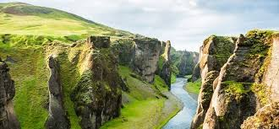
What skills will I develop during this course?

GCSE Geographers develop a wide-ranging skill set that can be transferred to other subject areas. You will improve your analytical, critical thinking and decision-making skills alongside literacy and numeracy - these are highly employable skills and will prepare you well for life after school. You will be required to evaluate complex data and create lines of arguments in extended answer questions which will include marks for spelling, punctuation and grammar.

Paired and group presentations or discussions will enable you to develop your confidence in presenting ideas and become confident speakers whilst improving your ability to work with others and become part of a team.

How will I be taught?
As in previous years, you will be taught in mixed ability groups. Expect to learn through independent learning and in small groups, through written tasks, role play and decision-making. There will be lots of opportunities to use and develop your literacy, numeracy and ICT skills. You will also be required to partake in compulsory fieldwork trips.

How will I be assessed?
The course will be 100% examination and you will sit three GCSE Geography exams at the end of Year 11. These exams are not tiered.

Paper 1: 35% of overall grade - 1hr 30 minutes - Physical Geography (assesses the topics in the table, above);
Paper 2: 35% of overall grade - 1hr 30 minutes - Human Geography (assesses the topics in the table, above);
Paper 3: 30% - 1hr 15 minutes - Geographical Applications. This covers the fieldwork skills you will experience and a pre-release booklet, which you will see before the exam.

Each exam assesses spelling, punctuation and grammar as part of the extended writing answers.

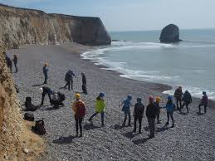
Other important information:
Fieldwork is an important and enjoyable part of the GCSE Geography course. It will be compulsory for you to be involved in at least two fieldwork visits during the course and you will then be examined on the skills that you used to do that fieldwork.

To be a successful Geographer, you will be expected to have a good understanding of mathematics and sound literacy skills.

You will need to be open-minded to the opinions of other people, fully accepting that not everyone thinks the same thing, or in the same way. You will be expected to formulate your own opinions on important matters within the subject based on the scientific evidence at hand.

A successful geographer thinks in greater complexity, taking into account the interactions between people and their environment when making decisions. They understand that decisions cannot always be straightforward and there is a fine balance to be struck when moving forward.

You will need the correct equipment every lesson, which will include a calculator, protractor and compass as well as writing equipment.
Thinking Ahead:

GCSE Geography is a well-respected subject at University as it creates global citizens, able to think critically and form their own opinions based on evidence.

GCSE Geography could be the first step towards many different careers, including within conservation, geoscience, travel and tourism, town-planning, development, disaster risk management, market research, cartography and mapping, landscape architecture, data analysis, or teaching and outdoor education.

GCSE History

Head of Curriculum Area: Mr M. Maguire

Which topics or units will I study?

In GCSE History, you will study History in a variety of ways and in depth, across a broad span of time, and through a range of cultures.

You will be expected to analyse challenging sources and interpretations of particular topics and write longer essay based answers on key subjects.

All students will complete the list, below. The percentage that this counts towards the
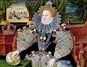
final grade is shown in brackets:
- A British Depth Study – Early Elizabethan England (20%);
- An Enquiry in Depth – The American West (20%);
- A Study of Historic Environment – Surgery & Treatment on the Western Front (10%);
- A Thematic Study: Medicine through Time c.1250-present day (20%);
- A Modern Depth Study – The USA 1954-75: Conflict at Home and Abroad (30%).

What skills will I develop during this course?

Studying GCSE History will further develop your writing skills through questions which will require you to plan and evaluate a line of argument, before writing an extended essay in response. There will be opportunities to assess and critically evaluate a variety of topics. This includes writing accurately and choosing appropriate and ambitious vocabulary.

Furthermore, History will enable you to build upon critical reading skills, including the ability to analyse, evaluate and compare sources, interpretations, factors and time periods. Reading a range of texts from different times, places and traditions will help develop wider cultural awareness and empathy with others. It is also intended to inspire a passion for the past and for the world around us.

In addition, you will become even more confident as speakers and listeners by taking part in presentations as well as paired and group discussions.


Overall, GCSE History will equip you to confidently communicate and to critically interpret the world around us, so that you understand how the past impacts on the modern world.

How will I be taught?

You will be taught in a mixed ability group in GCSE History.

You will learn though a variety of activities centred around the key skills of: class-based discussion; research; reading; writing and practical approaches with hands on History. In Year 10, you will have the opportunity to go on a Battlefields trip to study World War One medicine in Belgium and France.

How will I be assessed?

You will be assessed through 100% examination taken at the end of the course in Year 11. The exams are not tiered.

You will sit three exam papers for GCSE History:

Paper 1 – 1 hour and 15 minutes – worth 30% of the overall grade:
- Thematic study and historic environment, based on Medicine in Britain, c1250–present and The British sector of the Western Front, 1914–18: injuries, treatment and the trenches.
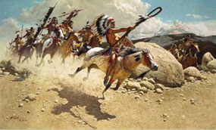
Paper 2 – 1 hour and 45 minutes – worth 40% of the overall grade:
- Section A period study option: American West 1835-1895
- Section B: British depth study Early Elizabethan England, 1558–88.
Paper 3 – 1 hour and 20 minutes – worth 30% of the overall grade:
- Modern depth study: USA 1954-1975, conflict at home and abroad.

In each exam, marks are available for spelling, punctuation and grammar.

Other important information:
As a History student, you will be expected to maintain a good homework record and a clear focus within lessons. You will be expected to arrive with the correct equipment and work hard in all lessons.

You need to be able to undertake independent research, using and interpreting different sources of information. You should be able to think about the causes and consequences of events. A passion for History, as well as for debating and challenging your own and others' ideas is essential.

To be successful in History you should have a good level of literacy and the ability to write extended essay-style responses.

Although textbooks are provided in lessons, we strongly recommend you obtain your own copies of set revision guides in order to support your learning at home and your revision for exams. Your History Teacher will advise you on which guides are recommended for your study.

Thinking Ahead:

History is an academic subject that is highly respected at universities and with employers.

Examples of careers to which History can lead include archaeology, heritage tourism, media, law, politics and banking.
Modern Languages: GCSE Spanish

Head of Curriculum Area: Ms A. Newport

“French is my best lesson” Sophie Whiting

Which topics or units will I study?

In Modern Languages, students will learn vocabulary and grammar in order to talk and write about six thematic areas. You will also be required to write about these themes under exam conditions, expressing your opinions on issues relating to young people and their lives. The emphasis is on effective communication rather than perfection and learning a valuable employability skill.

In GCSE Modern Languages, the topics you will study are:

Theme: My Personal World
- Describing yourself, your family and friends, physically and their character
- Talking about your relationships with them, what makes a good friend
- Talking about issues of equality

Theme: Lifestyle and Wellbeing
- Talking about interests and activities that you and others do in free time e.g. sports, reading, TV and films
- Describing daily life and customs including food and drink, shopping, cultural events and celebrations
- Talking about healthy and unhealthy lifestyles e.g. diet, exercise, bad habits, physical wellbeing

Theme: My Neighbourhood
- Describing your home, neighbourhood, places and what there is to do in your town

Theme: Media and Technology
- Talking about how you and others use social media, devices, gaming and technology in general
- Discussing the advantages and disadvantages of technology in today’s world

Theme: Studying and My Future
- Describing school life including subjects, facilities, teachers, uniform, activities, trips and rules
- Talking about options for further study such as apprenticeships and university as well as future opportunities (jobs and careers)

Theme: Travel and Toursim
- Describing holidays e.g. transport, accommodation, activities, solving problems, getting directions
- Thinking about global issues like environmental issues and the natural world
- Describing what there is to do in holiday destinations e.g. tourist attractions, trips, how these are influenced by weather

What skills will I develop during this course?

Studying GCSE Modern Foreign Languages, above all, will improve your standard of English. As you learn grammar in a foreign language, you will begin to understand more deeply the grammar of the English Language. You will be able to analyse texts, which increase in length and complexity as the course progresses.
You will also develop your skills as a writer to prepare you for your next steps after GCSE in learning a language. Your skills will be developed and extended through different styles of tasks aimed at developing your ability to write independently.

In addition, you will develop your skills in translation until you are able to work to and from English and French or Spanish quite easily on a range of topics.

Similarly, you will develop your speaking skills. You will be able to talk about all the topics individually, in pairs and in groups as your confidence grows. As the course progresses, your ability to communicate in your chosen language also progresses to a level whereby you can have transactional conversations.

Overall, GCSE Modern Languages equips you with a plethora of transferable skills, which will support your development and learning in other subjects and, at the same time, develop your confidence to speak.

How will I be taught?
You will be taught in a mixed ability group, wherever possible by a teacher who specialises in either French or Spanish. You will learn through a variety of activities centred around the key skills of reading, writing and speaking and listening.

How will I be assessed?
You will have four exams at the end of the GCSE course: writing; reading; listening; speaking.

Whether a pupil does Foundation tier (grades 1-5) or Higher tier (grades 4-9) is not decided until the mock exams in Year 11.

Other important information:
- Although we provide textbooks, it is important that you have the Oxford Learner’s Dictionary relating to the language you are studying.
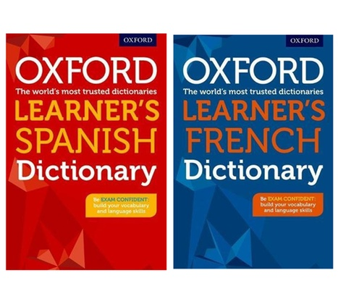
- CGP offer a range of revision guides covering all the skills in languages – your Modern Languages teacher will be able to tell you more about which guides would be most useful.
Thinking Ahead:

People who study a foreign language to degree level go on to a range of careers, including: journalism, diplomacy, the civil service, law, accountancy, marketing, publishing, translation, hotel management, import/export specialist, interpreter, teaching, film and television, tour guide, international development and aid (e.g. The Red Cross).

Other Courses

Students will be required to choose 3 courses from the list below which must include one of the subjects in BOLD type. Students will also be asked to select reserve courses, these will be given to the student in the case of the combination of subjects not being available or if one of their choices is over subscribed.

Art and Design: Fine Art | GCSE
Business Studies | GCSE
Child Development | Level 1 / 2 Cambridge National Certificate
Computer Science | GCSE
Creative Digital Media Production | Level 1 / 2 BTEC Technical Award
Drama | GCSE
Design and Technology | GCSE
Food Preparation and Nutrition | GCSE
French | GCSE
Geography | GCSE
History | GCSE
Music | Level 1 / 2 BTEC First Award
Performing Arts | Level 1 / 2 BTEC Technical Award
Religious Studies | GCSE
Separate Science | GCSE
Spanish | GCSE
Sports Science | Level 1 / 2 Cambridge National Certificate
Textiles | GCSE

GCSE Art and Design: Fine Art
Head of Curriculum Area: Mr Bedecker

Which topics or units will I study?

In Art and Design you will complete:

One coursework project: This coursework project will require you to develop a sketchbook of practical studies from a theme of your choice, concluding in a final piece using any media and technique of your choosing.
The coursework project will be comprised of;
  - observational studies related to your chosen theme using any media and technique of your choice;
  - an exploration of a variety of artist’s work of your choice – again, in any media and technique of your choosing;
  - the development of your own ideas, linking your artists and your observational studies;
  - a final piece which concludes all your research and experiments, using the media and techniques that best showcase your skills.

One examination project: This project consists of the same four elements as the coursework project. These are:
  - observational studies related to your chosen theme selected from the examination paper, using any media and technique of your choice;
  - an exploration of a variety of artist’s work of your choice, again using any media and technique of your choosing;
  - the development of your own ideas, linking your artists and your observational studies;
  - a final piece which concludes all your research and experiments, using the media and techniques that best showcase your skills. You will complete this piece under exam conditions.

What skills will I develop during this course?

By studying Art and Design, you will learn how to:
- express, record and present personal ideas using two-dimensions, three-dimensions, textile and/or photographic media and techniques;
- investigate, analyse and explore the work of artists and designers that inspire you;
- present a conclusion to your research and explorations that best showcase your skills.
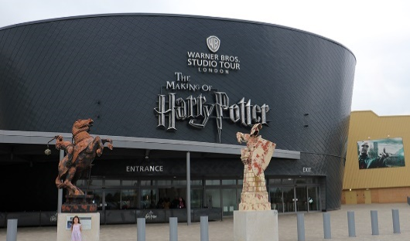
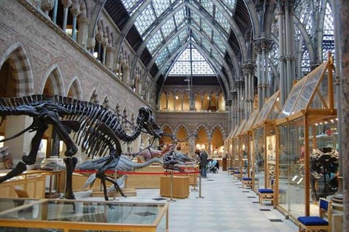
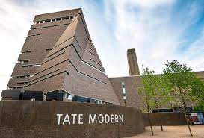

How will I be taught?

You will be taught in a mixed ability group and where possible, you will be taught by the same
Art teacher throughout the entire two-year course. Each Art Teacher will deliver and facilitate the course to suit your individual needs, both in relation to your choice of media and the individual support you may require.

During Key Stage 3, you will have explored a vast range of media in both two and three dimensions as well as numerous creative fabric and photographic techniques. During Key Stage 4, you will develop these creative experiences by selecting one or more techniques that best showcase your skills through the completion of a coursework and examination project during Years 10 and 11.

How will I be assessed?

The marks you gain from your coursework project will contribute to 60% of your overall GCSE grade.

The remaining 40% of your marks will be awarded through an examination project. This examination is completely practical. The exam paper is released in January. You will then use lesson time to produce a preparatory research sketchbook as in your coursework project. The only difference from the coursework is the concluding piece will be completed during a 10-hour practical session run over several days during April/May.

Other important information:
To enable you to extend and develop your studies outside the classroom, you will have the opportunity to purchase a pack of art materials, equipment and a sketchbook from the Art department. Visits to Art Galleries, Museums & other creative venues are arranged throughout the two-year course to support and extend your class studies.
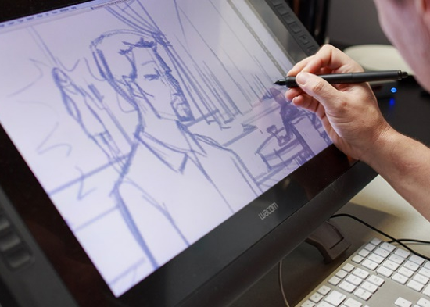


Thinking Ahead:

The creative industry is one of the largest in the U.K. A qualification in Art and Design will help you in the fields of animation, game design, architecture, fashion, illustration, interior design, advertising, photography, set design, theatrical make-up and many, many other creative avenues.

GCSE Business Studies
Head of Curriculum Area: Mr Hopkins

Which topics or units will I study?

In GCSE Business Studies you will study two key themes:

Theme 1: Investigating small business | Theme 2: Building a business
This theme will cover:  - enterprise and entrepreneurship  - spotting a business opportunity  - putting a business idea into practice  - making the business effective  - external influences on business | This theme will cover:  - growing the business  - making marketing decisions  - making operational decisions  - making financial decisions  - making human resource decisions

What skills will I develop during this course?

Studying GCSE Business Studies will help you to understand the dynamic world of business. You will develop skills in: making decisions; developing persuasive arguments; solving creative and practical problems; analysing and evaluating financial data.

In addition, you will further develop key skills relating to:


- creativity
- communication
- collaboration
- organisation

How will I be taught?

In GCSE Business Studies, you will be taught within mixed ability groups.

In Year 10, you will investigate local small businesses and examine how they become successful. We are always looking for opportunities to develop our enterprise skills, so you may get the chance to run a hot chocolate stall or do your own primary research in Melksham.

In Year 11, you will learn the key factors that contribute to building a successful business - a great opportunity for those who one day want to work within or own a business. You will examine these factors by studying successful organisations such as Cadburys, Dyson, and Thorpe Park.

You will study a wide range of businesses through a range of activities including: research, visits and case studies.

How will I be assessed?

GCSE Business Studies is assessed through 100% examination, taken at the end of the course in Year 11. There are two equally weighted exams. The first assesses Theme 1 and the second assesses Theme 2. The exams are not tiered. Both papers are 90 minutes and include multiple choice, short and extended answer questions.

Other important information:
Although texts are provided in lessons, we strongly recommend that you obtain your own copies of the Edexcel G.C.S.E. Business Studies (9-1) revision guide and/or workbook in order to support your learning at home and your revision for exams.

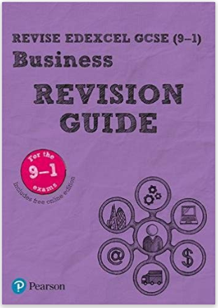

Thinking Ahead:

A GCSE Business course could help prepare you for an entrepreneurial role and help you to gain an understanding of what is involved in a business-related profession such as accountancy, law, marketing, retail or the leisure and tourism industry.



Cambridge National in Child Development
Head of Curriculum Area: Mrs K. Jones
Which topics or units will I study?

What topics or units will I study?
In Child Development, you will study three areas:

- Exam (1 hr 15 mins), taken in Year 11. This is worth 40% of the final grade and
will focus upon Health and Well-Being for Child Development, which will cover:
- Pre-conception health and reproduction;
- Antenatal care and preparation for birth;
- Postnatal checks, postnatal care and the conditions for development;
- Childhood illnesses and a child safe environment

- Coursework units, to be completed in Year 10. These are worth 30% of the final grade and will focus upon creating a safe environment and understanding the nutritional needs of children from birth to five years, which will enable each student to:
- Create a safe environment in a childcare setting;
- Choose suitable equipment for a childcare setting;
- Nutritional needs of children from birth to five years
  - Meal design and Government Guidelines to healthy Eating
  - Plan, Cook and evaluate the meal

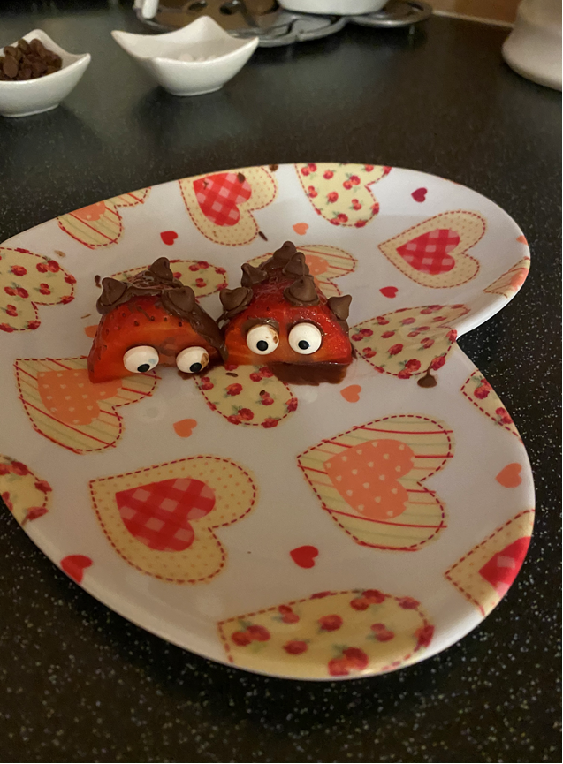

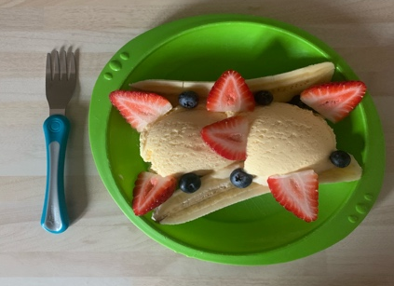

- Coursework units to be completed in Year 11. They are worth 30% of the final grade and will focus upon understanding the development of a child from birth to five years. This will enable each student to:
- Explain physical, intellectual and social developmental norms from one to five years;
- Understand stages and types of play and how play benefits development;
- Observe the development of a child aged one to five years;
Plan and evaluate play activities for a child aged one to five years for a chosen area of development.

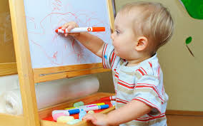
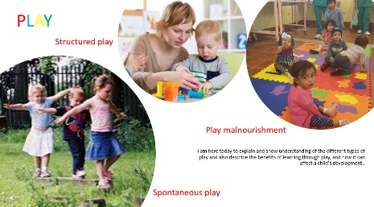
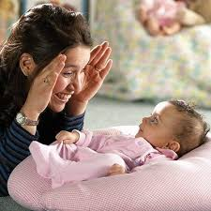

What skills will I develop during this course?
Studying Child Development will support the development of your communication skills such as extended writing and drafting. It will also develop a variety of other skills such as: critical skills of analysis; planning; working from a prescribed brief; working to deadlines; presenting information effectively; accurately completing tasks and processes.
Furthermore, studying Child Development will help to develop your study skills such as research and time management. Coursework assignments are based on independent research and observational studies.

How will I be taught?
You will be taught by teachers in the Design Technology Department. As in previous years, you will be taught within a mixed ability class.
The assignment-based approach will be taught through a variety of activities which are carried out as a class and independent tasks.

How will I be assessed?

You will be assessed in each unit and through module tests.

You will also be given practice exam questions regularly to build up your confidence and knowledge retention. You will then be formally assessed in an exam.

Two of the units are assessed internally. Once you have received feedback, you will be given a limited amount of time to address the comments, before submitting it for external moderation.

Other important information:
During Year 11, you will need to be able to observe a child (1-5years – the age is chosen and set by the exam board) in order to complete two of the coursework units. All pupils must be able to find a child to observe for this part of the coursework which will start in term 6 of Year 10. These coursework units consist of making an activity and then observing a child participate. It is therefore essential that you are able to organise this.
Thinking Ahead:

This would be an excellent choice if you are considering a career in the children’s care section. Possible careers include children’s nursing, midwifery, health visitor, social worker, teaching, nannying and teaching assistant. This would also link into the Level 3 Health & Social Care course.

GCSE Computer Science

Head of Curriculum Area: Mr G Mitchell

Which topics or units will I study?

In GCSE Computer Science you will develop your understanding and application of concepts in computer science. In addition, you will analyse problems in computational terms and devise creative solutions by designing, writing, testing and evaluating programs.

Topics will include:
- number systems
- Boolean algebra,
- hardware and Von-Neumann architecture
- primary and secondary storage
- algorithms
- using microcontrollers
- programming constructs
- cryptography
- the history of computing
- flowcharts and robotics.

What skills will I develop during this course?

By studying GCSE Computer Science, you will develop your logical problem-solving skills through the process of critical thinking, analysis, and solving real world problems. Your problem-solving skills will be enhanced with an understanding of how to produce robust programs, Boolean logic and fundamentals programming constructs.

In addition, you will enhance your understanding of the development of Computing over time and how it has influenced the way we live today. Overall, GCSE Computer Science will equip you to confidently use and understand computers, develop computational thinking strategies and solve complex problems.

How will I be taught?

You will be taught in a mixed ability group in a computer room. You will have access to a computer for most tasks. Teaching will involve a mixture of practical tasks and lessons based on the theory of how a computer works.

You will learn though a variety of activities centred around the key skills of abstraction, decomposition and pattern recognition.

How will I be assessed?

GCSE Computer Science will be assessed through exams taken at the end of the course in Year 11. The exams are not tiered.

In GCSE Computer Science the final assessment is based on two equally weighted exams:

- Paper 1 - Computer systems. This covers: systems architecture; memory and storage; network security; systems software, computer networks, connections and protocols, ethical, legal, cultural and environmental impacts of digital technology.

- Paper 2 - Computational thinking, algorithms and programming. This covers: algorithms, programming fundamentals, robust programming, Boolean logic, programming languages and integrated development environments.

Other important information:

During your course, the main programming language you will use is Python 3 and the majority of the software we will use throughout the course is free to download.

Although not a requirement of the course, it is recommended that students have access to a computer at home to support their ongoing learning and revision for exams.
Thinking Ahead:

GCSE Computer Science is highly regarded and useful for anyone wanting to enter into a range of I.T. and computing fields. These include computer programming, consultancy, cyber-security, gaming or software development, engineering and computer forensics.

BTEC Technical Award in Creative Digital Media Productions
Head of Curriculum Area: Mr N.Bedecker

Which topics or units will I study?

If you have an interest in the media industry and prefer a vocational or “hands on” approach to the subject, this may be a good choice of course for you.

You will use a variety of equipment such as cameras, computer editing and software and the use of green screen compositing to create visual effects.

This course is a BTEC Technical qualification. You will study three components, where you will explore, develop and create media products. The type of media products could include short films, television shows, music video, adverts, posters, newspapers and magazines.

What skills will I develop during this course?

You will develop your understanding of how media products are created for specific audiences and purposes.

You will explore the relationship between genre, narrative and representation within media products and develop your understanding of how they are interpreted by audiences. In addition, you will develop practical media production skills and techniques.

During the course, you will have the opportunity to specialise in one or more of the following media sectors: audio/moving image, or publishing.

You will respond to a client brief and create a product.

How will I be taught?

You will be taught through theoretical study, including activities which require analysis and reflection.

You will also take part in practical filming workshops using HD Cameras and video-edit your work using compositing techniques to create visual effects.

How will I be assessed?

The BTEC Technical Award in Creative Digital Media Production is assessed through three components:
- Internally assessed coursework - this coursework features a mixture of written and practical assessment. It counts as 60% of your qualification.
- Externally assessed exam – you will complete this in Year 11. It will involve responding to a commission-based exam question, which will require you to create a media product. This will feature a mixture of written and practical assessment. It will count as 40% of your overall qualification.

Thinking Ahead:

This course could lead on to a range of careers, including the various media industries such as T.V. and film, advertising, publishing, marketing, website design and journalism.

GCSE Design and Technology
Head of Curriculum Area: Mrs K. Jones

“What is design? It's where you stand with a foot in two worlds - the world of technology and the world of people and human purposes - and you try to bring the two together.” - Mitchell Kapor
Which topics or units will I study?

In GCSE Design and Technology, you will learn and develop greater breadth and depth of subject knowledge and understanding over three years. This will be through project-based learning on the different materials: paper, wood, metal, plastic, textiles, composites, SMART and electronics with systems.
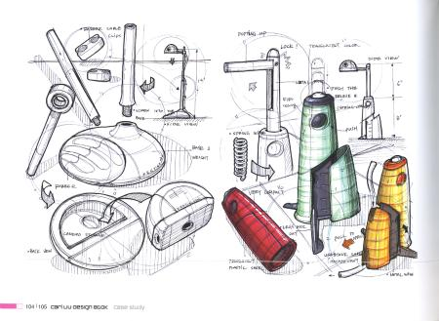
In GCSE Design and Technology, you will be examined on a range of theory based on three key aspects of design:
- core principles
- design and making principles
- specialist technical principles

What skills will I develop during this course?

By studying GCSE Design and Technology, you will further develop a variety of skills. There is an emphasis on designing and making products that are imaginative, problem-solving and durable in character, both for everyday use and for a variety of users.

You will develop an understanding of manufacturing practices in industry, and will also investigate sustainable design and the effects, or impact, that it has on the environment. You will also have the opportunity to enter some national competitions whilst studying the Design and Technology syllabus, which focuses on key design and manufacturing skills.

In addition, you will develop skills in CAD/CAM – Google Sketch Up, 2D Design, Photoshop, laser cutter, 3D printer, CNC lathe and 3D router to produce high quality and creative products.

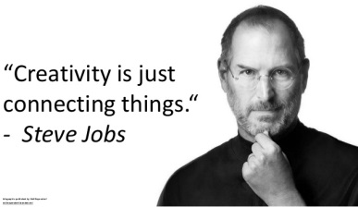
Design and Technology offers:
- real life skills: problem solving, communication and independence ready for the outside world.
- a career pathway that leads you to one of the highest rates of employment after higher education or apprenticeship.

How will I be taught?

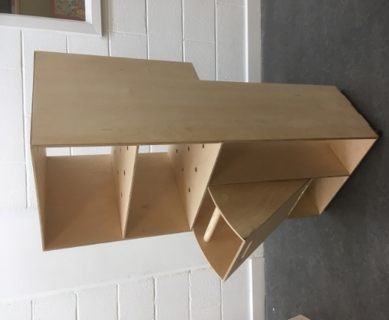
You will be taught by teachers in the Design Technology Department.

As in previous years, you will be taught as a mixed ability class. You will be assessed and reviewed regularly to ensure that you are supported to achieve your best.

You will learn though a variety of activities centred around the key skills of researching, designing, making and evaluating. Most of the content is taught through project-based challenges.

How will I be assessed?

GCSE Design and Technology is assessed through 50% NEA (non-examination assessment), which is a coursework project set by the exam board. You will start this in Term 6 of Year 10.

The other 50% will be based on an examination which is taken at the end of the course in Year 11. The exam is not tiered.
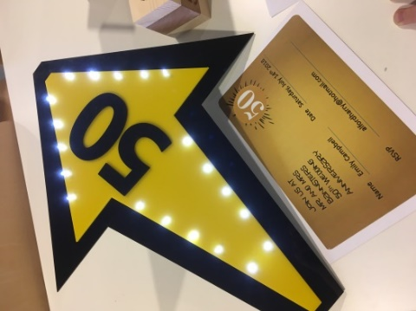
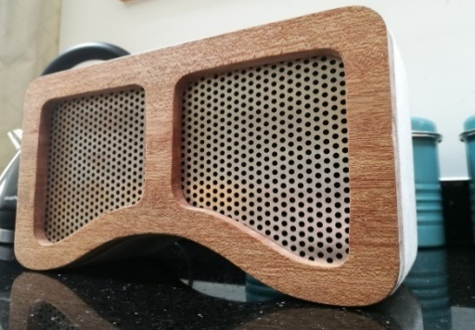
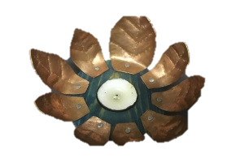

Other important information:
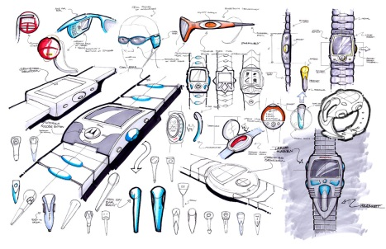
We strongly recommend that students obtain their own copy of a revision book or a set of flash cards in order to support their learning at home and their revision for exams.

If you are interested in products, asking why and how they are made, are good at solving problems, communicating ideas through the use of image, and working with different materials, this could be the course for you.
Thinking Ahead:

Studying Design and Technology can lead to a career in a wide-range of industries and businesses. They include engineering, graphic design, construction and the motor trade. You may be interested in working on aircraft design, or creating zero carbon cars - the possibilities are endless.

GCSE Drama

Head of Curriculum Area: Miss J Williams

Which topics or units will I study?

In GCSE Drama under the OCR exam board students will have the opportunity to explore preexisting performance texts and create there own based on stimuli. Students can choose styles of theatre that most fit with there skill set and be assessed on this choice. You will have the chance to improve your acting by taking part in workshop lessons, build confidence and get creative. You will study professional performance/script and go on trips to see live works. This course can be taken as an actor or designer.

What skills will I develop during this course?

Studying GCSE Drama will further develop your critical analysis of theatre performance including the ability to justify, explain and evaluate yours and professionals’ choices. You will explore style of theatre from Brecht to Stanislavski expanding your skill set, knowledge and performance technique. This course creates a real community and sense of belonging in the PA department and helps students learn to academically write with a practical lens. Overall, you will develop key life-skills, such as team-work, problem solving, thinking creatively and critically, and decision making and confidence.

How will I be taught?

The class will be mixed ability but drama specialist lead. You will learn through a mix of practical activities and written tasks. All learners will take part in practical drama lessons. The assessment requires students to watch live theatre so a trip to watch a performance will be compulsory.

All Learners must be able to work collaboratively as a group and be keen players in the performance company the class will develop. All students must have the confidence to perform to the class frequently and outside audiences.

How will I be assessed?

Component 1/2: Devising Drama – Practical 30%
Students are given a stimulus set by the exam board to inspire ideas, you are given the choice to be actor or designer. Working collaboratively in groups you will create a portfolio to show your progress with research, development of rehearsals and evaluate the work. You will perform the piece to an audience for assessment. This unit allows you a lot of creative freedom to choose our own practitioners, style and topics.

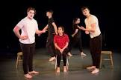
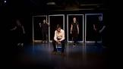
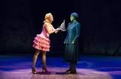

Component 3: Presenting and Performing Texts – Practical 30%
You will be given some options of performance texts to choose from, students will pick 2 contrasting extracts from the play to show a difference in character, plot and dramatic skill. You can choose to be either an actor or designer. A visiting examiner will come in an assess the performance live. You will also submit a concept proforma explaining your choices and intentions.

Component 4: Performance and Response – Written exam 40% (1 hour, 30 mins)
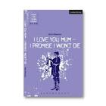
For section A of the exam, you will have studied a set text given by the exam board, you will be required to answer 4–12-mark questions on acting, design, genre, context and meaning. For section B you will have seen a piece of live theatre which you will analyse and evaluate discussing your interpretation and meaning shown to the audience. Although this may seem daunting the exam gives a lot of scope for students to be expressing their own opinions with justifications.
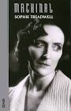
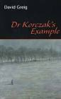
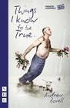

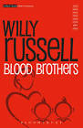



Additional opportunities:

As a department we endeavour to give students outside opportunities with a variety of trips and workshops including, Move It, Theatrical Performances, Bath Forum West Wilts dance festival and more.

Other important information:

It is highly recommended that learners either purchase kit from school or bring their own in for practical lessons.
Thinking Ahead:

This course will prepare students for jobs in the performing arts industry as Actors, Directors, teachers, Theatre analysis/review, production designing and more. It will also build students confidence to present themselves and work in a team on creative tasks.

GCSE Food Preparation and Nutrition

Head of Curriculum Area: Mrs K. Jones

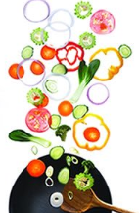
Which topics or units will I study?
In GCSE Food Preparation and Nutrition, the five topics covered are:
- food, nutrition and health;
- food science;
- food safety;
- food choice;
- food provenance.

What skills will I develop during this course?
By studying GCSE Food Preparation and Nutrition, you will:
- demonstrate effective and safe cooking skills by planning, preparing and cooking using a variety of food commodities, cooking techniques and equipment;
- develop knowledge and understanding of the functional properties and chemical processes as well as the nutritional content of food and drinks;
- understand the relationship between diet, nutrition and health, including the physiological and psychological effects of poor diet and health;
- consider the nutritional needs and food choices when selecting recipes, including when making decisions about the ingredients, processes, cooking methods and portion sizes;
- make decisions about which techniques are appropriate based on their understanding of nutrition.

You will also be required to demonstrate knowledge and understanding of:
- appropriate cooking methods to conserve or modify nutritive value or improve palatability;
- how preparation and cooking affect the sensory and nutritional properties of food;
- how to make informed choices about food and drink to achieve a varied and balanced diet, including awareness of portion sizes and costs.

How will I be taught?
You will be taught by teachers in the Design Technology Department. You will be taught within a mixed ability class.
You will be given practical tasks to complete and will have to bring ingredients weekly. Practical work will be followed up by a written evaluation.

How will I be assessed?

In GCSE Food Preparation and Nutrition, you will be assessed by:
- Written examination (worth 50% of the final grade);
- Non-examination assessment (worth 50% of the final grade). This will be made up of two tasks:
  - Task 1 - food science investigation carried out in the Autumn of Year 11 (15%)
  - Task 2 – food preparation assessment carried out in the Winter of Year 11 (35%)
This includes a three-hour practical exam.

Other important information:

You will need to provide ingredients every week as this is an important part of GCSE Food Preparation and Nutrition.
Thinking Ahead:

This would be a good choice if you are considering a career relating to food. This includes as a chef, in catering, hospitality, tourism or retail.
BTEC Technical Award in Music
Head of Curriculum Area: Mr M Thomas

Which topics or units will I study?


BTEC Music is about performing, sequencing, listening and appreciating a wide variety of musical styles. There are opportunities to use music technology such as sequencing and recording as well as the usual performing.
You will learn skills and techniques, putting them into practice straight away through projects, assignments and workshops. It’s all about getting stuck in and developing the skills and knowledge to help your talent shine and succeed in your chosen career.

The course is completed in three units called ‘components’:

Component 1: Exploring Music Products and Styles
- Learners will explore the techniques used in the creation of different musical products and investigate the key features of different musical styles.

Component 2: Music Skills Development
- Learners will have the opportunity to develop two musical disciplines through engagement in practical tasks, while documenting their progress and planning for further improvement.

Component 3: Responding to a Music Brief
- Learners will be given the opportunity to develop and present music in response to a given music brief.

What skills will I develop during this course?


By taking this course, you will broaden your appreciation of music - how it is written, performed and delivered. A wide range of musical styles and genres are studied and allow you, as a musician, to understand how modern music has developed and evolved from classical traditions.

You will be supported and encouraged to perform at a variety of events during the course - both in and out of school.

You will work independently and as part of a team. Through the course, you will develop your ability to work under your own initiative and learn how to become self-motivated. You will need to problem solve and learn how to organise yourself through working to a brief and meeting deadlines. Overall, this will add up to you developing a very useful bank of employability skills.

With the Technical Award students will:

- Get a taste of what the music sector is like.
- Gain transferable skills and confidence that will help them in the world today and prepare them for their futures.
- Build applied knowledge and skills that show an aptitude for further learning, both in the sector and more widely.

How will I be taught?

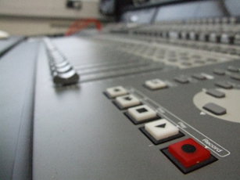
You will be taught in a mixed ability group. The lessons will involve a huge range of teaching methods from written to practical tasks. This includes the use of iPads to record performance reviews along with the use of musical technology for composing / arranging tasks.
How will I be assessed?
- Component 1 and 2 are assessed through non-exam internal assessments. Students will work to a given brief set by the exam board and will complete the tasks in a set amount of time.
- Component 3 is an external assessment which builds directly on the knowledge and skills acquired in Components 1 and 2 and will be completed in Year 11.
Students work continuously throughout the two years on their assessments and there is no final exam in the summer season.

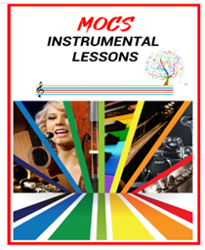
Other important information: It is strongly advised that pupils consider instrumental / vocal lessons to help them achieve the highest possible performance grades.
Please contact Mr Thomas, Head of Music, for further information.

BTEC Technical Award in Performing Arts

Head of Curriculum Area: Miss J. Williams

I

Which topics or units will I study?

In BTEC Tech Performing Arts you will have the opportunity to specialise in dance, drama or design. Within the units, you will be able to select the performance style within which you will be assessed. You will have the chance to learn dance routines, produce plays or design a variety of production elements. You will study professional productions and delve into how performances are created.

What skills will I develop during this course?

Studying BTEC Tech Performing Arts will further develop your critical analysis of theatre performance, including the ability to justify, explain and evaluate your choices, the choices of others and the effectiveness of the choices of professionals. Exploring styles of dance and drama while workshopping performance material, will develop you as a skills-based performer as well as a productive member of the performing arts world. Your skill as a performance creator will be expanded as you experience the development of your own performances or design pitches. Overall, you will develop key life-skills, such as team-work, problem solving, thinking creatively and critically, and decision making and confidence.

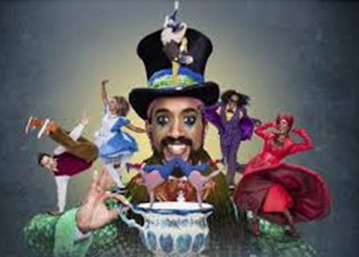

How will I be taught?

The class will be mixed ability. You will learn through a mix of practical activities and written tasks. All learners will take part in practical dance, acting and design disciplines. You will then have the option which you choose to be assessed on for each component.

All Learners must be able to work collaboratively as a group and be keen players in the performance company the class will develop.
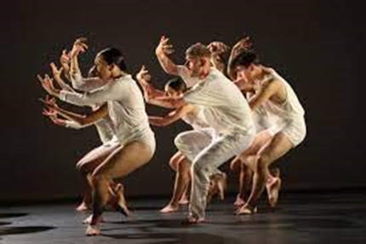

How will I be assessed?

Component 1: Exploring the Performing Arts – internal assessment (30% of total marks available):
This unit is about the observation and exploration of professional work. This unit also requires a written response or a presentation of findings. It is internally assessed. This consists of a in class-controlled examination with a typed response over a series of lessons.

Component 2: Developing Skills and Techniques - internal assessment (30% of total marks available):
This is a rehearsal and performance-based unit. You will need to demonstrate a development of skills and discipline in replicating existing repertoire.

Component 3: Perform to a Brief – external assessment (40% of total marks available):
This is a personal creation unit. The work will be in response to a stimulus and brief. It will be assessed as a live performance to an audience. This is an externally assessed unit. For this unit you will work in groups to create a performance or design pitch.

Additional opportunities:

As a department we endeavour to give students outside opportunities with a variety of trips and workshops including, Move It, Theatrical Performances, Bath Forum West Wilts dance festival and more.

Other important information:

It is highly recommended that learners either purchase kit from school or bring their own in for practical lessons.

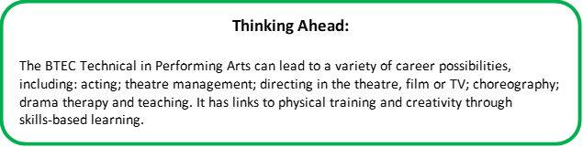

GCSE Religious Studies
Head of Curriculum Area: Mrs K. Brickell

Which topics or units will I study?

Religious Studies (R.S.) is a subject that helps you to understand morality, ethics and the credibility of evidence from a range of viewpoints. R.S. is split into two components: Themes and Religion. The themes component focuses on ethical issues through the study of four modern-day moral issues. The religion paper focuses on the beliefs and practices of two world religions (Buddhism and Christianity), where we explore how having a belief affects your behaviour, perception and goals in life.

The course is divided into two papers, where you will learn the following:
Paper 1: The Study of religion | Paper 2: Thematic Studies
Christian Beliefs (e.g. The nature of God, the Trinity, beliefs about creation and the role of humans, the life of Jesus, the afterlife and judgement, sin and salvation) | Life Issues (e.g. Creation, environmental issues, the use of animals in experiments, death and the afterlife, abortion and euthanasia)
Christian Practices (e.g. Worship, prayer, the sacraments, pilgrimage, festivals, food banks, street pastors, Church growth, Christian persecution and the Church’s response to world poverty) | War and Peace (e.g. peace and conflict, protests, terrorism, reasons for war, weapons of mass destruction, Just War and Holy War theory, pacifism and victims of war)
Buddhist Beliefs (e.g. The life of the Buddha, The teachings of the Buddha, dependant arising, the Four Noble Truths and the origins and answer to suffering, Types of Buddhism and Pure Land Buddhism) | Crime and Punishment (e.g. causes of crime, aims of punishment, the treatment of criminals, death penalty, forgiveness and attitudes towards law breakers)
Buddhist Practices (e.g. Places of worship, types of meditation, death ceremonies and rituals, festivals, Kamma and rebirth, compassion and love and kindness, guidelines on conduct; moral precepts and the six perfections) | Human Rights and Social Justice (e.g. Prejudice and discrimination, Religious freedom, poverty and wealth, exploitation of the poor; human trafficking, fair trade, helping the poor)


What skills will I develop during this course?

You will learn to ask questions about the nature of reality and the place of religion in our world. You will also develop a wide range of skills, including key employability skills, that will help you in a number of future careers. In R.S. you develop skills in explanation, critical analysis, evaluation and debate. You understand the world around you and the diverse views and actions of the people that live within it.

It also helps to develop your writing ability, helping you to present your thoughts clearly and write coherent arguments, which are grounded in reason. You also get to reflect and develop your own views about a range of religious, spiritual, ethical and philosophical issues. You will develop your ability to communicate with others and work as a team, showing compassion, understanding, tolerance and respect to others. These will all contribute to your preparation for adult life in a society and world where people hold many different beliefs.

How will I be taught?

You will be taught in mixed ability groups. Lessons involve using activities to develop your knowledge, understanding and evaluation of the topics studied.

There will be a good mix of individual and group work, and you will examine a range of case studies, evaluating how the beliefs and actions of others have an impact on those around you.

There will be lots of opportunities to use and develop your literacy and discussion skills.

How will I be assessed?

R.S. is assessed through 100% examination, which is taken at the end of the course in Year 11. The exams are not tiered.

You will have two examinations at the end of Year 11. One will be based on the two religions you have studied, and the other will be on the themes listed above. Each examination is 1 hour and 45 minutes long.

Both papers have the same structure and test your explanation of recall knowledge via some short answer questions. You are also tested on your evaluation skills via some longer answer questions. These will require you to show a balanced argument towards an issue, stating why people in our society may agree or disagree with it.

We will complete regular assessments to help you learn the skills needed for these different questions.
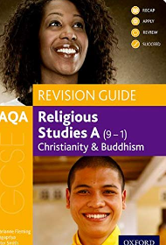

Other important information:

We will provide you with many useful revision resources and links to online support such as videos and apps, but you might find it helpful to buy the course book which has information clearly laid out as well as practice questions and exemplar answers.

The recommended book is ‘AQA GCSE Religious Studies A: Christianity and Buddhism Revision Guide’ by Marianne Fleming. Your teacher will be able to give you further details about this.
Thinking Ahead:

A GCSE in Religious Studies helps to demonstrate an understanding of the wider world, politics and social issues.

It is a subject that can be a stepping stone to many career options including; Medicine, Journalist, TV presenter, Political consultant, Teacher, Historian, Author, Health and social care, uniformed public services (e.g. The Police or Armed Forces), Travel and Tourism, Law, Marketing and Publishers.
GCSE Separate Science
(Biology, Chemistry & Physics)

Combined Science is compulsory for all students. However, Separate Sciences differs to Combined Science in that there is additional content to learn and it is more academically challenging. Separate Science includes the same modules but with additional content.

Combined Science vs Separate Sciences
Separate Science contains all of the content of the Combined award, but with additional material that allows each subject to be awarded it’s own GCSE. This route is most suited to students that wish to continue with the science’s at A-Level, or those that just have a keen interest in how the world around them works. Due to the additional content they exams are longer.

Some examples of additional content include:
- Biology: Culturing microorganisms, monoclonal antibodies, DNA structure, cloning, the brain, the eye, plant hormones and ecology pyramids and transfers.
- Chemistry: Further organic chemistry, further quantitative, titrations, corrosion, alloys, the Haber process.
- Physics: Static electricity, space, nuclear fission and fusion, sound and light waves, loud speakers, microphones, generator effect, transformers, moments and pressure in fluids.

 | AQA Combined Science (trilogy) | AQA Separate Science
Number of GCSEs | 2 | 3
Number of exams | 6 exams ( 2 x biology, 2 x chemistry, 2 x physics)
Length of each exam | 1 hr 15 mins | 1 hr 45 mins
Number of marks for each exam | 70 | 100

In order to choose Separate Sciences, each student must meet the following three criteria:
1. Consistently high grades within their science assessments across KS3. Ideally this will be grade 5-6 in the end of year 9 assessment.
2. A committed and focussed attitude to science which has been seen consistently by their teachers.
3. A strong aptitude for Maths and English as seen in their assessments.

As there is a higher workload, Science teachers will advise students which course they are best suited for.

Thinking Ahead:

Students do not have to take separate sciences to study a Science at A-level as content is revisited. It is better for students to receive two higher grades than three lower grades.
Cambridge National in Sport Science

Head of Curriculum Area: Ms B. Sawyer

Which topics or units will I study?

In Sport Science you will cover a range of units and be assessed in a number of ways, including examination, coursework and practical fitness-based activities.


You will study the following units during the course:
R180; Reducing the risk of sports injuries and dealing with common medical conditions
- Factors that influence injury
- Warm-up and Cool down routine
- Different types and causes of sports injuries
- Reducing risks of sports injuries
- Treatment of Sports Injuries
- Rehabilitation of Sports injuries
- Causes, symptoms and treatment of medical conditions

R181; Applying the principles of training: fitness and how it affects skill performance
- Completion of fitness tests
- Components of fitness applied in sport
- Principles of training
- Organising and planning a fitness training programme
- Evaluating own performance in planning and delivery of a fitness training programme
R182; The Body’s response to physical activity and how technology informs this.
- Cardio-respiratory system and how the use of technology supports diverse types of sport and their intensities
- The muscular and skeletal system and the technology support movement
- Short term effects of exercise on the body systems.
- Long term effects of exercise on the body systems.

R183; Nutrition and Sports performance
- Nutrients needed for a healthy, balanced nutrition plan
- Applying differing dietary requirements for varying types of sporting activity
- Developing a balanced nutrition plan for a selected sporting activity
- Understand how nutritional behaviours can be managed to improve sports performance

What skills will I develop during this course?

You will develop your physical fitness and will apply your knowledge and understanding of fitness training and how targeted training can support general and sports specific fitness.

In addition to improving physical fitness for sport, you will be taught how to write assignments and present work both in a written, word-processed format and through verbal presentations.

You will be taught important exam technique and be supported to prepare for the examination on Sports Injuries and common medical conditions in sport.

Furthermore, you will develop analytical skills that enable you to review planning and performance in sport which, in turn, will help you to reflect and evaluate your own work.

How will I be taught?
Wherever possible, you will be taught by the same P.E. Teacher for the duration of the course.
You will have a combination of theory based and some practical lessons. Some lessons will be teacher-led in the classroom and in practical situations, whilst others will give you the opportunity to plan and take responsibility, allowing you to develop important independent, group and leadership qualities.

How will I be assessed?

- 1 hour written exam paper;
- Coursework - through a series of assignments, usually completed on computers and submitted electronically;
- A combination of practical performance in fitness tests, fitness programmes and coursework. For this, you will be assessed on your practical planning and performance in fitness-based activities. You will produce coursework that will explain and evaluate some of the science behind practical performances.

Other important information:

Due to the significant amount of the assessment process being based on practical performance, we strongly advise that students considering opting for Sport Science should be interested in the body, physical activity and sport and regularly participating in physical activity and sport outside of school.

In addition, students should attend at least one after school club each week in order to develop their fitness and skill levels.
Thinking Ahead:

The course provides an excellent foundation for careers in sport, health and fitness, including physiotherapy, sports psychology, sports coaching, fitness instructor and teaching. It can also help to prepare you for a career in uniformed public services (e.g. The Police, Armed Forces, NHS).
GCSE Textiles

Head of Curriculum Area: Mrs K. Jones

Which topics or units will I study?
Textile design is defined here as the creation of designs and products for woven, knitted, stitched or printed fabrics and involves an understanding of fibres, yarns and fabrics.
In GCSE Textiles, you will undertake a variety of exploration and investigation of textiles techniques. You will learn about how to make relevant critical analysis using contextual sources such as the work of historical and contemporary fashion/textile designers and makers, as well as the different purposes, intentions and functions of textile design as appropriate to their own work.
There are close links between constructed, embellished, printed, sewn and dyed methods of textile design with fashion design and installed textiles. Interdisciplinary opportunities might be explored as well as developing a specialisation in one area.

What skills will I develop during this course?
Studying GCSE Textiles will allow you to demonstrate the ability to work creatively with processes, techniques and skills appropriate to the chosen areas of study. These might include: weaving, surface printing (block, screen or digital), pattern making, pattern cutting, embroidery (machine or hand), knitting, batik, soft sculpture, appliqué and collage.

How will I be taught?
You will be taught by teachers in the Design Technology Department. As in previous years, you will be taught in a mixed ability class.
Textile Design encompasses a very broad range of materials, techniques and processes, including recyclable materials and a growing number of interdisciplinary approaches. The range is increasing as new materials and technologies emerge, for example, in the field of ‘intelligent textiles’.
Skills you learn are relevant for the life you live in the 21st century.

Everything in your life is designed.
Skills you learn are relevant for the life you live in the 21st century.

Everything in your life is designed.
In order to provide sufficient opportunities for research into contemporary practice, you will explore practitioners working in occupations such as a textile designer, textile buyer, fashion designer, fashion forecaster, knitwear designer, milliner, fashion journalist, colour consultant, theatrical costume designer, fashion illustrator, pattern-cutter and designer-maker.

How will I be assessed?

GCSE Textiles is assessed through a personal investigation-based coursework project which is set by you and the teacher. This is worth 60% of your overall grade.

The remaining 40% is based on an externally-set practical examination. This is taken at the end of the course in Year 11. Preparation for the exam starts in Term 3 of Year 11. The 10-hour practical exam will be held in May. The exam is not tiered.

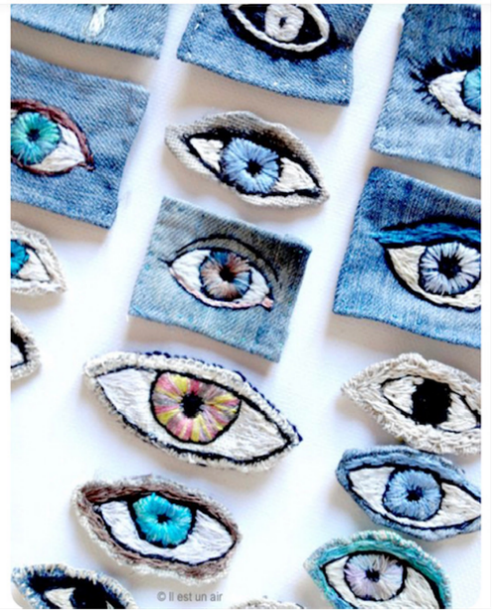
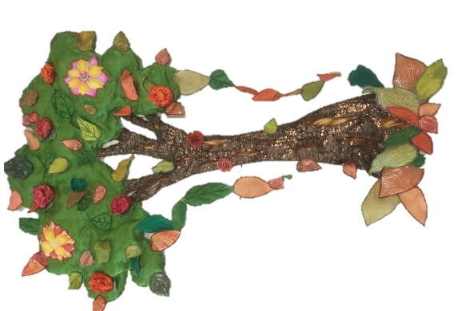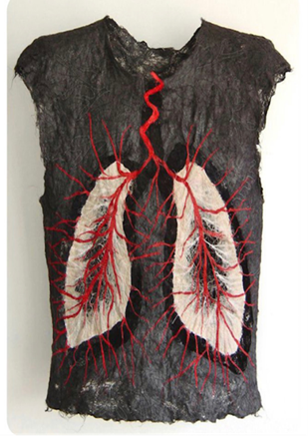

Other important information:
It is essential that you have a sketch book alongside some different types of medium, so that you can create your designs.
Thinking Ahead:

The creative industry is one of the largest in the UK. A qualification in Textiles will help equip you to work towards a range of careers, including: textile designer, textile buyer, fashion designer, fashion forecaster, knitwear designer, milliner, fashion journalist, colour consultant, theatrical costume designer, fashion illustrator, pattern-cutter and designer-maker.

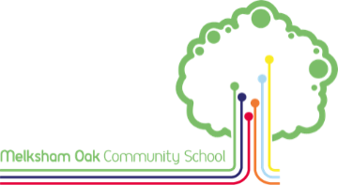
The Online Options Form
We will be using an online rather than a paper options form.
Year 9 parents/carers will be sent an email giving access to an online options form. This will be sent to the first priority contact we have recorded only.
If you would like the email to go to a different address or have not received the email by Friday 27th March, then please e-mail Mrs Pavarnie Jackson via jacksonp@melkshamoak.wilts.sch.uk
This form will clearly state the courses from which your child may select.
Using this online form, you will be able to state your child’s course preferences. The form will also guide you to state 2 reserve choices beyond the number of courses they will actually follow.
As always, we will do our best to allocate each student’s most preferred courses. However, this cannot be guaranteed, hence our request for reserve subject choices.
The deadline for the online options form to be completed is 4pm on Friday 21st March.

