Economics
Exam board & Specification code:
Edexcel (9EB0)
Core textbooks required for the course:

Aforme - Markets, Consumers and Firms Theme 1

Anforme- The Wider Economic Environment Theme 2

Interesting reads:
- Ha-Joon Chang: “Economics: The User’s Guide”
- Kate Raworth: “Doughnut Economics”
- Steven D. Levitt and Stephen J. Dubner: “Freakonomics”

Podcasts (available on Apple and Android phones)

- TED Talks: Business
- The Economist
- The Economist Expresso

Websites:
1 https://www.tutor2u.net/economics/blog This provides you with weekly updates on important goings-on in the world of economics.

2 https://www.economist.com/ This gives bite size articles suitable for extending your general economics knowledge.

3 https://www.globaldata.com/timetric/ This will give you access to a vast bank of economic data and research.

4 http://ww1.theworldbank.org/ A great resource of information regarding the world banks, banking sector and some more generic material on world history and financial history.

5 https://www.bbc.co.uk/news/business/economy A vast bank of economics news that will keep you up to date with the latest in the UK economy.
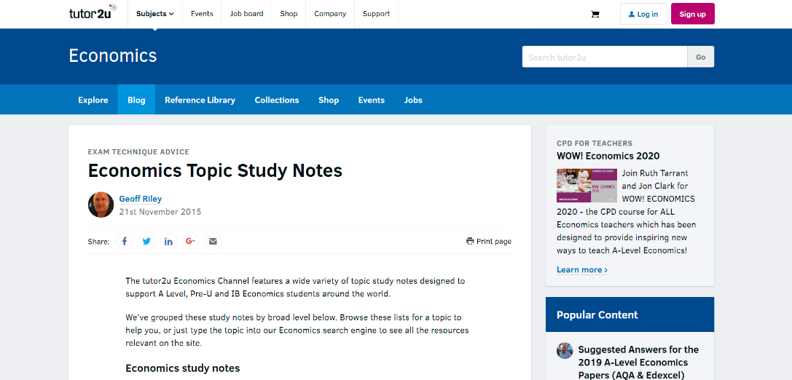

Bridging Task – to be completed over the summer holidays

- Choose ONE of the following economic terms:
  - Scarcity
  - Opportunity cost
  - Supply and demand
  - Specialisation
- Research your chosen term using reliable sources (e.g. BBC Bitesize, textbooks, or introductory economics websites).
- Write a short explanation (500–800 words) that answers the following:
Your Essay Should Include:
1. Definition (What does it mean?)
Explain the term clearly in your own words. Avoid copying definitions—focus on understanding.
2. Real-Life Example
Give at least one example from everyday life. This could be related to:
- School
- Work
- Shopping
- Personal decisions
3. Why It Matters
Explain why this concept is important in the real world. How does it affect individuals, businesses, or governments?
4. Simple Analysis
Try to go a step further:
- What happens if this concept is ignored?
- Are there any advantages or disadvantages linked to it?

Submission Date: First lesson, September 2026
Challenge Extension (Optional)
Try to link your concept to a current issue (e.g. rising prices, shortages, or decision-making in businesses).

Success Criteria:
A strong response will:
- Show clear understanding of the chosen concept
- Use relevant, realistic examples
- Explain ideas logically and in detail
- Attempt some analysis rather than just description

