List of Facts and Formulae to Memorise: Foundation Tier
This document lists the facts and formulae that will not be provided in your maths GCSE exam. Keep testing yourself until you get them right every time. Read yourself a quiz into your phone for facts you keep forgetting! This is not a full revision list – it only covers facts and does not list all the skills and procedures you also need to know.

Number Facts  - First fifteen square numbers: 1, 4, 9, 16, 25, 36, 49, 64, 81, 100, 121, 144, 169, 196, 225  - First five cube numbers: 1, 8, 27, 64, 125  - Powers of 2: 2, 4, 8, 16, 32, 64, 128, …  - Powers of 3: 3, 9, 27, 81, …  - Powers of 4: 4, 16, 64, …  - Powers of 5: 5, 25, 125, 625, …  - Powers of 10: 10, 100, 1000, 10000, …  - The triangular numbers: 1, 3, 6, 10, 15, 21, 28, …  - The Fibonacci sequence: 1, 1, 2, 3, 5, 8, 13, 21, …  - Primes: 2, 3, 5, 7, 11, 13, 17, 19, 23, 29, …  Index Laws  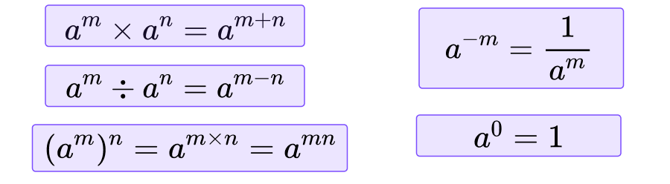  Types of Sequence  - Arithmetic: add the same amount each time  - Geometric: multiply by the same amount each time  - Quadratic: common second difference  - Fibonacci: add the previous two terms  Standard Graph Shapes  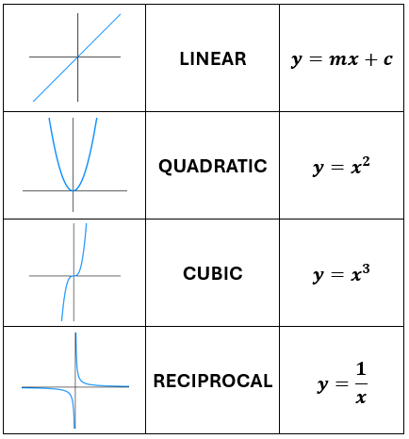  Exact Trig Values  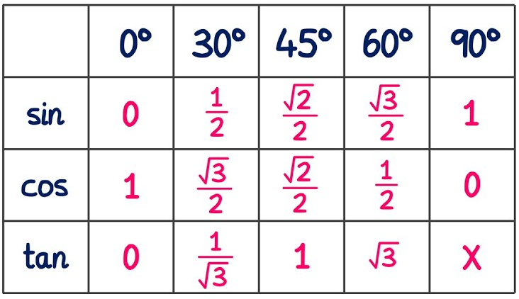  Averages and Spread  - Mode = most frequent value  - Median = middle value (when ordered)  - Mean = sum the values and divide by how many there are  [from a grouped frequency table, estimate the mean using the midpoint of each class]  - Range = maximum value minus minimum value  Scatter Graphs  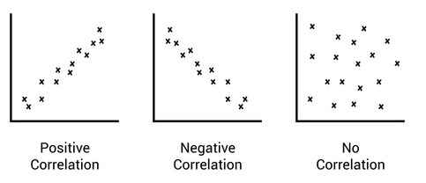  - Interpolation: making a prediction within the range of the data [using a line of best fit]  - Extrapolation: making a prediction outside the range of the data [unreliable]  Sets Notation  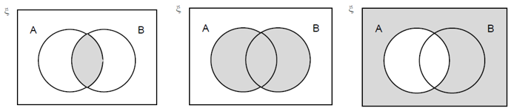  A and B A or B Not A  Linear Graphs  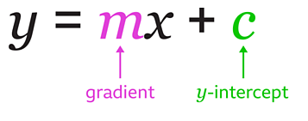  - $m=\frac{Rise}{Run} or \frac{change in y}{change in x}$  - Parallel lines have the same gradient  - $y=2$ is a horizontal line, intersecting y axis at 2  - $x=-3$ is a vertical line, intersecting x axis at -3  - $y=x$ is a diagonal “up” line  - $y= -x$ is a diagonal “down” line  - y-axis is also x = 0  - x-axis is also y = 0  Compound Measures  Speed = Distance ÷ Time  Density = Mass ÷ Volume  Fractions, Decimals and Percentages | Metric Unit Conversions  - Length: 10mm in 1cm, 100cm in 1m, 1000m in 1km  - Mass: 1000mg in 1g, 1000g in 1kg, 1000kg in 1 tonne  - Capacity 1000ml in 1l, 100cl in 1l  Parts of a Circle  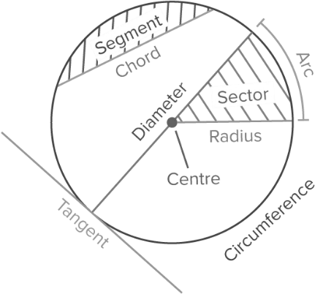  Area  - Area of rectangle, square and parallelogram  = base x perpendicular height  - Area of triangle = ½ x base x perpendicular height  Sectors and Arcs  - Area of sector (radius r, angle $x)$: $\frac{x}{360}πr^{2}$  - Length of arc (diameter d, angle $x)$: $\frac{x}{360}πd$  Types of Angle  - Acute: Between 0º and 90º  - Right: 90º  - Obtuse: Between 90º and 180º  - Reflex: Between 180º and 360º  Quadrilaterals  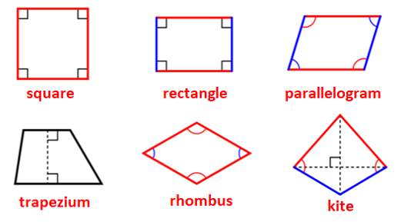  Triangles  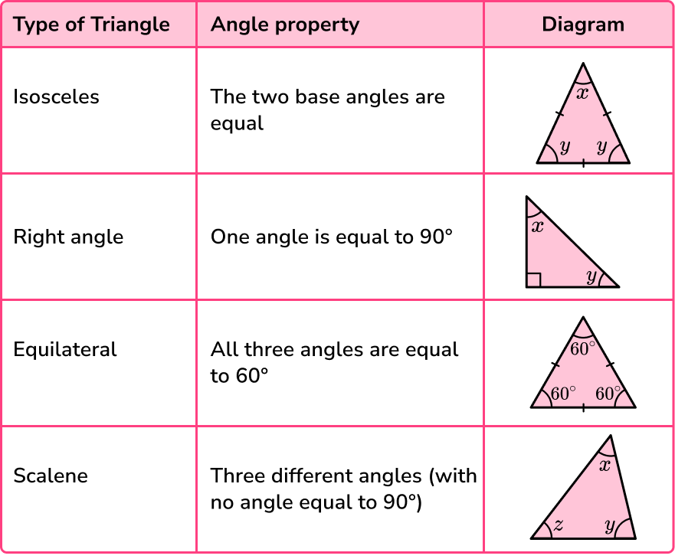  Polygon Names  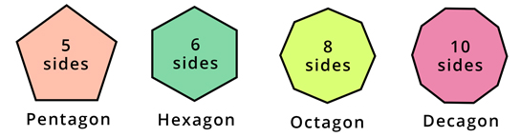  - Sept/Heptagon = 7 sides, Nonagon = 9 sides  Angle Facts  - Angles around a point sum to 360º  - Adjacent angles on a straight line sum to 180º  - Vertically opposite angles are equal  - Interior angles in a triangle sum to 180º  - Interior angles in a quadrilateral sum to 360º  - Opposite angles in parallelograms are equal  Angle in Parallel Lines  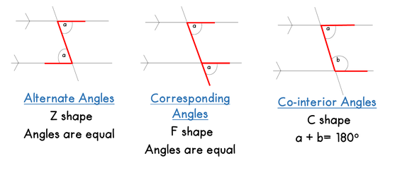  Angles in Polygons  - Sum of the interior angles of an n-sided polygon is 180(n − 2)  - Sum of the exterior angles of any polygon is 360º  - interior angle + exterior angle = 180º  3D Shapes  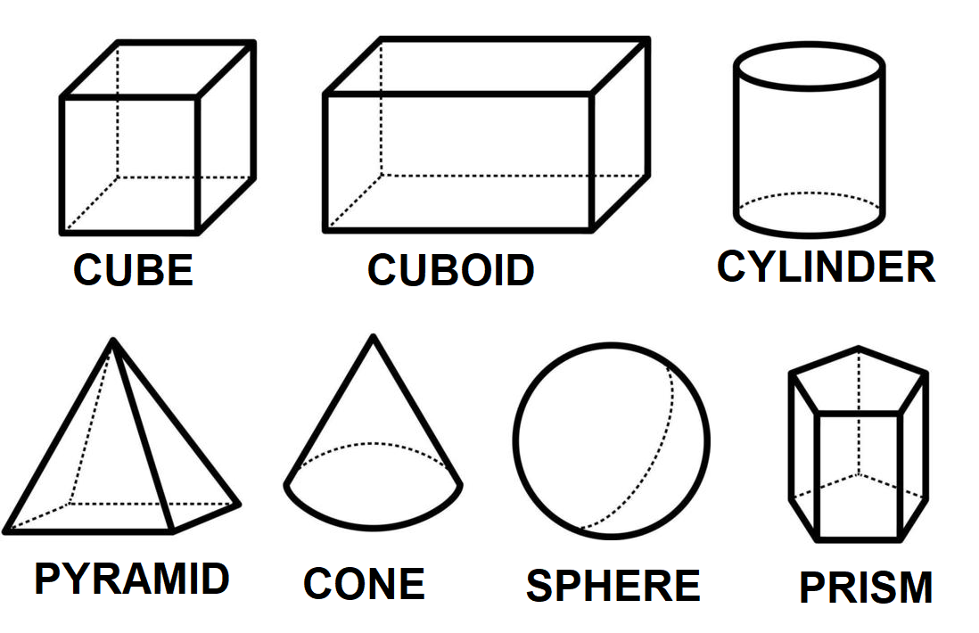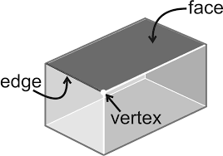  - Cuboid volume = width x depth x height  Describing Shape Transformations  Reflection: Line of reflection  Rotation: Centre, angle and direction  Translation: Vector  Enlargement: Centre and scale factor  Bearings  Measure from the north, measure clockwise and give three figures  Plans and Elevations  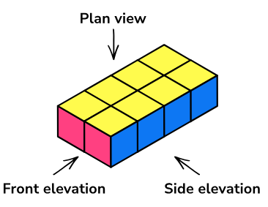
  0.5 | 50% | $$\frac{1}{2}$$
  0.25 | 25% | $$\frac{1}{4}$$
  0.1 | 10% | $$\frac{1}{10}$$
  0.01 | 1% | $$\frac{1}{100}$$
  0.2 | 20% | $$\frac{1}{5}$$
  0.75 | 75% | $$\frac{3}{4}$$

