List of Facts and Formulae to Memorise: Higher Tier
This document lists the facts and formulae that will not be provided in your maths GCSE exam. Read yourself a quiz into your phone for facts you keep forgetting! This is not a full revision list – it only covers facts and does not list all the skills and procedures you also need to know.
Number Facts  - First fifteen square numbers: 1, 4, 9, 16, 25, 36, 49, 64, 81, 100, 121, 144, 169, 196, 225  - First five cube numbers: 1, 8, 27, 64, 125  - Powers of 2: 2, 4, 8, 16, 32, 64, 128, …  - Powers of 3: 3, 9, 27, 81, …  - Powers of 4: 4, 16, 64, …  - Powers of 5: 5, 25, 125, 625, …  - Powers of 10: 10, 100, 1000, 10000, …  - The triangular numbers: 1, 3, 6, 10, 15, 21, 28, …  - The Fibonacci sequence: 1, 1, 2, 3, 5, 8, 13, 21, …  - Primes: 2, 3, 5, 7, 11, 13, 17, 19, 23, 29, …  Index Laws  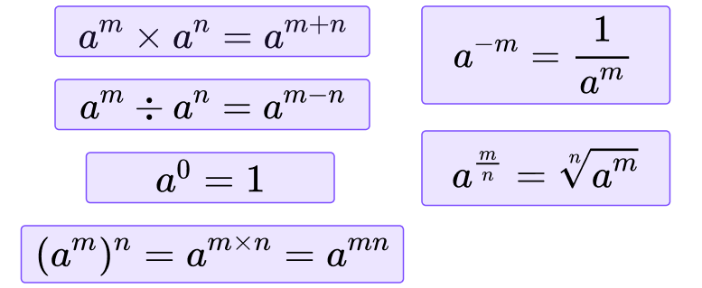  Inequalities  Linear Graphs  - In $y = mx + c$, $m$ is the gradient and $c$ is the y-intercept  - $m= \frac{change in y}{change in x}$  - Parallel lines have the same gradient  - Perpendicular gradient = negative reciprocal  - $y=c$ is a horizontal line  - $x=a$ is a vertical line  Standard Graph Shapes  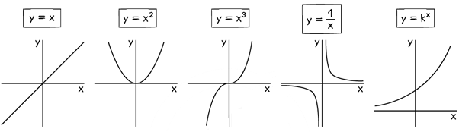  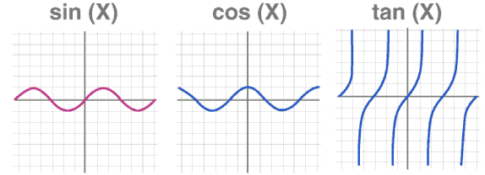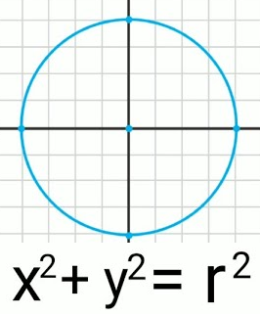  Graph Transformations  - $y=f\left(x+a\right):$ translate $a$ units left  - $y=f\left(x\right)+a:$ translate $a$ units up  - $y= -f\left(x\right)$: reflect in x axis (vertical)  - $y=f(-x)$: reflect in y axis (horizontal)  Proportion Formulae  - $y$ is directly proportion to $x$: $y=kx$  - $y$is inversely proportional to $x$: $y=\frac{k}{x}$ | Metric Unit Conversions  - Length: 10mm in 1cm, 100cm in 1m, 1000m in 1km  - Area: 100mm² in 1cm², 10 000cm² in 1m²  - Volume: 1000mm³ in 1cm³, 1 000 000cm³ in 1m³  - Capacity 1000ml in 1l, 100cl in 1l  - Also 1ml in 1cm³, 1000cm³ in 1l  - Mass: 1000mg in 1g, 1000g in 1kg, 1000kg in 1 tonne  Parts of a Circle  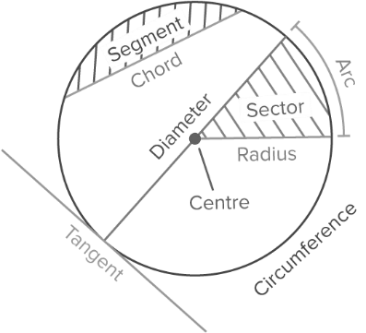  Area  - Area of rectangle, square and parallelogram  = base x perpendicular height  - Area of triangle = ½ x base x perpendicular height  Sectors and Arcs  - Area of sector (radius r, angle $x)$: $\frac{x}{360}πr^{2}$  - Length of arc (diameter d, angle $x)$: $\frac{x}{360}πd$  Describing Shape Transformations  Reflection: Line of reflection  Rotation: Centre, angle and direction  Translation: Vector  Enlargement: Centre and scale factor  Invariance: When a point or shape remains in the same place after a transformation has been applied.  Types of Angle  - Acute: Between 0º and 90º  - Right: 90º  - Obtuse: Between 90º and 180º  - Reflex: Between 180º and 360º  Quadrilaterals  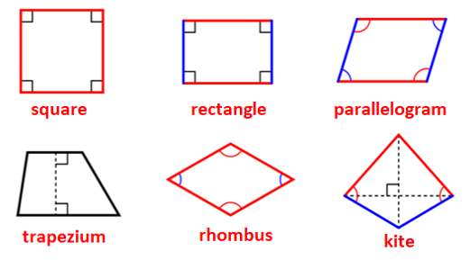  Triangles  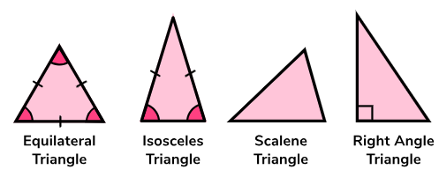
   | Not included | Included
  On a number line | $$∘$$ | $$•$$
  Graphical | Dashed line | Solid line
Exact Trig Values  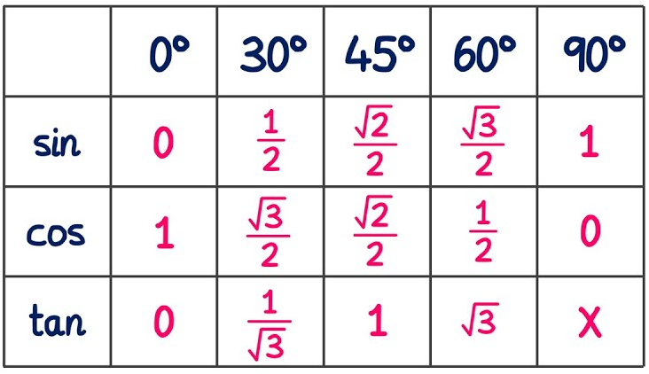  Averages and Spread  - Mode = most frequent value  - Median = middle value (when ordered)  - Mean = sum the values and divide by how many there are  [from a grouped frequency table, estimate the mean using the midpoint of each class]  - Range = maximum value minus minimum value  - Interquartile range = upper quartile minus lower quartile  Box Plots  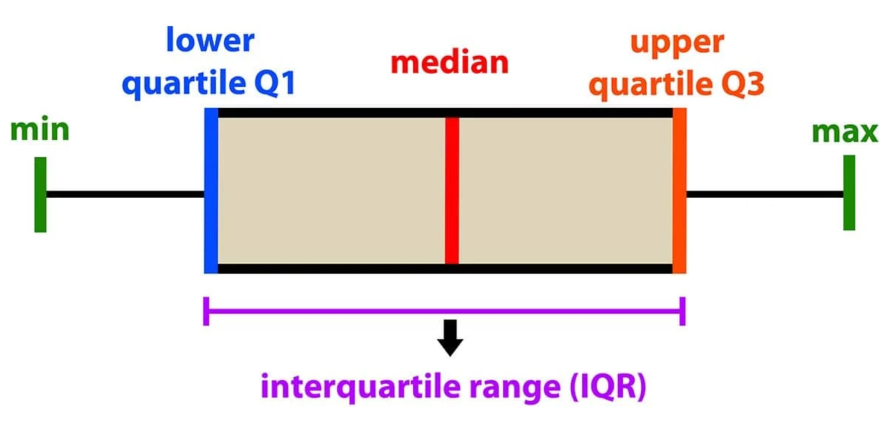  Scatter Graphs  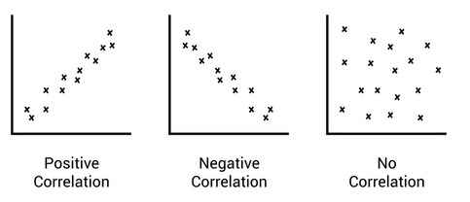  - Interpolation: making a prediction within the range of the data [using a line of best fit]  - Extrapolation: making a prediction outside the range of the data [unreliable]  Histograms  $$Frequency density=\frac{frequency}{class width}$$  Set Notation  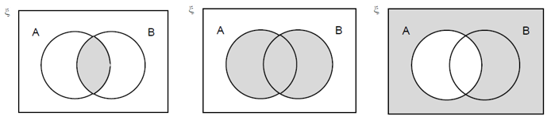  A and B A or B Not A  Types of Sequence  - Arithmetic: add the same amount each time (common difference)  - Geometric: multiply by the same amount each time (common ratio)  - Quadratic: common second difference  Fibonacci: add the previous two terms | Polygon Names  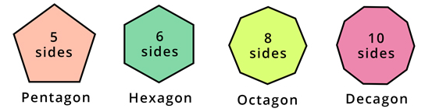  - Sept/Heptagon = 7 sides, Nonagon = 9 sides  Angle Facts  - Angles around a point sum to 360º  - Adjacent angles on a straight line sum to 180º  - Vertically opposite angles are equal  - Interior angles in a triangle sum to 180º  - Alternate angles in parallel lines are equal  - Corresponding angles in parallel lines are equal  - Co-interior angles in parallel lines sum to 180º  - Opposite angles in parallelograms are equal  - Interior angles in a quadrilateral sum to 360º  - Sum of the interior angles of an n-sided polygon is 180(n − 2)  - Sum of the exterior angles of any polygon is 360º  - interior angle + exterior angle = 180º  Circle Theorems  - The angle at the centre is twice the angle at the circumference  - The angle in a semicircle is a right angle  - Angles in the same segment are equal  - Opposite angles of a cyclic quadrilateral sum to 180º  - A tangent meets a radius at 90º  - Tangents from an external point are equal in length  - The perpendicular from the centre to a chord bisects the chord  - The angle between a tangent and a chord is equal to the angle in the alternate segment  3D Solids  cube, cuboid, prism, cylinder, pyramid, cone and sphere  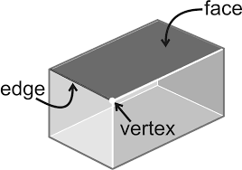  - Cuboid volume = width x depth x height  - Pyramid volume = 1/3 of surrounding prism volume  Similarity  - Length scale factor = $k$  - Area scale factor = $k^{2}$  - Volume scale factor = $k^{3}$  Bearings  Measure clockwise from the north and give three figures.  Congruency Proofs  - SSS: Side, Side, Side  - SAS: Side, Angle, Side (must be the included angle)  - ASA: Angle, Side, Angle  - RHS: Right Angle, Hypotenuse, Side  Compound Measures  Speed = Distance ÷ Time  Density = Mass ÷ Volume

