A Level History Transition Booklet

Welcome to A Level History at Melksham Oak Community School.

This Transition work is designed to help you to bridge the gap between your GCSE studies and A Level.

Why do Transition work?
Preparation is crucial for studying A levels. A levels require you to be an independent learner. Although you have fewer subjects, A levels require different study skills, and the volume of work is greater due to the
increased demand of depth and detail. The exercises in this booklet will ensure that you are ready for the exciting challenges of becoming an A level student in September. It may be necessary to complete some
of the tasks on separate sheets of paper. You have the choice of either typing or handwriting your responses. Each subject will be slightly different, but they will all require you to use the skills you will need
for A level: independent enquiry; evidence of reading around the subject and enthusiasm and interest.

Is Transition work assessed?
Yes. In September, your subject teacher will ask you for your Transition work and it will be assessed.
Teachers will be able to diagnose your strengths and weaknesses and begin to support and challenge you in a more targeted way.
You must bring all the work with you to your first Year 12 History lesson in September.​

Key information
Your AS/A Level History will cover the following units
Exam board & Specification code: A Level History: OCR. Spec. code: H505. Q no: 601/4701/5

Topics studied (*=Studied in year 12 **=Studied in year 13):
Unit 1*: Y107 (British History Topic study and enquiry) England 1547–1603: the Later Tudors (Enquiry topic: Mid Tudor Crises 1547–1558)
Key topics: ·​ ​The stability of the monarchy ·​ ​Religious changes ·​ ​Rebellion and unrest ·​ ​- Elizabeth and Religion ·​ ​The nature of the Elizabethan Monarchy, Government and Parliament ·​ ​Elizabeth’s management of financial, economic and social affairs ·​ ​Elizabethan later years 1588-1603

Unit 2*: Y221 (Non-British period study) Democracy and Dictatorships in Germany 1919–1963
Key topics:
- The Weimar Republic and the rise of Nazism (1919–Jan 1933)
- The Nazi Dictatorship: pre-War (Feb 1933–1939) and war years (1939-1945):
- Divided Germany (1945–1963): Post-war occupation, division and development of East and West Germany

Unit 3**: Y319 Thematic study and historical interpretations, Civil Rights in the USA 1865–1992
Key topics: ·​ ​African Americans ·​ ​Trade Union and Labour Rights ·​ ​Native American Indians ·​ ​Women
Depth studies: ·​ ​Civil rights in the ‘Gilded Age’ c.1875–c.1895 ·​ ​The New Deal and civil rights ·​ ​Malcolm X and Black Power

Non exam assessment*/**: Y100 Topic based essay: Germany1919-45 coursework element.
​This is an extended essay of 3,000-4,000 words, arising from independent study and
research, on a topic of the student’s choice. This will involve the collection and evaluation of both primary and secondary source material, the ability to analyse different historian’s interpretations and construct a clear line of argument.

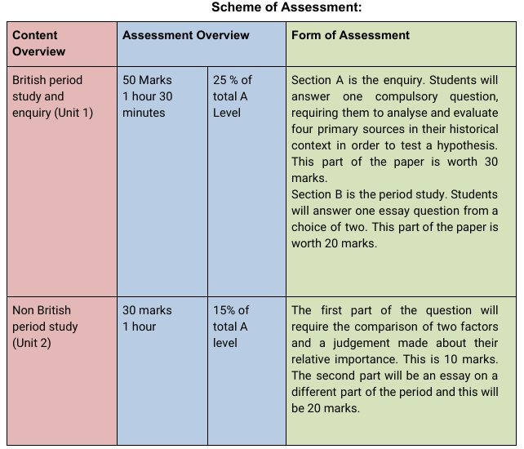

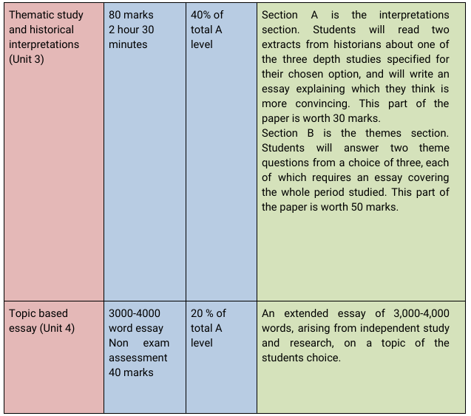

Books & magazines: Books specifically for the course in Year 12:
Unit 1: OCR A Level History - England 1485-1603 by N. Fellows, M. Dicken ISBN: 9781471836695 Publisher: Hodder Education June 2015
My Revision Notes: OCR AS/A-level History: England 1547-1603: the Later Tudors (Paperback) by Nicholas Fellows Publisher: Hodder Education ISBN: 9781510416406
*Access to History: Democracy and Dictatorships in Germany 1919-63 for OCR Second Edition
Geoff Layton ISBN: 9781471839153 Published: 28/08/2015
*My Revision Notes: OCR AS/A-level History: Democracy and Dictatorships in Germany 1919-63 (Paperback) Nicholas Fellows Publisher: Hodder Education ISBN: 9781471875854
Optional alternative for Unit 2: *OCR A Level History: Democracy and Dictatorships in Germany 1919–63 Student Book Author: N. Fellows ISBN: 9781510416543 Publisher: Hodder Education Date: March 2018

What equipment will be needed for the subject? A ring binder folder for notes and handouts.
Useful Websites:
- OCR History (exam board details, specification and useful links)
- Hodder Education (for ordering resources -though do source out cheaper second-hand copies)
- BBC Bitesize & BBC History - it has interesting articles, links to TV and radio programmes
- School History - it has revision information, online help, games and quizzes, and so on.
- Spartacus Schoolnet - this is a good site for general research.
- Explaining History - ebooks that explain different aspects of 20th Century History.
- School History - it's a school site. it has revision notes, quizzes and resources
- Others: History Learning Site - Quite a few A Level course outlines -History Magazines online
- History Home - English History -The History Channel -Modern History Source Book
- S-cool - A Level History on the Tudors Learning Curve - National Archives History Learning Site
- A Level History on Key individuals during the reign of Edward VI, Mary I & Elizabeth I
Transition tasks: Over the summer holidays you should read and explore the resources provided, complete the DO tasks answering the key questions/tasks:
**** Key compulsory challenge tasks for September 2026:
DO: Using all the resources listed below and prior reading links you must complete the following two compulsory tasks:
- Create a profile on the following key people:
- Edward VI
- Duke of Somerset
- Duke of Northumberland
- Mary I
- Cardinal Pole
- Elizabeth I
- William Cecil
- Earl of Essex.
- Essay skills:

This is looking for the skills of judgement, argument and evaluation. Remember to substantiate your judgement (thinking of stretch the why) and to evaluate the individuals using tentative language. Answer like a 16 mark How far do you agree question.

Q1) Evaluate who served Edward VI and his realm more effectively – Somerset or Northumberland?

To support both compulsory tasks we suggest the following:

Suggested Watch: Youtube, Netflix, Iplayer etc have lots of relevant Films/Programmes to watch on Germany and Tudors e.g. Rise of Evil (Adolf Hitler), Mary, Queen of Scots (see below).
Unit 1 tasks: Optional READ, WATCH, SEE & LISTEN tasks to support compulsory DO tasks.
Optional: READ: Wider reading and notes on Mid Tudor crisis:
http://spartacus-educational.com/OCR_MidTudorCrisis.htm
https://www.history.org.uk/secondary/resource/2075/a-mid-tudor-crisis
Elizabeth I:
http://www.historyextra.com/article/elizabeth-i/queen-elizabeth-great-love
http://www.historyextra.com/article/premium/deadly-rivals-elizabeth-and-mary
http://www.historyextra.com/article/premium/enchanting-history-charisma

WATCH: She Wolves, England's Early Queens: 03 Jane, Mary, & Elizabeth: Youtube
· https://www.youtube.com/watch?v=cViQwM8-NDE
Edward and Mary by David Starkey: · King Edward VI of England - Tudor Documentary - David Starkey https://www.youtube.com/watch?v=Ngd_X7Ua9Os
· https://www.youtube.com/watch?v=EB8qQpnn7eA
Elizabeth I Film (1998)

SEE: · National Portrait Gallery · Hampton Court Palace · Tower of London · Hatfield House

LISTEN: · https://itunes.apple.com/gb/course/as-history-mid-tudor-crises/id876319410
· http://www.bbc.co.uk/programmes/b0076fdw
· http://www.bbc.co.uk/programmes/b00n5nqr
· http://www.missedinhistory.com/podcasts/rival-queens-mary-stuart-and-elizabeth-i.htm
· http://www.missedinhistory.com/podcasts/elizabeth-the-first-before-she-was-queen.htm

