**Permission to Collect a Candidate’s Results**

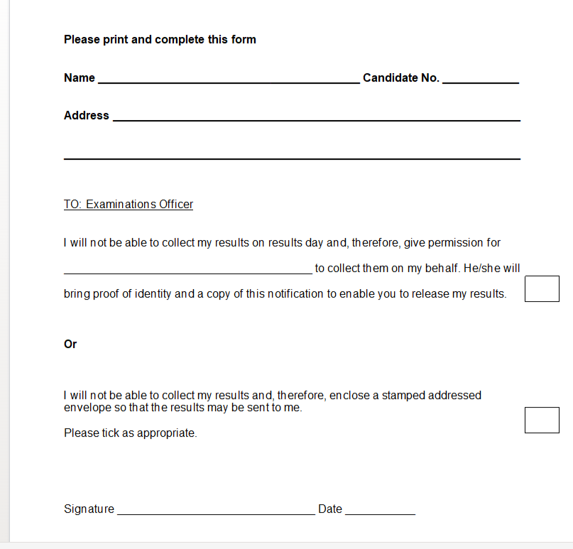

**Examination Results – Summer 2025**

Provisional results for the examinations that students have taken this year will be available for collection from school on:-

*A2 & AS Exam Results day – Thursday 14th August* *GCSE Exam Results day – Thursday 21st August*

You will need to sign for your results on this day. If you (the student) are unable to collect the results yourself, you may either nominate another person to collect them on your behalf or send a stamped addressed envelope to the examinations office by Wednesday 24th July.

Please complete and return to the examinations office the ‘Permission Form’ (available on the school website or from the exams office) if you wish to nominate a friend/relative to collect your results or have them sent by post.

We regret that we will be unable to release your results to a third party (even a parent/carer) without your signed, written consent, which is kept on file in school in case of any future enquiries.