Top 10 must know
Buddhist BELIEFS
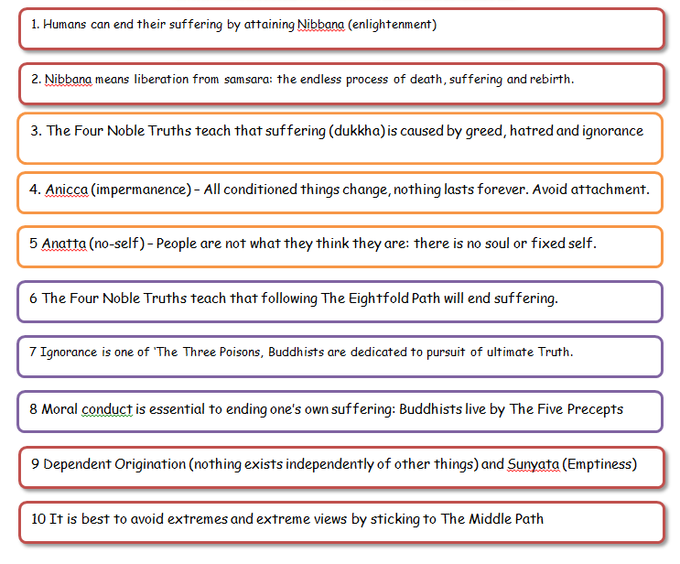
What is the cause of suffering?
What is the end of suffering called?
How can it be achieved?
If nothing lasts forever, what should Buddhists avoid?
What is the middle path? How did the Buddha come to realise it was the best path?
Why are the 5 precepts essential?
What is the no self idea called?
What’s the link between no self and importance?
Explain dependent origination using a plant as an example

