At Meynell Primary School, we believe mathematics is an important part of children’s development throughout school, right from an early age. We intend on delivering a curriculum which:  - Recognises that mathematics underpins much of our daily lives and therefore is of paramount importance in order that children ASPIRE and become successful in the next stages of their learning.  - Gives each pupil a chance to BELIEVE in themselves as mathematicians and develop the power of resilience and perseverance when faced with mathematical challenges.  - Allows children to be a part of creative and engaging lessons that will give them a range of opportunities to EXPLORE mathematics following a mastery curriculum approach.  - Engages all children and entitles them to the same quality of teaching and learning opportunities, striving to ACHIEVE their potential, as they belong to our school community.  - Makes rich connections across mathematical ideas to develop fluency, mathematical reasoning and competence in solving increasingly sophisticated problems.  - Provides equal opportunities for children to apply their mathematical knowledge across a rich and varied range of other subjects (cross-curricular links).  - Is in-line with the National Curriculum 2014. | 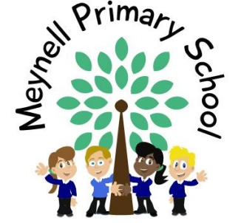

Maths teaching at Meynell: We are using the White Rose schemes of Learning to inform the progression of our Maths teaching, whilst using additional materials to supplement lesson planning and activities. These overviews are designed to support a mastery approach to teaching and learning and are designed to support the aims and objectives of the new National Curriculum. Supporting resources for every small step are available, to include a wide variety of visual ideas and materials to strengthen consistency across school.
The Overviews:
- have number at their heart. A large proportion of time is spent reinforcing number to build competency.
- ensure teachers stay in the required key stagwe and support the ideal of depth before breadth.
- ensure children have the opportunity to stay together as they work through the schemes as a whole group.
- provide plenty of opportunities to build resasoning and problem solving elements into the curriculum.
Concrete – Pictorial – Abstract
We believe that all children when introduced to a new concept, should have the opportinity to build competency by taking this approach.
Concrete – children should have the opportunity to use concrete objects and manipulatives to help them understand what they are doing.
Pictorial – alongside this children should uise pictorial representations. These representations can then be used to help reason and solve problems.
Abstract – both concrete and pictorial representations should support children’s understanding of abstract methods.

NEW for 2020/21
2020 will go down in history. The world has changed for all of us. We all want to do as much as we can to support children, teachers, parents and carers in these very uncertain times.
The schemes for 2020/21 have been amended to:
- Highlight key teaching points
- Flag any content that you might not have covered during the school closures period.
- Recap essential content that children may have forgotten

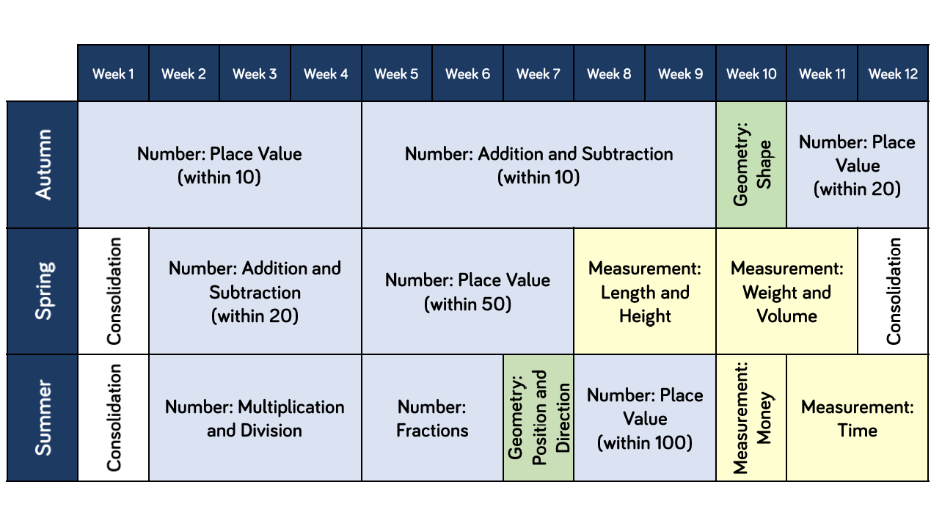
Whole Year Overview
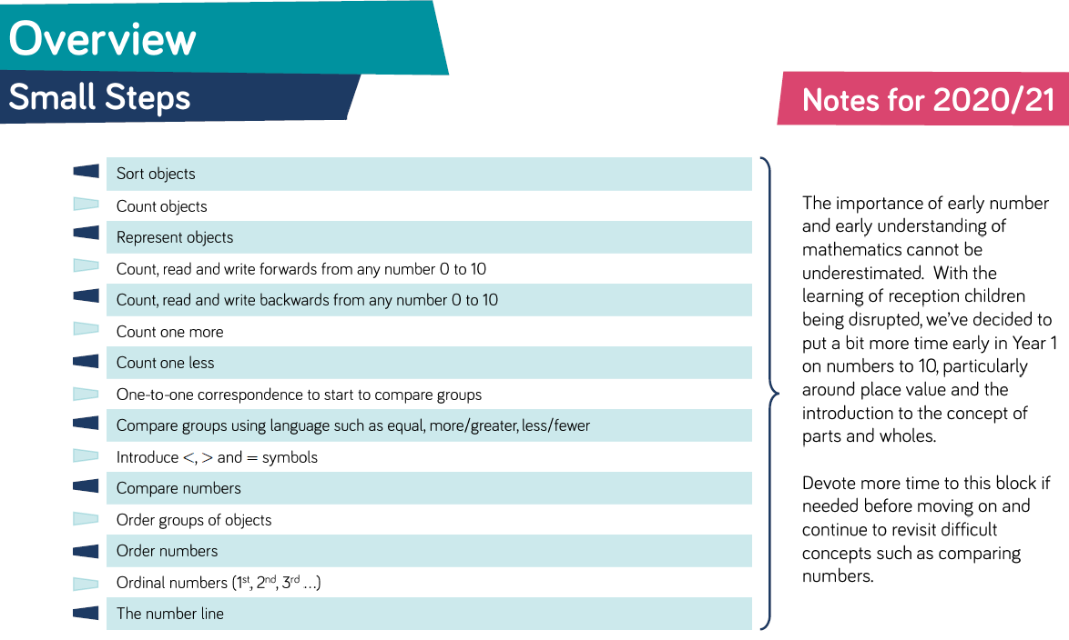
Autumn Progression – Week 1 to 4 Number: Place Value
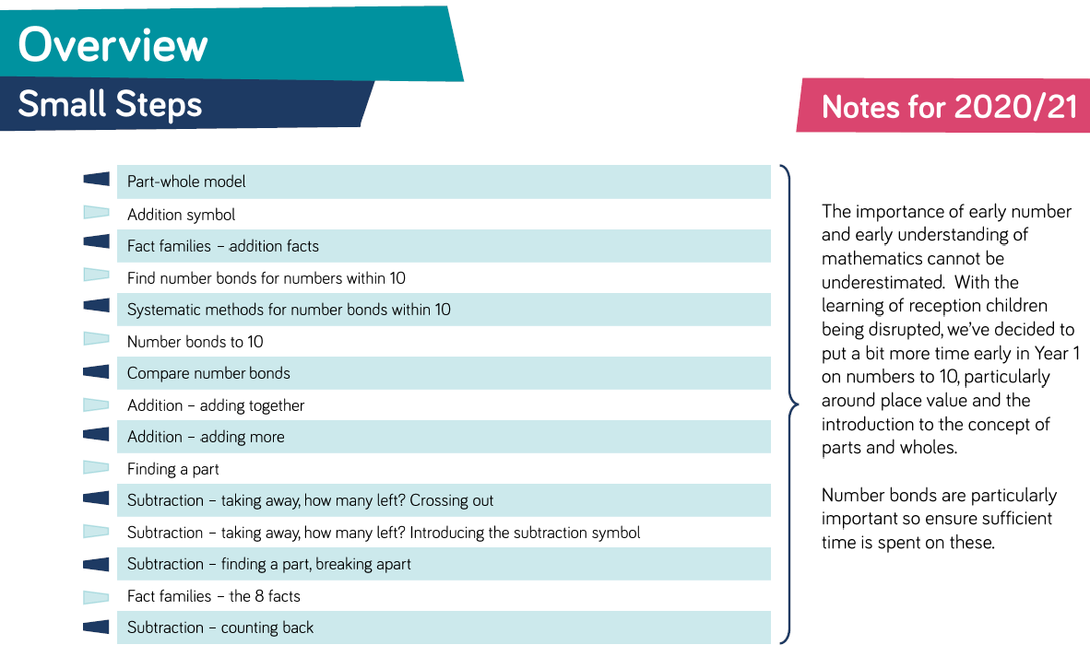
Autumn Progression – Week 5 to 8 Number: Addition & Subtraction
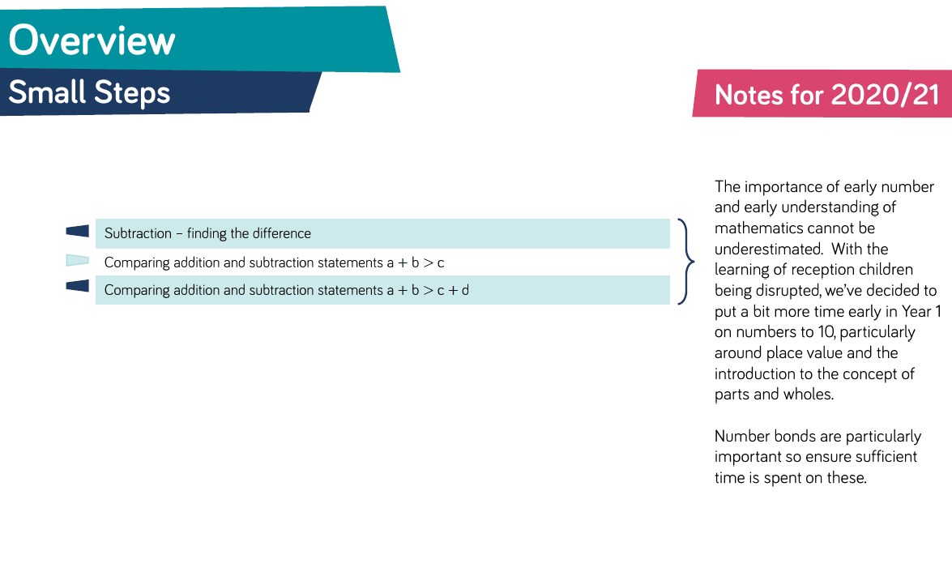
Autumn Progression – Week 5 to 8 Addition & Subtraction
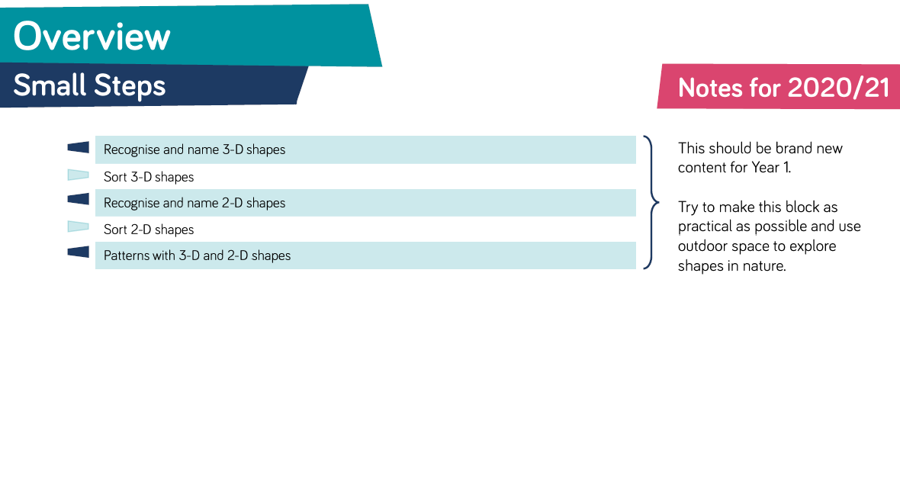
Autumn Progression – Week 9 Geometry: Shape
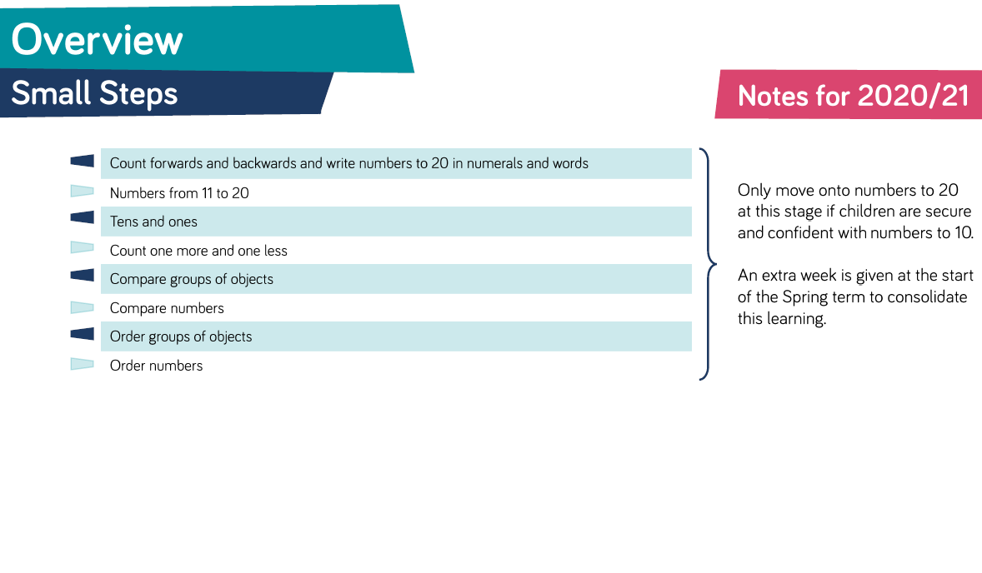
Autumn Progression – Week 10 to 11 Number: Place Value (within 20)
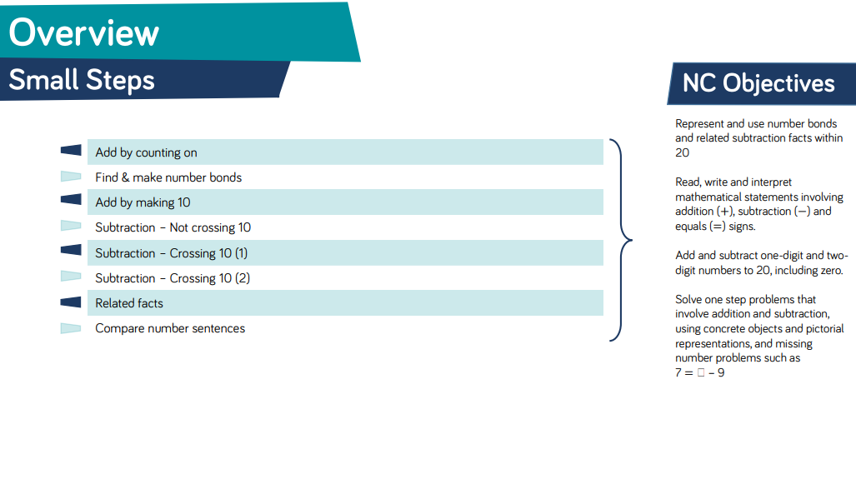
Spring Progression – Week 1 to 4 Number: Addition & Subtraction
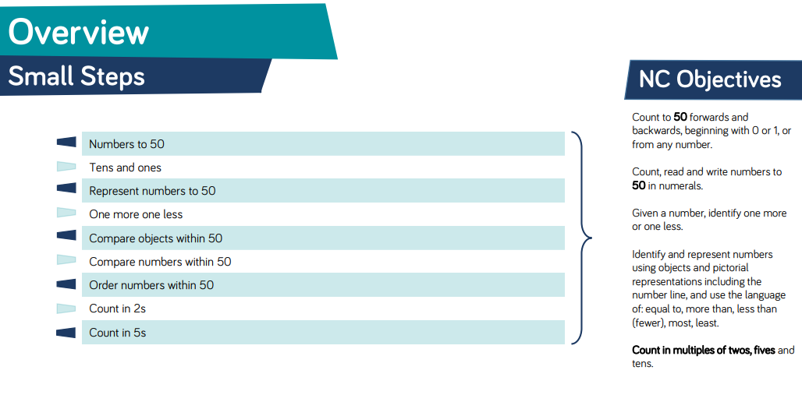
Spring Progression – Week 5 to 7 Number: Place Value (within 50)

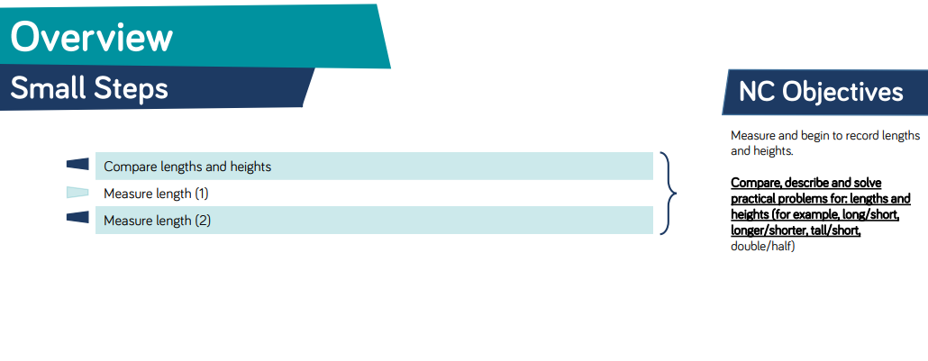
Spring Progression – Week 8 to 9 Measurement: Length & Height

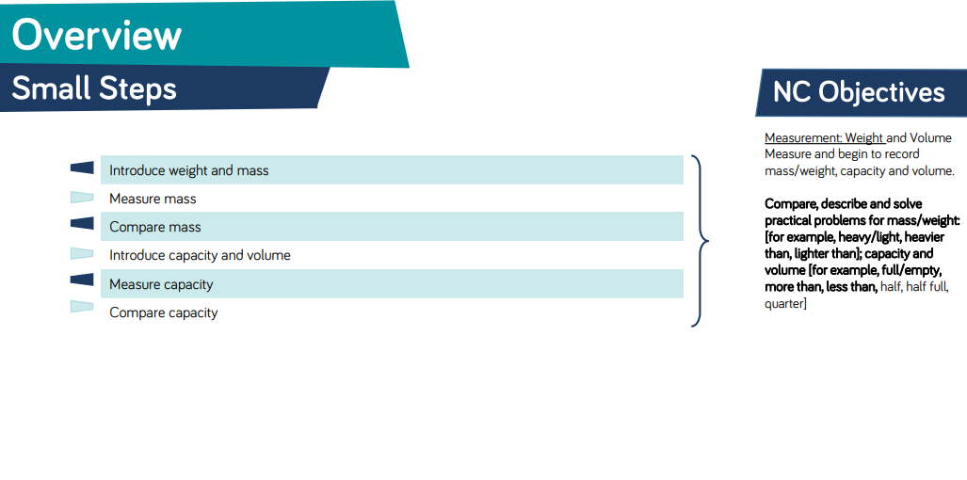
Spring Progression – Week 10 to 11 Measurement: Weight & Volume

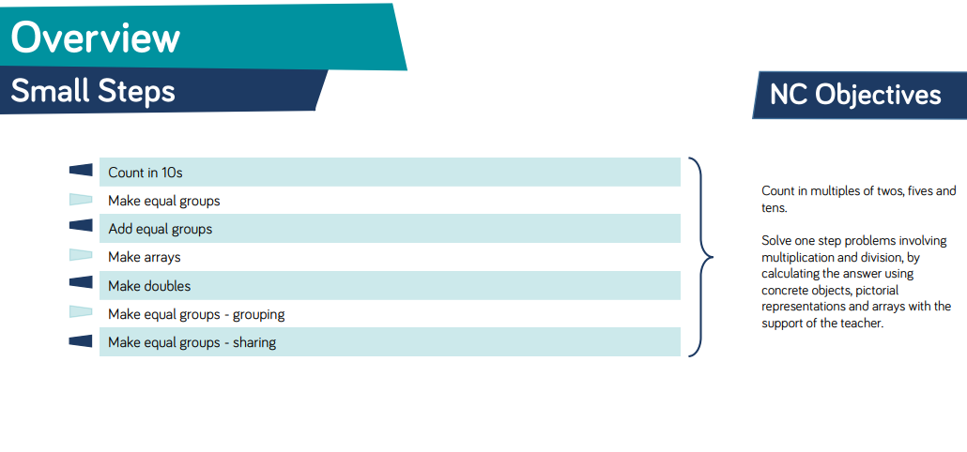
Summer Progression – Week 1 to 3 Number: Multiplication & Division

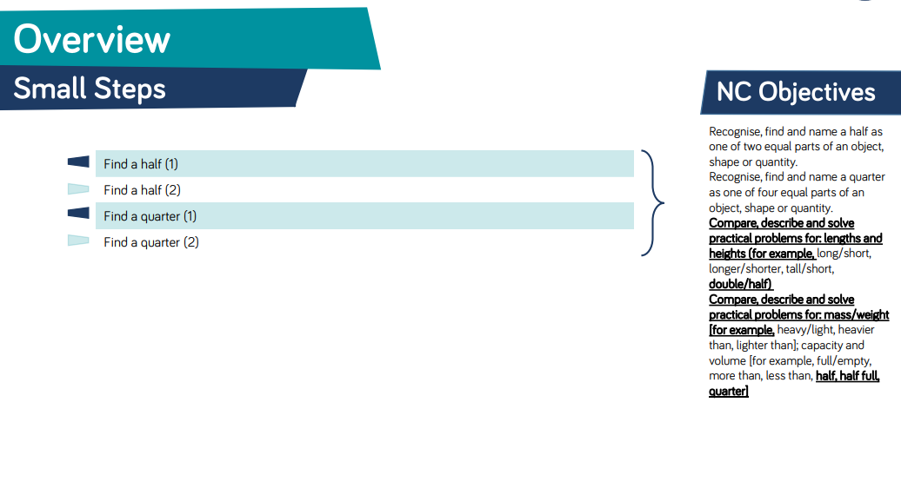
Summer Progression – Week 4 to 5 Number: Fractions
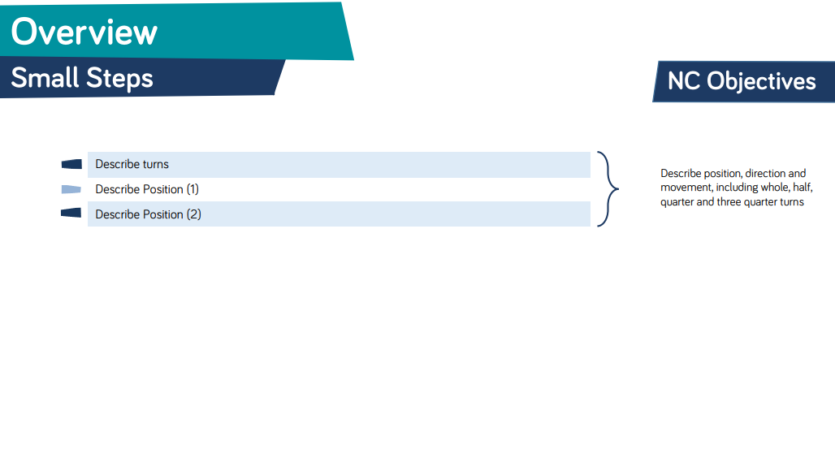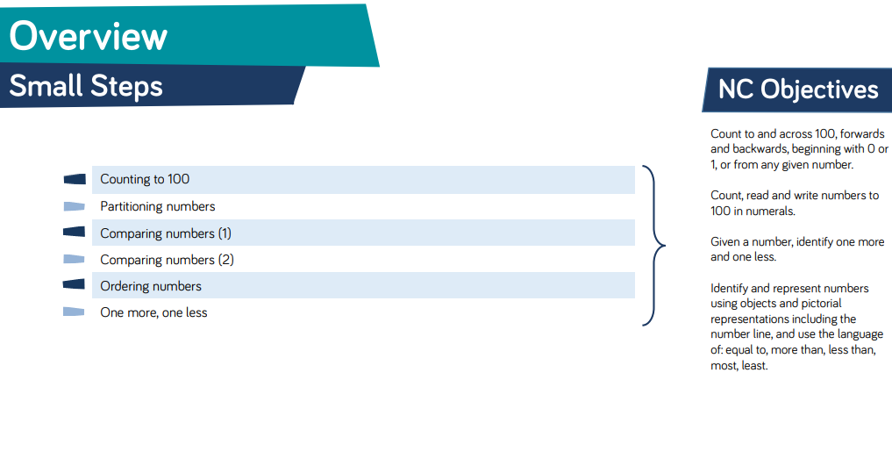
Summer Progression – Week 6 Geometry: Position & Direction
Summer Progression – Week 7 to 8 Number: Place Value (within 100)

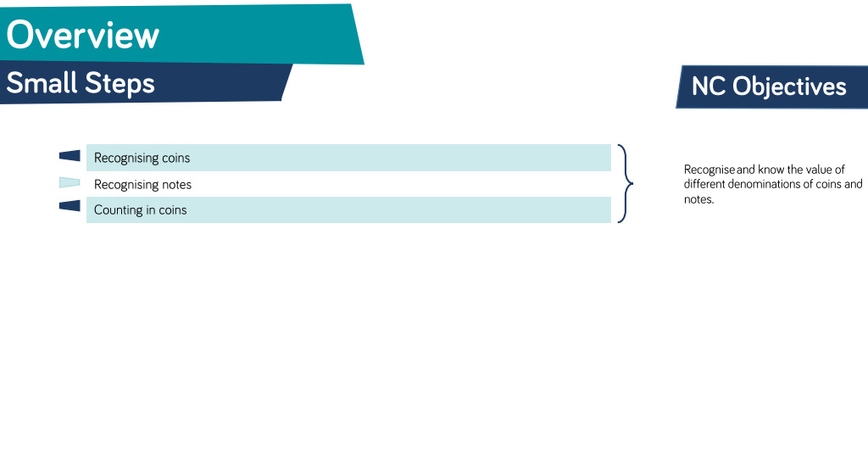
Summer Progression – Week 9 Measurement: Money
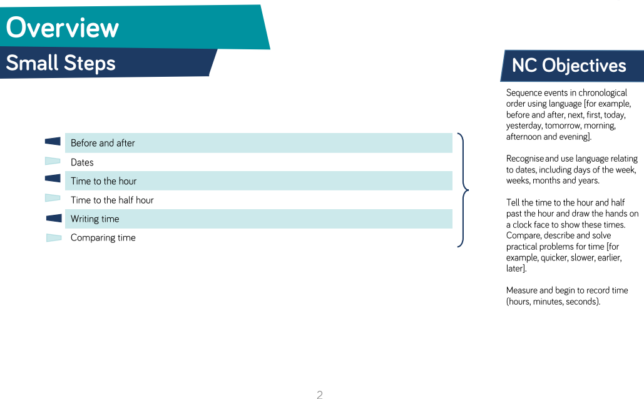
Summer Progression – Week 10 to 11 Measurement: Time

We have collaborated with TSAT Trust schools to produce a moderated Trust Y1 booklet, to share
‘What a Year 1 Mathematician Looks like’.
Please see the TSAT Y1 booklet for end of year objectives and examples of End of Year 1 Expected and Greater Depth learning.

