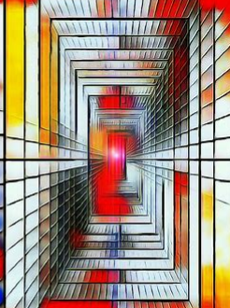
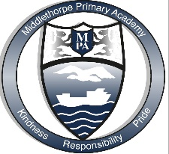
Middlethorpe Primary Academy Art Intent 2022-2023

Art is not what you see, it is what you make others see. Degas

Intent
At Middlethorpe our Art curriculum is designed to develop curiosity and fascination about the world around us and enable our children to express themselves in a variety of ways. Our curriculum takes into account the experiences of our children, the content of the National Curriculum and the current art climate to ensure our children have the skills, understanding and knowledge to be able to represent relationships and draw conclusions through art. The essential art knowledge has been carefully sequences to ensure it builds within a year, across years and across subjects. Children investigate a variety of media and art techniques and genres.
We aim to develop the following essential characteristics of artists:
- An extensive base of artistic knowledge and vocabulary
- The ability to problem solve and to understand that there may be more than one solution
- The ability to express themselves in ways that are not restricted by their understanding of words and numbers
- The willingness to surrender to the unanticipated possibilities of the work as it unfolds
- The ability to express well-balanced critiques and to make good judgements about qualitative relationships
- The understanding that small differences can have large effects
- The understanding there are many ways to see and interpret the world
- Fluency in artistic enquiry and the ability to explore possibilities
- A genuine interest in art and a real sense of curiosity about the world
Implementation
Leaders have carefully selected the knowledge and skills children at Middlethorpe require to fulfil the aims of the subject. The long term plan takes into account the experiences of our children, the content of the National curriculum and has the flexibility to take into account current popular artists. Key concepts have been identified that children encounter at different stages of their educational journey and then revisit repeatedly. The content has been mapped into one half termly units per year. During the term Spring 1 the whole school has an art focus. In Key Stage 1 children study how artists use line, colour and pattern and how they use shape, form, space and texture. In Key Stage 2 children study how artists are inspired by nature, how they represent people, use perspective and express modern life. Learning is sequenced and builds progressively and where possible links have been made to other subject areas. When children are not studying art, learning across other subject areas and the wider curriculum provides opportunities to apply their artistic knowledge and skills where ever possible.
Within a block of art study the key knowledge, skills and vocabulary have been identified for teachers to ensure that content and concepts are progressive across the whole school. Knowledge organisers are designed to support children in their knowledge acquisition and are used continuously through units to support children in recalling and retaining the key knowledge and vocabulary. Low stakes quizzing is also used as a strategy to support children in knowing more and remembering more. All units begin with children investigating what key concepts are and what they are not. This is designed to support children in making links in their learning. Children then use a range of artistic skills to obtain and apply new and existing knowledge. Such skills include drawing, painting, sculpture, textiles, collage, and printing. Opportunities are provided to present their art knowledge, learning and understanding in a range of ways. At Middlethorpe the local area is fully utilised to aid children’s artistic understanding and there are extensive opportunities for learning outside the classroom embedded in practice. Where an area or concept can be seen in real life it is. Consideration is given to how children who grasp concepts more rapidly and those learners who need more support are catered for within art lessons.

Impact
Our art curriculum is high quality, well thought out and is planned to demonstrate progressions of knowledge and skills. If children are keeping up with the curriculum, they are deemed to be making good or better progress. In addition, we measure the impact of our curriculum through the following methods:
- A reflection on standards achieved against the planned outcomes
- Tracking of knowledge and understanding through low stakes quiz
- Pupil discussions about their learning
- An end of unit task giving children the opportunity to apply the art skills they have throughout the unit
Outcomes in art books evidence a broad and balanced art curriculum and demonstrate children’s acquisition and retention of identified key knowledge. The ultimate impact of our art curriculum is that our children will have a sound understanding of different art techniques and different genres of art and artists, and through this will be able to express themselves and think imaginatively and creatively.

