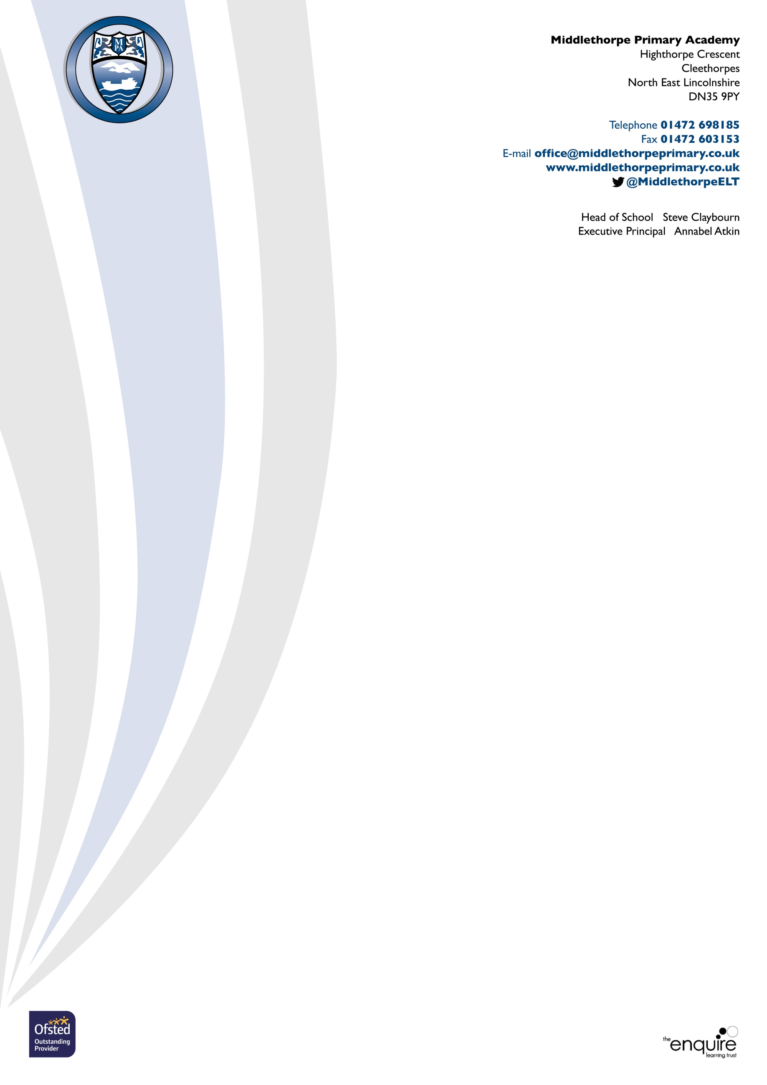

If you have any Child Protection concerns, these are the named Child Protection staff in our school, do not hesitate to speak to them immediately

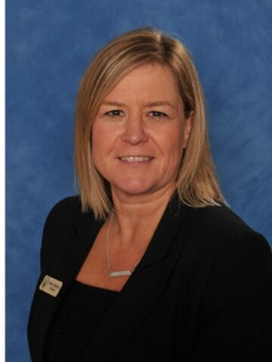


Mrs. A. Atkin Mr. S. Claybourn
Designated Safeguarding Lead Deputy Designated Safeguarding Lead
Executive Principal SENDCo/Head of School

