How do artists use line, colour and pattern?
Key Questions:
- Can I use a range of materials creatively?
- Can I use drawing or painting to develop and share my ideas?
- Can I develop a range of art and design techniques in using colour, pattern, texture, line, shape, form and space?
- Can I explore and talk about a range of artists and their work, describing their similarities and differences?
Words | Meaning
primary colours | 3 colours from which all other colours can be made by mixing  Red, Yellow and Blue
secondary colours | A colour made by the mixing of 2 primary colours
tertiary colours | A colour made by mixing the equal amount of a primary and a secondary colour
neutral colours | Pale grey, cream or beige
shade | Mixing a colour with black, increasing darkness
tint | Mixing a colour with white, reducing darkness
complement | Opposite colours on a colour wheel
contrast | Arranging opposite elements for example light and dark or rough and smooth
vertical | Up and down
horizontal | Across from left to right or right to left
parallel | Lines which run side by side and have the same distance between them at all times
abstract | Does not attempt to accurately represent something but instead uses shapes, colours and marks to achieve the effect.
pioneer | A person who is among the first to explore, develop, apply or use in a certain way.
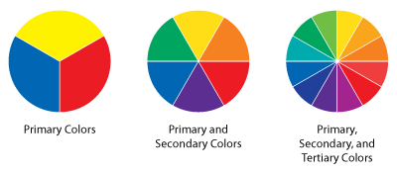
Primary Colours
Primary and Secondary Colours
Primary, Secondary and Tertiary Colours

