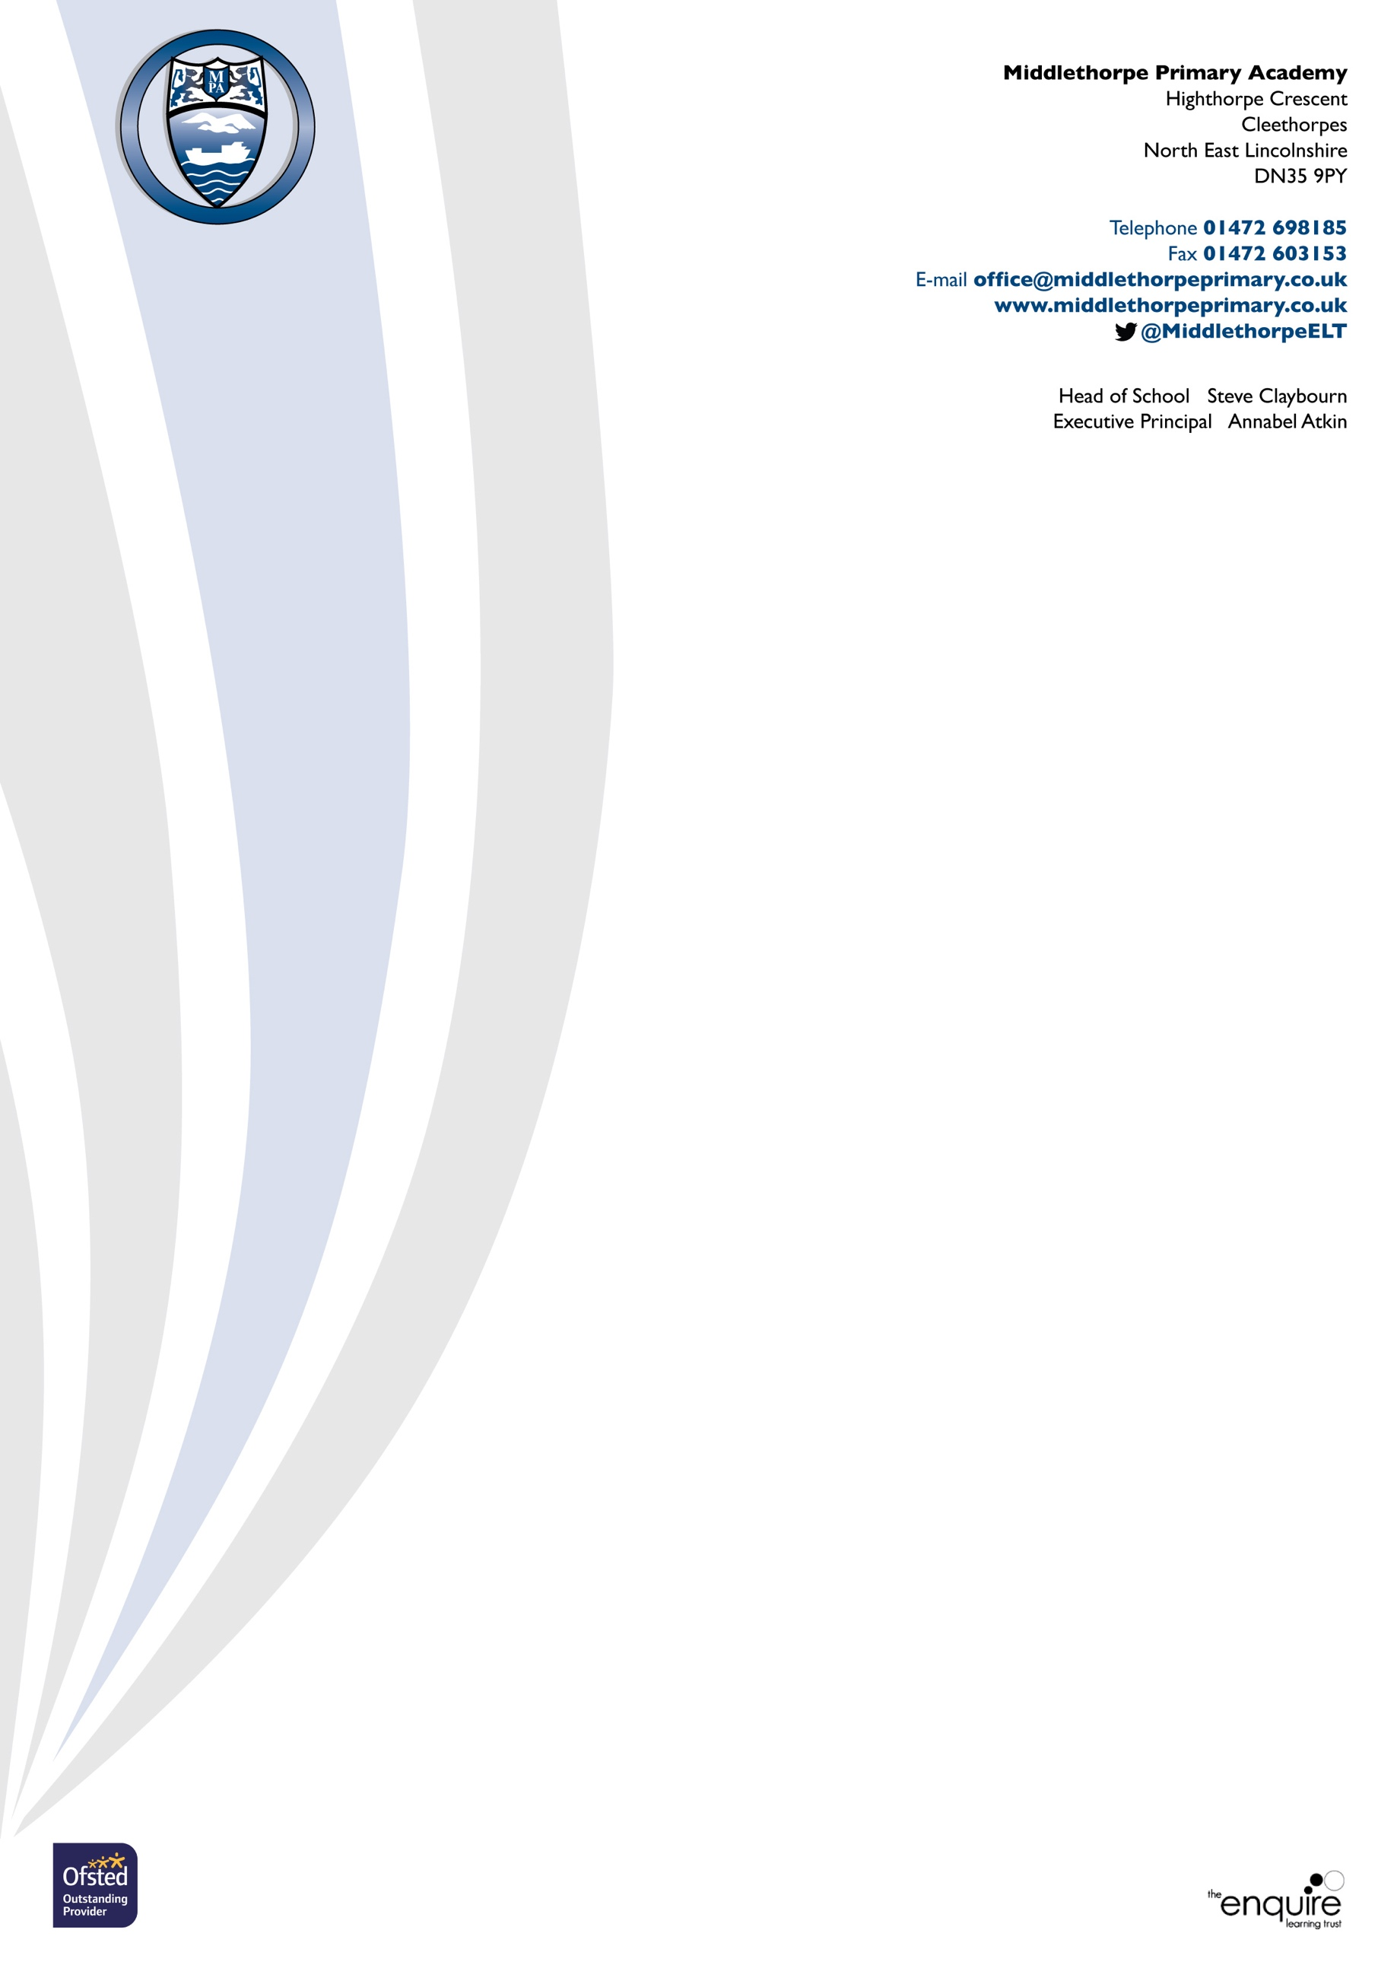

**If you have any Child Protection concerns, these are the named Child Protection staff in our school, do not hesitate to speak to them immediately**

**Mrs. A. Atkin Mr. S. Claybourn**

**Designated Safeguarding Lead Deputy Designated Safeguarding Lead**

**Executive Principal SENDCo/Head of School**