​
Summer Term 1: Bluebell Class Year 1 1

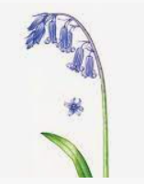
We hope you have all had a lovely break and are ready to learn lots of new things this term. We will continue on with our knowledge based curriculum, with content which has been chosen and carefully sequenced to build on prior learning. This half term’s focus is Geography. To support children in their learning, we have developed knowledge organisers for Geography and Science. Knowledge organisers aim to help children retain and recall the essential knowledge that they are taught. Each knowledge organiser includes key dates, people, vocabulary, definitions, events and contextual or technical information that we want the children to know by heart by the end of the topic. Knowledge organisers for each class can be found on the website but will also be sent home with the children for you to support them in their learning. We expect the majority of children to be able to recall all of the information on the Knowledge Organiser by the end of a half term.

SUMMER TERM SUBJECT FOCUS
We will be focusing on Geography.
Our enquiry question will be… Where in the world do animals live?
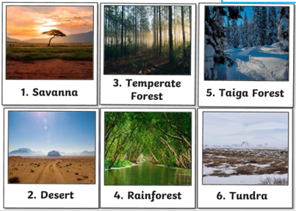

In each subject we will be learning:
Science: Animals including humans
PE: Locomotion
PSHE: Relationships
RE: Christianity: What did Jesus teach?
Music: Singing with Mrs Gooch
Computing: Book design and illustration

English and Maths
English: Our next unit of writing is non-fiction and will be a report about penguins.
Maths: Addition and subtraction within 20 and Place value within 50 and measurement.
Important Information
Our PE day is Tuesday
Reading books: Children will read with an adult in a small group, focusing on decoding and fluency, prosody and comprehension. This will take place over 3 days. Children will then bring the reading book home to practise their skills with you.

Follow us on Twitter:

Follow us on Class Dojo Bluebell Class

