All Year Groups follow the teaching sequences from Power of Reading. This process is used to raise the engagement and attainment in reading.
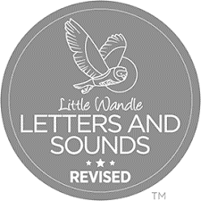
Phonics teaching and learning starts immediately upon each child’s entry into school. We follow the Little Wandle Letters and Sounds programme.
In FS early reading is linked directly to phonic teaching and home reading books are matched to the phonics sounds taught.
In our reading meeting parents are made aware of the importance of both reading phonetically and reading for pleasure.
Each phonic lesson encourages the children to review previously learnt phonemes and graphemes, teaches them new or alternative ways to say a sound, followed by engaging activities which support the practice and application of phonics for both reading and writing.
At every stage we emphasise the importance of decoding words by orally segmenting the sounds we see, this prepares the children for the Phonic Screening Test (the reading of 20 real words and 20 non-real words.)
Year 1 children receive regular phonic assessments, based on these further teaching or consolidation will occur in order to support the children to develop their understanding and ability to decode familiar and unfamiliar words using their phonics.
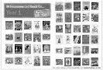
We have a selection of class books in every year group that we read and reread in order to build fluency skills.
We use Reading Plus in school which monitors children reading fluency and adjusts the tasks according to the individual children’s ability. All children complete at least 90 mins on Reading Plus each week.

Whole School Reading Mileage KS1- Children will engage with a whole class reading for enjoyment session daily- adults will read aloud a story to their class purely focusing on appropriate reading pace and enjoyment. Whole class Guided reading sessions (Little Wandle reading squad) take place each day. These guided sessions are closely linked to the child’s phonic stage in FS and Yr1.
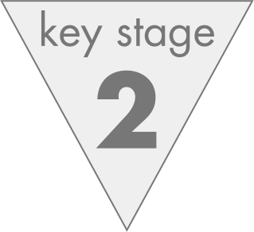
Whole School Reading Mileage KS2- Children will engage with a whole class reading for enjoyment session daily- adults will either aloud a story to their class purely focusing on appropriate reading pace and enjoyment or as children progress through KS2 this will incorporate independent reading for pleasure. Whole class Guided sessions follow the structure of reading for fluency on day 1 followed by reading for comprehension linked to VIPERS on day 2. The process will be repeated on days 3 and 4. The whole class session on Friday will explicitly teach age appropriate spelling patterns using morphology and to revisit vocabulary they have come across during guided reading sessions.

Reading activities will also be incorporated in the English lessons as part of the Power of Reading teaching sequences. These will be evidenced in English books.

