Background:
At Middlethorpe we have chosen to focus on closing the vocabulary gap of our students. We know that too many children fail to access the reading that is integral to the academic curriculum in school. Our goal as a school is to close the gap between the children’s personal word-hoard and the academic vocabulary of school and the curriculum. We are aware that in order for a child to be able to access and comprehend an age-appropriate text, then they need to be familiar and understand 95% of the words within that text. A good deal of the reading in our classrooms will include vocabulary that is unfamiliar and difficult. Every teacher needs to be acutely aware of the challenge of academic reading and the teaching tools to make it accessible.
Key findings:
- Being in a word-poor context at a young age can have a far-reaching negative consequences for our children. A restricted vocabulary as a young child goes on to correlate with factors in later life such as employment, pay, and even health and well-being as an adult.
- We need to make the hidden process of vocabulary development visible.
- The explicit teaching of vocabulary can enrich children’s knowledge and understanding of the world and vocabulary is a useful proxy for a great deal of general knowledge in a range of subject domains.
- By explicitly teaching a mere 300-400 words a year we can foster an annual growth of around 3000-4000 words. From reception to leaving school, we can therefore help children to develop an essential word-hoard of something like 50,000 words.
- The challenges of the new academic curriculum in England are related to an increase in reading comprehension demand. Complex academic vocabulary is one of the biggest drivers when it comes to an increased degree of difficulty in schools.
- Supporting children to read more is vital to helping them grow their vocabulary, but we need to ensure that we better teach reading and not solely rely on ‘reading for pleasure’. We should encourage children to read broadly for pleasure, whilst immersing children in word-rich classrooms that have a focus on vocabulary development.
- Research suggests that children with reading difficulties who are exposed to explicit vocabulary teaching benefitted three times as much as those children who were not.
Teaching of vocabulary
All knowledge organisers for History, Geography and Science units include a ‘Vocabulary’ section which will highlight words that are crucial to being able to access/understand that unit. These words will be accompanied by a child friendly definition (use of Collins Co-build dictionary is encouraged for this).
All knowledge organisers are shared termly with children and their families using Class Dojo.

Words and their meaning in context from the knowledge organise are to be planned for and taught as part of the delivery of History, Geography and Science units.
Each teacher establishes a ‘Weekly Top 10’ each week of ten words that will be encountered in class over the following week. Teachers ensure these words are in context with what is being covered as part of the curriculum.

Weekly Top 10 words can be derived from a mixture of the Theme knowledge organiser, the Science knowledge organiser and a number of words from up-and-coming chapters from the class Power of Reading text or class read (E.g. two words from History KO, two from the Science KO for that half-term and six words from the next chapter of the POR text).

Teachers teach explicitly the vocabulary and their meaning in context from the ‘Weekly Top 10’ list.

Teachers ensure that the ‘Weekly Top 10’ are on display in the classroom from Monday of each week.

Teachers ensure the words from the ‘Weekly Top 10’ are revisited regularly throughout the week to add word depth.

Teachers explicitly teach words from the ‘Weekly Top 10’ using a selection of the ‘Power-Up Strategies’

Teachers use a selection of the ‘Power-Up Strategies’ before, during and after reading Vocabulary work around the Weekly Top 10 is to be recorded in a book or folder so the children can refer back to those words when writing.
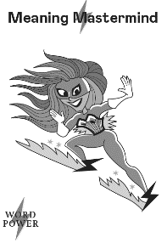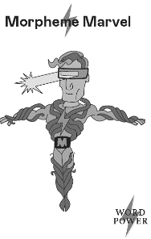

Teachers explore synonyms and antonyms of the words from the Weekly Top 10 to extend word exposure beyond those ten words to result in a larger word haul. See example below…
