All Year Groups follow the teaching sequences from Power of Reading. This process is used to raise the engagement and attainment in reading and writing.
Writing
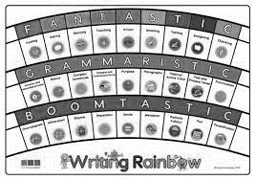
Each POR teaching sequence has writing opportunities included and the opportunity to practice grammar and punctuation linked to the learning objectives for each year group.
All staff are trained to teach ‘The write Stuff’ approach to writing and this is incorporated in to writing lessons across the school.
In KS1 and 2 the writing for purpose guidance is used to structure teaching of writing. In KS1 children are taught to write to entertain- stories, descriptions, poetry and in character and also to inform- recounts, letter and instructions. In LKS2 to entertain- stories, descriptions, poetry and character/settings, to inform- explanation, recount, letter, biography and newspaper article and to persuade- advertising, letter, speech and poster. In UKS2 to entertain- narrative, descriptions, poetry and characters/settings, to inform- report, recount, biography and newspaper article, to persuade- advertising, letter, speech and campaign and to discuss- balanced argument, newspaper article and review.
For the longer writing opportunities (at least 2 per unit) children will have the opportunity to draft and redraft. At this time the teacher will model the writing, children will write using the rubric for their writing. This draft will be marked in detail by the teacher and specific feedback will be given. At this point the teacher may decide to put in lessons to teach specific features in groups or whole class. The child will then redraft the writing working on the targets given and using the rubric. The final draft will be marked against the assessment sheets at the front of the children’s book. Children use yellow highlighter for the first draft and green for the second.
There should be at least 4 pieces of evidence in books per week and all pieces should be marked.
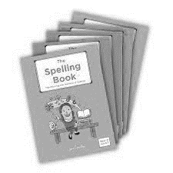
Spelling
In Y2 to Y6 we use a clear systematic approach to teaching spellings that provides children with life-long strategies.
‘The Spelling Book’ by Jane Considine is based on three zones of spelling. Spelling patterns are explored through the ‘Groupings’, and the remembering and recall of spelling is through the ‘Acquirings’

Year group spelling lists are also at the back of English books.
Handwriting
Each of the key stage requirements for handwriting are met by teaching using ‘Letter Join’.
In Early Years the children begin by following pre-cursive patterns which naturally leads on to the introduction of real letters.

In KS1 children master correct letter formation including capital letters and numbers then move on to writing cursive letters and how to join them in Year 2

In KS2 children build on skills learnt in KS1, improving legibility, consistency and quality of handwriting

Letter Join can also be accessed at home via iPads.

