Week 1 | Week 2 | Week 3 | Week 4 | Week 5 | Week 6
c Sound | k sound | ck sound | e sound | u sound | r sound
cap | kiss | tick | egg | mum | rip
cot | kid | duck | set | run | rat
cat | kit | sock | pen | rug | ram
cup | kip | pick | get | mug | rot
can | kin | sack | pet | cup | rag
cog | yak | back | ten | fun | rug
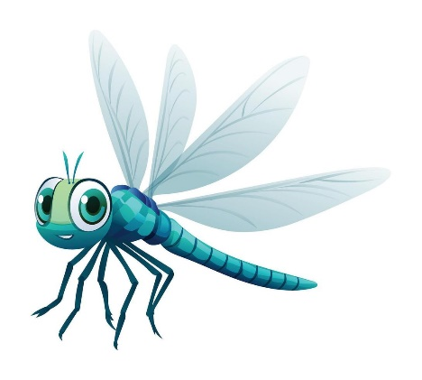
Dragonfly Spellings – Term 3

