Week 1 | Week 2 | Week 3 | Week 4 | Week 5
h Sound | b sound | f sound | ff sound | l sound
had | but | if | off | leg
him | big | fit | huff | lit
hot | bet | fun | cuff | lid
hut | back | fin | riff | log
hop | bad | fig | puff | lock
hum | tub | fog | muffin | lap
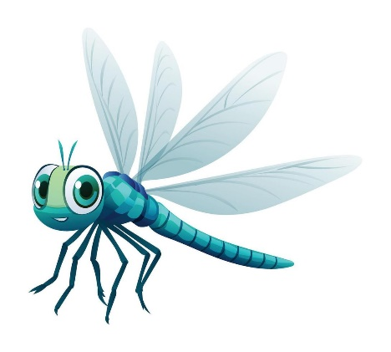
Dragonfly Spellings – Term 4

