Mathematics Vocabulary list for Year 2
Maths has its own language. Sometimes that language is written words and sometimes it is symbols but it is a language and it must be learned for fluency and competency. If your child doesn’t have a good understanding of the vocabulary, it can hinder their performance in Maths. At Millbrook, we teach this vocabulary and give it context which allows the children to apply it to a variety of problems. Listed below is the vocabulary your child will learn this year.
Number and place value
Calculate | To work out mathematically. | Can you calculate the answer to 13+4?
Column | A vertical arrangement of numbers or objects. | Tens Ones  1 4  There are 4 ones in the one’s column.
Continue | To carry something on. | Can you continue counting to 20.  10,11,12,13,14,15,……………..
Efficient | Well organised using the best strategy and utilise known facts. | I can use my number bonds knowledge to do 23+7 as I know 7+3=10 therefore the answer is 30. That is the most efficient method for me.
- Greater than | The > symbol means greater than. | Eight is greater than 2  8 > 2
Hundreds | The number equivalent to the product of 10x10. The first three-digit number. | 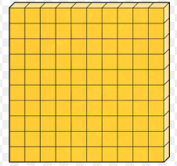
< Less than | The symbol < means that one number is smaller than the other number. | 5 is less than 8  5 < 8
Operation | A mathematical process. There are four types. Addition, Subtraction, multiplication and division. | 10+10=20  The operation above is addition.
Place value | A system for writing numbers in which the value of a digit is defined by its position within the number. | The number 43. The place value of the 4 is forty and the place value of the 3 is 3 ones.
Predict | A prediction is a reasonable guess as to what will happen. | I predict the next number will be higher.  1,3,4,8,
Representation | A very general relationship between objects or structures. | Make the number 7 using objects, counters and dienes.
Rule | A procedure that a count must follow. | The rule is to add 2.  2,4,6,8,10
Sequence | A list of numbers or objects in an order. | The sequence starts with 2 and goes up in 2s.  2,4,6,8,10

Addition and Subtraction
Carrying | When you carry from ones to tens. | 32  + 29  6 1  1
Exchanging | When you change a ten into ten ones. | 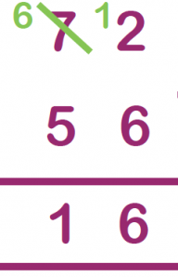
Facts | A group of equations using the same set of numbers. | 22+12=34  12+22=34  34-22=12  34-12=22
Inverse operations | Opposite operations that undo each other. | Addition and subtraction are inverse operations.

Multiplication and division
Division fact | Division number sentences related to tables knowledge. | 20 divided by 5 equals 4 is a division fact.
Equal groups of | A group of the same number of items as the other groups. | 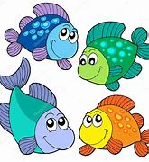  This shows two equal groups of 4
Left over | When dividing in Maths the groups can be the same amounts however there can be some left over. A remainder. | 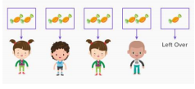
Multiplication fact | The answer to 2 times 5 is 10. Is a multiplication fact. | 2x5=10
Multiplication table | A list that shows the results of multiplying two numbers by each other. | 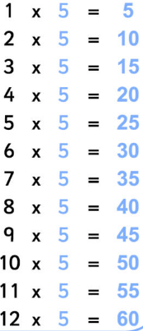
Times | The same as multiply and the inverse to division. | Three times five equals 15.

Fractions
Denominator | The bottom number on a fraction. | 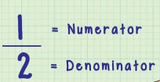
Equivalent | The fractions are the same. | 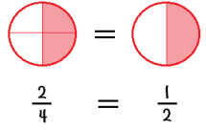
Mixed Number | A number consisting of an integer and a proper fraction. | 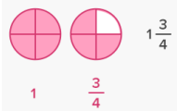
Numerator | The top number on a fraction
One of three equal parts | When a shape or object is split into 3 equal parts each part is called a third. | 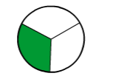
One third or two thirds | When a shape or object is split into 3 equal parts. One part is one third and two parts are two thirds. | 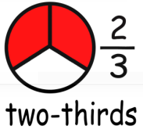
Two halves | Two equal parts of a whole. | 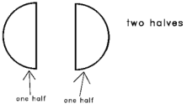
Three quarters | When a shape is split into four equal parts and you have 3 of those parts. It is called three quarters.

Length
Centimetre (cm) | A measure of length there are 100 of them in a metre. | I used my ruler to measure how many cms my pencil was.
Furthest | At or by the greastest distance. | The girl ran 100 meters and the boy ran 80 metres. So the girl ran the furthest.
Tape measure | A measuring tool. | The boy measured his leg with a tape measure.
Weight
Gram | A metric unit of mass equal. One thousand grams are equal to 1 kilogram. | An apple weighs approximately 100 grams.
Capacity and volume
Milliliters | A measurement of liquid. | A small beaker holds approximately 60 milliliters of water.

Temperature
Degree | A measurement of temperature. | The temperature was 14 degrees today.
Temperature | Measurement of how hot or cold something is. | The boiling water had a temperature of 100 degrees Celsius.

Time
Minutes past | The amount of time past the hour. | 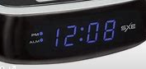  It is 8 minutes past 12.
Digital clock | A clock that displays the time in numerical order rather than using hands on a clock. | 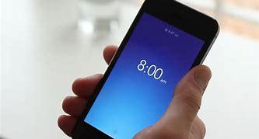
Fortnight | A period of 2 weeks. | There are 14 days in a fortnight.
Seconds | A unit of time. | There are 60 seconds in a minute.

2D and 3D shape
Hexagon | A 6-sided shape.
Line of Symmetry | A shape is symmetrical when it fits exactly onto itself when folded in half. | 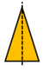
Octagon | An 8-sided shape
Pentagon | A 5-sided shape
Vertices | Where two lines meet. One is called a vertex. | A pentagon has 5 vertices.  Vertex

Position and direction
Right angle | An angle of 90 degrees. A square has 4 right angles. | 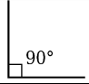
Straight line | A line that does not curve.

Statistics
Frequency | The number of times something occurs. | A blue car drove passed 4 times therefore the frequency of blue cars is 4.
Label | The horizontal label across the bottom and the vertical label down the side tell us the facts on a graph. | colour  Number of  The graph shows the number of colours of cars.
Least common | The smallest amount. | No one chose the colour yellow as their favourite it was the least common.
Least popular | The smallest amount | No one chose the colour yellow as their favourite it was the least popluar.
Most common | The biggest amount. | The highest choice of colour was blue it was the most common.
Most popular | The biggest amount. | The highest choice of colour was blue it was the most popular.
Pictogram | A representation of data using pictures or symbols. | 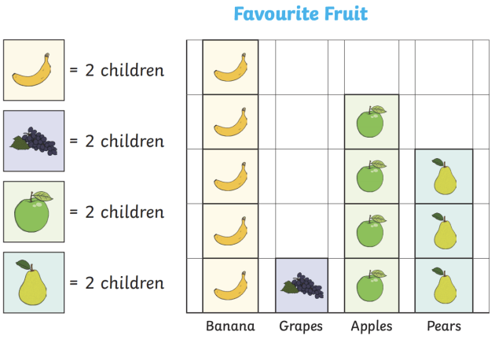
Represent | To present something in a certain way. | We are going to represent your data in a pictogram.
Tally | A form of counting using lines. | 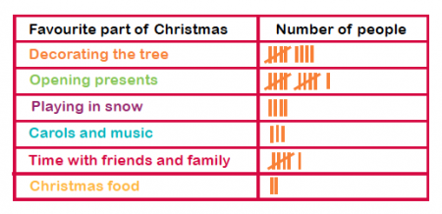
Title | At the top of the graph telling you what it is about. | 