Mathematics Vocabulary list for EYFS
Maths has its own language. Sometimes that language is written words and sometimes it is symbols but it is a language and it must be learned for fluency and competency. If your child doesn’t have a good understanding of the vocabulary, it can hinder their performance in Maths. At Millbrook, we teach this vocabulary and give it context which allows the children to apply it to a variety of problems. Listed below is the vocabulary your child will learn this year.

Number and Place Value
Vocabulary | Definition | Example
Before | In front of or prior to | The number 3 comes before the number 4 on a number line.
Between | A preposition that indicates an objects location in reference to two other objects. One object is to the left and one is to the right. | 4 is between 3 and 5 on a number line.  1,2,3,4,5,6,7,8,9,10
Compare | Look for similarities and differences between at least two objects. | Let me compare these cars. Some are red and some are blue. There are more red cars than blue.  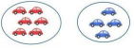
Count | Assigning one number name to each of a set of objects to work out how many there are. | I counted the children in the class.
Digit | A digit is a single symbol used to make numerals. | Numerals  126  Digit Digit Digit
Estimate | To find a value that is close to the right answer usually using prior knowledge. | Can you estimate how many sweets are in the jar?  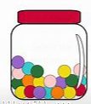

Fewer | A lesser amount. Used when counting objects, Such as toys, books, pencils. | 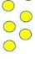  There are fewer red counters than yellow counters.
First | Before anything or anyone else. | 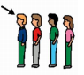  Jack is first in the line.
First, Second, Third | The order in which things happen. | 1st, 2nd, 3rd, 4th, 5th
Greater | When a quantity or number is larger than another quantity or number. | 8 is greater than 4.
How many? | What number. | How many counters are there?
Same as | Is equal to | 5 is the same as 3+2
Largest, greatest and biggest | The most in a set | The largest number is 8 in the set 2,5,3,8,4
Last | Comes after all the others. | 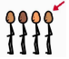  Fred is the last person in the line.
Less than | A smaller amount or not as much. | Sophie has 10p and Jasmine has 5p. Jasmine has less than Sophie.
Next | Comes immediately after. | The next number after 3 is 4.

Number | A count or measurement. | 1,2,3,4,5,6,7,8,9,10
Ones and tens | Two-digit numbers are split into tens and ones. | 12  Tens Ones
Order | Describes the placement of items | 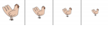  I have ordered the chickens from biggest to smallest.
Pair | A set of two things used together. | 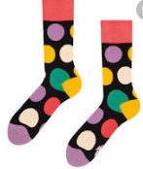  A pair of socks.
Pattern | A systematic arrangement according to a rule.
Zero | The number before 1. | O,1,2,3,4,5,

Addition and Subtraction
Add/plus | The process of addition. | I can add two numbers together to find the total. 2+3=5
Addition | The operation to combine two numbers or quantities to form another number or quantity. It is the inverse to subtraction. | Eight plus two is equal to 10.  8+2=10
Altogether | In total. | There are 3 red cars and 2 blue cars there are 5 cars altogether.
Double | Too add a value to itself or multiply by 2. | Double 5 is 10.  5+5=10
Less | A smaller amount or not as much. | 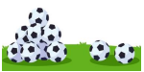  There are less footballs on the right.
More | A greater amount. | There are more footballs on the left.
Sum and equal | The result of an addition sentence. | The sum of 4 and 6 is 10.
Takeaway | To remove a number of items from a set. Used in subtraction. | Stan had 6 juice cartons and Yusuf took one away how many did he have left?  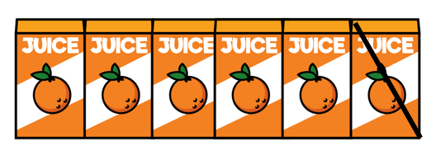  6-1=5
Total | The sum found by adding. | There are a total of 10 children on the carpet.

Multiplication and Division
Doubling | To Multiply by 2 or add the value to itself. | Ten is double 5.  5+5=10
Halving | One of two equal parts of a shape, quantity or object. | Half of 4 is 2.  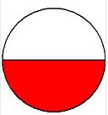
Number patterns | A systematic arrangement of numbers. | 2,4,6,8,10 is a number pattern is it goes up in twos.
Sharing | To distribute fairly between a number of people. This is one model for division. | 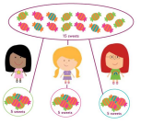  The sweets are shared fairly between 3 people.

Fractions
Half | Split into two equal parts. | 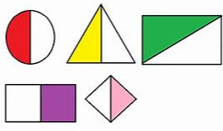
Parts of a whole | A ratio or a fraction that represents a relationship between a part and its whole. | A pizza has been cut down the middle. Therefore, the whole pizza has been split into two parts.

Measurement
Compare | Look at similarities and differences. | I can compare these two pencils, B is longer than A.  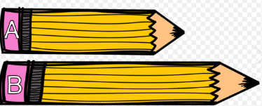
Guess | To estimate | My guess is this pencil is 12cm long.
Measure | To find the size of something in a given unit. | 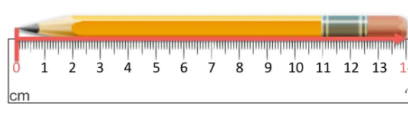  How can we measure a pencil?
Size | An element over dimensions. | The size of the child’s shoe smaller than the size of the teacher’s shoe.

Length
Height | The vertical distance from the top to the base of the object. | 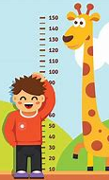
Length | A linear measurement. | 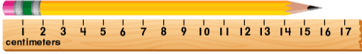
Long | An adjective used to describe length. | I have a long piece of string.
Short  Shortest  Shorter  Shorter than | An adjective used to describe length. | The boy is short compared to the giraffe.
Tall  Taller  Tallest | Measuring a specific distance from top to bottom. | 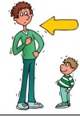  The teacher is tall compared to the child.

Weight
Balanced or same | A measuring tool used to weigh objects. It has two dishes hanging on a bar. Both dishes will be level. | The objects balancing are level therefore they are equal.
Heavy  Heaviest  Heavier than | Having a weight that is greater than that of another object. | The box is heavy.  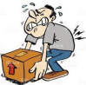
Light  Lightest  Lighter than | Having a weight that is less than that of another object. | The feather is light.
Scales | An instrument for weighing. | 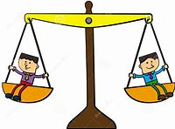
Weigh | To find out how heavy something is. | 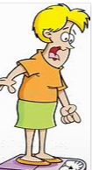
Weight | The force exerted on an object by gravity. | The weight of the book is heavier than the pencil.

Capacity and volume
Container | An object for holding or transporting something. | 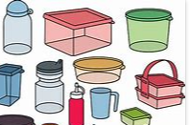
Empty | Containing nothing | 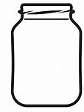  The jar is Empty.
Full | Holding as much as possible. | 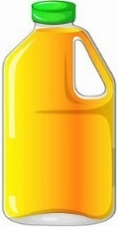  The cartoon is full.

Time
Afternoon | The time from lunchtime till the evening. | We are doing to the park this afternoon.
Days of the week | Monday, Tuesday, Wednesday, Thursday, Friday
Early | Near the beginning of a time or period. | You have arrived early to school today.
Evening | The period of time at the end of the day. | You eat dinner in the evening.
First | Comes before all others in time order. | The first thing you do in the morning is get out of bed.
Hour | A period of time the same as 60 minutes. | Lunchtime at school lasts 1 hour.
Last | Comes after all others in time or order. | The last thing you do before bed is brush your teeth.
Late | Doing something or turning up after the expected or usual time. | The pupil was late for the register.
Morning | The period of time between midnight and noon. | You woke up in the morning.
Night | The period of time from sunset to sunrise every day. | You can normally see the moon and stars at night.
O’clock | A time that is on the hour. | 1 o’clock
Soon | In or after a short time. | We are doing PE soon.
Time | A measurement using Hours, minutes, seconds or Days, weeks, months years. | The time is half past 12.
Today | The present day. | You are working hard today.
Tomorrow | The next day. | Tomorrow the weather will be nice.
Week | A period of seven days. | Monday, Tuesday, Wednesday, Thursday, Friday, Saturday and Sunday.
Yesterday | The previous day. | What did you eat yesterday?

Money
Buy | Get something in exchange for payment. | Purchase something from the shop.
Coin | A piece of metal with an official stamp used as money. | 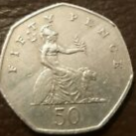
Money | An object that is accepted as payment for good or services. | 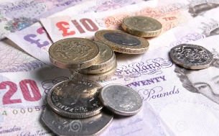
Pay | Give someone money for a service or goods. | How much do I need to pay for that?
Pence | A small sum of money. | 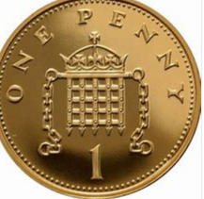
Pound | Equal to 100 pence | 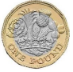
Price | The amount an item cost. | The price of the car is 14p 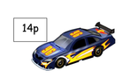
Sell | Give something to someone in exchange for money. | The shop sells books.
Spend | Give money to buy goods or services | How much do you have to spend on the trip?

Shape
Bigger | Of considerable size | This square is bigger.
Curved | A line that isn’t straight.
Flat | A level surface. | A table has a flat surface.
Empty | Having an space with nothing inside. | 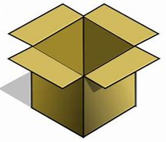  The box is hollow.
Pattern | A systematic arrangement of numbers, shapes or objects. | The pattern is circle square circle triangle.
Repeating pattern | A design composed of a number of elements arranged in a formal manner. | Red, Blue, Green, Red Blue Green.
Round | A circular object. | A circle is round.
Shape | A geometric figure. | Triangle, Square, rectangle
Size | An objects overall dimensions. | A tennis ball is smaller than a football.
Smaller | A size that is less than another size. | An Ant is smaller than a Giraffe.
Solid | Firm and stable in shape. | A cube is a solid.
Sort | Arrange systematically in groups .
Straight | A line without bends or curves.
Symmetrical | Made up of exactly similar parts facing each other or around an axis

2D Shapes
Corner | A point where two or more lines meet. The Mathematical term is a vertex (vertices). | A table has 4 corners (vertices)
Circle | Name of a 2d shape. A circle has a curved side.
Pentagon | A 5-sided shape
Quadrilateral | A 4 sided shape.
Rectangle | A quadrilateral with four right angles.
Side | A straight line that forms part of the boundary of the shape. | A rectangle has 4 straight sides.
Square | A quadrilateral with 4 equal sides.
Triangle | A polygon with 3 sides.
3d shapes
Cone | A 3d shape with one circular face which tapers to an apex. | 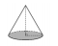
Cube | A 3d shape with six identical square faces. | 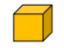
Cuboid | A 3d shape with six rectangular faces.
Cylinder | A 3d shape with two circular faces joined by a curved surface.
Edge | A line segment joining two vertices. | A cube has 12 edges. 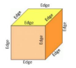
Face | A surface of a 3d shape. | A cube has 6 faces. 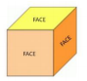
Pyramid | A 3d shape with a polygonal base and triangular faces which form edges with the base and meet at an apex. | 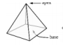
Sphere | A 3d shape with a continuous surface where the surface is all equidistant from its centre. | A football is a sphere.  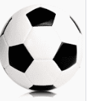
Vertex, Vertices | The point in which two or more lines intersect. | 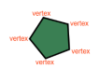  This shape has 5 vertices.

Position and direction
Above | 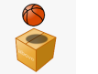  The ball is above the box
Across | 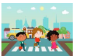  The children walk across the road.
Apart | 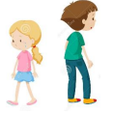  Move apart from each other.
Around | 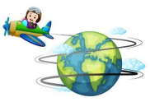  The plane flew around the world.
Away from | 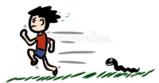  The boy ran away from the snake.
Back | 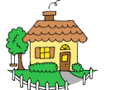  Please go round the back of the house.
Backwards | 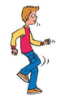  He is walking backwards.
Behind | 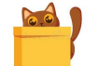  The cat is behind the box.
Below | 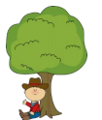  The boy is sat below the tree.
Bend | 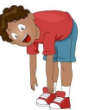  How far can you bend to touch your toes?
Between | 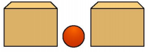  The red ball is between the boxes.
Bottom | 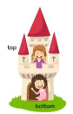  The girl with dark brown hair waved from the bottom of the castle.
Close | 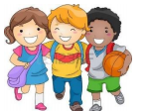  The children walked close together.
Corner | 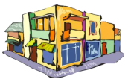  Around the corner is the food shop.
Down | 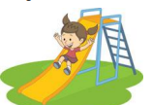  The girl slid down the slide.
Far | 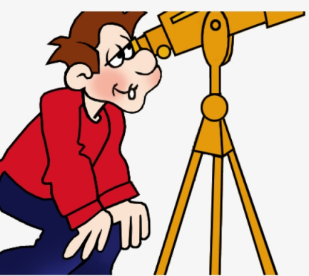  The stars are far away.
Forwards | 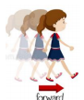  The girl walked forwards.
From | 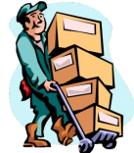  The man took his boxes from the van to the school.
Front | 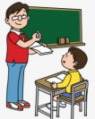  The teacher was at the front of the class.
Half Turn | 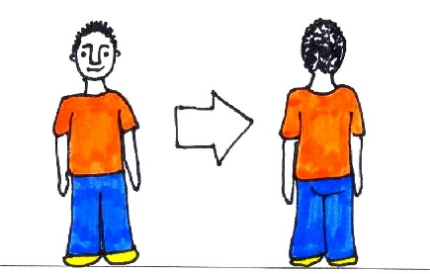  The boy turned half a turn.
In | 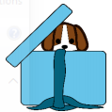  The dog hid in the box.
Inside | 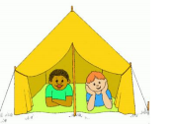  The boys led inside the tent.
Left
Middle | 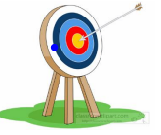  The arrow hit the middle of the target.
Near | 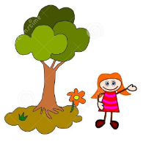  The girl was near the tree.
Next to | 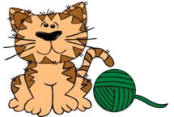  The cat is next to the string.
On | 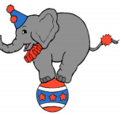  The Elephant was on the ball.
Opposite | 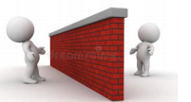  The cartoons were on opposite sides of the wall.
Outside | 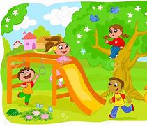  The children played outside.
Over | 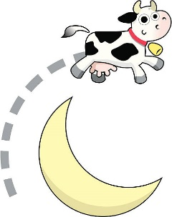  The cow jumped over the moon.
Position | Location of an objects or person.
Right
Roll | 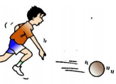  Roll the ball on the floor.
Slide | 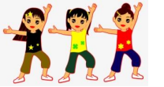  The girls slide to the right.
Stretch | 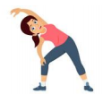  Before exercise you must stretch.
Through | 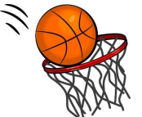  Throw the basketball through the hoop.
Top | 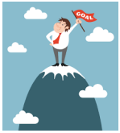  The man climbed to the top of the mountain.
Towards | 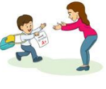  The boy ran towards his Mum at the end of the day.
Turn | 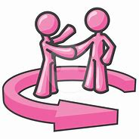  The cartoons turn around.
Under | 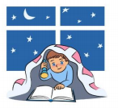  The boy hid under his blanket.
Up | 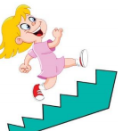  The girl ran up the stairs.

Statistics
Count | Assigning a number name to each of a set of objects to determine how many there are. | 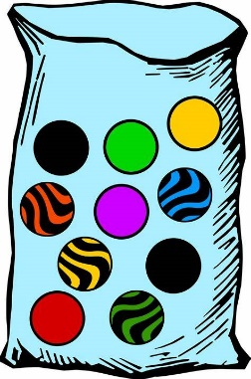  I counted the marbles and I have 10.
Group | To make an amount of an object. | Group the marbles. 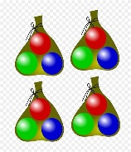
Set | A defined group of objects. | I have placed all the purple counters in a set because they are all the same colour.
Sort | To organise objects into a specific category. | I will sort these shapes based on how many sides they have.

