Mathematics Vocabulary list for Year 1
Maths has its own language. Sometimes that language is written words and sometimes it is symbols but it is a language and it must be learned for fluency and competency. If your child doesn’t have a good understanding of the vocabulary, it can hinder their performance in Maths. At Millbrook, we teach this vocabulary and give it context which allows the children to apply it to a variety of problems. Listed below is the vocabulary your child will learn this year.

Number and Place Value
Vocabulary | Definition | Example
Above | Something that is over another number. | 6 is above 2 when we count
Backwards | Back towards the starting point. | 5,4,3,2,1, is counting backwards.
Below | Something that is lower than something else. | 2 is below 5 when we count.
Equal to | Being the same in quantity. | 2+1 is equal to 3  4 is equal to 4
Equivalent to | Equal in value. | 3+3 is equivalent to 2x3
Forwards | To advance something. | 2,4,6,8 We are jumping forwards in 2s.
Half way between | In the middle. | Half way between 1 and 3 is 2.
Least | Smallest amount. | A B C  C has the least.
Many | A number representing some quantity. | How many have you got in total?
Most | Largest amount. | A B C  A has the most.
Multiple of | A number that may be divided by another a certain number of times without a remainder | 6 is a multiple of 2.  2,4,6.
Numeral | A symbol that stands for a number. | 86 is a numberal and is made up of 8 tens and 6 ones.
Rule | A consistent pattern which allows generalisation. | The rule is that each number is two greater than the previous number.  1,3,5,7 Therefore the next number is 9.

Addition and Subtraction
Difference | The numerical difference between two numbers or sets of objects. It is found by comparing the quantity of one set of objects with another. | There are 6 red cars and 4 blue cars therefore there is a difference of 2.  6-4=2
Equals | The same as in number or amount. | 2 add 2 equals 4  2+2=4
Half | A number split into two equal parts. | Half of 6 is 3.
Missing number | A part of an equation that is missing. | Find the missing number.  5 + = 10
Near | Close to | 6 is close to 7.
Number bonds | A pair of numbers with a given total. | These are the number bonds to 10.  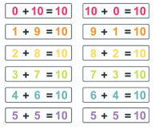
Repeated addition | A structure of division where the equal parts are subtracted. | I can use repeated subtraction to divide 15 by 5.  15-5-5-5.
Subtract | To take a number away. | 10 subtract 6 is equal to 4.  10-6=4
Subtraction | The inverse operation to addition where you take a number away. | We are doing subtraction therefore we are going to takeaway. 10-8=2

Multiplication and division
Array | An arrangement of counters in columns and rows to represent a multiplication or division sum. | 2x4= 8  4x2=8  8 divided by 4 equals 2
Divide | To share or group into equal parts. | I can divide 10 by 2. Using sharing or grouping.
Division | Distributing a group of things into equal parts. | Answer the division question.  12 divided by 2.
Grouping | Dividing things into equal groups or sets. This is one method of division. | Divide these triangles between 4 people by grouping.
Multiplication | The result of combining groups of equal sizes. | 5 x2 = 10  5+5=10
Multiple | The product result of one number multiplied by another number. | 10 is a multiple of 5 and 2. 5 x 2=10
Multiply | Add equal groups. | Multiply 5 by 2.  5x2 or 5 add 5.
Product | The result of one or more multiplication. | The product of 2 x 5 is 10.
Sharing | To distribute equally between a number of recipients. This is another model for division. | Share 10 triangles between 2 circles.

Fractions
Equal Grouping | Groups that have the same number of equivalent items. | Each bucket has the same number of equal groups.
Equal part | Having the same portion, division, piece or segment of a whole. | Whole Two equal parts
Equal sharing | Dividing the whole or a group of objects into equal parts. | 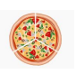  The pizza has been shared equally.
Fractions | How many parts of a whole.  Top number is the numerator and the bottom number is the denominator. | I have shared my sweets into equal parts. Everyone will get a fraction of the whole quantity of sweets.  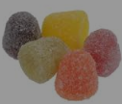
One of two equal parts. | When something is divided into two equal parts half is one of the two parts. | 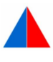  One of two equal parts.
Quarter | One of four equal parts of a whole, quantity or object. | I have shared 12 conkers into four equal groups. A quarter of 12 is 3.

Length
Metre | A standard unit of measure equal to 100 centimetres | I estimate that the table is about a metre tall.
Metre Stick | A measuring stick one metre long and marked with 100 centimetres. | Measure that table in metres.
Ruler | A tool or device used to measure length and draw straight lines. | 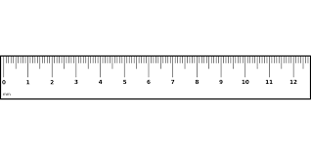
Weight
Kilogram | A standard unit of mass, equal to 1000 grams. | A bag of sugar weighs 2 kilograms.
Capacity and volume
Capacity | The maximum amount that something can contain. | 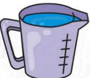  The capacity of the jug is 1 Litre.
Less than | One value or amount is lesser than the other. | The amount of water in a cup is less than the amount of water in a jug.
Litre | A standard unit of volume, equal to 1000 Millilitres | The Jug holds about 1 Litre.
More than | One value or amount is greater than the other. | The jug holds more water than the cup.
Volume | A quantity or amount of any substance and the 3D space it fills. | The volume of water in the jug is 1 litre however the jugs capacity is 2 litres. It is half full.  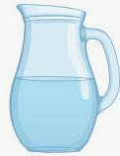

Time
Always | At all times. | Tuesday always comes after Monday.
Analogue clock | A clock with a face and hands. | 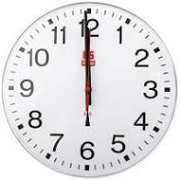
Date | The day of the month or year as specified by a number. | Monday 1st September  1/09/21
Earlier | Before the usual or expected time. | School starts at 08:45 and I arrived earlier than my class at 08:40.
Half past | 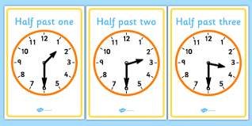
Hour hand | 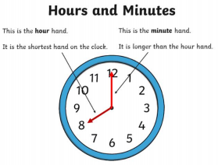
Later | A time or situation that is after the one that you have been talking about or the present. | Dinner time is later.
Midnight | 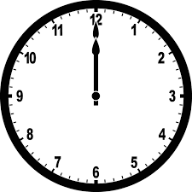
Minute hand
Minute | A unit of time. | 60 seconds is the same as 1 minute.
Months of the year | January, February, March, April, May, June, July, August, September, October, November and December.
Never | I never win races because I’m slow.
Often | It often rains in England in the winter.
Once | On one occasion or for one time only. | I ran a marathon once.
Quarter past | 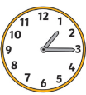
Quarter to | 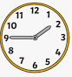
Seasons | Spring, Summer Autumn Winter
Sometimes | Something that doesn’t happen often. | Sometimes it snows in winter.
Twice | Happens on two occasions. | I jumped up and down twice.
Usually | Something that happens normally. | Usually lunchtime is 12 O’clock
Weekend | Saturday and Sunday | I do not go to School on the weekend.
Year | A period of 365 days usually sometimes 366 days on a leap year. | Next year I am going on holiday.

Money
Change | Receiving money back after a purchase. | If I buy a packet of sweets for 15p with a 20p coin how much change would I have?
Cheap | Low in price. | These sweets are cheap.
Costs less | Cheaper than another item | The teddy was 20p but the sweets were 10p therefore the sweets cost less.
Costs more | More expensive than something else. | The ipad costs more than the chair.
Costs the same as | Equal in price. | The white chocolate bar costs the same as the mint chocolate bar.
Total | The amount. | The teddy was 20p and the book was 20p so the total was 40p

Position and direction
Anti-Clockwise | Movement in the opposite direction to the motion of the hands of a clock. | 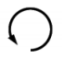
Centre | A centre is a point that is in the middle and the same distance from the edges. | 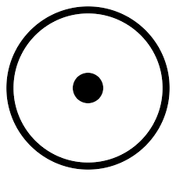
Clockwise | Movement in the direction of the hands of a clock. | 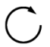
Quarter turn | A 90 degree rotation | 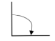
Three-quarter turn | A 270 degree rotation | 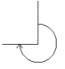

Statistics
Block Graph | A way of representing data using blocks coloured in. | 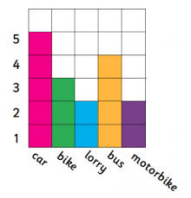
Chart | A table or a graph.
Data | Quantitative information which has been counted or measured. | The block graph shows us data for the type of transport people use.
Table | A structure organised into columns and rows in which data can be recorded. | The table shows how many children were ill In the week.  Mon Tues Weds Thurs Fri  2 3 2 5 0

