Mathematics Vocabulary list for Year 3 and 4
Maths has its own language. Sometimes that language is written words and sometimes it is symbols but it is a language and it must be learned for fluency and competency. If your child doesn’t have a good understanding of the vocabulary, it can hinder their performance in Maths. At Millbrook, we teach this vocabulary and give it context which allows the children to apply it to a variety of problems. Listed below is the vocabulary your child will learn this year.
Number and place value
Vocabulary | Definition | Example
Approximate | Anything that is similar but not exactly equal to something else. | The approximate answer to 199+100 is 300 because 199 is very close to 200.
Consecutive | Following each other continuously. | 1,2,3,4,5…  21,22,23,24,25,26…..  These are consecutive number examples.
Formal written method | A way of carrying out calculations which is done on paper rather than entirely mentally. | 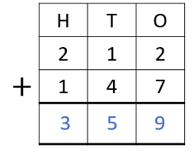
Integer | A whole number that can be positive or negative. | 5 is an integer. 0.05 is not an integer.
Negative number | A number that is less than 0. | -6 is a negative number.
Place holder | A place holder is the number 0 used in any place value column. | I need to add a place holder when I multiply by 10. So 2 x 10 becomes 20.
Positive number | A number that is greater than 0. | 3, 7, 9 are all positive numbers.
Relationship | The relationship between sets of numbers or elements. | The relationship between multiplication and division is that it’s the inverse.
Round | Approximate a number normally to the nearest ten. | I would round 6 up to 10 as its closer to 10 than 0. If it’s a 5 in the ones round up.

Addition and subtraction
Column addition and subtraction | The formal written method used for addition and subtraction.

Multiplication and division
Factor | A number that when multiplied with one or more other factors makes a given number. | The number 8 has the factors 1,2,4 and 8.
Short division | A formal written layout where the answer is calculated showing only one written step. | 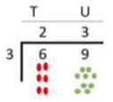
Short multiplication | A formal written layout where the multiplier is usually 9 or less. | 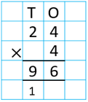
Product | The result you get when you multiply two numbers | 21 is the product of 3 and 7.
Remainder | When dividing in Maths the groups can be the same amounts however there can be some left over.

Fractions
Decimal equivalent | Two decimal numbers that are equivalent, that is, they represent the same value or amount. | 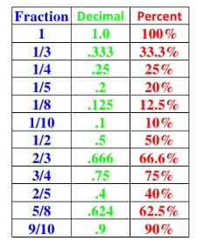
Decimal fraction | A fraction expressed in its decimal form. | Half written as a decimal fraction is 0.5.
Decimal place | The position of a digit to the right of the decimal point. | 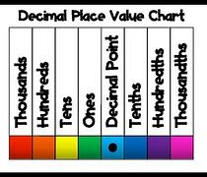
Hundredths | Each of one hundred equal parts into which something is or may be divided.
Mixed number | Numbers consisting of an integer and a fractional part. | 1 ½ is a mixed number.
Proper fractions | A fraction with a value less than one. | ½ ¾ are proper fractions.
Proportion | Harmonious relation of parts to each other or to the whole. | 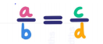
Simplify | To write a number or equation in its simplest form. | You can simplify 4/8 to 1/2

Length
Area | The space a surface takes up inside its perimeter. Area is always measured in square units. | 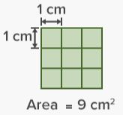
Convert | To change from one unit of measurement to another. | 10,000 m can be converted to 10km
Distance from/to | How far something is | The track is 80m long.
Kilometre (km) | A metric unit measure used to measure length that is equal to 1000m. | A mile is 1.6km
Millimetre (mm) | A metric unit of measure used to measure length 10mm make 1 cm | The length of a 30cm ruler is 300 mm.
Perimeter | The perimeter of a 2D shape is the total distance around the outside. | 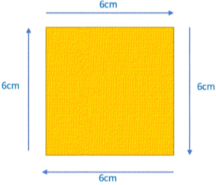  The perimeter of this shape is 24cm.
Square centimetre (cm2) | A unit of measure for area equal to a square with the dimensions 1 cm by 1cm. | Sometimes referered to as cm squared or cm2.

Weight
Mass | Commonly measured by how much something weighs. | How much do the apples weigh? What is there mass?
Weight | The measure of how heavy an object is. | The weight of those rocks is 500g.

Capacity and Volume
Measuring cylinder | They are used for holding and measuring the amount of a liquid. | 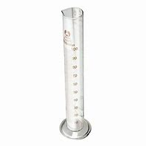

Temperature
Centigrade | The Celsius scale of temperature. | The temperature outside is 15 degrees centigrade.

Time
12 hour clock | A clock using am and pm to indicate morning and afternoon. | 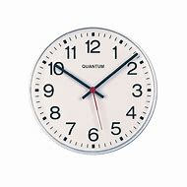
24 hour clock | A clock which runs from midnight to midnight and has numbers 0-24. | 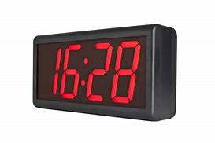
Am | The morning between 12 mid night and 12 mid-day. | I woke up at 9 am.
Arrive | The time you are going to reach your destination. | The bus will arrive at 11am.
Calendar | A chart showing the days, weeks and months of a particular year. | 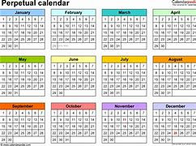
Century | A period of 100 years. | World war one happened over a century ago.
Depart | Leave or start a journey. | The bus is expected to depart at 11:10am.
Earliest | Happening or done before the usual or expected time. | What is the earliest you can arrive at school.
Latest | Of most recent date. | The latest I can be out till is 6pm.
Leap year | A year which has 366 days and occurs every four years. | There are 366 days in a leap year how many are there in a normal year?
Millennium | A period of 1000 years. | The year 2000 was a millennium.
Noon | 12 oclock in the middle of the day. Midday. | 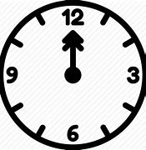
PM | The time between midday and midnight. | You have your lunch at 12:30pm.
Roman numerals | Roman numerals are a system of symbols used to represent numbers that were developed and used by the Romans. They do not use a place value system. | 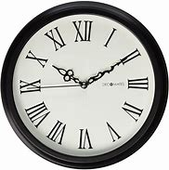
Timetable | A chart showing when something will happen. | On the timetable at school the register comes first.

2D shapes
Construct | Build or make. | Can you construct a triangle using 3 lolly sticks?
Equilateral | Having all sides, the same length. | 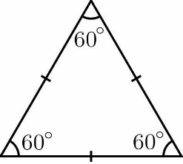
Heptagon | A plane figure with seven straight sides and angles. | 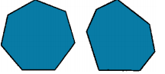
Irregular | In geometry, irregular is a term used to describe shapes that are not regular | 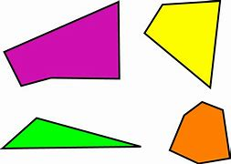
Isosceles | Having two sides of equal length. Isosceles triangles have two equal sides; isosceles trapezia have two equal, non-parallel sides. | 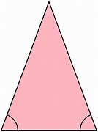
Kite | A flat shape with 4 straight sides that: • has two pairs of equal length sides. • each pair is made of two adjacent sides (they meet) that are equal in length. The angles are equal where the pairs meet. | 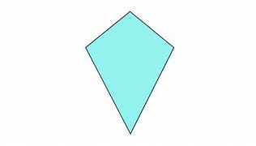
Oblong | A rectangle that is not a square.
Parallel | Line segments that can be described as parallel must be on the same plane and will never meet, regardless of how far either or both line segments are extended. | 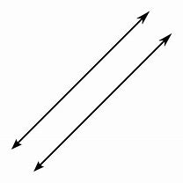
Parallelogram | A 2-D shape that has two pairs of parallel sides and equal opposite angles. | 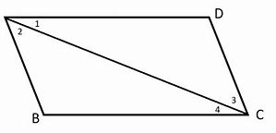
Perpendicular | A pair of line segments (or surfaces) can be described as perpendicular if they intersect at (or form) a right angle. | 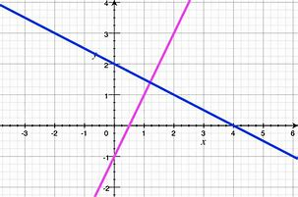
Polygon | A plane 2D shape with straight sides.
Regular | Regular 2-D shapes (regular polygons) have angles that are all equal and side lengths that are all equal.
Rhombus | An equilateral parallelogram with four equal length sides.
Scalene | A scalene triangle has three unequal sides and three unequal angles. | 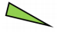
Trapezium | A quadrilateral with exactly one pair of parallel sides.

3D shapes
Cylinder | 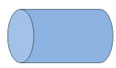
Hemisphere | A hemisphere is a 3D geometric figure that is half of a sphere. | 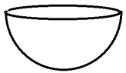
Polyhedron | A solid with flat faces. Each flat face is a polygon. | 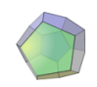
Prism | A prism is a 3D solid with two identical, parallel bases and otherwise rectangular faces. | 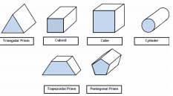
Spherical | Shaped like a sphere. | The Earth is spherical.
Square/ triangular based pyramid | A pyramid is a 3D shape with a 2D shape as a base and triangular faces that taper to point called the vertex. | 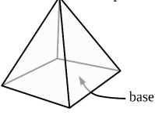
Tetrahedron | A polyhedron (a flat-sided solid object) with 4 faces. | 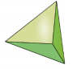

Position and direction
Acute angle | An angle that is smaller than a right angle. | 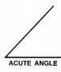
Compass point | The directions on the magnetic compass. The 4 main points are North, South, East and West. | 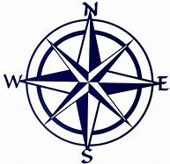
Coordinate | The position of a point, usually described using pairs of numbers. | 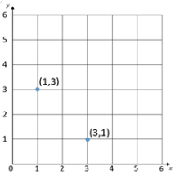
Degree | A measure for angles. There are 360 degrees in a full rotation. | There are 180 degrees in a triangle.
Diagonal | A diagonal is a straight line joining two non-adjacent vertices of a shape, that is, two corners of a shape that are not next to each other. | 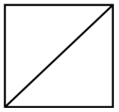
Grid | A series of evenly divided and equally spaced shapes, usually squares. | 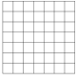
Obtuse angle | An angle that is greater than a right angle but less than 180 degrees. | 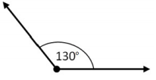
Protractor | A measuring device for measuring the size of an angle. Angles are measured in degrees (°). | 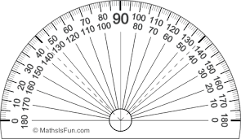
Reflection | An image or shape as it would be seen in the mirror. | 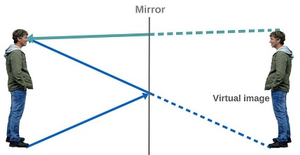
Rotation | The action of rotating about an axis or centre. | 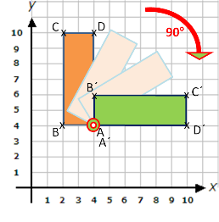
Set square | A right-angled triangular plate for drawing lines, especially at 90°, 45°, 60°, or 30°. | 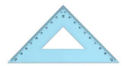
Translation | The shape still looks exactly the same, just in a different place. | 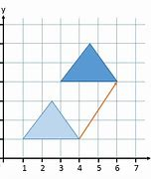
Vertical | A line that runs from top to bottom. | A vertical line-

Statistics
Axis (plural axes) | A real or imaginary reference line. The y-axis (vertical) and x-axis (horizontal) on charts and graphs are used to show the measuring scale or labels for the variables. | 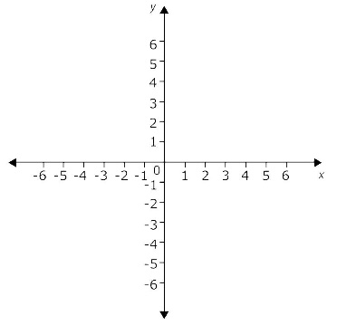
Bar graph | A representation of data in which the frequencies are represented by the height or length of the bars. | 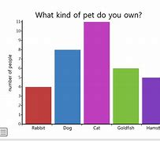
Carroll diagram | A way of sorting objects, numbers and shapes by their traits. | 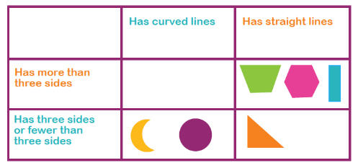
Data | A collection of facts, such as numbers, words, measurements, observations or even just descriptions of things. | 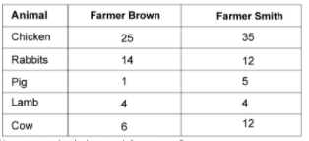
Frequency | The number of times an event or a value occurs. | The colour blue was chose by most of the children in the class it was the most frequent colour choice.
Interval | An interval on a graph’s axis lies between two values. | 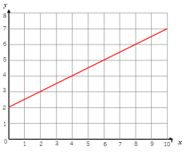  This shows intervals of one.
Survey | To gather information by individual samples so we can learn about the whole thing. | The class completed a survey on the colours of cars that are in the car park.
Time graph | A graph that uses lines to connect the points on a data chart. Used to present continuous data, such as change over time. | 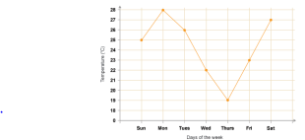
Venn diagram | An illustration that uses circles to show the relationships among things or finite groups of things. | 