Mathematics Vocabulary list for Year 5 and 6
Maths has its own language. Sometimes that language is written words and sometimes it is symbols but it is a language and it must be learned for fluency and competency. If your child doesn’t have a good understanding of the vocabulary, it can hinder their performance in Maths. At Millbrook, we teach this vocabulary and give it context which allows the children to apply it to a variety of problems. Listed below is the vocabulary your child will learn this year.
Number and Place Value

Vocabulary | Definition | Example
Ascending order | Arranged from smallest to  largest. Increasing. | 13, 29, 36, 55 are in ascending order.
Brackets | The symbols ( ) used to separate parts of a multi-step calculation. | ( 6-3) x 10= 30
Degree of accuracy | A description of how accurately a value is communicated. | The degree of accuracy needed is rounded to one decimal place. 0.74= 0.7
Descending order | Arranged from largest to  smallest. Decreasing. | 90, 35, 24, 16, 2 are in descending order.
Equivalent expression | An expression, which can be algebraic, which is equal in value to another expression. | 16+10 is an equivalent expression to 20+6.
≥ Greater than | Something is either greater than another thing | 9 > 5
≤ Less than | Something is either less than  another thing. | 5 < 9
Order of operations | The internationally agreed order to complete operations in a multi-step equation with multiple operations. | 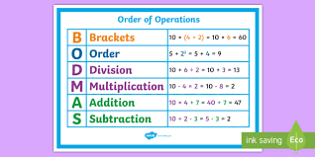

Addition and subtraction
See previous years

Multiplication and division
Common factor | A factor of two or more given numbers. | A common factor of 12 and 18 is 3 because 3x4=12 and 3x6=18
Common multiple | A multiple of two or more given numbers. | A common multiple of 3 and 6 is 12 because 3x4=12 and 6x2=12.
Cube number | The result of multiplying a whole number by itself twice. | 3x3x3=27, so 27 is a cube number.
Divisible | A number is said to be divisible by another if it can be divided by that number without a remainder. | 12 is divisible by 6. As 12 divided by 6 is 2.
Factorise | To identify factors of a given number. To express a number as factors. | ‘I can factorise 12 by looking at its factor pairs. 1 × 12 = 12, 2 × 6 = 12, 3 × 4 = 12. So the factors of 12 are 1, 2, 3, 4, 6 and 12.’
Factor pair | A factor pair is a pair of numbers that, when multiplied will result in a give product. | The factor pairs of 10 are.  1 and 10  2 and 5
Long division | The formal written method that can be used to divide by a number with two or more digits. | 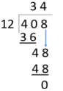
Long multiplication | The formal method that can be used to multiply a number by a number with two or more digits | 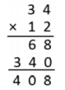
Prime factor | A factor that is a prime number. In other words: any of the prime numbers that can be multiplied to give the original number | ‘The prime factors of 15 are 3 and 5 (because 3×5=15, and 3 and 5 are prime numbers)’.
Prime number | A whole number with only two factors, one and the number itself. | 2,3,5,7,11,13,17,19 are the prime numbers less than 20.
Square number | The product of two equal factors. | 9 is a square number because 3x3=9

Fractions
Ratio | A ratio shows the relative sizes of two or more values. | 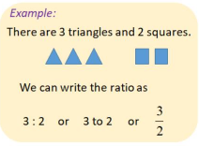
Percentage | The number of parts per hundred which is written using the % symbol. | 20% of children hate sweets shows that for every 100 people 20 don’t like it.
Proportion | A comparison between two or more parts of a whole or group. Proportion expresses a part whole relationship. This may be represented as a fraction, a percentage or a decimal. | 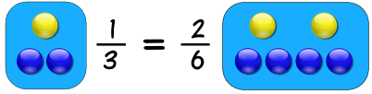
Thousandths | The third decimal digit from the decimal point is the thousandths digit | 5.432 The thousandths digit is 2.

Algebra
Equation | An equation says that two things are equal. It will have an equals = | 7+3= 14-4  The left is equal to the right.
Formula | An algebraic expression of a rule. | The area of a rectangular can be found by multiplying the width and height. A = w x h
Unknown | A number we do not know. | In the equation below, y is unknow but can be calculated.  Y + 13=20
Variable | A symbol for a value we don’t know yet. It is usually a letter like x or y. | Y= 4 x + 8

Length
Feet/foot | An imperial unit of measure of length. | ‘I am approximately five feet tall.’
Imperial unit | A system of measurement in use in the UK now mostly superseded by metric system. | The metric length of the line is 3cm. The imperial length of line is 1.18 inches.
Inches | A measurement of length. | One inch is exactly 2.54cm
Mile | An imperial unit of measure of length. | ‘Five miles is equivalent to eight kilometres.’
Scale | The ratio of lengths, in a drawing are in proportion to the measurements of the real object. The length is not in proportion when not to scale. | The diagram of the school is not drawn to scale. 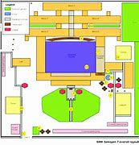
Square Metre | The area of a square that is 1m on the side. | The area of the square is 1 m Squared.  1m  1m
Yard | A unit of length (or distance) equal to 3 feet or 36 inches. | ‘In football, the penalty spot in 12 yards from the goal line.’

Weight
Ounce | An imperial unit of measure of mass. | The new born baby had a mass of 6 pounds and 1 ounce.
Pounds | A measure of mass in the Imperial measurement systems. | An average adult weighs 180lb.
Tonne | A unit of mass equal to 1000 kilograms. | A small car weighs about 1 tonne.

Capacity and volume
Centilitre | A metric unit of capacity, equal to one hundredth of a litre. | ‘There are 500 centilitres in this beaker. It is about the same 5 litres.’
Cubic centimetre | A unit used to measure volume. The space taken up by a cube with edges of length 1 cm or which measures 1 cm × 1 cm × 1 cm. | ‘The volume of this multilink cube model is eight cubic centimetres.’
Cubic metre | A unit used to measure volume. | The space taken up by a cube with edges of length 1 metre.
Gallon | An imperial unit of measure of volume/capacity | A gallon is approximately 4.5 litres.
Pint | A measure of volume in the imperial systems of measurement. | 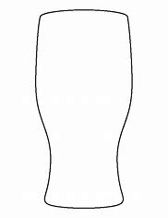  A pint is equal to about half of a litre.

Temperature
See previous year groups

Time
See previous year groups

Money
Currency | A system of money in general use in a particular country. | The currency in England is Pound sterling.
Discount | A reduction in price
Loss | If the income is less than the expenses.
Profit | Income minus expenses. | 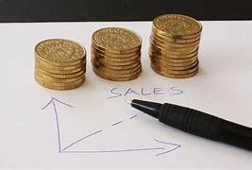

2D shapes
Arc | A portion of the circumference of a circle. | 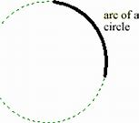
Circumference | The perimeter/ boundary of a circle. | 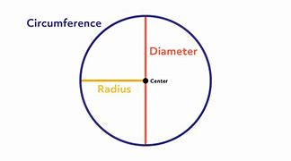
Compass | A tool for creating curved lines and arcs. | 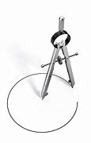
Congruent | Used to describe two shapes or figures which are exactly the same size. | The two triangles are congruent.
Decagon | A ten-sided shape. | 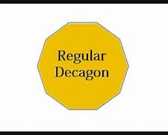
Diameter | A line from one point of the circumference of a circle to another on the opposite side, which must pass through the centre of the circle. | 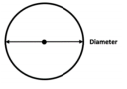
Intersect | The point at which two (or more) lines meet is where they intersect. | ‘The x and y axes intersect at (0,0) ‘
Nonagon | A polygon with nine sides and nine angles. | 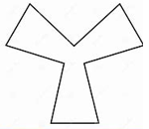
Quadrant | Any of the 4 areas made when we divide up a plane by an x and y axis. | 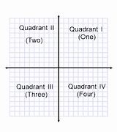
Radius | A line from one point of the circumference of a circle to the centre of the circle.
Similar | Similar shapes are those which have the same internal angles and where the side lengths are in the same ratio or proportion. Enlarging a shape by a scale factor (for example by doubling all side lengths) creates a similar shape. | 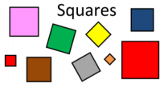

3D shapes
Dodecahedron | A polyhedron (a flat-sided solid object) with 12 Faces. | 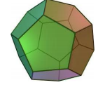
Octahedron | A polyhedron (a flat-sided solid object) with 8 Faces. | 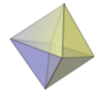
Net | A group of 2-D shapes which, when folded and connected, forms a 3-D polyhedron. | 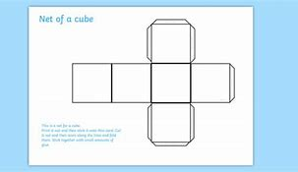

Position and direction
Angle at a point | Angles that meet at a point that make 360 degrees. | 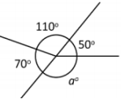
Angle on a line | Angles formed on a straight line that add up to 180 degrees. | 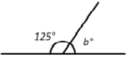  b= 55 degrees
Bisect | To bisect an angle means that we divide the angle into two equal parts without actually measuring the angle. | 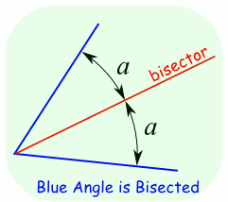
Coordinate | A set of values that show an exact position. On graphs it is usually a pair of numbers: the first number shows the distance along, and the second number shows the distance up or down. | 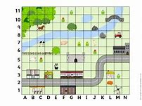
Origin | The point at which axes in a coordinates grid cross; the point (0,0). | 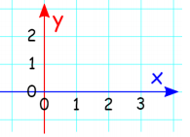
Reflex angle | An angle that is greater than 180°. | 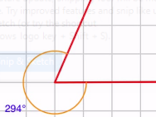
Transformation | A collective term for the ways that shapes can be changed, resulting in congruent or similar shapes | Translation, reflection, rotation and enlargement are transformations.
Vertically opposite angles | Angles which are positioned opposite to one another when two lines intersect. | 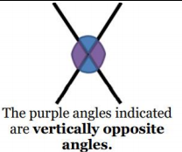

Statistics
Line graph | A graph with points connected by lines to show how something changes in value as time goes by. | 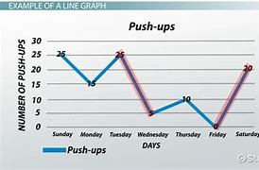
Mean | The arithmetic mean is the average of the numbers. Calculated by adding all the numbers up and dividing by how many numbers there are. | What is the mean of 3,5,11?  3+5+10= 18  18 divded by 3= 6  The mean equals 6.
Pie chart | A representation of a set of data where each segment represents one group in proportion to the whole group. | 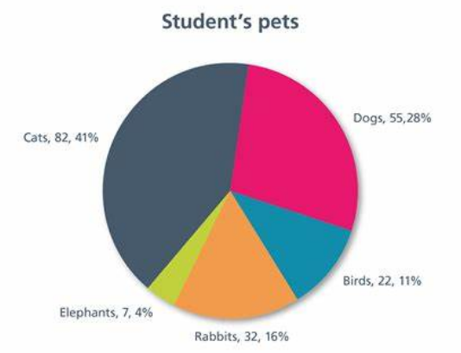
Statistic | The study of data: how to collect, analyse, summarise and present it. | 