Millbrook Primary School
Calculation policy

Maths calculation Policy
This policy supports the White Rose maths scheme used throughout the school.
Progression within each area of calculation is in line with the programme of study in the 2014 National Curriculum.
This calculation policy should be used to create consistency across the school from Foundation to year 6 and therefore to support children to develop a deep understanding of number and calculation.
This policy has been designed to teach children through the use of concrete, pictorial and abstract representations and this will be shown throughout the school using DO IT, SECURE IT and CHILLI CHALLENGE.
Concrete representation— a pupil is first introduced to an idea or skill by acting it out with real objects. This is a ‘hands on’ component using real objects and is a foundation for conceptual understanding.
Pictorial representation – a pupil has sufficiently understood the ‘hands on’ experiences performed and can now relate them to representations, such as a diagram or picture of the problem.
Abstract representation—a pupil is now capable of representing problems by using mathematical notation, for example 12 x 4 = 48. It is important that conceptual understanding, supported by the use of representation, is secure for all procedures. Reinforcement is achieved by consistently going back over and repeating areas of Maths, therefore imbedding this in the child.

EYFS

Addition
Explore part part whole relationship— combining two parts to make a whole. | 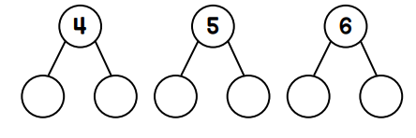
Using the ten frame/egg boxes to support addition of single digits— counting all/ combining two groups | 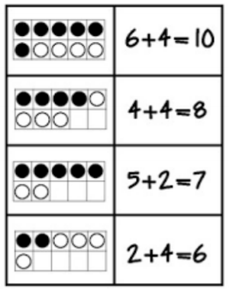
Number bonds to 10 using numicon. | 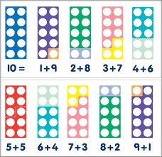
Solving problems using concrete, pictorial images. | 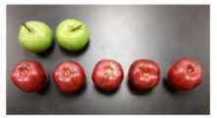  There are 2 green apples and 5 red apples how many apples are there all together?
Staircase pattern to show one more and one less. | 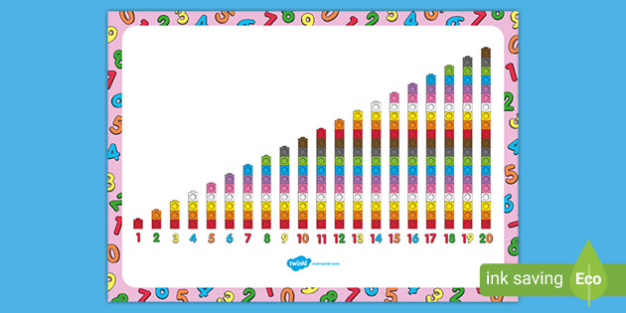

Subtraction
Using concrete strategies for counting | Counting out practical equipment and physically moving equipment to take away. This could be done with any objects.  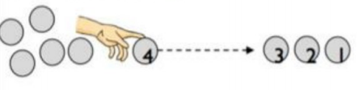
Using the ten frames to support subtraction by taking away | 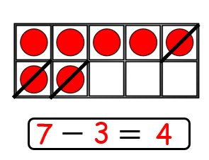
Solving problems using concrete, pictorial images. | 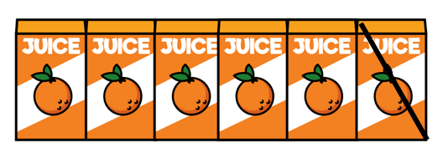  There are 6 orange juice cartoons. If you take one away how many are there?

Multiplication
Experiencing equal groups of objects They will think about doubling when solving practical problems. | 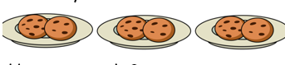  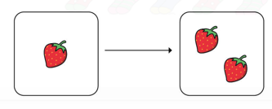  Equal groups  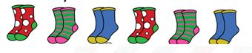  Doubling
Sharing practical objects. Hearing and being exposed to language to describe half and seeing visual representations. | 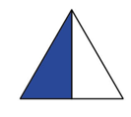  Half  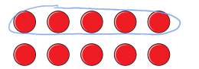

Year 1

Addition
Combining two parts to make a whole: part whole model. Joining two groups and then recounting all objects (lots of practice making 10 and numbers to 10 e.g 9+1=10 1+9=10 | 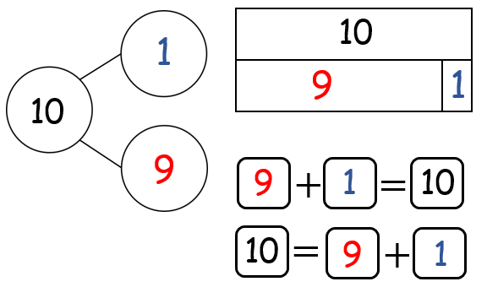  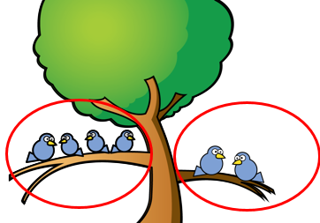  4+2=6  2+4=6
Number Bonds Learn number bonds to 20 and demonstrate related facts. Addition and subtraction taught alongside each other as pupils need to see the relationship between the facts. | 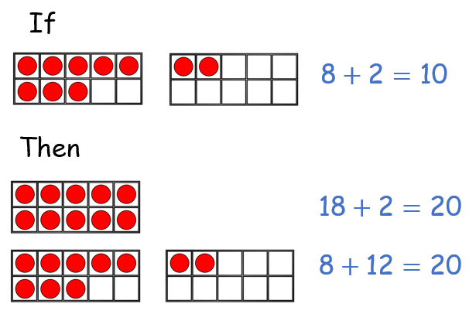
Add and subtract one digit numbers and two digit numbers to 20, including zero | 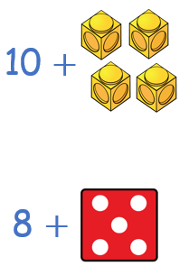  10+4=14  8+5=13  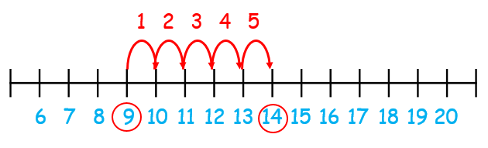  9+5=14
Bridging 10; 9+1 by filling the first ten frame then 10 +6.  Children should start with the larger number and add the smaller number seeing what | 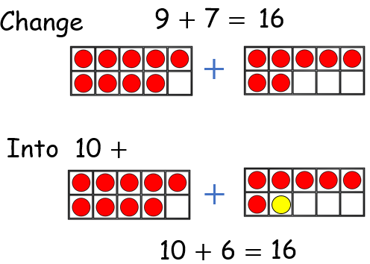

Subtraction

Taking away should begin with physical objects: counters, cubes, Dienes etc | 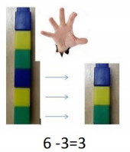
Subtraction by counting back | 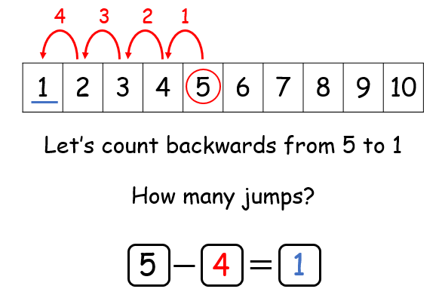
Subtracting a single digit number from a single digit number and a single digit from a two digit by crossing out pictures | 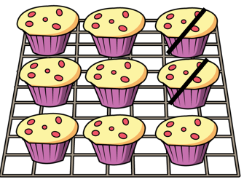  9-2=7
Subtracting using the part part whole model (include problem solving with missing digits).  8-5=3 | 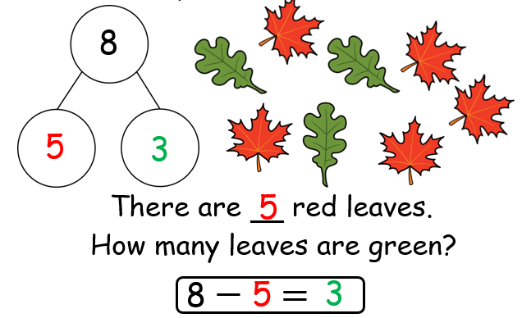
When subtracting using Dienes children should be taught to regroup (rename) a ten rod for 10 ones and then subtract from those | 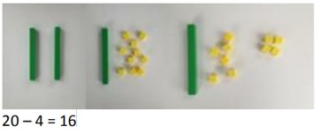
Subtracting Multiples of 10. Using the vocabulary of 1 ten, two tens, etc, alongside 10, 20, 30 is important | 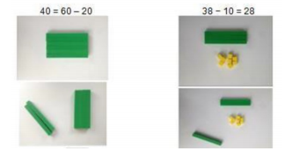

Multiplication
Counting in Multiples of 2, 5 and 10 from zero. Children should count the number of groups on their fingers as they are skip counting. | 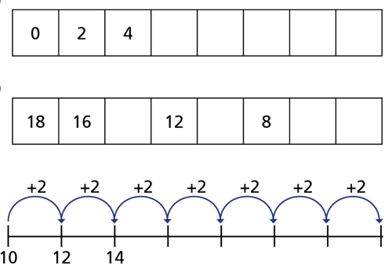
When moving to pictorial/written calculations the language is important | 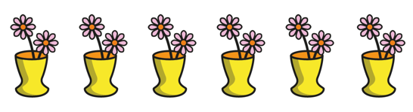
Solving Multiplication Problems using repeated addition | 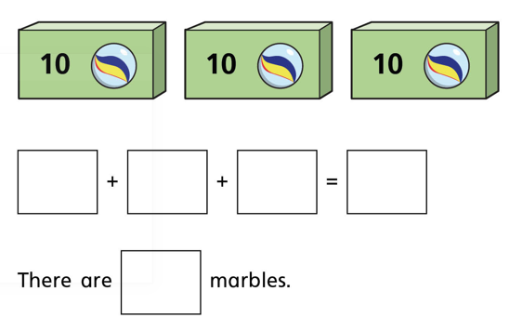

Division
Pupils should be taught to divide by working practically and the sharing should be shown below the whole to familiarise children with the concept of the whole. | Whole amount of sweets is 8. They share and get 4 each this is equal.  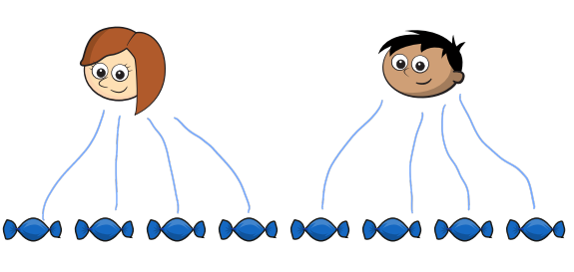
Year 2

Addition
Using concrete and pictorial representations to add a 2 digit number to a 1 digit number and a 2 digit number to a tens number. | 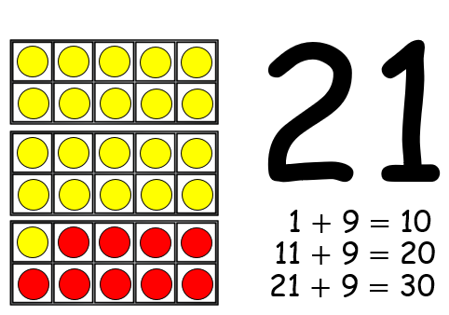
Using concrete and pictorial representations to add two 2 digit numbers.  Addition sums must be set out with the + sign to the left. | 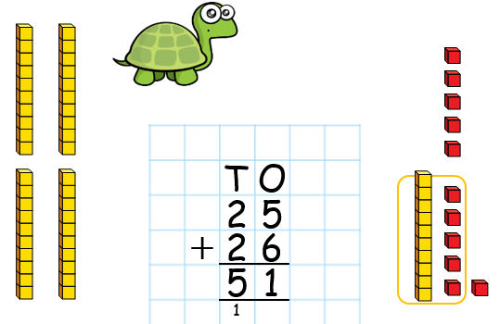
Using concrete and pictorial representations to add 3 single digit numbers. | 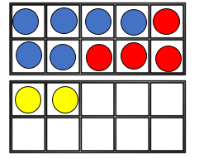  6+4+2=12
Using the bar model to find missing digits: It is important for the children to use the bar model in this way to encourage the use of it to aid problem solving. | 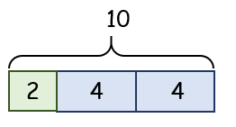

Subtraction
Using concrete and pictorial representations to subtract a 1 digit number from a 2 digit number | 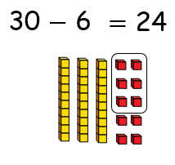
Using concrete and pictorial representations to subtract a 2 digit number from a tens number | 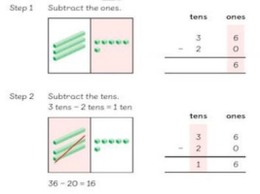
Using concrete and pictorial representations to subtract a 2 digit number from a 2 digit number | 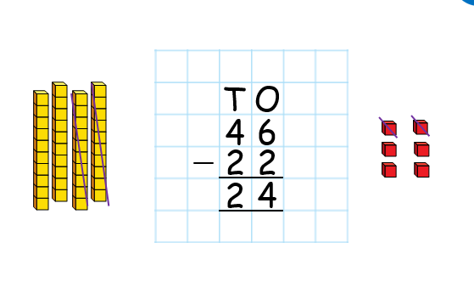
Recognise and use the inverse relationship between addition and subtraction. | 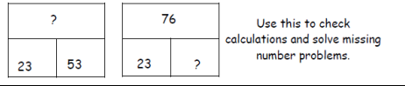

Multiplication
Skip counting in multiples of 2, 5 and 10 from zero. | 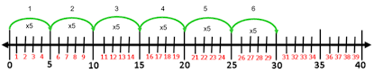
Recall and reuse multiplication facts for the 2, 5 and 10 times tables. | 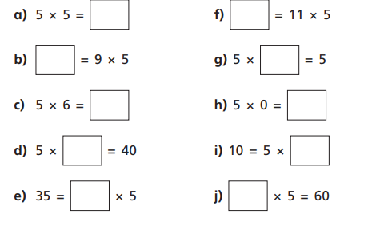
Use multiplication sign (X) and equals sign (=) when writing out multiplication tables. | 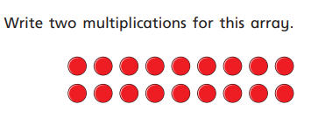
Understand that multiplication is commutative Pupils should understand that an array can represent different equations and that as multiplication is commutative the order doesn’t affect the answer. | 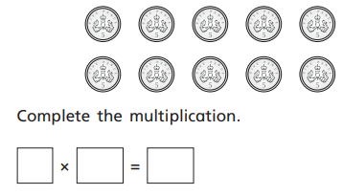
Solve multiplication problems using arrays and repeated addition. | 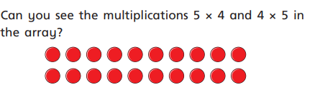

Division
Recall and use the division facts for 2, 5 and 10 multiplication tables. | 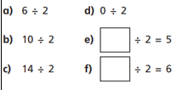  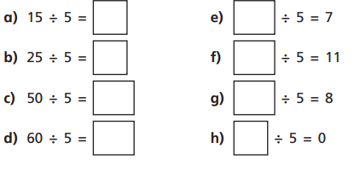
Solve division problems in context by using concrete objects by sharing. | 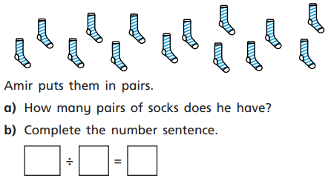
Solve division problems in context using arrays. | 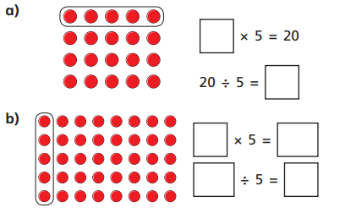
Solve division using grouping. | 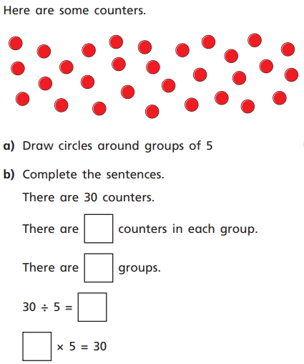
Use the inverse This should be taught alongside both multiplication and division. | 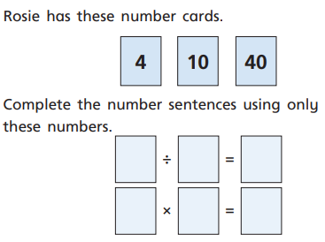

Year 3

Addition
Add two three digit numbers. Children need to first use equipment to support understanding of place value. Start without crossing 10/100 then move on to crossing 10 and 100.  Addition sums must be set out with the + sign to the left and the numbers to carry underneath. | 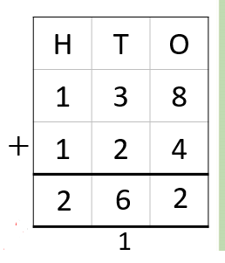  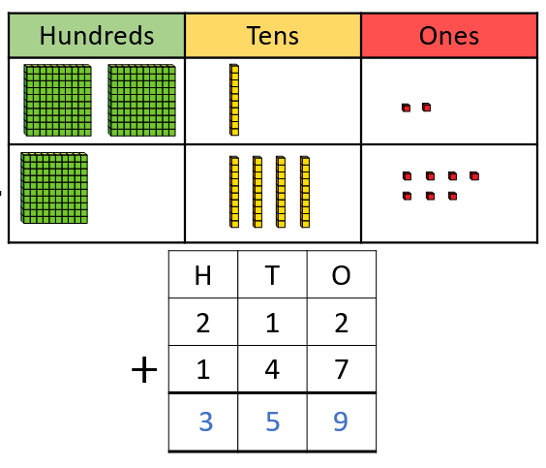
Bar Modelling It is important for the children to use the bar model in this way to encourage the use of it to aid problem solving. | 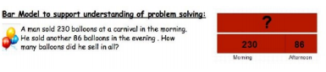

Subtraction
Subtract up to 3 digits from 3 digits. Children need to first use equipment to support understanding of place value. Only when children are secure with method should exchanging be introduced. | 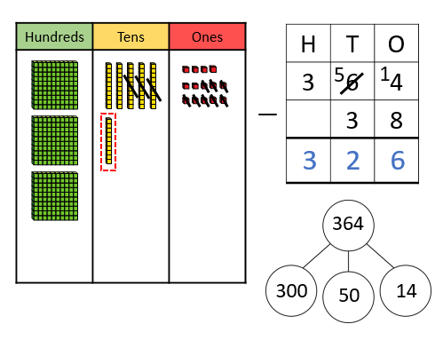
Bar Modelling It is important for the children to use the bar model in this way to encourage the use of it to aid problem solving. | 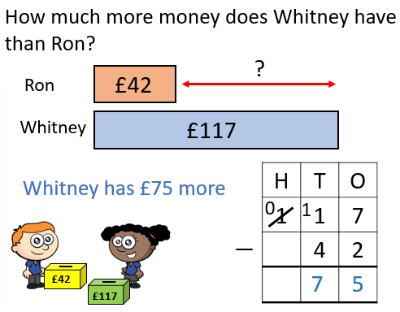

Multiplication
Children should be able to recall the 2, 5, 10, 3, 4 and 8 multiplication tables. Multiply a 2 digit number by a 1 digit number. | 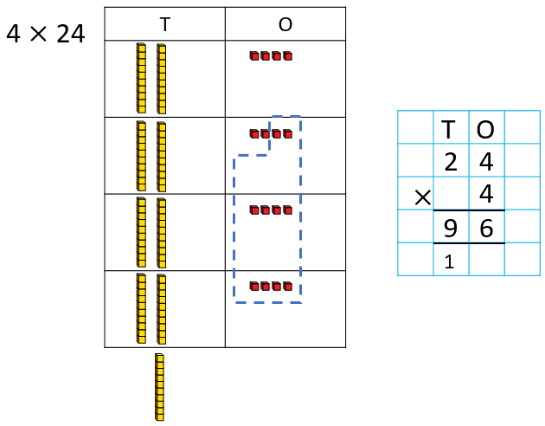  24  X 4  16 (4x4)  + 80 (20x4)  96  Start by multiplying the ones column so 4 ones multiplied by 4 ones= 16  Then multiply the tens so 2 tens multiplied by 4 ones =80  80+16=96
Bar Modelling It is important for the children to use the bar model in this way to encourage the use of it to aid problem solving. | 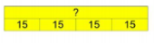  Four children go to the cinema paying £15 each. How much does it cost all together?

Division
Dividing using short division Once the children are secure with division as grouping and can demonstrate this on number lines, arrays etc. short division should be introduced for dividing larger 2 digit numbers. Initially with carefully chosen calculations requiring no remainders. | 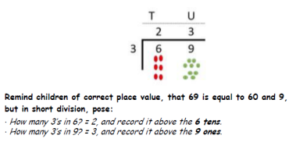
Bar Modelling It is important for the children to use the bar model in this way to encourage the use of it to aid problem solving | 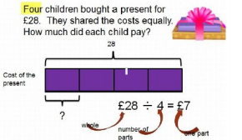

Year 4

Addition
Adding numbers with up to 4 digits. Again, this should start with the children using equipment to support and lots of discussion about the values of digits.  Start with no exchange  Move onto one exchange  Then move on to multiple exchanges  Addition sums must be set out with the + sign to the left and the numbers to carry underneath. | 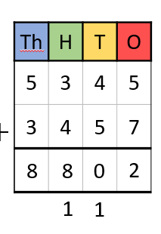  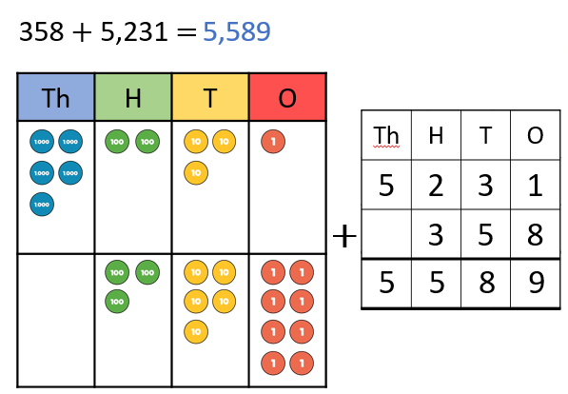
Using the bar model to find missing digits. | 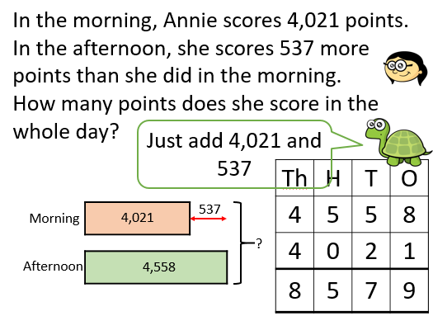

Subtraction

Subtract with numbers up to four digits, including exchanging.  Start without exchanging  Move onto exchanging. | 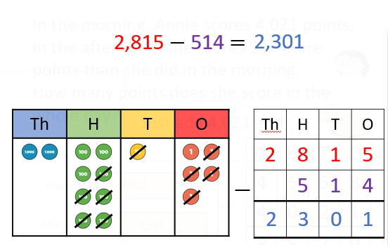  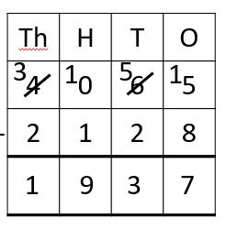
Using the bar model to find missing digits. | 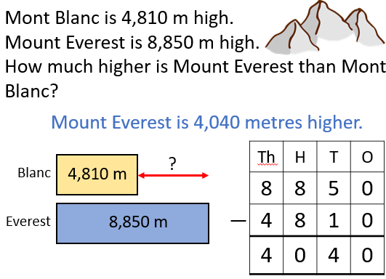

Multiplication

Children know all times tables up to 12 x 12. Children use expanded column multiplication and move on to compacted. | 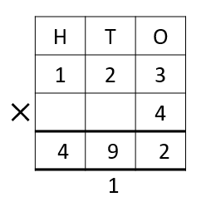  Start with the ones multiplying 3 by 4 =12  Then 20 multiplied by 4. =80  Then 100 multiplied by 4 =400  Total= 492
Multiply using the bar model | 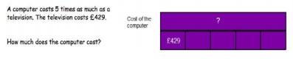

Division
Dividing 3 digit numbers by a 1 digit number using a variety of methods. | 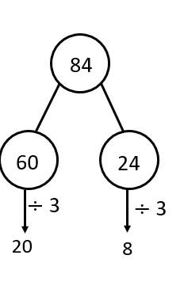  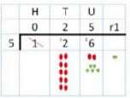
Divide using the bar model | 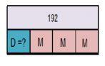  Des and Melissa collect cards they have 192 in total but Melissa has 3 times as many as Des. How many does Des have?
Dividing decimals. | 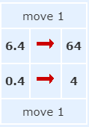  Divide 6.4 by 0.4.  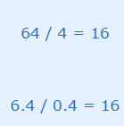
Dividing fractions. | 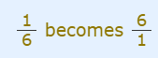  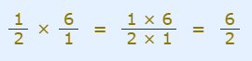  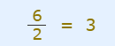

Year 5

Addition
Adding numbers with more than 4 digits including decimals.  Using place value charts and place value counters is key when understanding adding decimals.  Addition sums must be set out with the + sign to the left and the numbers to carry underneath. | 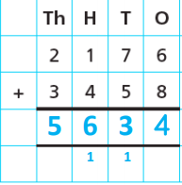  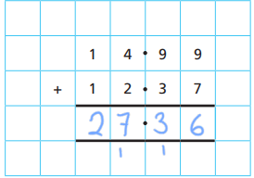
Using the bar model to find missing digits. | 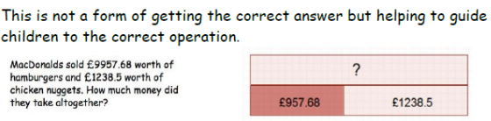

Subtraction

Subtract with at least 4 digit numbers including two decimal places. Include money, measures and decimals.  Use the word exchange when taking a number from one to give to another. | 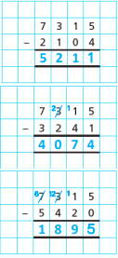
Using the bar model to find missing digits. | 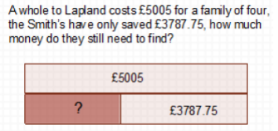

Multiplication
Multiply up to 4 digit numbers by 2 digit numbers using long division.  Children need to be taught to approximate first to check the reasonableness of their answers.  So 56 x 27 could be 60 x 30 = 1800 | 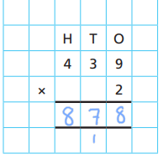  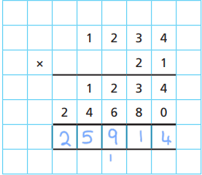
Using the bar model to support multiplication | 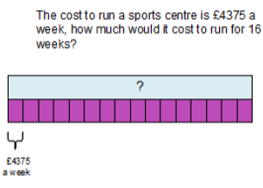

Division
Divide up to 4 digit numbers by 1 digit numbers using short division.  Also, numbers that have remainders. | 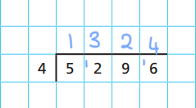  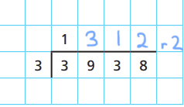

Year 6

Addition
Adding several numbers with up to 3 decimal places.  Ensure you line the decimal places up. | 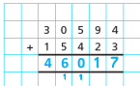  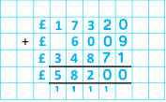  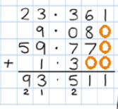
Using the bar model to support addition | 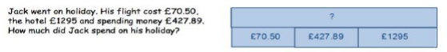

Subtraction
Subtracting with increasingly more complex numbers including decimals. | 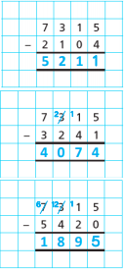
Using the bar model to support subtraction | 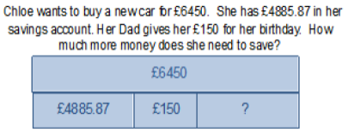

Multiplication
Short and long multiplication with up to 2 decimal places. | 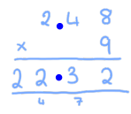
Using the bar model to support multiplication | 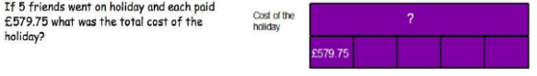

Division
Short division to divide by a 1-digit number. | 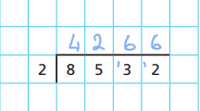
Long division to divide by 2-digit number. | 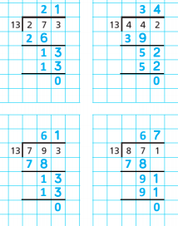
Using the bar model to support division | 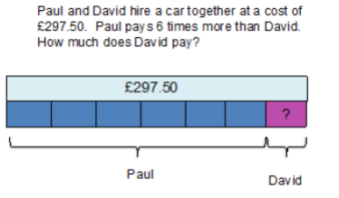

Forming numbers correctly

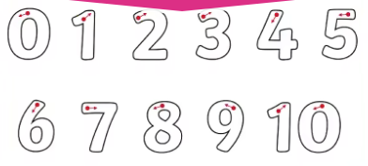
Glossary of term

Deines- Concrete resource showing hundreds, tens and ones.
Exchange- When one is taken from a number and given to another number.

