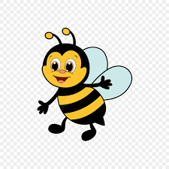**Spelling Bees**

**Term 1 Spellings**

|  |  |  |  |  |  |
| --- | --- | --- | --- | --- | --- |
| Week 1  Mixed words with a range of spelling patterns and rules | Week 2 –  The /ge/ sound spelt as ge and dge at the end of words, and spelt as g elsewhere before e, i and y | Week 3  Homophones and near-homophones | Week 4  The /i:/ sound spelt ey | Week 5  Statutory word list | Week 6  The /ɒ/ sound spelt a after w and qu |
| annoy | charge | there | key | move | want |
| dream | bulge | their | donkey | prove | watch |
| cried | village | they’re | monkey | just | wander |
| instead | gem | hear | chimney | sure | quantity |
| summer | giant | here | valley | sugar | squash |
| blackberry | magic | quite | journey | eye | wallet |
| moon | giraffe | quiet | alley | could | wasp |
| hutch | energy | see | honey | should | quality |
| fresher | jacket | sea | hockey | would | quarry |
| sketch | adjust | one | money | like | wash |