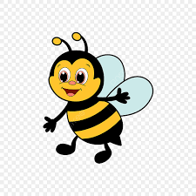
Spelling Bees
Term 3 Spellings

Week 1  The /l/or /ɘl/ sound spelt -le at the end of words | Week 2 –  Homophones and near-homophones | Week 3  The /l/or /ɘl/ sound spelt -el at the end of words | Week 4  The /l/ or /ɘl/ sound spelt -al at the end of words | Week 5  Exception words list | Week 6  The /n/ sound spelt kn and (less often) gn at the beginning of words and The /ʒ/ sound spelt s
table | bare | camel | metal | wild | knock
apple | bear | tunnel | pedal | climb | know
bottle | sun | squirrel | capital | most | knew
little | son | travel | hospital | only | gnat
middle | to | towel | animal | both | gnaw
example | too | tinsel | magical | old | television
battle | two | vowel | signal | cold | treasure
terrible | be | enamel | mammal | gold | usual
struggle | bee | angel | general | into | measure
possible | night | level | formal | told | visual

