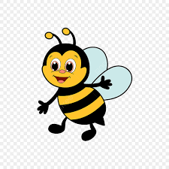
Spelling Bees
Term 4 Spellings
Week 1  The possessive apostrophe (singular nouns) | Week 2 –  Adding -ed, ing, -er and -est to a root word ending in -y with a consonant before it | Week 3  Adding the endings - ed, -ing, -er, -est, and -y to words ending in -e with a consonant before it | Week 4  Adding -ed, -ing, -er, -est and -y to words of one syllable ending in a single consonant after a single vowel | Week 5  Exception words list
Megan’s | copied | hiking | patting | every
Ravi’s | copier | hiked | patted | everybody
girl’s | happier | hiker | humming | even
child’s | happiest | nicer | hummed | great
man’s | cried | nicest | dropping | break
boy’s | replied | shiny | dropped | from
bike’s | copying | describing | sadder | pretty
computer’s | crying | described | saddest | beautiful
school’s | replying | wiring | fatter | after
parent’s | relied | tiled | fattest | fast

