
Diary Dates:
13th September- Class open evening
22nd September- School fete
18th October- TD DAY
Half term- 19th October- 27th October
3rd October School photos
Swimming this term and next
11th-22nd September- Foxes Swimming
25th September- 6th October Squirrels Swimming
9th- 13th October Badgers swimming
30th October- 3rd November- Badgers Swimming

A massive welcome to all children joining Year 3/4 and those that are coming back! We are excited and look forward to working with you and your children this year.
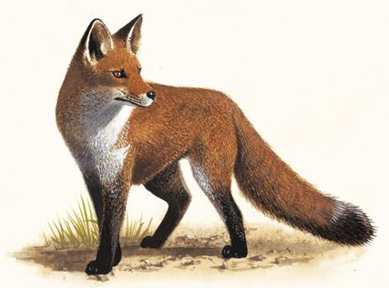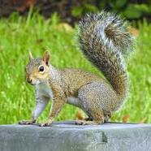
Mr Brown, Mr Adams and Mr Patterson

READING
We are strongly focusing on reading as we do every year. It is important for your child to read 3-4 times a week. Being able to read fluently has an impact on all areas of learning. Reading books will be sent home and the children are expected to change books with a TA when they have finished the book daily. Awards are given for the class with the most reads.
Swimming: In Year 3 and 4 the children will be going swimming for two weeks dates are in the diary dates section. Please make sure your child comes with their swimwear and towel on these days.
PE: PE will take place Mondays and Tuesdays, please ensure your child comes to school in their PE kit on these days.

Important information
All communication with class teachers is to come through the class email addresses which are below.
badgers@millbrook.swindon.sch.uk
squirrels@millbrook.swindon.sch.uk
foxes@millbrook.swindon.sch.uk
Changes from KS1
Children come into school on their own in the mornings to develop their independence. In KS2, children are no longer provided with a mid-morning snack, however, are encouraged to bring a healthy snack from home. There is no afternoon break in KS2, but we are giving them a run around mid-afternoon for the week whilst they all adapt to being back!!

This term’s topic: What’s on the Menu
This is a Geography topic where children will be looking at foods and where they come from. I am sure the children will enjoy all the things we have planned.

Homework:
Homework will be electronically based. The children will have spellings that will be set via the Purple Mash online learning platform.
Children will need to be fluent in all of their times tables by the end of year 4, therefore they will need to use the TT Rockstars online platform to become confident, there will be regular challenges set for the children to compete in either against each other or staff.
In order to improve vocabulary, we are focussing on 5 wonder words in class each week. The children will be encouraged to use them in their writing and speaking. Please ask your child what their wonder words are each week help them with their fluency.

