Welcome back – we hope you enjoyed the break.
. 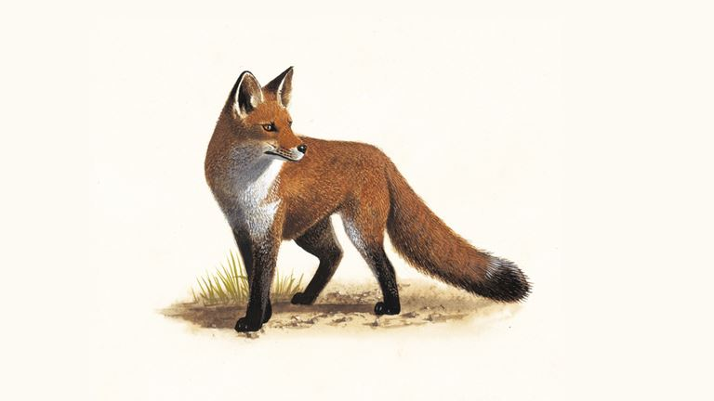
Diary Dates:
4th November – individual photos
12th November – Cinema visit
12th and 13th November – Parents’ Evenings
26th November – Hedgehogs Class Assembly
15th December – Christmas Service at the Church
18th December – KS2 Christmas Lunch
19th December – End of term (1:15pm finish)
-------------------------------------------------
21st January – Bears class assembly
4th February – Foxes class assembly

This term’s topic: Swindon during WWII
This term we will be finding out about the outbreak of World War II and its impact upon the local area. The study will involve looking at how local sites, such as the railway works and Lydiard House, changed and adapted to support the war effort. The children will use primary evidence from local residents at the time to find out how people’s lives were affected by the war. We will also be researching the role of women during war time and how their lives changed.

Homework:
Reading:
As a school, we really value reading and it is key to the academic and social development of our children. It is important for your child to read 5 times a week at home. Reading books will be sent home and the children are expected to change books with a TA when they have finished the book.
Spellings:
Spelling tests will be on a Friday.
The first test will be Friday 7th November. Your child will bring their spelling test home on Friday to share their results.
Times tables
Please can you support your children – they need to be learning the times tables at home so that they are fluent. This will help enormously with their maths.

The multiplication tables check (MTC) is statutory for all year 4 pupils registered at schools in England.

The children have a TT RockStars Login (in their reading record book). This is an excellent fun on-line resource for your children to use at home. It is recommended that they use this little and often (a daily ten-minute session is recommended 5 times a week).

Important information
Please contact us via class email if you have important information to share.
hedgehogs@grovelearningtrust.co.uk
bears@grovelearningtrust.co.uk
foxes@grovelearningtrust.co.uk

PE:
No earrings, however if your child has small studs that cannot be removed, they need to be taped on PE days.
Millbrook fleece or sweatshirt for outdoor PE – branded sports jumpers are not school uniform.
Bears: Tuesday & Friday.
Foxes: Tuesday & Friday.
Hedgehogs: Monday & Tuesday.
. 

Snack
A reminder that snacks are not provided in KS2. If you would like your child to have a morning snack they need to bring one from home – fruit, a cereal bar or another healthy choice.


