Quest Title: ‘LET’S GROW TOGETHER’  We Care, We Aspire, We Belong  These words underpin the ethos of our school and the teaching and learning that takes place. We strive to ensure all children care for their community on every level, aspire to be the best they can be and most importantly, develop a strong sense of belonging here at Milverton Community Primary School.  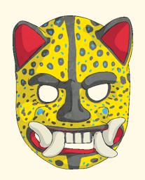  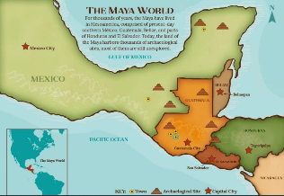  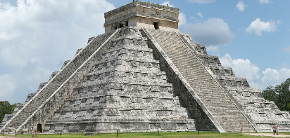  We care by: working with and learning from our school community. We do this through responsibilities such as being house captains, playground leaders and buddies.  We aspire by: respecting our education (including homework), participating fully in all activities and by developing an idea for our future careers.  We belong by: showing positive learning behaviours, supporting the school with its aims, being polite, well-mannered and participating. |  | As historians: we will study the Ancient Mayan civilisation and the impact it had on the world. We will learn about key aspects of their civilisation including culture, diet and religion.  We will learn about the Mayan temples and key archaeological sites. We will also learn about the demise of this ancient civilisation.
 |  | As geographers: we will look at the physical and human geography of Central America by using atlases, digital mapping software and pictures. We will focus on an area of Central America and compare it to the locality of Milverton. We will also study how important trade was to the Ancient Maya.
 |  | As mathematicians: We will continue the maths curriculum. We will complete maths project work using our knowledge developed over the year. We will also study the Mayan number system and compare it to our own.
 |  | As design and technologists: we will be undertaking a project. This will involve researching, designing, making and evaluating an electronic game.
 |  | As scientists: we will study buoyancy and water resistance as part of our forces work. We will also learn that mechanisms such as levers, pulleys and gears, allow a smaller force to have a greater effect.
 |  | As linguists: we will read, write and speak for a variety of purposes and to a range of audiences. We will develop our writing by creating newspaper articles based on Fairy Tales and creating non-fiction pieces around the topic of the Mayans. We will develop our speaking and listening skills in our performances of a play and leavers’ assembly.
Drivers: Personal Learning and Thinking Skills | Learning outside the classroom and Eco-Schools: |  | The Arts: | Diversity:
We will develop our independent enquiry skills across the curriculum focussing specifically on exploring issues, events or problems from different perspectives.  We will also look to analyse and evaluate information, judging its relevance and value. | We will be spending time out of class making props and backdrops.  We will also look at the ecosystems and vegetation around the school during our forest school work. |  | We will study Mayan art and we will make our own masks in the style of Mayan ones.  We will spend time designing and creating props for our end of year play as well as learning a variety of songs.  We will create art work as part of our celebrations for the Queen’s Platinum Jubilee. | We will compare and contrast the beliefs of the Ancient Maya with a variety of cultures and religions from around the world.  We will spend time thinking about children around the world who don’t have enough food or clean drinking water.

