English at Milverton Community Primary and Pre-School
Care, Aspire, Belong
Reading
At Milverton Community Primary and Pre-School, we love reading and value the many benefits that it provides. We are passionate in our role in ensuring children secure the strong foundations needed to understand the world we live in and place reading at the heart of our teaching and learning. We promote a reading culture that inspires children to love reading, allows our children to see beyond what they know, share in cultural experiences and develop the vocabulary they need to express themselves effectively.

We have developed a reading spine of core books for all classes from Reception to Year 6. This list of essential reads are books that will be shared with the children throughout their learning journey at Milverton. We are passionate about sharing read aloud books with our children and ensure that daily reading takes place in all classes. Reading stories aloud to children builds language and a greater vocabulary; stories also develop imagination. Sharing common stories also supports the children in belonging to our community at Milverton, as stories are a collective and deeply imagined common experience.

Each class in school has a bookcase full of books appropriate to their age group and level of reading. These books are regularly evaluated as we look to ensure they are up to date, exciting and motivating for children to want to read. Children still reading within the phonics phases read phonetically decodable books, which align to our Pearson Bug Club Phonics scheme. This is regularly assessed by adults in school to ensure the children are at the appropriate level of books.

The school utilises SSE School Library Service by loaning both fiction and non-fiction texts. Years R to 6 have been allocated an author of the term, which gives the children a specific author to focus on. This awareness of authors and the books they read allows our staff to promote reading and ensure that children meet inspirational authors throughout their learning journey at Milverton. We believe that listening to stories from different authors can make children aspirational and care about a variety of topics. We also loan a selection of books directly linked to topics. This offers opportunities for the children to apply their reading skills across the curriculum and further develop their understanding and knowledge of their current topic.

All children from Reception to Year 6 have reading record books or folders. Adults will regularly listen to children read in school working on fluency and comprehension. We expect families to regularly read with their children at home and to make comments and sign their record books or folders. Any children not on track with their reading are listened to read in school by adults and their reading is regularly assessed to help inform teaching and learning needs.

All children from Pre-School to Year 6 take part in whole class reading sessions. In Pre-School and Reception this is in the form of story sharing with class discussions. In Years 1 and 2, the children will continue with whole class reading with adults recording children’s answers before the children begin to record their own written responses. In KS2, the children take part in weekly whole class reading sessions, recording their own responses following whole class, group and paired discussions. Small group guided reading work is used by teachers alongside whole class work and is dependent on the needs of the children. We use a set of progressive resources for whole class reading that allow the children to meet a range of texts whilst also developing key comprehension skills.

Phonics
At Milverton Community Primary and Pre-School, we firmly believe that all of our children can become fluent readers and writers, the direct teaching of which, starts with Phonics. Therefore, children in the Pre-School participate in planned speaking and listening activities that are closely matched to their developing needs. Adults draw upon observations and continuous assessment to ensure children are stretched and challenged and to identify children who may need additional support.

In Reception and Year 1, children follow Pearson Bug Club Phonics, which is a Department for Education validated systematic and synthetic phonics programme. The programme ensures that children build on their growing knowledge of the alphabetic code, mastering phonics to read and spell as they move through school.

At Milverton, we model the application of the alphabetic code through phonics, in shared reading and writing, both inside and outside of the phonics lesson and across the curriculum. We have a strong focus on language development for our children because we understand that vocabulary, speaking and listening are crucial skills for reading and writing in all subjects.

At Milverton, we value reading as a crucial life skill. By the time children leave us, we expect that all children will have acquired the skills necessary to read confidently for meaning and regularly enjoy reading for pleasure and purpose.

Through a relentless and rigorous approach to the teaching of phonics and early reading, our readers are equipped with the tools to tackle unfamiliar words as they read. More detailed information can be found in our Phonics and Early Reading Policy.

Pre-School
Reading Spine | 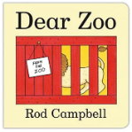  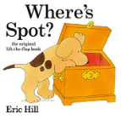  Dear Zoo - Rod Campbell  Where’s Spot? – Eric Hill  You Choose! – Nick Sharratt & Pippa Goodheart  Jasper’s Beanstalk – Nick Butterworth  We’re Going on a Bear Hunt – Michael Rosen
Poetry Spine | Dinosaur Roar!  The Oxford Treasury of Nursery Rhymes  Shark in the Park!  The Puffin Baby and Toddler Treasury
Reading at Home | Children are able to bring in books from home to share with the class, as well as taking books and resources from Pre-School to read at home.
Reading for Pleasure | Daily storytelling sessions are timetabled.  Adults read a range of genres covering poetry, fiction and non-fiction.

Reception
Reading Spine | Lost and Found – Oliver Jeffers  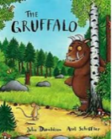  The Gruffalo - Julia Donaldson  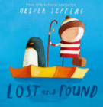  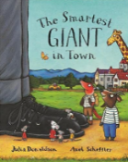  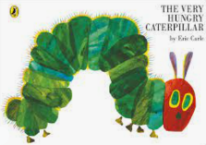  The Smartest Giant in Town - Julia Donaldson  The Very Hungry Caterpillar - Eric Carle  The Bad Tempered Ladybird - Eric Carle  Owl Babies - Martin Waddell  Handa’s Surprise - Elleen Brown  Rosie’s Walk – Pat Hutchins  Whatever Next! – Jill Murphy  The Tiger Who Came to Tea – Judith Kerr
Author of the Term | Julia Donaldson | Oliver Jeffers | Eric Carle
Poetry Spine | My Many Coloured Days  This Little Puffin  A Treasury of Songs  Sharing a Shell
Reading at Home | Children are expected to read at least 4 times a week at home.  Adults at home record when their child reads in their Reading Diary.  Reading Diaries are checked regularly in school.  Every child reads to an adult each week in school and children who do not regularly read at home read more than once a week to an adult in school.
Reading for Pleasure | Daily storytelling sessions are timetabled.  Adults read a range of genres covering poetry, fiction and non-fiction.  Class bookcase available for children to select books from for reading for pleasure.
Reading Assessment | Reading Early Learning Goals:  Word Reading – Say a sound for each letter in the alphabet and at least 10 digraphs. Read words consistent with their phonic knowledge by sound-blending. Read aloud simple sentences and books that are consistent with their phonic knowledge, including some common exception words.  Comprehension – Demonstrate understanding of what has been read to them by retelling stories and narratives using their own words and recently introduced vocabulary. Anticipate – where appropriate – key events in stories. Use and understand recently introduced vocabulary during discussions about stories, non-fiction, rhymes and poems and during role-play.

Year 1
Reading Spine | One Snowy Night – Nick Butterworth  Each Peach Pear Plum - Janet and Alan Ahlberg  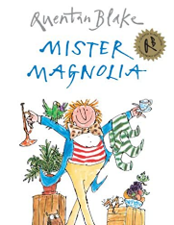  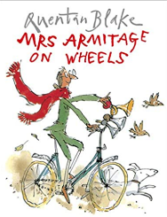  Mister Magnolia - Quentin Blake  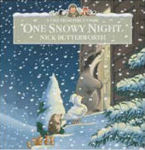  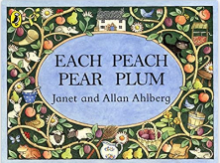  Mrs Armitage - Quentin Blake  Hairy MacLairy - Lynley Dodd  Peace at Last - Jill Murphy  There is no Dragon in this story - Lou Carter  The Rainbow Fish - Marcus Pfister  Not Now Bernard - David McKee  The Lion Inside - Rachel Bright  Pumpkin Soup - Helen Cooper  The three little wolves and the big bad pig - Eugene Trivizas
Author of the Term | Nick Butterworth | Jill Murphy | Quentin Blake
Poetry Spine | Twinkle Twinkle Chocolate Bar  Hey, Little Bug!  When We Were Very Young  The Puffin Book of Fantastic First Poems
Reading at Home | Children are expected to read at least 4 times a week at home.  Adults at home record when their child reads in their Reading Diary.  Reading Diaries are checked regularly in school.  Every child reads to an adult each week in school and children who do not regularly read at home read more than once a week to an adult in school.
Reading for Pleasure | Daily storytelling sessions are timetabled.  Adults read a range of genres covering poetry, fiction and non-fiction.  Class bookcase available for children to select books from for reading for pleasure.  Topic boxes from SSE Somerset Library Services available in class for children to read.
Reading for Pleasure | Topic Related Texts:
Reading for Pleasure | - Stone Girl Bone Girl: The Story of Mary Anning  - The Fossil Hunter  - Dragon Post  - There is no Dragon in this Story
Reading Assessment | 1. Apply phonic knowledge and skills as the route to decode words. (Word Reading)  2. Say sounds for 40+ graphemes, including one grapheme for each of the 40+ phonemes. (Word Reading)  3. Respond speedily with the correct sound to graphemes (letters or groups of letters) for all 40+ phonemes, including, where applicable, alternative sounds for graphemes. (Word Reading)  4. Read accurately by blending sounds in unfamiliar words containing GPCs that have been taught. (Word Reading)  5. Read many common exception words from (English appendix 1). (Word Reading)  6. Read words containing taught GPCs and -s, -es, -ing, -ed, -er and -est endings. (Word Reading)  7. Read aloud many words containing taught GPCs quickly and accurately without overt sounding and blending. (Word Reading)  8. Read other words of more than one syllable that contain taught GPCs. (Word Reading)  9. Read words with contractions e.g. I'm, I'll, we'll, and understand that the apostrophe represents the omitted letter(s). (Word Reading)  10. Read aloud accurately books that are consistent with developing phonic knowledge and that do not require use of other strategies, such as guessing words from pictures or the context of the sentence, to work out words. (Word Reading)  11. Re-read phonically decodable books to build up fluency and confidence in word reading. (Word Reading)  12. Develop pleasure in reading, motivation to read, vocabulary and understanding by listening to and discussing a wide range of poems, stories and non-fiction at a level beyond that at which he/she can read independently. (Comprehension)  13. Develop pleasure in reading, motivation to read, vocabulary and understanding by being encouraged to talk about events in what is read or heard read and link them to his/her own experiences. (Comprehension)  14. Retell some of a familiar story/rhyme, when being read to by an adult (one-to-one or in a small group). (Comprehension)  15. Develop pleasure in reading, motivation to read, vocabulary and understanding by joining in with predictable phrases. (Comprehension)  16. Develop pleasure in reading, motivation to read, vocabulary and understanding by becoming very familiar with key stories, fairy stories and traditional tales, retelling them and considering their particular characteristics. (Comprehension)  17. Develop pleasure in reading, motivation to read, vocabulary and understanding by learning to appreciate rhymes and poems, and to recite some by heart. (Comprehension)  18. Develop pleasure in reading, motivation to read, vocabulary and understanding by discussing word meanings, linking new meanings to those already known. (Comprehension)  19. Understand both the books he/she can already read accurately and fluently and those he/she listens to by drawing on what is already known or on background information and vocabulary provided by the teacher. (Comprehension)  20. Understand both the books he/she can already read accurately and fluently and those he/she listens to by checking that the text makes sense as he/she reads and corrects inaccurate reading. (Comprehension)  21. Understand both the books he/she can already read accurately and fluently and those he/she listens to by discussing the significance of the title and events. (Comprehension)  22. Understand both the books he/she can already read accurately and fluently and those he/she listens to by making inferences on the basis of what is being said and done. (Comprehension)  23. Understand both the books he/she can already read accurately and fluently and those he/she listens to by predicting what might happen on the basis of what has been read so far. (Comprehension)  24. Participate in discussion about what is read to him/her, taking turns and listening to what others say. (Comprehension)  25. Explain clearly his/her understanding of what is read to him/her. (Comprehension)  Answer questions in discussion with the teacher and make simple inferences. (Comprehension)

Year 2
Reading Spine | Traction Man – Mini Grey  Mr Penguin and the Lost Treasure - Alex T Smith  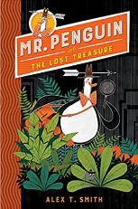  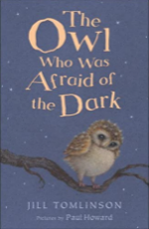  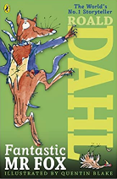  The Owl That’s Afraid of the Dark - Jill Tomlinson    Fantastic Mr Fox - Roald Dahl  The Hodgeheg - Dick King-Smith  Ottoline and the Yellow Cat - Chris Riddell  The Day the Crayons Quit - Drew Daywait  The Tear Thief - Carol Ann Duffy  Where the Wild Things Are – Maurice Sendak  Meerkat Mail – Emily Gravett  Journey - Aaron Becker  The Tin Forest - Helen Ward
Author of the Term | Mini Grey | Alex T Smith | Jill Tomlinson
Poetry Spine | Heard it in the Playground  The Works Key Stage 1  Crazy Mayonnaisy Mum  A First Poetry Book
Reading at Home | Children are expected to read at least 4 times a week at home.  Adults at home record when their child reads in their Reading Diary.  Reading Diaries are checked regularly in school.  Every child reads to an adult each week in school and children who do not regularly read at home read more than once a week to an adult in school.
Reading for Pleasure | Daily storytelling sessions are timetabled.  Adults read a range of genres covering poetry, fiction and non-fiction.  Class bookcase available for children to select books from for reading for pleasure.  Topic boxes from SSE Somerset Library Services available in class for children to read.
Reading for Pleasure | Topic Related Texts:
Reading for Pleasure | - Vlad and the Florence Nightingale Adventure  - Vlad and the Great Fire of London  - The Great Fire of London: an illustrated history  - Toby and the Great Fire of London
Reading Assessment | 1. Continue to apply phonic knowledge and skills as the route to decode words until automatic decoding has become embedded and reading is fluent. (Word Reading)  2. Read accurately by blending the sounds in words that contain the graphemes for all 40+ phonemes. (Word Reading)  3. Recognise alternative sounds for graphemes. (Word Reading)  4. Read accurately words of two or more syllables that contain graphemes taught so far. (Word Reading)  5. Read words containing common suffixes. (Word Reading)  6. Read common exception words, noting unusual correspondences between spelling and sound and where these occur in the word. (Word Reading)  7. Read words in age-appropriate books accurately and fluently without overt sounding and blending, and sufficiently fluently to allow him/her to focus on understanding rather than decoding. (Word Reading)  8. Read aloud books closely matched to his/her improving phonic knowledge, sounding out unfamiliar words accurately, automatically and without undue hesitation. (Word Reading)  9. Re-read books, sounding out unfamiliar words accurately, to build up fluency and confidence in word reading. (Word Reading)  10. Develop pleasure in reading, motivation to read, vocabulary and understanding by listening to, discussing and expressing views about a wide range of contemporary and classic poetry, stories and non-fiction at a level beyond that at which he/she can read independently. (Comprehension)  11. Develop pleasure in reading, motivation to read, vocabulary and understanding by discussing the sequence of events in books and how items of information are related. (Comprehension)  12. Develop pleasure in reading, motivation to read, vocabulary and understanding by becoming increasingly familiar with and retelling a wider range of stories, fairy stories and traditional tales. (Comprehension)  13. Develop pleasure in reading, motivation to read, vocabulary and understanding by recognising simple recurring literary language in stories and poetry. (Comprehension)  14. Develop pleasure in reading, motivation to read, vocabulary and understanding by discussing and clarifying the meanings of words, linking new meanings to known vocabulary. (Comprehension)  15. Develop pleasure in reading, motivation to read, vocabulary and understanding by discussing his/her favourite words and phrases. (Comprehension)  16. Develop pleasure in reading, motivation to read, vocabulary and understanding by continuing to build up a repertoire of poems learnt by heart, appreciating these and reciting some, with appropriate intonation to make the meaning clear. (Comprehension)  17. Understand both the books that he/she can already read accurately and fluently and those that he/she listens to by drawing on what he/she already knows or on background information and vocabulary provided by the teacher. (Comprehension) Understand both the books that he/she can already read accurately and fluently and those that he/she listens to by checking that the text makes sense to him/her as he/she reads and corrects inaccurate reading. (Comprehension)

Year 3
Reading Spine | How to Train your Dragon - Cressida Cowell  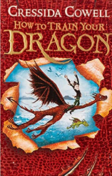  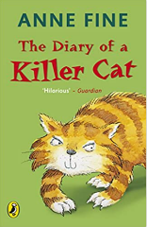  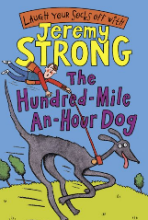    The Diary of a Killer Cat – Anne Fine  The Hundred-Mile-an-Hour-Dog – Jeremy Strong  The Iron Man - Ted Hughes  The Abominable - Eva Ibbotson  The Worst Witch - Jill Murphy  The 13-Storey Tree House - Andy Griffiths  Ugo - Raymond Briggs  The Moonshine Dragon - Cornelia Funk  Dragons at Crumbling Castle - Terry Ratchet
Author of the Term | Cressida Cowell | Anne Fine | Jeremy Strong
Poetry Spine | Quick, Let’s Get Out of Here  The World’s Greatest Space Cadet  Paint Me a Poem  The Puffin Book of Utterly Brilliant Poetry
Reading at Home | Children are expected to read at least 4 times a week at home.  Adults at home record when their child reads in their Reading Record Folder.  Reading Record Folders are checked regularly in school.  Every child reads to an adult regularly in school and children who do not regularly read at home read more than once a week to an adult in school.
Reading for Pleasure | Daily storytelling sessions are timetabled.  Adults read a range of genres covering poetry, fiction and non-fiction.  Class bookcase available for children to select books from for reading for pleasure.  Topic boxes from SSE Somerset Library Services available in class for children to read.
Reading for Pleasure | Topic Related Texts:
Reading for Pleasure | - Stone Age Boy  - How to Wash a Woolly Mammoth  - The Ancient Greek Mysteries  - Amazing Rivers  - Rivers: An Incredible Journey from Source to Sea  - Everything: Romans in Britain  - Roman Boy  - What the Romans Did for Us
Reading Assessment | 1. Apply his/her growing knowledge of root words, prefixes and suffixes (etymology and morphology) both to read aloud and to understand the meaning of new words he/she meets, to include: dis-, mis-, in-, il-, im-, ir-, -ly; (English Appendix 1)  2. Read further exception words, noting the unusual correspondences between spelling and sound, and where these occur in the word (linked to spelling English Appendix 1)  3. Maintain positive attitudes to reading and understanding of what he/she reads by listening to and discussing a wide range of fiction, poetry, plays and non-fiction.  4. Maintain positive attitudes to reading and understanding of what he/she reads by reading books that are structured in different ways  5. Maintain positive attitudes to reading and understanding of what he/she reads by increasing his/her familiarity with a wide range of books, including fairy stories, myths and legends, and retell some of these orally  6. Maintain positive attitudes to reading and understanding of what he/she reads by identifying themes in books  7. Maintain positive attitudes to reading and understanding of what he/she reads by reading aloud poems and perform play scripts  8. Maintain positive attitudes to reading and understanding of what he/she reads by discussing words that capture the reader's interest and imagination  9. Understand what he/she reads independently by checking that the text makes sense to him/her, discussing his/her understanding of words  10. Understand what he/she reads independently by asking questions to improve his/her understanding of a text  11. Understand what he/she reads independently by drawing inferences such as inferring characters' feelings, thoughts and motives from their actions, and justifying inferences with evidence  12. Understand what he/she reads independently by predicting what might happen from details stated  13. Understand what he/she reads independently by identifying main ideas drawn from within one paragraph and summarise these  14. Understand what he/she reads independently by identifying how language, structure, and presentation contribute to meaning to include paragraphs, headings, sub-headings, inverted commas to punctuate speech  15. Retrieve and record information from non-fiction  16. Participate in reasoned discussion about books, poems and other material that are read to him/her and those he/she can read for himself/herself, taking turns and listening to what others say

Year 4
Reading Spine | 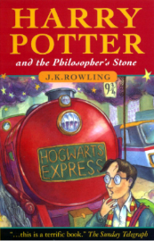  The Witches - Roald Dahl  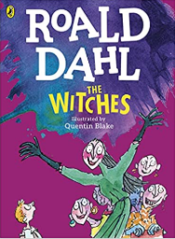  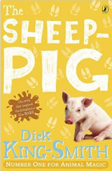  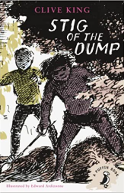  Charlie and the Chocolate Factory – Roald Dahl  Matilda – Roald Dahl  The Sheep Pig – Dick King-Smith  Harry Potter and the Philosopher’s Stone – JK Rowling  Stig of the Dump – Clive King  Varjak Paw - S F Said  The Demon Headmaster - Gillian Cross  Charlotte’s Web - E.B White  Oliver and the Seawigs - Sarah McIntyre
Author of the Term | Roald Dahl | Jacqueline Wilson | JK Rowling
Poetry Spine | Deep in the Green Wood  Hot Like Fire  Hello H₂O  Sensational!
Reading at Home | Children are expected to read at least 4 times a week at home.  Adults at home record when their child reads in their Reading Record Folder.  Reading Record Folders are checked regularly in school.  Every child reads to an adult regularly in school and children who do not regularly read at home read more than once a week to an adult in school.
Reading for Pleasure | Daily storytelling sessions are timetabled.  Adults read a range of genres covering poetry, fiction and non-fiction.  Class bookcase available for children to select books from for reading for pleasure.  Topic boxes from SSE Somerset Library Services available in class for children to read.
Reading for Pleasure | Topic Related Texts:
Reading for Pleasure | - Winter of the wolves  - Anglo-Saxon Boy  - Viking Voyagers  - How to Be a Viking  - The Littlest Viking
Reading Assessment | 1. Apply his/her growing knowledge of root words, prefixes and suffixes (etymology and morphology) both to read aloud and to understand the meaning of new words he/she meets, to include re-, sub-, inter-, super-, anti-, auto-, -ation, -ous; (English Appendix 1)  2. Read and decode further exception words accurately, noting the unusual correspondences between spelling and sound, and where these occur in the word (linked to spelling English Appendix 1)  3. Maintain positive attitudes to reading and understanding of what he/she reads by listening to and discussing a wide range of fiction, poetry, plays, non-fiction and reference books or textbooks  4. Maintain positive attitudes to reading and understanding of what he/she reads by reading for a range of purposes  5. Maintain positive attitudes to reading and understanding of what he/she reads by using dictionaries to check the meaning of words that he/she has read  6. Maintain positive attitudes to reading and understanding of what he/she reads by reading a wide range of books, including fairy stories, myths and legends, and retell some of these orally  7. Maintain positive attitudes to reading and understanding of what he/she reads by discussing words and phrases that capture the reader's interest and imagination  8. Maintain positive attitudes to reading and understanding of what he/she reads by recognising some different forms of poetry e.g. free verse, narrative poetry  9. Maintain positive attitudes to reading and understanding of what he/she reads by identifying themes and conventions in a wide range of books  10. Understand what he/she reads independently by checking that the text makes sense to him/her, discussing his/her understanding and explaining the meaning of words in context  11. Understand what he/she reads independently by asking questions to improve his/her understanding of text with increasing complexity  12. Understand what he/she reads independently by drawing inferences such as inferring characters' feelings, thoughts and motives from their actions, and justifying inferences with evidence clearly taken from the text  13. Understand what he/she reads independently by predicting what might happen from details stated and implied  14. Understand what he/she reads independently by identifying main ideas drawn from more than one paragraph and summarise these  15. Understand what he/she reads independently by identifying how language, structure, and presentation contribute to meaning, to include: paragraphs, use of pronouns for cohesion, inverted commas for speech, apostrophes to mark possession, fronted adverbials  16. Retrieve and record information from non-fiction over a wide range of subjects  17. Participate in clear reasoned discussion about books, poems and other material that are read to him/her and those he/she can read for himself/herself, taking turns and listening to what others say

Year 5
Reading Spine | 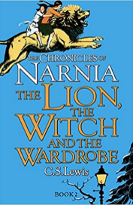  The Butterfly Lion – Michael Morpurgo  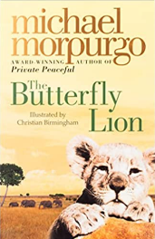  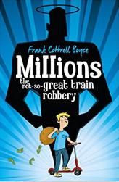  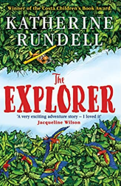  Kensuke’s Kingdom – Michael Morpurgo  War horse – Michael Morpurgo  Millions – Frank Cottrell Boyce  Cosmic - Frank Cottrell Boyce  The Explorer – Katherine Rundell  Rooftoppers – Katherine Rundell  Cogheart (Victorian) - Peter Bunzel  Wolf Brother - Michelle Paver  The Lion the Witch and the Wardrobe - C. S Lewis
Author of the Term | Michael Morpurgo | Frank Cottrell Boyce | Katherine Rundell
Poetry Spine | Lost Magic  The Magic Box  Juggling with Gerbils  The Works 4
Reading at Home | Children are expected to read at least 4 times a week at home.  Adults at home record when their child reads in their Reading Record Folder.  Reading Record Folders are checked regularly in school.  Every child reads to an adult regularly in school and children who do not regularly read at home read more than once a week to an adult in school.
Reading for Pleasure | Daily storytelling sessions are timetabled.  Adults read a range of genres covering poetry, fiction and non-fiction.  Class bookcase available for children to select books from for reading for pleasure.  Topic boxes from SSE Somerset Library Services available in class for children to read.
Reading for Pleasure | Topic Related Texts:
Reading for Pleasure | - Letters from the Lighthouse  - Friend or Foe  - Phoenix  - What was it like to be an Ancient Maya?
Reading Assessment | 1. Read aloud and understand the meaning of new words that he/she meets linked to the expectations of year 5 spelling  2. Maintain positive attitudes to reading and understanding of what he/she reads by continuing to read and discuss an increasingly wide range of fiction, poetry, plays, non-fiction and reference books or textbooks  3. Maintain positive attitudes to reading and understanding of what he/she reads by increasing their familiarity with a wide range of books, including myths, legends and traditional stories, modern fiction, fiction from our literary heritage, and books from other cultures and traditions  4. Maintain positive attitudes to reading and understanding of what he/she reads by recommending books that he/she has read to his/her peers, giving reasons for their choices  5. Maintain positive attitudes to reading and understanding of what he/she reads by identifying and discussing themes and conventions in writing  6. Maintain positive attitudes to reading and understanding of what he/she reads by making comparisons within a book  7. Maintain positive attitudes to reading and understanding of what he/she reads by preparing poems and plays to read aloud and to perform, showing understanding through intonation, tone and volume so that the meaning is clear to an audience  8. Understand what he/she reads by checking that the book makes sense to him/her, discussing his/her understanding and exploring the meaning of words in context  9. Understand what he/she reads by asking questions to improve his/her understanding of complex texts  10. Understand what he/she reads by drawing inferences such as inferring characters' feelings, thoughts and motives from their actions, and justifying inferences with evidence  11. Understand what he/she reads in increasingly complex texts by predicting what might happen from details stated and implied  12. Discuss and evaluate how authors use language, including figurative language, considering the impact on the reader  13. Distinguish between statements of fact and opinion  14. Retrieve, record and present information from non-fiction  15. Participate in discussions about books that are read to him/her and those that can be read for himself/herself, building on his/her own and others' ideas and challenging views courteously

Year 6
Reading Spine | 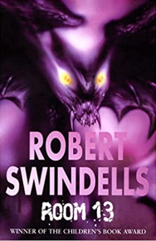  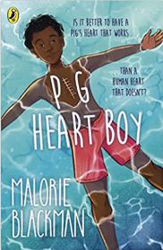  There’s a boy in the girls’ bathroom - Louis Sachar  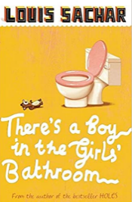  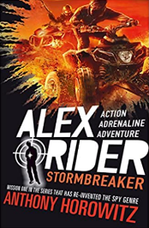  Holes - Louis Sachar  Stormbreaker – Anthony Horowitz  Room 13 (suspense) - Robert Swindells  Wonder - R J Palacio  Who Let the God’s out - Maz Evans  Skellig - David Almond  Sky Song - Abi Elphinstone  Philip Pullman – Clockwork  Pig Heart Boy – Malorie Blackman
Author of the Term | Louis Sacher | Anthony Horowitz | Emma Carroll
Poetry Spine | Ted Hughes: Collected Poems for Children  Carol Ann Duffy: New and Collected Poems for Children  Charles Causley: Collected Poems for Children  The Works Key Stage 2
Reading at Home | Children are expected to read at least 4 times a week at home.  Adults at home record when their child reads in their Reading Record Folder.  Reading Record Folders are checked regularly in school.  Every child reads to an adult regularly in school and children who do not regularly read at home read more than once a week to an adult in school.
Reading for Pleasure | Daily storytelling sessions are timetabled.  Adults read a range of genres covering poetry, fiction and non-fiction.  Class bookcase available for children to select books from for reading for pleasure.  Topic boxes from SSE Somerset Library Services available in class for children to read.
Reading for Pleasure | Topic Related Texts:
Reading for Pleasure | - Street Child  - The little match girl  - Secrets of a Sun King  - Hunt for the Golden Scarab
Reading Assessment | 1. Read aloud and understand the meaning of new words that he/she meets linked to the expectations of year 6 spelling  2. Maintain positive attitudes to reading and understanding of what he/she reads by reading books that are structured in different ways and reading for a range of purposes  3. Maintain positive attitudes to reading and understanding of what he/she reads by increasing his/her familiarity with a wide range of books, including from our literary heritage and books from other cultures and traditions  4. Maintain positive attitudes to reading and understanding of what he/she reads by identifying and discussing themes and conventions in and across a wide range of writing  5. Maintain positive attitudes to reading and understanding of what he/she reads by making comparisons within and across books  6. Maintain positive attitudes to reading and understanding of what he/she reads by learning a wider range of poetry by heart  7. Read age-appropriate books, including whole novels, with confidence and fluency  8. Understand what he/she reads by summarising the main ideas drawn from more than one paragraph, identifying key details that support the main ideas and using quotations for illustration  9. Understand what he/she reads by identifying how language, structure and presentation contribute to meaning  10. Discuss and evaluate how authors use language, including figurative language, considering the impact on the reader  11. Participate in discussions about books that are read to him/her and those that can be read for himself/herself, building on his/her own and others' ideas and challenging views courteously and with clear reasoning  12. Explain and discuss his/her understanding of what he/she has read, including through formal presentations and debates, maintaining a focus on the topic and using notes where necessary  13. Provide reasoned justifications for his/her views

