

EAL POLICY

Lead Teacher: Mrs. Taswinder Heer-Smith

Rationale
At Moat Community College, we believe that all staff and students have the right to work in a safe, courteous, stimulating and happy environment, conducive to effective learning for all. We are all entitled to strive towards “Maximising Our Achievements Together”. Every member of the school community has a responsibility to develop student potential and everyone has the right to feel valued and respected.

We believe that the development of student potential should be a partnership between home and college and we will try to make this partnership as effective as possible. In all aspects of our work, we recognise that all students are individuals with different backgrounds and abilities, and that any actions/interventions we put in place should support the growth of the individual.

Aims
This policy aims to specifically support.
‘all pupils who use or have access to more than one language at home or at school – it does not necessarily imply full fluency in both or all languages’ (DfES 2003).

It aims to:
• Welcome and value the cultural and linguistic experiences that these students bring to the college. • Implement strategies across the college which help these students to access the curriculum.
• Develop English language skills so they can fulfil their potential.
• Recognise that EAL students who may seem fluent still deserve some intervention.
• Ensure that they are effectively prepared for the opportunities, responsibilities and experiences of life in British society.
• To promote the understanding that limited English does not reflect a lack of ability or lack of literacy in the mother tongue.
• To promote the understanding that EAL is not the same as SEN.
• To promote the ethos that language development is the responsibility of all staff.

Strategies

• Regular training of staff to ‘buy in’ to the immersion principle for newcomers and to recognise that for many students there will be an initial ’silent period’.
• Regular training of staff to give them classroom strategies for EAL students
• To employ EAL specialists to provide structured intervention and mainstream support.
• To employ EAL specialists to provide specific language-based intervention through withdrawal. • To employ staff who can offer more than one language.
• To provide resources to support language acquisition.
- To be committed to contacting parents/carers in an accessible manner

Monitoring and evaluation

All staff are expected to track the progress of their students. The Head of Department has specific responsibility to look for underachievers and implement targeted interventions. Where students have no baseline data at KS2, the college will use CATs tests to find out more about the student’s potential. This will be shared with all teaching staff. The Head of Department will also track pastoral related data (attendance, rewards and sanctions).

As a school we record the proficiency of students English acquisition on SIM’s through the DFE EAL categories as set out in February 2020, and shown below.
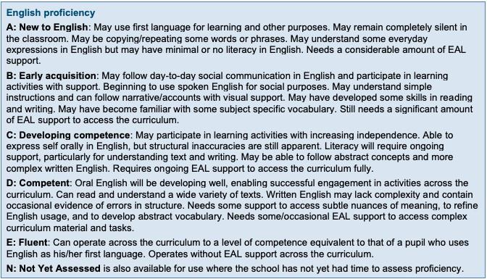

Linked policies:

Behaviour policy

Medical policy

Child Protection policy

SEND policy

Teaching and Learning policy.

Equality and Diversity statement

