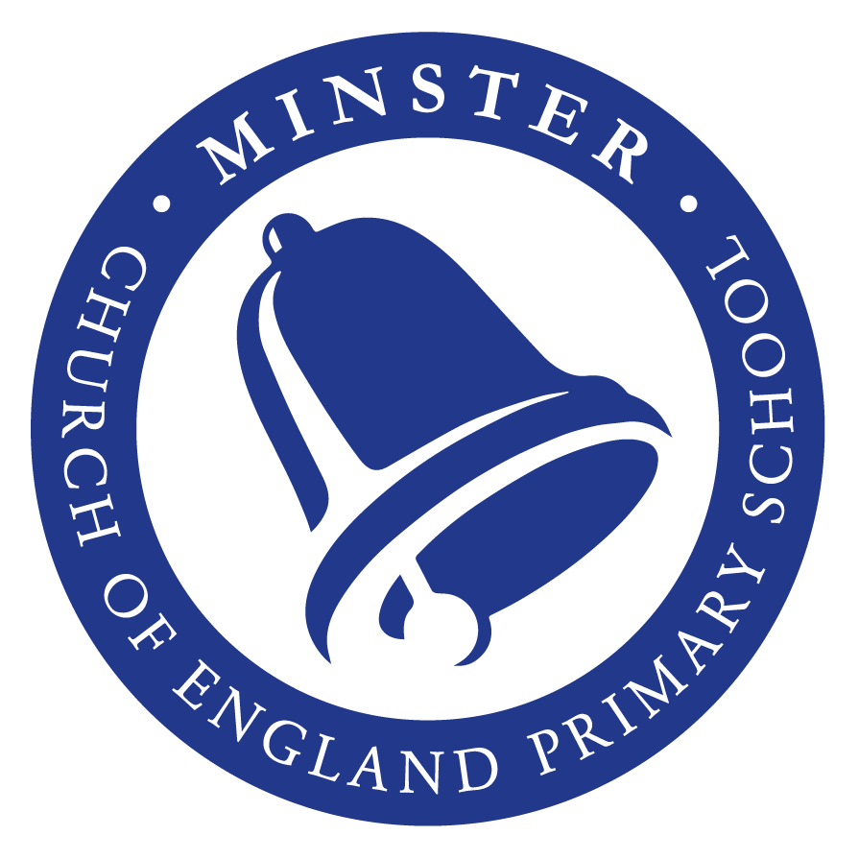

Federation of Minster and Monkton
Church of England Primary Schools

Admissions Policy

Lead Person: EHT

Policy Date: September 2022

Review Date: September 2023

Signatures:

_______________________ ________________________
Chair of Governors Executive Headteacher

  Minster Church of England Primary School |   Monkton Church of England Primary School
Nurturing Foundations, Flourishing With God | Compassion, Courage, Justice  Jesus said, ‘Go and do the same.’
Rooted in our Christian Foundations, we nurture, respect and value each individual, in the loving community of our village school.  Through our holistic development of both character and curriculum, our children learn and flourish.  From little seeds we grow: caring for God’s world, building lifelong foundations and striving for a just and harmonious society. | Our school has compassion at its heart, which inspires us to be people of courage, who care for ourselves, stand with others and seek justice as we grow and discover the world around us.  By knowing each individual, our learning environment is shaped to encourage creativity, promote challenge through our learning values and nurture spirituality, ensuring all thrive.
The Mustard Seed  Matthew 13:31-32 English Standard Version Anglicised (ESVUK) | The Parable of the Good Samaritan  Luke 10:25-37 English Standard Version (ESV)
Christian Foundations
Creation Justice Love  Forgiveness Peace | Compassion Courage  Justice
As a Federation, we are passionate about every individual flourishing, so that they can be nurtured and develop as well-rounded children, living life in all its fullness.

Every policy is written with our Christian Vision and Foundations in mind.

Admission arrangements for a child to a school in our Federation, are in accordance with those published by the Kent Local Education Authority.
Minster CEP School
Pupil Admission Number (PAN) Year group :- 60
Pupil Admission Number (PAN) Whole School 420
Monkton CEP School
Pupil Admission Number (PAN) Year group :- 15
Pupil Admission Number (PAN) Whole School 105

Process of Admission
- Parents are invited to make an appointment at an open day session to look around school if the place is needed in Foundation Stage for a September start. If the request for a place is part of the in-year casual admissions process, an appointment needs to be made through the school office to arrange for a tour of the school.
- New children (4 year olds) are gradually phased in during their first term. Parents will be invited to a pre-school assessment meeting with their teacher within the first two weeks prior to their child starting school.
- We admit children once a year in September when they are four years old. All children therefore enjoy 17 full terms and 1 part-time term before the end of Key Stage 1 (infants).
- In term 6 prior to admission, parents and children have several opportunities, including an Open Day and Familiarisation Day, to meet staff in the Foundation Stage.
Information on the process and the on-line application links can be found on the KCC website. Please follow this link:
http://www.kent.gov.uk/education-and-children/schools/school-places/primary-school-places
Parents of children with a disability are asked to meet with the Inclusion Leader to discuss how best the school can meet the needs of the child.

Oversubscription
As a Kent County Council School we are governed by their admission arrangements and over subscription criteria.
The criteria used to prioritise applications when there is over-subscription are detailed on KCC’s website. A link to the document can be found below (this opens as a pdf file.)
https://shareweb.kent.gov.uk/Documents/education-and-learning/school-education/applying-for-school.

A summary of the over-subscription criteria for all Community and Voluntary Controlled primary schools is outlined below:

- Children in Local Authority Care – a child under the age of 18 years for whom the local authority provides accommodation by agreement with their parents/carers (Section 20 of the Children Act 1989) or who is the subject of a care order under Part IV of the Act.
- Current Family Association - a brother or sister in the same school at the time of entry where the family continue to live at the same address as when the sibling was admitted – or – if they have moved – live within 2 miles of the school, or have moved to a property that is nearer to the school than the previous property as defined by the ‘Nearness’ criterion’ (below). Linked infant and junior schools are considered to be the same school for this criterion. In this context brother or sister means children who live as brother and sister in the same house, including natural brothers or sisters, adopted siblings, stepbrothers or sisters, foster brothers or sisters.
- Health and Special Access Reasons - children whose health or physical impairment means they have to attend a particular school. Health reasons must be strong and must be supported with evidence in writing by a medical practitioner. The evidence must demonstrate a special connection between the child's needs and the particular school. A physical impairment must be such that it requires the child to attend a particular school because its buildings do not inhibit his/her mobility.
- Nearness of children's homes to school - we use the distance between the child’s permanent home address and the school, measured in a straight line using Ordnance Survey address point data. Distances are measured from a defined point within the child’s home to a defined point within the school as specified by Ordnance Survey.

In Year Admissions/Casual – starting school mid-year or at the beginning of years 1-6
For casual admissions we follow the Kent Admissions Policy. Please follow the link to KCC’s website where you can download the form required should you wish to apply for a place at Minster Church of England Primary School or Monkton Church of England Primary School.
http://www.kent.gov.uk/education-and-children/schools/school-places/move-to-a-different-school

