Monkton Church of England Primary School

Character Education and Cultural Capital Policy

Lead Person: Chris Marston

Policy Date: November 2022

Review Date: November 2025

Signatures:
__________________ _________________
Chair of Governors Executive Headteacher
Federation of Monkton and Monkton Church of England Primary Schools
MONKTON CHURCH OF ENGLAND PRIMARY SCHOOL
‘In God’s Eyes, Everyone is Special’

Our school has a warm, Christian family ethos where our children thrive in a secure and happy atmosphere. They are fully supported and nurtured from when they join us until they leave our care.
Monkton Primary School is a Church of England Primary School and our Christian Foundations are at the heart of everything we do.
- Compassion
- Friendship
- Forgiveness
- Justice
- Trust

Every school policy is written with this in mind.
Character Education Policy
Monkton Church of England Primary School
Introduction

As a Church of England school, we have a very clear vision in terms of ‘Who are we?’ (See our Vision)

Our Character Education policy clearly outlines our approach in terms of ‘How do we live?’ (This policy)

This is supported by our strong curriculum that demonstrates ‘How do we learn?’ (See our Curriculum Policy)

Core Purpose

At Monkton we believe that our core purpose is to prepare and enable our children to be ready to be active and valued members of our society. We believe there is a strong link between character development and attainment. However, as a school, we do not limit our definition of pupil success to measurable outcomes such as examination results or attendance figures. We want all our children to flourish in our world and to understand their value as an individual as shown in our motto, ‘In God’s Eyes, Everyone Is Special.’

To do this, we believe that there must be a focus on Character Education and how through this, we can help children’s development of their own self, their self-esteem and confidence with a consideration of, and respect for others. This will develop their knowledge and awareness of wider spiritual, social, moral and cultural understanding, enabling them to develop as rounded individuals and fulfil their potential.

What is Character Education?

‘Character education seeks to develop and celebrate the flourishing of individuals, communities, families and societies, through the cultivation and encouragement of an expansive range of moral, spiritual, intellectual, civic and performance character virtues.’

‘It is central to a Christian vision for education for ‘life in all its fullness’ and is concerned with developing virtues seeing them as ‘character in action’, grown through experience and demonstrated over time in word and deed.’ (Church of England)

We have a role in ensuring that we develop our students holistically to ensure that they are well-rounded individuals, ready for the next step. Character Education at Monkton is found throughout the school; a golden thread that weaves through our curriculum and the daily lives of our children. This will develop their spirituality and their character regardless of any religious faith or non.

Character Education at Monkton is developed through the Windows, Mirrors and Doors approach.

Window: The school community of both staff and pupils, supported by our parents/carers, provide the example, culture and the inspirational influence in a positive ethos that motivates and promotes character development. The school provides educational experiences in and out of the classroom that equip pupils with the language, knowledge, understanding, skills and attributes that enable character development.

Mirror: The school give the children the time and the opportunity to reflect on, and think deeply about, a variety of things that allow character development. This may be related to lessons in class, Collective Worship, activities and events that happen both inside school and in the wider world. The school allows the children time and space to reflect on how these things make them feel, affect their own behaviour and the effect on others and the world we live in. This allows them to make up their own mind about what they think, feel, believe and what they want to act on.

Door: The school provides varied opportunities that generate the formation of personal habits and character commitments. These help pupils over time to seek, desire and freely pursue their character development and decide how they want to act and make a difference or contribution to our society.

This means that Character Education can be in many aspects of school life, including (but not limited to); school rules, behaviour expectations, displays, lessons, collective worship and the way everyone in school speaks to and treats each other, with respect and a positive attitude.

All adults in school are expected to be good role models. They encourage positive feelings of self-worth in all children, as well as in each other. We believe strongly in the important role we play in shaping our children’s future and through developing their character, we are increasing their chances of success in life.

Objectives

Schooling is a preparatory stage for adulthood. Schools play an integral role in helping children become responsible for themselves, for each other and for their world. Since we hold Character Education of such high importance at Monkton, we aim for all of our students to be well-rounded individuals when they leave and to be well on the path to be able to:

- have the ability to be independent and use their initiative
- have a sound understanding of right and wrong
- have high self-esteem
- be confident communicators
- be reflective and independent thinkers
- be enquiring, flexible and creative
- to be aspirational and make the most of opportunities
- be co-operative, adaptable and able to work as a team
- develop a sense of belonging that allows them to have a voice and to influence society
- be good role models for future generations
- value diverse life-styles, cultures and faiths
- have concern for their environment
- make reasoned, informed and ethical choices
- understand and apply our core Christian Foundations

As well as evolving their own spiritual understanding, we want our children to develop a set of character virtues, attributes and behaviours that underpin success in their education, work and personal life.

This chart below helps to show you how everything fits into Character Education. The Christian Ethos of our school (our motto, Christian vision and narrative) are overarching and permeate through all we do. Our Christian Foundations help to explain ‘Who are we?’ and then guide ‘How do we live?’.
How we then live our daily lives, is developed by our personal qualities and how we choose to use them. We may demonstrate our own thoughts, feelings and personal beliefs through our actions, becoming ‘Foundation Champions’, regardless of whether we have a religious faith or none.

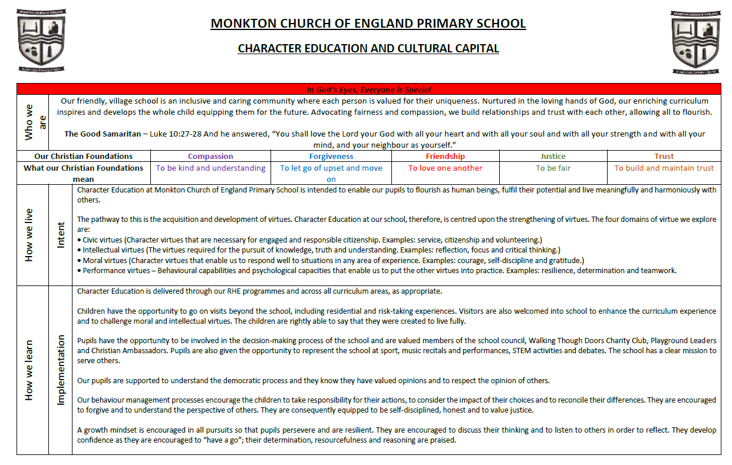

Christian Foundations

As a Church of England School our Christian Foundations are an integral part of our school vision and ethos and they form the backbone of our school. We recognise that not all of our children are from a Church of England background, however, we believe that our foundations, our ethos, and our opportunities for character development, enable the development of character education and are key to developing all children, regardless of their ethnicity, cultural or religious background.

Our motto is ‘In God’s Eyes, Everyone Is Special’ which highlights our vision. Under this statement sit our Christian Foundations. These are five key foundations that are part of our everyday lives at Monkton. They are:

Compassion: To be kind and understanding
At Monkton, we teach our children the importance of respecting and valuing all life, including their own and to do the same for the world in which we live.

Forgiveness: To let go of upset and move on
At Monkton, we teach our children the importance of both giving and asking for forgiveness. We recognise that this isn’t always easy and when asking to be forgiven, we must strive to make changes so that we are not in the same situation again.

Friendship: To love one another
At Monkton, we teach our children that they should care for everyone in our society. Acting with love and friendship, even when we don’t get on or when we disagree. Looking after each other and caring for our neighbour is part of who we are.

Justice: To be fair
At Monkton, we teach our children to try to act out of concern for what is right and to see right prevail. This foundation is about social justice, especially for those who suffer most and are least able to protect themselves. It is about treating each other fairly.

Trust: To build and maintain trust
At Monkton, we teach our children about the importance of trust and living together in harmony. This includes working together as a team, supporting each other and valuing the contributions of all.

These foundations demonstrate how we expect everyone at Monkton to live and learn together as a school community. By promoting our foundations in our daily lives, we model and give guidance of how to be good citizens. They are the backbone of our children’s character development.

A major aspect of this is Spiritual Development and the development of Character Virtues. Please read about both of these areas in more detail below.
Spiritual Development at Monkton

All children, regardless of religious backgrounds, need to develop spiritually. A useful definition of spiritual development is one from Ofsted as it clearly explains what is meant by it.

‘Spiritual development is shown by a pupil’s ability to be reflective about their own beliefs, religious or otherwise, that inform their perspective on life and their interest in and respect for different people’s faiths, feelings and values.’

Everything we do in school can develop our pupil’s spiritual development. We intend to develop our children’s spiritual capacities, including our children’s ability to:

- be guided by their beliefs and values and be willing to take a stand to defend them
- be self-aware and empathise with the experience of others in the school and wider community
- love themselves, care for themselves, believe in their potential to achieve, and find inner strength and resilience when facing challenges
- exercise imagination and creativity, appreciate beauty in the world and be alive to experiences of awe and wonder
- be intrigued by mystery and be open to an awareness of the transcendent in the whole of life
- be comfortable with stillness and silence and open to engage in reflection/meditation/prayer
- be ready to say sorry when mistakes are made, to forgive themselves and to forgive others
- be willing to take risks and to reflect, learn and grow following experiences of failure as well as success
- demonstrate curiosity and open mindedness when exploring life’s big questions
- appreciate and be thankful for what is good in life and show generosity towards others

(Taken from Imaginor Ltd, November 2018)

At Monkton, we develop these capacities by also using the ‘Windows, Mirrors, Doors’ model (Liz Mills) as a way to describe the journey, from experience (window), through reflection (mirror) to growth and transformation (door).

Windows: giving children opportunities to become aware of the world in new ways; to wonder about life’s ‘WOWs’ (things that are amazing – which can be small or huge) and ‘OWs’ (things that bring us up short). In this, children are learning about life in all its fullness.

Mirrors: giving children opportunities to reflect on their experiences; to meditate on life’s big questions and to consider some possible answers. In this they are learning from life by exploring their own insights and perspectives and those of others.

Doors: giving children opportunities to respond to all of this; to do something creative as a means of expressing, applying and further developing their thoughts and convictions. In this they are learning to live by putting into action what they are coming to believe and value.

Opportunities for spiritual development are woven through our curriculum as part of our golden thread of character education. As a Church of England school, some are given within Collective Worship, RE lessons and through the promotion of our Christian Foundations, however it is important to recognise that opportunities are not just based on our Christian nature. We want our children to develop their spirituality as members of our local and the wider community regardless of their own beliefs, faith or ethnicity.

Therefore, at Monkton our children have the opportunities for spiritual development at the core. We then also develop their characters further, by cultivating character virtues (personal qualities) which are then modelled by all. Our ‘Foundations Champions’ help to demonstrate this – see further on in our policy.

Character Virtues - An adult perception and explanation

Although with the children we do not intend to go into the wording of ‘character virtues’ and the areas they divide into, we feel a brief explanation for adults may help to understand the background.

When Character Development is discussed often it can describe the development of character virtues. These can be Intellectual Virtues, Moral Virtues, Civic Virtues and Performance Virtues. These look at the different areas in which character virtues can be developed to allow children to:

- Develop wisdom, think critically and reflect on life (Intellectual virtues)
- Make choices that uphold the good for ourselves and our communities and develop the proper regard for individual dignity and the respect of others (Moral Virtues)
- Enable us to live successfully and harmoniously in groups, communities and societies (Civic Virtues)
- Make things happen and get things done (Performance Virtues)

Although this is important for adults to understand, we want to concentrate in school in developing this in a way that makes it clear and easy for the children to understand.

We encourage our children, through discussing the way they themselves, act and behave, as well as the modelling from those around them, to develop the following:

- To reflect and think deeply
- Being kind and caring to all
- Being respectful and tolerant
- Being compassionate to others, including standing up for those who need it (Courageous Advocacy)
- Developing a sense of community and doing things for others (Social Action)
- Equality and Fairness to all
- Understanding we have a voice and the idea of choice (Democracy and Liberty)
- Positive: To be confident and hopeful so we take the good aspects of a challenging situation
- Resourceful: To use our own skills and what is around us to be successful
- Innovative: To think and act creatively
- Determined: To not give up
- Engaged: To be motivated and in the flow

If our children can develop these personal qualities, through Character Education, as they move through our school, we know they will really flourish as members of our society.

We also give our children the opportunity to use these qualities, for their own learning and reflection, as well as to help others and make a difference in our society.

We do this by developing our Foundation Champions!

Foundation Champions

Our Foundation Champions, the character traits they exhibit and the way they act, can show a window to the wider world for our children, they can allow a mirror to reflect and develop our children’s thinking and then open the door to allow them to decide how they want to act and live their lives. This gives them the opportunity to make their own decisions about what they think, what they believe in and how they want to act and live their own lives.

Meet our Foundation Champions

- Compassion Champion
- Forgiveness Champion
- Friendship Champion
- Justice Champion
- Trust Champion

By talking about things that our Foundation Champions do, we can, over time, build in all the character virtues and spiritual development as shown above (the personal qualities), into everyday school life.

How children become a Foundation Champion

Throughout the week, children can nominate someone to be a Foundation Champion if they see any act that should merit a nomination. The Christian Ambassadors then choose a Foundation Champion each week for each of our Foundations. The champions then receive a sticker which they place on their grid. Once they have all 5 foundations (been a champion in all 5 foundations) then they receive a prize.

All of this develops our children’s character and it can be discussed and reinforced as part of every day school life.

Behaviour in School

This obviously also the main stay of behaviour in school, both the school rules and expectations. All school rules are linked with our foundations and are relevant for the expected behaviour and personal qualities of our children.

Monkton Church of England Primary School Rules
Compassion | To be kind and understanding
Forgiveness | To let go of upset and move on
Friendship | To love one another
Justice | To be fair
Trust | To build and maintain trust

This also an essential in how we manage behaviour as we use Restorative Justice at Monkton.

Restorative Justice

Restorative Justice is based on 4 key features:
- RESPECT: for everyone by listening to other opinions and learning to value them
- RESPONSIBILITY: taking responsibility
- REPAIR: developing the skills within our school community so that its individual members have the necessary skills to identify solutions that repair harm and ensure behaviours are not repeated
- RE-INTEGRATION: working through a structured, supportive process that aims to solve the problem

If we ‘are’ our Christian Foundations, how then do we live?
- Use our Christian Foundations as a basis for dealing with conflict and for deciding next steps.
- Our school rules are based on the Christian Foundations – we use them to help challenge negative choices and to recognise excellent behaviour.
- By doing this we are encouraging children to live out the Christian Foundations – this leads to a happier community and ultimately, better learning.

What does this look like at Monkton?

We go through the four steps with the children involved, discussing calmly. All adults in the school have prompt questions for each step, along with the school rules, on their lanyards; this is so they are accessible to all whenever the need might arise.

The four steps at Monkton and how they are conducted:
- RESPECT: Calmly discussing what has happened (there may need to be adult intervention for this, especially to begin with). Everyone will have their voice heard in a respectful way.
- RESPONSIBILITY: Being honest about your own actions and taking responsibility.
- REPAIR: Asking our children, ‘Which of our Christian Foundations can we use to sort this out?’
- RE-INTEGRATION: Asking the children, ‘Which Christian Foundation can you use the next time you are in this situation to help you?’ Then, ‘What shall we do about this now? What do you think our next step should be?’

Our behaviour reflection form follows the Windows, Mirrors, Doors approach so children understand the process clearly as this is something that has been embedded throughout the school. See below…

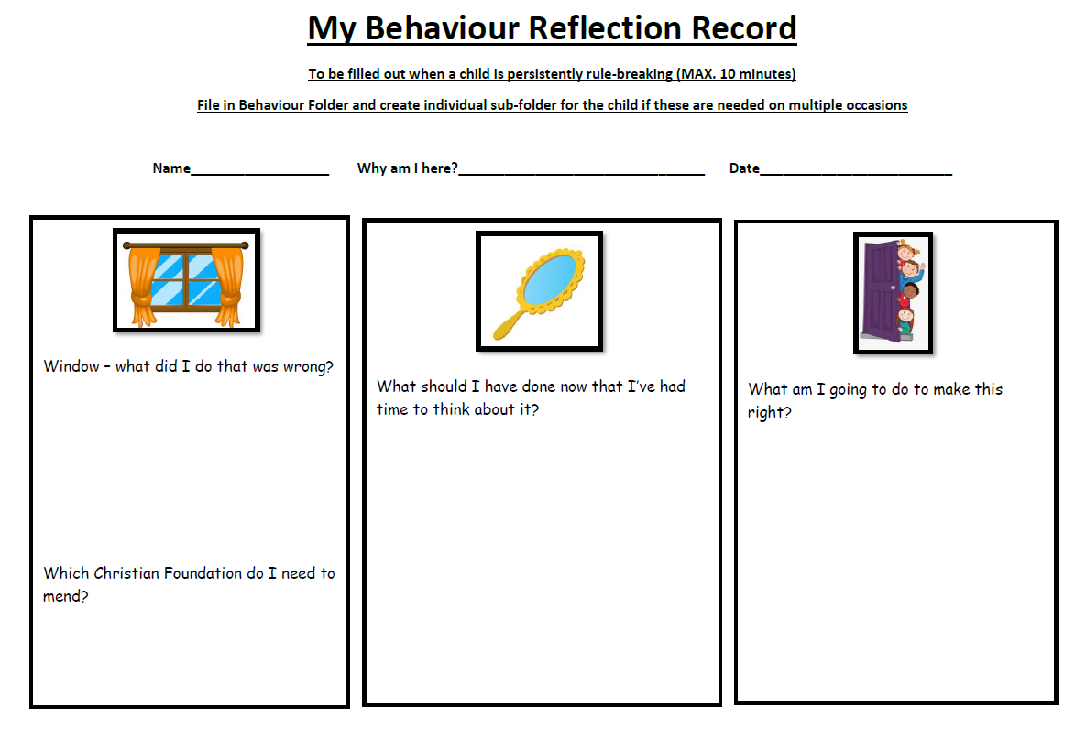

This process helps all the children in the conflict to feel supported, and there is a chance to ‘come back’ from the incident. It also helps the wronged party, and the person in the wrong, come up with a sanction that is fitting and just.

Our Curriculum

How does Character Education support teaching and learning?

Character Education helps children to grow up as responsible, independent, open-minded members of society, but it also enhances their learning across the curriculum. By teaching character, we are encouraging children to develop skills that are necessary in almost every lesson in school. If we develop the student holistically from Year R, we believe that we are giving them the right tools when it comes to adolescence and all its challenges. A child must have the emotional resilience that character education develops, to ensure that they succeed and are ready for the next steps.

Character education also develops the confidence and self-belief that children need in order to succeed educationally. We employ a holistic approach to developing character at our school – the ‘golden threads’ of character education weave through our curriculum and develop well-rounded, resilient and capable children.

Our approach to learning, allows a clear pathway for teaching and learning and we then use curriculum vehicles to help deliver the skills, knowledge and experiences to our children. However, the golden thread of character education still runs through all of these.

We use the following curriculum vehicles:
- Curriculum Maestro
- Understanding Christianity
- Heartsmart

Curriculum Maestro

Maestro allows us as a school to choose cross curricular learning that is appropriate and valid for our children. Each year group carefully plans 3-6 projects a year that are used as a vehicle to deliver the National Curriculum. However, these are chosen to reflect the needs and interests of our children. Each Imaginative Learning Project (ILP) has identified strands within it, which demonstrate how Character Education is woven into our curriculum.

When the overview for the year is planned (long term plan), specific opportunities for Character Education are identified and these are recorded on this plan.

Understanding Christianity

As a Church of England School, we follow Understanding Christianity to deliver our RE. It is an excellent way to deliver the knowledge the children need to have, however, more importantly it is a great vehicle for asking ‘Big Questions’. This allows our children to consider the big questions of life, to reflect and analyse their own thoughts, ideas and beliefs. It allows our children the opportunities to question and explore their thoughts and beliefs about our world.

Heartsmart

Heartsmart is a vehicle we use to deliver Relationships, Health and Sex Education in our school. Many of the areas covered are strongly linked to Character Education and our Christian Foundations (see RHE Policy for more information)

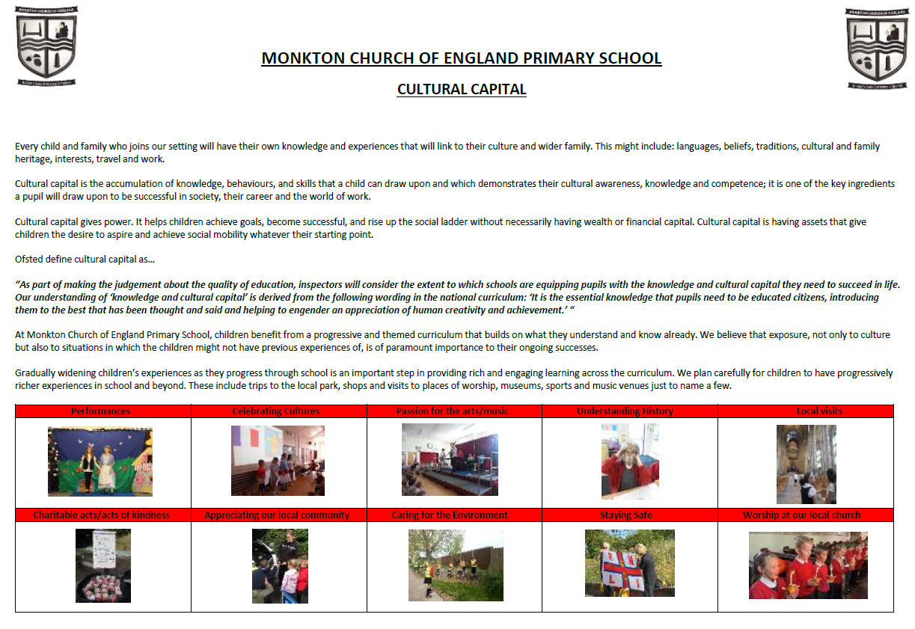

Other Opportunities

As a school we also provide many other opportunities for our children to experience, take part in, organise etc. that enrich both our curriculum and the children’s character development. There are examples of this on the next page.
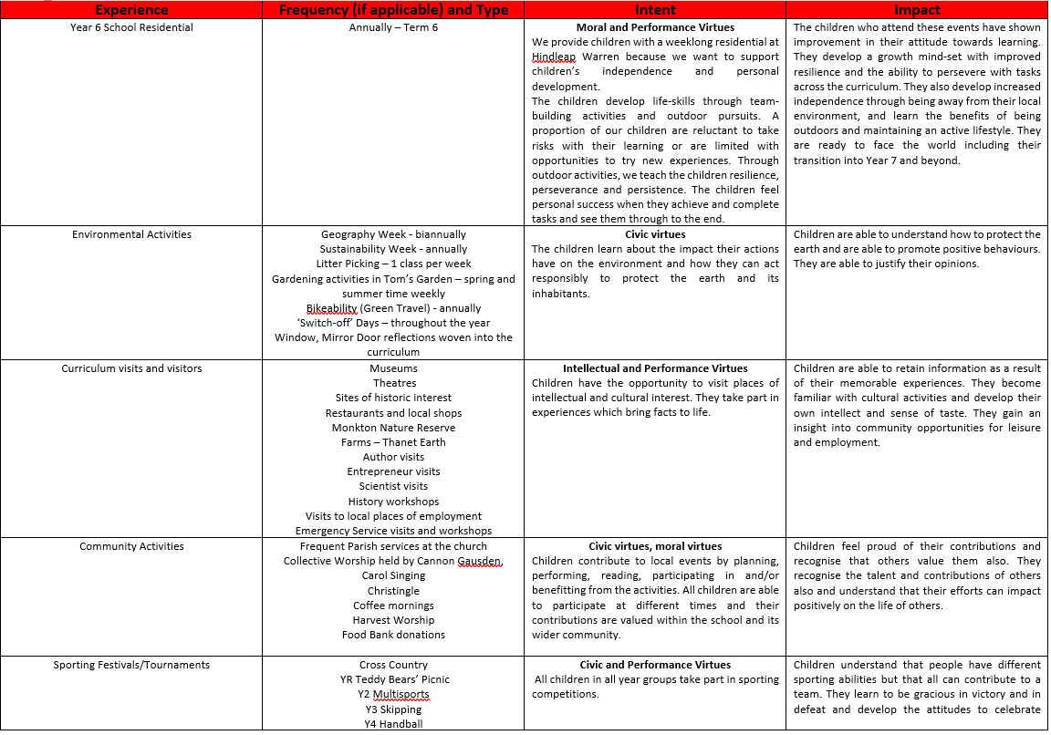

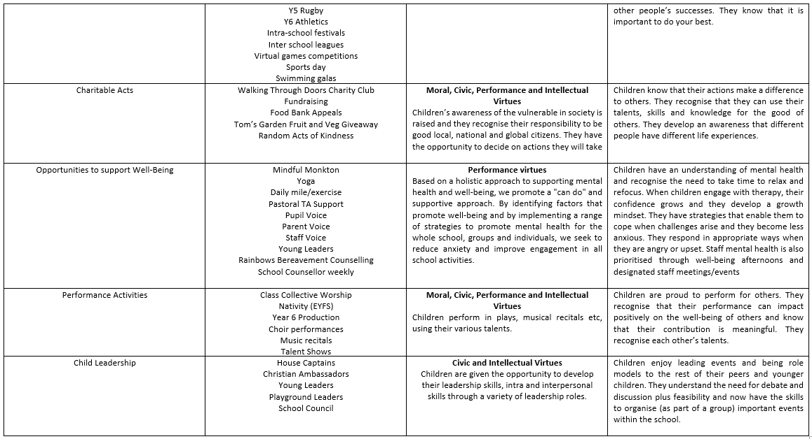

Staff

We recognise that our staff play a vital part in this, and have to be acting as role models for pupils to learn from. This is the case for all staff, whether they are teachers, TAs or support staff. Our same expectations are in place for our Governors and for parents.

There are regular messages/sessions with staff about the importance of character education and the role that they play. Questions around Character Education will form part of the interview process for potential new staff and all staff will complete CPD on character development.

Our staff lead by example for our children in terms of character education. This means that in school the expectation is, that they live, work and act in a manner that is consistent with our Christian Foundations, just as our Foundations Champions do, demonstrating how to live our lives.

As a Church of England School, we may talk to the children about what Christians believe, but the message of our Foundations Champions is one of an inclusive nature – developing good character virtues, for adults and children of all faiths or none, in order to develop as well-rounded people, living life in all its fullness.

Therefore, all staff must follow school policy in these areas.

An example of this would be our expectations about interactions with any adult or child in our school. The expectations are that all (child or adult), are treated with respect as well as treating others in the same way. We expect everyone to be treated with fairness and all to be tolerant of the faith and beliefs of others.

When staff plan learning they are expected to ensure that the golden thread of character education in the forms discussed in this policy are woven through the learning and experiences of the children in their class.

Parents

Parents play a crucial role within the process. We ensure that parents are aware of what we are trying to do and actively encourage them to reinforce our character education and the character virtues at home. We believe that it is really important for the school and home to work together as obviously character education happens at all times and in all places. Every experience that our children have shapes their character and futures and we want to work alongside our parents to offer our children every opportunity we can, and any support they need.

Monitoring and Evaluation

The delivery and impact of Character Education is a continuous improvement process. There is no one specific way in which to measure the impact but we triangulate a variety of different processes/methods including:
- School evaluation tool (Jubilee Centre)
- Coverage of scheme of work
- Staff feedback
- Pupil feedback
- Parental feedback
- Increased children's knowledge and understanding
- Improved and strengthened characteristics and behaviours
- Attendance issues
- Leuven’s scale data where appropriate
- Students work/display
- Governor monitoring
- Social media / website / newspaper etc?
- Feedback from local residents and external bodies the school works with
- Feedback from the Church
- General public / school trips etc. Always lots of praise for our pupils!

Related Policies

This policy should be read in conjunction with:
- Our school Christian Vision
- Curriculum intent statement
- Curriculum booklet
- Relationships, Sex and Health Education (RSHE) Policy
- Collective Worship Policy
- RE Policy
- Behaviour Policy
- SEND Policy

