Monkton Church of England Primary School

Monkton Church of England Primary School
Curriculum (Teaching and Learning) Policy
Lead Person: Chris Marston
Policy Date: September 2022
Review Date: September 2025
Signatures:
__________________ _________________
Chair of Governors Executive Headteacher
MONKTON CHURCH OF ENGLAND PRIMARY SCHOOL
Federation of Minster and Monkton Church of England Primary Schools
‘In God’s Eyes, Everyone is Special’
Our friendly village school, is an inclusive and caring community where each person is valued for their uniqueness.
Nurtured, in the loving hands of God, our enriching curriculum inspires and develops the whole child equipping them for the future.
Advocating fairness and compassion, we build relationships and trust with each other, allowing all to flourish.

The Parable of the Good Samaritan
Luke 10:25-37 English Standard Version (ESV)

²⁵ And behold, a lawyer stood up to put Jesus to the test, saying, “Teacher, what shall I do to inherit eternal life?” ²⁶ He said to him, “What is written in the Law? How do you read it?” ²⁷ And he answered, “You shall love the Lord your God with all your heart and with all your soul and with all your strength and with all your mind, and your neighbour as yourself.” ²⁸ And he said to him, “You have answered correctly; do this, and you will live.”
²⁹ But he, desiring to justify himself, said to Jesus, “And who is my neighbour?” ³⁰ Jesus replied, “A man was going down from Jerusalem to Jericho, and he fell among robbers, who stripped him and beat him and departed, leaving him half dead. ³¹ Now by chance a priest was going down that road, and when he saw him he passed by on the other side. ³² So likewise a Levite, when he came to the place and saw him, passed by on the other side. ³³ But a Samaritan, as he journeyed, came to where he was, and when he saw him, he had compassion. ³⁴ He went to him and bound up his wounds, pouring on oil and wine. Then he set him on his own animal and brought him to an inn and took care of him. ³⁵ And the next day he took out two denarii and gave them to the innkeeper, saying, ‘Take care of him, and whatever more you spend, I will repay you when I come back.’ ³⁶ Which of these three, do you think, proved to be a neighbour to the man who fell among the robbers?” ³⁷ He said, “The one who showed him mercy.” And Jesus said to him, “You go, and do likewise.”

We believe that this Bible narrative represents our school because it shows that we recognise and celebrate the uniqueness of each child. We are a close community that respect and value each other.
Whether we are friends or neighbours, children or adults, we believe that each person is important and we love and care for everyone equally, welcoming those of all faiths and none.
We want the best for each individual with whom we share our lives and we want everyone to be part of our loving school family. Our actions demonstrate this, as with God’s help, we embody our Christian Foundations of Compassion, Forgiveness, Friendship, Justice and Trust on a daily basis.
Every school policy is written with this in mind.

Philosophy for Learning at Monkton C of E Primary School

CURRICULUM INTENT
At Monkton, we believe that ‘In God’s Eyes, everyone is Special’. By living out our vision, we strive to ensure that all children, who attend our school, flourish and develop both educationally and holistically.
Through our broad and balanced curriculum, children are provided with rich and varied opportunities to reach and exceed their academic potential in all subjects. Teachers have constructed a curriculum that progresses in both skills and knowledge as well as containing continuity, ensuring prior learning is embedded and retrieved.
Holistic, ‘personal development’ and how children are to learn skills and realise talents, develop character and resilience, and learn about British values, diversity and mental health & well-being, are fundamental aspects of our curriculum. Therefore, our curriculum has also been carefully crafted so that our children develop their social and cultural capital needed to succeed in life.
Reading, Writing, Maths and RE are a large part of our curriculum. However, children are exposed to a variety of subjects taught discreetly and in a cross-curricular manner so that children learn using many different strategies and styles and are able to apply their learning in a variety of contexts. Learning is enriched and enhanced through extra-curricular activities which give children the experiences to draw upon as they progress in life.

CURRICULUM IMPLEMENTATION
Our curriculum delivers national curriculum content through a range of knowledge-rich, fully resourced learning projects. We take the themed approach where learning is through one central topic. The theme could have strong links to one subject but also be more creative, for example ‘Dangerous Dinosaurs’, ‘Time Traveller’ or ‘Scrumdiddlyumptious’. Theme-based learning helps to inspire children to learn any subject (maths, English, science, history, art etc) through the teaching of one topic.
Running through the core of our curriculum are our Christian Foundations and Learning Values. These are:
Christian Foundations – Compassion, Forgiveness, Friendship, Justice and Trust
Learning Values – Positive, Resourceful, Innovative, Determined and Engaged

Within each theme, our aim is to develop children’s spirituality by giving children a sense of awe and wonder in order to motivate and inspire and awaken their inner desire to learn. As educators, we seek to develop natural curiosity, creativity and the ability to make connections. We use ‘Windows, Mirrors and Doors’ to promote spirituality in all subjects. Children see through the window of the world and all the ‘ows’ and ‘wows’ that it has to offer. They then reflect on their newfound knowledge by thinking about how the world affects their lives and others’ (mirror). And, then finally, children have an opportunity to make the school, their community, the world a better place by walking through a door and creating social action. This can also culminate in the form of ‘courageous advocacy’ where children are given opportunities to develop their voice in order to speak up for others.
This policy will set out how we want teaching and learning to look in every class.

The Beginning of the Learning Journey
Hooks into Learning - Lighting the candle
A hook is something that gets children fully engaged in a topic that you are about to teach (it could be for a one-off lesson, but generally it comes at the beginning of a unit of work, or a series of lessons).
The hook could be something that the children take part in creating, like an immersive display (such as building a rainforest scene in the classroom before teaching a unit of work about the rainforest: playing rainforest sounds, placing giant potted plants around and creating more trees out of card and paper and … fake animal poo). Or, it could be a secret, prepared by the teacher beforehand. It might be ten minutes to introduce or a whole lesson.
Why do we need to use hooks?
Motivation. This is an incredibly important facet of teaching, one that all teachers must recognise. In order to get the best out of any child, they must be motivated, because even the best teacher on the planet, without capturing a child’s interest, will not be able to teach them anything.
When students are engaged and motivated and feel minimal stress, information flows freely…and they achieve higher levels of cognition, make connections, and experience “aha” moments. Such learning comes not from quiet classrooms and directed lectures, but from classrooms with an atmosphere of exuberant discovery (Feel-Bad Education in Education Week, Kohn, 2004).
Hook ideas: • Trips • Guest speaker • Unusual event • Converted classroom into a new environment • A letter from somebody • Show and tell / props • Media e.g. video, music etc. • Challenge • Experiment • News article • A game

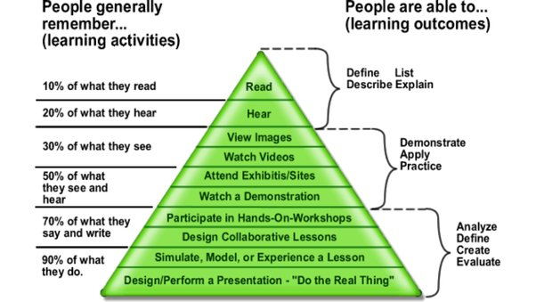
Active Learning

Active learning is a process that has pupil learning at its core. Active learning focuses on how children learn, not just on what they learn. Our children are encouraged to ‘think hard’, rather than receive information from the teacher and then be expected to retain it. Teachers, here at Monkton, make sure that they challenge the children’s thinking. With active learning, the children play an important role in their own learning process. They build knowledge and understanding in response to opportunities provided by their teacher. We believe that active learning increases the chances of children remembering key skills and knowledge.
At the beginning of the planning process, teachers will ask themselves the following in order to incorporate active learning into the lesson.
- What do the children in my class need to learn?
- How will the task that I have chosen help the children in my class learn?
- How am I using questioning?
- How far am I creating a positive classroom culture where it is ok to take intellectual risks?
- If I need to focus on content, can I focus on the skills at the same time?
- How will I present the task to the children?
- How will I know that every child in my class has learnt the skill or has progressed towards learning the skill?
Catering for all – Differentiation, the Monkton way
It’s not just about giving children different work
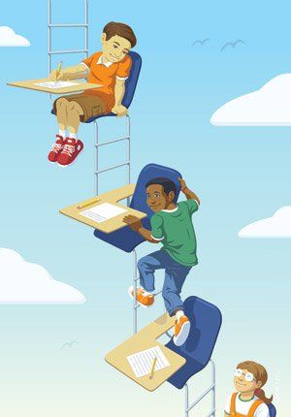
There is a range of ways to differentiate, which could be employed whatever the need of an individual pupil, dependent upon what you are trying to achieve. None of these are set in stone and all should be approached and applied with flexibility and creativity. Types of differentiation include:

- Support: the expectations of output may be the same but you provide more support/different support for some people. This may be through adult support or the use of resources and displays. Consider in particular how you are using TAs – just putting a TA with a pupil with SEND is not going to meet their needs if the TA is not clear about what they need to do. We need to provide the optimum level of support, which particularly means not too much; in other words, if a pupil has TA support, then the support should be focused on developing their learning and independence rather than task completion, and the TA should not sit with them all the time (unless there is a very clear reason for doing this). It is the teacher’s responsibility to direct the TA, and the teacher should also ensure that they spend time teaching all pupils including, or especially, those with SEND (more info on page 8)
- Task: sometimes it is appropriate to provide different tasks to suit different people’s needs
- Resource/presentation: the task is the same, but different resources are provided or it is presented in a different way as children have different learning styles.
- Time: the task and expectations for outcomes are the same, but some people have longer to complete it, and/or the task is broken down into shorter ‘chunks’.
- Feedback: this is something that teachers tend to do automatically (offer different feedback to different pupils, both written and verbal) and so may not think of it as differentiation but it is. Specific praise targeted at individual needs tends to be effective, focusing on the positives

The Learning Pit
The learning challenge is designed to normalise challenge, resilience, and reflection, in order to build a growth mindset. Its aim is to encourage children to become more comfortable with metacognition, and have the skills to question and reflect so that their knowledge can move from the surface level to deep understanding. It’s important that children not only question the concepts that are presented to them, but also their own thinking as well. That way, they can develop critical thinking, and the skills for learning other concepts. It aims to nurture childrens’ curiosity and by effect, a love of learning.

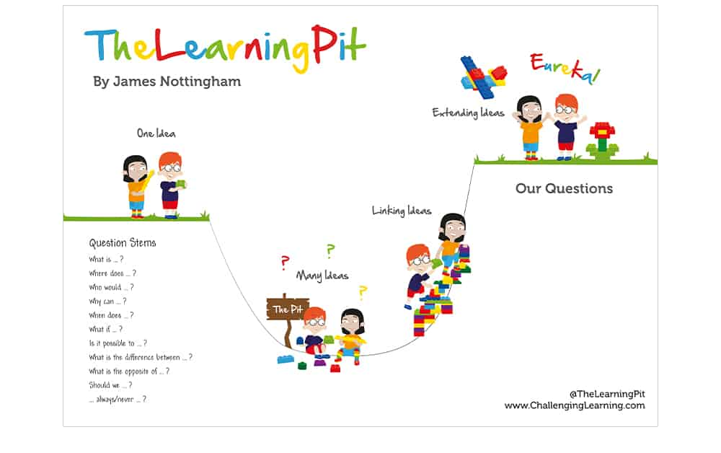
Stage 1: Concept
In this stage, the learner is presented with a concept or idea that they already have a very basic, surface level understanding of.
Stage 2: Conflict (Otherwise known as the learning pit!)Get your pupils into the learning pit, otherwise known as cognitive conflict, by asking them a series of questions about the concept. This is a challenging stage, but it’s important to get your pupils thinking more deeply about the concept so that they can understand it more deeply. The learning pit is a positive place to be because it means that the child has fully considered the concept, and now has more questions than they started with. Learners can then get out of the pit by finding answers to their questions, which brings us onto the next stage.

Stage 3: Construct
This stage is about your learners starting to construct some meaning from the previous questioning stage. Your pupils will begin to link multiple ideas together by considering different options, points of view, and explaining cause and effect. Often in this stage, pupils will find some clarity on the concept, with a sense of revelation. This is why it’s so important to make sure that your pupils go through the somewhat uncomfortable conflict stage, so that they are able to more deeply inquire about the concept.

Stage 4: Consider
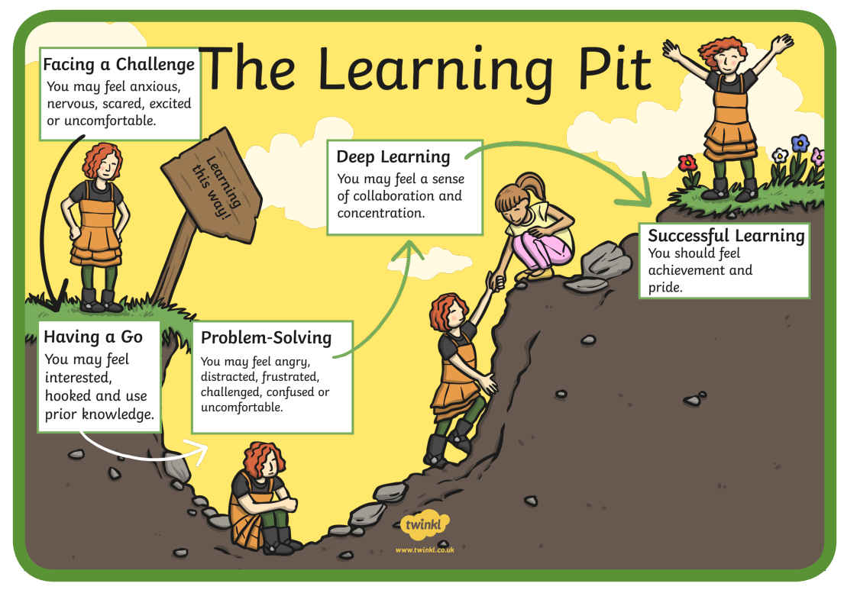
Now that your learners understand the concept more deeply, the consider stage allows for a reflection on their learning journey. This is an incredibly important stage because in order to apply this method of deeper learning to other contexts, they need to become consciously aware of how they achieved. So, they will need to consider how they got from the stage of understanding the concept through a set of simplistic, surface level ideas in stage 1, to realising that there are multiple complex questions and conflicting ideas that relate to the concept in stage 2, to the final stage which is where the learner achieves a deeper understanding through connecting lots of ideas and answers. Once they have considered how they transitioned through each stage, they can apply the process to other learning challenges, and will understand the importance of the learning pit.
The image here helps to illustrate the process children need to go through to achieve deeper learning, all classes need a ‘Learning Pit’ display.

Assessment and Feedback
The Pupil
The Teacher and Teaching Assistant
Before the lesson – the roots
- Children can learn the vocabulary for the specific lesson.
- Children can also research their topic in order to have a greater understanding of the content.
In the lesson – the self - nurturing
During the lesson, children can take many steps to address and improve their own learning.
- Self checking/correcting/editing
- Peer assessment and editing
- Children can provide feedback to the teacher. This is often more valuable than the teacher feedback to the children!
- Independently use learning strategies to them
- Independently choose resources that will aid their learning and help them step into expected or greater depth
After the lesson – the flourishing
- Children act on feedback and request more if needed
- Children will understand what they learnt, retain knowledge and know how their learning will progress in the short and long term.
Before the lesson – the roots
Before the learning takes place, teachers have the freedom to pre-teach and find out what knowledge the children have attained from previous learning (sticky knowledge). This is a great way of providing a basis for future planning in order to create a meaningful and progressive curriculum. Vocabulary can also be provided.

In the lesson – the nurturing
During the lesson, the class teacher and teaching assistant can assess and provide feedback in a number of ways.
- Carpet Club to address common misconceptions
- Whole Class Feedback addresses common mistakes
- At a glance feedback (verbal or written) with a focus group or when floating
- Adapt the lesson for certain pupils or even adapt the resources required for good learning to take place
- Praise and motivation
After the lesson – the flourishing
- Next steps – requires excellent knowledge of the curriculum and subject
- Assess the excellence of learning and praise effort
- Let learning inform how best to adapt the next lesson to help the children flourish even more
- Same day clinics to diminish the difference
Summary of key schemes and resources
Subject | Scheme/Resource
Maths | EYFS – Power Maths  Years 1-6 Mixed Age White Rose Maths
Phonics | Little Wandle
Reading | Reading lessons are taught 3 x weekly for 20 minutes using Little Wandle books.
Writing | 2/3 week unit of writing based on a specific genre and linked to the term’s theme  Within this unit, the children learn to plan, draft, redraft and publish independent writing as well as learning the key ‘age – expected’ grammar and punctuation commonly used in the genre being taught
RHE (PSHE) | HeartSmart
Music | Sparkyard
MFL | French - Eurostars
ICT | Teach Computing
Geography, History, Art, DT, & Science | Maestro 22 (adaptable)
Religious Education | Diocese Plans
Collective Worship | Diocese Plans
PE | TeamTheme

