**Federation News**

**JUNE 2025**

Dear Parents and Carers,

Welcome back to Term 6 and another instalment of the Federation News. I will keep you up-to-date with any key information for both schools, celebrate achievements and highlight some of the challenges we are currently facing, not just in our schools but in most cases, education generally in our area. It will also contain a governor section so that you can hear about their work and findings about both schools. This time it’s a celebration of the SEN provision in both schools despite the challenging circumstances financially and an OPAL update - you can read about this at the end.

**Thank a Teacher Day**

Today (18.6.25) is National Thank a Teacher Day. Please join me in celebrating what an amazing team we have at both schools and what a difference they make to your children's lives. I am so lucky to have such a hardworking and dedicated team who truly have the best interests of all of our pupils at heart.

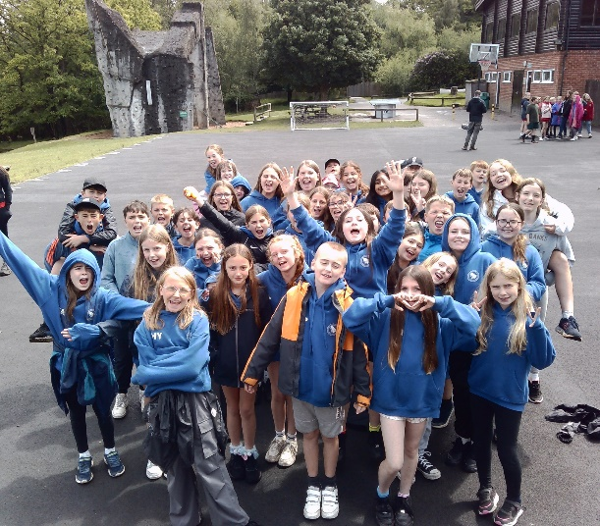**Federation Activities**

Our Y6 children from both schools recently went to Hindleap Warren for the annual Federation residential trip. They had a week of fun-filled activities and had an amazing time away. Thanks to the staff for enduring some sleepless nights but they all had fun too!

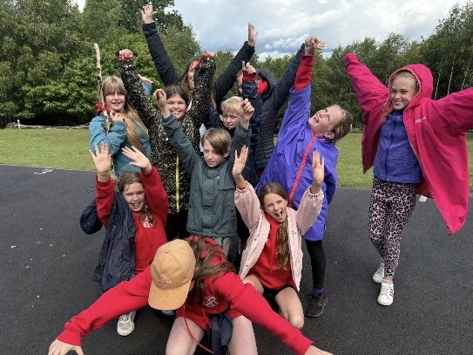We always welcome feedback regarding our activities and it was lovely to hear and read about the amazing, positive impact that it has had on the children. Thank you parents for taking the time to let us know – it helps us know when we are getting it right and also steers us when improvements can be made.

**Important information about changes to SEND funding in Kent**

Here is an update on the information I provided last time regarding the changes to Special Educational Needs and Disabilities (SEND) funding in Kent that may affect how support is delivered in primary schools, including ours.

From 1st September 2025, Kent County Council is introducing a revised model for funding SEND provision in mainstream schools. In real terms, this is a **25% reduction** in non-EHCP High Needs Funding compared to now. This will drop further the following year.

The thinking is to create a more consistent and needs-led approach across the county, ensuring that children with additional needs receive appropriate support at the right time. This will address the deficit in funding compared to other counties and is a model used successfully across the country. Transition however will be challenging when combined with the increase in complex education needs that mainstream schools are catering for.

**What’s changing?**

Under the new system:

* High Needs Funding, in its current form, will cease.
* If your child receives current High Needs Funding, we will be in touch to arrange a meeting soon.
* Schools will receive allocations for children with an EHCP directly from KCC.
* There will be a greater emphasis on early identification and intervention.
* Rather than individual funding, there is a shift to schools accessing funding to support specific group needs.
* We have never used the term 1:1 but do use the term ‘designated adults’ which fits this transition model well.

**What this means for your child**

If your child currently receives SEND support, we want to reassure you that this will continue. The changes are designed to help schools respond more flexibly and effectively to individual needs. However, how support is planned, recorded, and funded may look slightly different.

We are committed to working closely with you throughout this transition.

Our Inclusion Leaders, Mrs Guilder and Mrs Hill are available to answer any questions or discuss any specific concerns you may have about how this may affect your child.

**Next steps**

Kent County Council is providing further information and guidance for families, which we will share with you as it becomes available. In the meantime, if you would like to know more, please visit the SEND section on the Kent County Council website: [Special educational needs and disabilities (SEND) - Kent County Council.](https://www.kent.gov.uk/education-and-children/special-educational-needs-and-disabilities)

We understand that changes to funding, provision and external SEND support can cause concern, but please be assured that our priority remains to provide high-quality support for our pupils with additional needs.

A further additional piece of work carried out by KCC will set out the criteria for a range of support settings from mainstream through to specialist schools. This is almost complete and will offer schools and parents a clear matrix to identify what setting best meets a pupil's needs. This will lead to a greater understanding of what criteria are needed to access a specialist setting and ultimately a fairer process. It will also help schools and parents navigate the pathway that best meets pupil's individual needs.

**Attendance**

Attendance at both schools remains a concern and both are below the National Average for the year.

Ultimately if your child isn’t in school they cannot learn. Learning can be likened to building blocks and we all know that if solid foundations are not in place or bricks are missing we don’t get the desired outcome. There has been a lot of illness this year but there are still areas we could improve on. Here is a reminder of some of the areas where you can support your child's attendance.

**Unnecessary absence -** These include the following:

* Holidays – you are not allowed to take children on a holiday during term time. This will always be unauthorised and may result in a fine.
* Appointments – please make these outside of school hours where possible these can be very disruptive.
* Minor illness e.g. runny nose. Children who are well enough to be in school but may need some Calpol or a tissue should be in and learning.
* Poorly brother or sister – a child that is well enough to be in school, should be in school regardless of a sick sibling.
* Family Occasions/Celebrations – this includes birthdays, family visiting, special days out, new pets etc.
* Parental appointments.
* Lateness – we understand that road closures and traffic can be challenging. However, please consider this when planning your school run in the morning as lateness contributes to absence, as well as causing disruption to the morning class. Any lateness will be challenged and we will discuss with you how we can support.
* If a child is sent home poorly their unaffected siblings cannot go as well.
* Children should never be collected to go home early unless this is pre-arranged with the office and for a legitimate reason.

Should you be struggling with any of the above issues and need support from school, please let us know. We are always happy to work with families to enable better attendance for our pupils.

**Pupil Premium Funding (Free School Meals)**

Last time I outlined what Pupil Premium was and how this funding massively benefitted our disadvantaged pupils.

There has been a recent news feed (this is how I found out and not via the DFE!) that they are widening the criteria for accessing Free School Meals to **all** families that receive Universal Credit. This is welcome news and will benefit many more families within our Federation. For some of our children, this is their main meal of the day and we are very fortunate to have such a good catering team at both schools. The downside is that this will not take effect until September 2026 currently. We will keep you updated with information regarding this as we find out more.

Here is a news link if you’d like some more information:

<https://www.itv.com/news/2025-06-05/free-school-meals-to-be-expanded-to-all-families-on-universal-credit>

**Working in Partnership – Home and School**

As a Federation, we have worked together to develop a home learning offer that reflects the feedback and priorities shared by our families. We are committed to working in partnership with parents to support children in mastering key skills such as reading, comprehension of age-appropriate texts, and learning their times tables. These core skills are essential foundations for learning and have a significant impact across the curriculum—and beyond, in everyday life. Additionally, to support a smooth transition into secondary school, our Year 6 pupils have the opportunity to complete optional coursework designed to encourage independence and time management as they prepare for Year 7.

Look out for our new Home Learning sheet that will come home soon.

**EKC Trust**

As we continue our partnership with EKC we continue to benefit and develop as a Federation. Here are some of the things that have/will happen since the last update.

SEND Materials Day – Mrs Guilder attended the SEND materials day for the Federation to further develop the offer that we can provide for our pupils and families. This was a sharing of resources session with everybody from the EKC Trust and also an identification of further signposting of support beyond the school context. She came back very enthused and will be implementing it over the coming term.

Y5/6 Joint School Trip – We have a very exciting opportunity for our older pupils at each school to visit the Agricultural College in Canterbury. This is a free trip (apart from transport) and will give an important insight into this industry and also provide inspiration and aspiration in an area they might not have considered before. In addition to this, they will learn an awful lot and also enjoy seeing the animals I’m sure!

TA CPD cross-school – Our TAs have been able to take advantage of visiting other schools within the Trust and receiving additional CPD (training) to further upskill them. In addition, we will also be hosting these events at Monkton for their staff as well, with Minster hosting in the coming year. Shared good practice is imperative to ensure our staff have all of the necessary skills to best meet the needs of our pupils – this has been an excellent way of achieving this collaboratively.

Leadership training – Middle Leaders/Senior Leaders – EKC runs a comprehensive programme for developing leadership and is part of the package we bought into. Our staff at both schools have accessed this training and have come back with great ideas to put into practice and utilise.

**THRIVE, Behaviour and Relationships**

As a reminder, I talked about the development of one of our key policies in both schools - The Behaviour Policy. This policy utilises the Thrive approach with two key drivers at its heart – **‘Everybody has the Right to Feel Safe’** and **‘Everybody has the Right to Learn’**. You will be hearing this key language from staff and no doubt your children will start to use it as well. We are nearly complete on this policy, with input from staff and pupils being key voices in its development. We welcome parental input when developing policies such as these – watch out for an invitation to a meeting soon so that you can make any contributions and ask any questions.

**Governor News**

With the forthcoming challenges regarding the changes in High Needs Funding, schools are having to cope with increasing needs, and the ever-increasing complexity of SEN on an ever-decreasing budget. The SEND staff and the whole school community at Minster and Monkton schools are battling to provide your children with the best support they can, and they are dedicated to the children in their care, working to support them with the amenities that are available. Teachers and TAs are being upskilled in SEN and the Thrive approach, always with the aim to support all pupils in their care. Through the embedment of Thrive there is a real growing sense of developing a whole school community ingrained in supporting SEMH wellbeing. It is rewarding to see that the SEN coffee afternoons are popular and gaining much support from parents. It is a useful tool for building stronger and valuable communication between parents and school. Despite the challenges they face, both schools work tirelessly and go from strength to strength in supporting SEN pupils. We, as Governors, would like to thank the staff for their dedication and commitment.

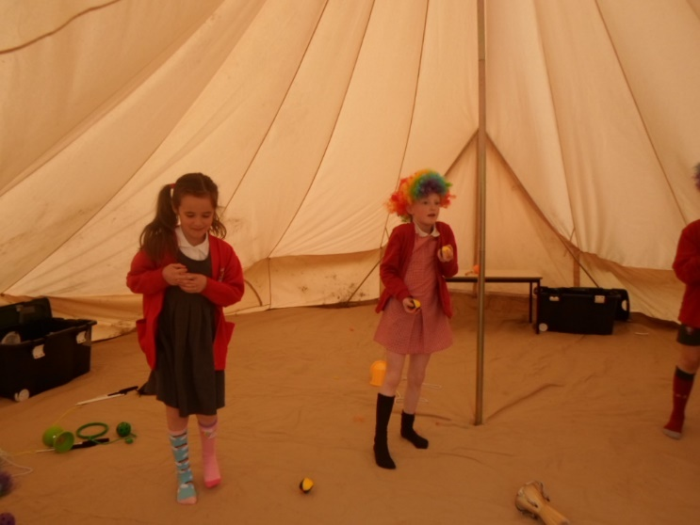Both schools continue to make great progress with their Opal initiatives and have received glowing feedback on the work undertaken to date. The Governors wish to thank not only the children and staff who have thoroughly embraced the programme, but also parents who have both bought into the initiative and given their time and assistance to collaborate with both schools. Monkton is especially pleased with its new giant sandpit and bell tent where the children will be able to be creative with circus school skills, musical instruments, and drama. We encourage everyone to try to attend one of the Opal Open Afternoons if the opportunity arises to see the benefits in action.

As Church of England schools, we are continuing to increase our links with the church and its community and have got several projects in the pipeline that we will keep you informed about.

And as for the Colour Run day at Minster, WOW, what a greeting in the playground at the end of the day. Lively chatter and excitement and colour lots of colour. What a fantastic idea for the children to enjoy and raise OPAL funds.

We would like to thank all the staff, parents and carers for their continued support in everything that the schools do.

Minster and Monkton Federation Governors June 2025

**And finally……**

That’s it for this instalment. I look forward to catching up with you all at the multitude of summer events planned at both schools – a busy but fun term ahead!

Warmest regards,

P. McCarthy

**Paul McCarthy**

**Executive Headteacher**