MONKTON CHURCH OF ENGLAND PRIMARY SCHOOL
CHARACTER EDUCATION AND CULTURAL CAPITAL

Compassion, Courage, Justice – Jesus said, ‘Go and do the same.’
Who we are | Our school has compassion at its heart, which inspires us to be people of courage, who care for ourselves, stand with others and seek justice as we grow and discover the world around us.  By knowing each individual, our learning environment is shaped to encourage creativity, promote challenge through our learning values and nurture spirituality, ensuring all thrive.  The Good Samaritan – Luke 10:27-28 And he answered, “You shall love the Lord your God with all your heart and with all your soul and with all your strength and with all your mind, and your neighbour as yourself.”
Our Christian Foundations |  |  | Compassion | Courage | Justice
How we live | Intent | Character Education at Monkton Church of England Primary School is intended to enable our pupils to flourish as human beings, fulfil their potential and live meaningfully and harmoniously with others.  The pathway to this is the acquisition and development of virtues. Character Education at our school, therefore, is centred upon the strengthening of virtues. The four domains of virtue we explore are:  • Civic virtues (Character virtues that are necessary for engaged and responsible citizenship. Examples: service, citizenship and volunteering.)  • Intellectual virtues (The virtues required for the pursuit of knowledge, truth and understanding. Examples: reflection, focus and critical thinking.)  • Moral virtues (Character virtues that enable us to respond well to situations in any area of experience. Examples: courage, self-discipline and gratitude.)  • Performance virtues – Behavioural capabilities and psychological capacities that enable us to put the other virtues into practice. Examples: resilience, determination and teamwork.
How we learn | Implementation | Character Education is delivered through our RHE programmes and across all curriculum areas, as appropriate.  Children have the opportunity to go on visits beyond the school, including residential and risk-taking experiences. Visitors are also welcomed into school to enhance the curriculum experience and to challenge moral and intellectual virtues. The children are rightly able to say that they were created to live fully.  Pupils have the opportunity to be involved in the decision-making process of the school and are valued members of the school council, Walking Though Doors Charity Club, Playground Leaders and Christian Ambassadors. Pupils are also given the opportunity to represent the school at sport, music recitals and performances, STEM activities and debates. The school has a clear mission to serve others.  Our pupils are supported to understand the democratic process and they know they have valued opinions and to respect the opinion of others.  Our behaviour management processes encourage the children to take responsibility for their actions, to consider the impact of their choices and to reconcile their differences. They are encouraged to forgive and to understand the perspective of others. They are consequently equipped to be self-disciplined, honest and to value justice.  A growth mindset is encouraged in all pursuits so that pupils persevere and are resilient. They are encouraged to discuss their thinking and to listen to others in order to reflect. They develop confidence as they are encouraged to “have a go”; their determination, resourcefulness and reasoning are praised.

Experience | Frequency (if applicable) and Type | Intent | Impact
Year 6 School Residential | Annually – Term 6 | Moral and Performance Virtues  We provide children with a weeklong residential at Hindleap Warren because we want to support children’s independence and personal development.  The children develop life-skills through team-building activities and outdoor pursuits. A proportion of our children are reluctant to take risks with their learning or are limited with opportunities to try new experiences. Through outdoor activities, we teach the children resilience, perseverance and persistence. The children feel personal success when they achieve and complete tasks and see them through to the end. | The children who attend these events have shown improvement in their attitude towards learning. They develop a growth mind-set with improved resilience and the ability to persevere with tasks across the curriculum. They also develop increased independence through being away from their local environment, and learn the benefits of being outdoors and maintaining an active lifestyle. They are ready to face the world including their transition into Year 7 and beyond.
Environmental Activities | Geography Week - biannually  Sustainability Week - annually  Litter Picking – 1 class per week  Gardening activities in Tom’s Garden – spring and summer time weekly  Bikeability (Green Travel) - annually  ‘Switch-off’ Days – throughout the year  Window, Mirror Door reflections woven into the curriculum | Civic virtues  The children learn about the impact their actions have on the environment and how they can act responsibly to protect the earth and its inhabitants. | Children are able to understand how to protect the earth and are able to promote positive behaviours. They are able to justify their opinions.
Curriculum visits and visitors | Museums  Theatres  Sites of historic interest  Restaurants and local shops  Monkton Nature Reserve  Farms – Thanet Earth  Author visits  Entrepreneur visits  Scientist visits  History workshops  Visits to local places of employment  Emergency Service visits and workshops | Intellectual and Performance Virtues  Children have the opportunity to visit places of intellectual and cultural interest. They take part in experiences which bring facts to life. | Children are able to retain information as a result of their memorable experiences. They become familiar with cultural activities and develop their own intellect and sense of taste. They gain an insight into community opportunities for leisure and employment.
Community Activities | Frequent Parish services at the church  Collective Worship held by Cannon Gausden,  Carol Singing  Christingle  Coffee mornings  Harvest Worship  Food Bank donations | Civic virtues, moral virtues  Children contribute to local events by planning, performing, reading, participating in and/or benefitting from the activities. All children are able to participate at different times and their contributions are valued within the school and its wider community. | Children feel proud of their contributions and recognise that others value them also. They recognise the talent and contributions of others also and understand that their efforts can impact positively on the life of others.
Sporting Festivals/Tournaments | Cross Country  YR Teddy Bears’ Picnic  Y2 Multisports  Y3 Skipping  Y4 Handball  Y5 Rugby  Y6 Athletics  Intra-school festivals  Inter school leagues  Virtual games competitions  Sports day  Swimming galas | Civic and Performance Virtues  All children in all year groups take part in sporting competitions. | Children understand that people have different sporting abilities but that all can contribute to a team. They learn to be gracious in victory and in defeat and develop the attitudes to celebrate other people’s successes. They know that it is important to do your best.
Charitable Acts | Walking Through Doors Charity Club  Fundraising  Food Bank Appeals  Tom’s Garden Fruit and Veg Giveaway  Random Acts of Kindness  Money Week | Moral, Civic, Performance and Intellectual Virtues  Children’s awareness of the vulnerable in society is raised and they recognise their responsibility to be good local, national and global citizens. They have the opportunity to decide on actions they will take | Children know that their actions make a difference to others. They recognise that they can use their talents, skills and knowledge for the good of others. They develop an awareness that different people have different life experiences.
Opportunities to support Well-Being | Mindful Monkton  Yoga  Daily mile/exercise  Pastoral TA Support  Pupil Voice  Parent Voice  Staff Voice  Young Leaders  Rainbows Bereavement Counselling  School Counsellor weekly | Performance virtues  Based on a holistic approach to supporting mental health and well-being, we promote a "can do" and supportive approach. By identifying factors that promote well-being and by implementing a range of strategies to promote mental health for the whole school, groups and individuals, we seek to reduce anxiety and improve engagement in all school activities. | Children have an understanding of mental health and recognise the need to take time to relax and refocus. When children engage with therapy, their confidence grows and they develop a growth mindset. They have strategies that enable them to cope when challenges arise and they become less anxious. They respond in appropriate ways when they are angry or upset. Staff mental health is also prioritised through well-being afternoons and designated staff meetings/events
Performance Activities | Class Collective Worship  Nativity (EYFS)  Year 6 Production  Choir performances  Music recitals  Talent Shows | Moral, Civic, Performance and Intellectual Virtues  Children perform in plays, musical recitals etc, using their various talents. | Children are proud to perform for others. They recognise that their performance can impact positively on the well-being of others and know that their contribution is meaningful. They recognise each other’s talents.
Child Leadership | House Captains  Christian Ambassadors  Young Leaders  Playground Leaders  School Council | Civic and Intellectual Virtues  Children are given the opportunity to develop their leadership skills, intra and interpersonal skills through a variety of leadership roles. | Children enjoy leading events and being role models to the rest of their peers and younger children. They understand the need for debate and discussion plus feasibility and now have the skills to organise (as part of a group) important events within the school.

MONKTON CHURCH OF ENGLAND PRIMARY SCHOOL
CULTURAL CAPITAL

Every child and family who joins our setting will have their own knowledge and experiences that will link to their culture and wider family. This might include: languages, beliefs, traditions, cultural and family heritage, interests, travel and work.

Cultural capital is the accumulation of knowledge, behaviours, and skills that a child can draw upon and which demonstrates their cultural awareness, knowledge and competence; it is one of the key ingredients a pupil will draw upon to be successful in society, their career and the world of work.

Cultural capital gives power. It helps children achieve goals, become successful, and rise up the social ladder without necessarily having wealth or financial capital. Cultural capital is having assets that give children the desire to aspire and achieve social mobility whatever their starting point.

Ofsted define cultural capital as…

“As part of making the judgement about the quality of education, inspectors will consider the extent to which schools are equipping pupils with the knowledge and cultural capital they need to succeed in life.
Our understanding of ‘knowledge and cultural capital’ is derived from the following wording in the national curriculum: ‘It is the essential knowledge that pupils need to be educated citizens, introducing them to the best that has been thought and said and helping to engender an appreciation of human creativity and achievement.’ “

At Monkton Church of England Primary School, children benefit from a progressive and themed curriculum that builds on what they understand and know already. We believe that exposure, not only to culture but also to situations in which the children might not have previous experiences of, is of paramount importance to their ongoing successes.

Gradually widening children’s experiences as they progress through school is an important step in providing rich and engaging learning across the curriculum. We plan carefully for children to have progressively richer experiences in school and beyond. These include trips to the local park, shops and visits to places of worship, museums, sports and music venues just to name a few.

Performances | Celebrating Cultures | Passion for the arts/music | Understanding History | Local visits
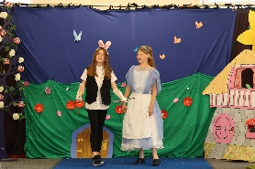 | 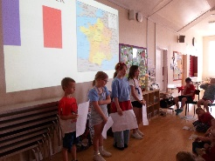 | 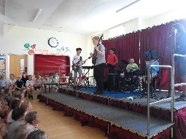 | 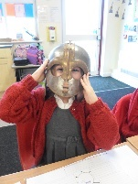 | 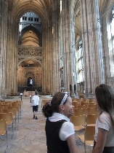
Charitable acts/acts of kindness | Appreciating our local community | Caring for the Environment | Staying Safe | Worship at our local church
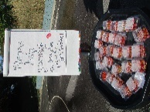 | 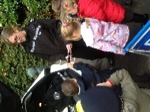 | 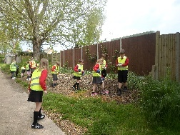 | 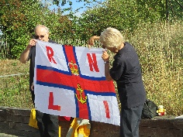 | 